Patient Full Name (PRINTED)
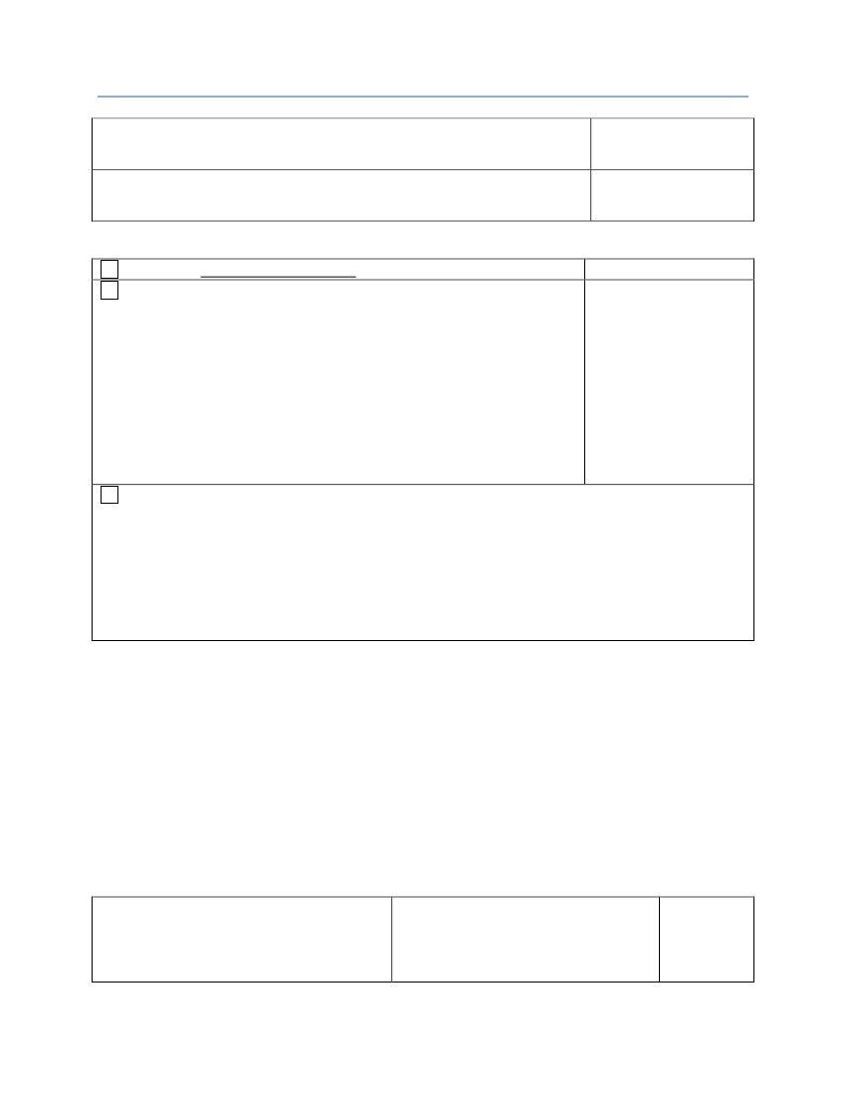PD Labs: Request to Access Records
Date of Birth
Address / City / State / Zip
Telephone #
Must be completed for each patient.
I would like a Medication Expense Report for the following Years:
I am requesting data from
Please describe the Information you wish to have access to and in what format
(we will try to comply with the format if possible):
the following time frame
(you may be able to go
back six (6) years).
Start Date: __________
Email Address, if requesting records emailed:________________________________________
Fax Number, if requesting records faxed:___________________________________________
End Date: ___________
Start Date: __________
I would like the following Individuals to have access to my facility health records. Please describe the type of
records. Please print clearly.
End Date: ___________
If the records are being requested for a spouse or a child that is above the Age of Medical Consent, they will be
mailed directly to the patient.
I understand that if the Facility grants access to records, they will provide the requested records within thirty (30)
days. Also, I understand there may be a cost-based fee charged to process this request and the Facility will contact
me prior to continuing action on this request for my acceptance of the fee amount (if any). If the Facility needs
additional time, then the Facility’s Privacy Officer will notify me with the reason.
When completed, please return to Specialty Compounding, LLC.
PD LABS
Ray Solano
101 Commercial Pkwy
Cedar Park, TX 78613
Tel: (512) 219-0724
Fax: (512) 219-0943
Email: info@pdlabs.net
Signature of Patient/Legal Guardian/Personal
Representative.
Relationship to the Patient.
Date
PRS HIPAA COMPLIANCE PROGRAM © 2002 – 2013 (0813a)

