Dirt Warrior Accessories – POLARIS RANGER
Front Windshield
Helpful Hints for Installation:

Tools Needed:
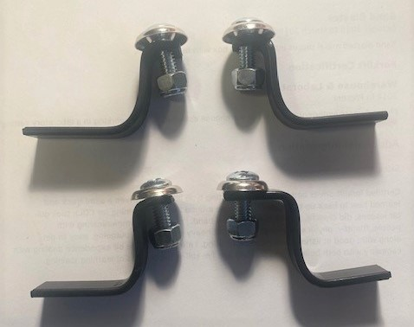
- Phillips #3 Screwdriver or Screw tip for Screw Gun
- 7/16” Socket or wrench

- First remove “S” clips and brackets from window (if they came attached to window) See Diagram on back page: This windshield has (2) S clips and (2) brackets.
PIC 1A
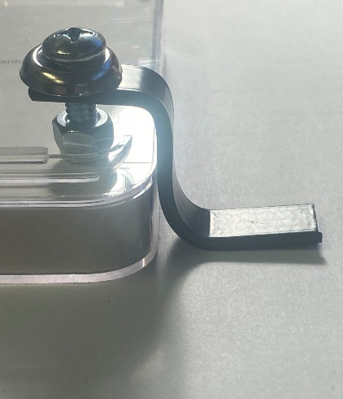
Hold windshield up and lay in place on cage. It should sit inside grooves on the pro-fit cage. This step usually works best with 2 people

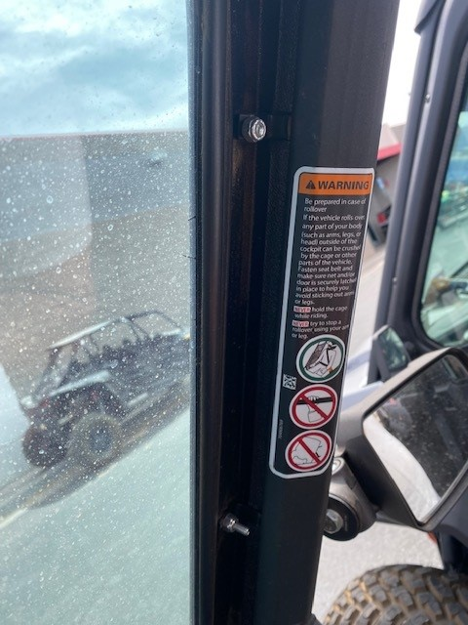
- With screws, washers, and nuts (supplied & shown in pic) Place S clip in slot of cage as shown in Pic 1C.
Windshield Aluminum Frame Here This end fits in the slot on the Pro-fit cage
PIC 1B
- Next, attach brackets to windshield first and then to roll cage. The end with 2 holes mounts to the windshield and the end with 1 hole mounts to the roll cage. You do not have to drill, there is a hole in the cage from the factory that you will use. (See diagram on back page for placement)
PIC 1D
PIC 1C

- Next, position window so that it is high enough for the vents to open but close enough to the hood that you get a tight fit. Then, position side to side to center window on roll cage.
- Once you have the window positioned, begin tightening all screws.
- Now that the window is on, verify that the vent flaps operate correctly.
Thank YOU for your BUSINESS & Have A DiRtY DAY!!!
