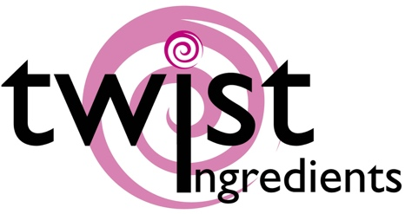

|  |  |  |
| --- | --- | --- |
| Truly (UK) Ltd  Sprinkles HQ  Brimfield  Ludlow  SY8 4NX | Product specification nutritional Information | May 2019  V1 2019 |

|  |
| --- |
| 1752: Sprinkletti – Snowman Poop |

|  |
| --- |
| Ingredients |
| Sugar, Rice Flour. Rapeseed, Oil (partly hydrogenated), Thickener (tragacanth), Milk chocolate [sugar, cocoa butter, whole MILK powder, cocoa mass, emulsifier: SOYA lecithin, natural vanilla flavouring, cocoa solids: 32% min], sugar, crispy cereal centre (12%) [WHEAT flour, whole meal WHEAT flour, sugar, WHEAT gluten, malted WHEAT flour, salt, raising agent: baking soda E500(ii)], rice starch, stabilizer: arabic gum, coloring (E171, E174), stabilizers: E460(i) & E464, emulsifier: E472α, gelatine (fish), Glazing Agent (carnauba wax, beeswax)  Allergens shown in CAPITALS |

|  |  |
| --- | --- |
| Nutrition facts | per 100 g |
| Energy value | 2001.5kJ |
| Energy value | 476.5 Kcal |
| Total fat | 17.36g |
| . of which saturated fat | 10.42g |
| Carbohydrate | 75.93 g |
| . of which sugars | 73.44 g |
| Proteins | 3.25g |
| Salt | 0.9g |

|  |
| --- |
| Storage conditions - 15° C – 25° C, dry |

|  |
| --- |
| Allergens: |
| Wheat, Milk, Soya  We handle the following allergens on site:- Wheat, Soya, Milk, Eggs, Fish  We are not a certified ‘Free From’ site – For further information please ask |
| We certify that all of our products do not contain any ingredients or raw materials manufactured from GMO substances. |

|  |  |
| --- | --- |
| Vegetarian | No |
| Vegan | No |

|  |
| --- |
| This product information has been edited and checked carefully and corresponds to the relevant EC food legislation at this moment |