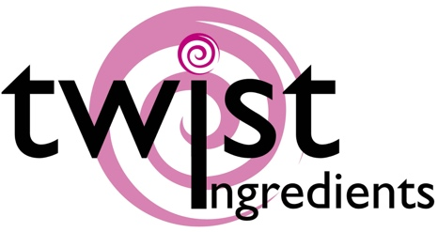

|  |  |  |
| --- | --- | --- |
| Truly (UK) Ltd  Sprinkles HQ  Brimfield  Ludlow  SY8 4NX | Product specification nutritional Information | May 2019  V1 2019 |

|  |
| --- |
| 1290: Glimmer Pearls – Blue and Turquoise |

|  |
| --- |
| Ingredients |
| Sugar, Dextrose, Glucose Syrup, WHEAT Starch, Colours (E133, E141, E171), Glazing Agent (shellac)  Allergens shown in CAPITALS |

|  |  |
| --- | --- |
| Nutrition facts | per 100 g |
| Energy value | 1663 kJ |
| Energy value | 391 Kcal |
| Total fat | 0.1g |
| . of which saturated fat | 0.1g |
| Carbohydrate | 98 g |
| . of which sugars | 96 g |
| Proteins | 0.2g |
| Salt | 0.03 g |

|  |
| --- |
| Storage conditions - 15° C – 25° C, dry |

|  |
| --- |
| Allergens: |
| Wheat  We handle the following allergens on site:- Wheat, Soya, Milk, Eggs, Fish  We are not a certified ‘Free From’ site – For further information please ask |
| We certify that all of our products do not contain any ingredients or raw materials manufactured from GMO substances. |

|  |  |
| --- | --- |
| Vegetarian | Yes |
| Vegan | No |

|  |
| --- |
| This product information has been edited and checked carefully and corresponds to the relevant EC food legislation at this moment |