

MOB:07720560299

PHONE:01759 306777

**Bespoke ‘Room Design Scheme’**

**Initial Consultation - £60 (full refund on order)**

**Design Scheme Board - £120 (full refund on order)**

**What’s included*:**

**Approx one-hour home visit to get to know your living space, and a one-hour follow-up in store**

**Creation of personalised design scheme**

**Digital mood board and shopping list of items collated for your home**

**Booking of any services required such as measuring and fitting**

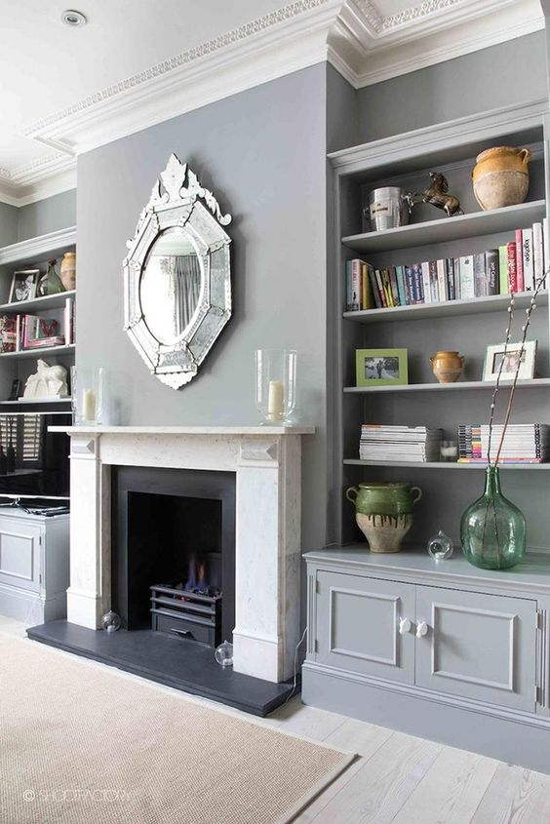

**Step 1: Home visit   
Vicki - Our Home Design Stylist will visit your home to understand what you're looking to achieve and get a sense of what would work well. We will take photos of the rooms and approximate room and window dimensions if required.**

**Step 2: In-store appointment (1 hour)  
A follow-up in-store appointment where Vicki will present her ideas and proposed design scheme**

**Step 3: Visualise your new decorating scheme  
We’ll reveal the designs we've collated for you, along with a digital mood board and personalised product list.**

**Step 4: Order  
We’ll place orders for you as well as arranging samples and any measuring appointments you may need**

**A ‘Room Design Scheme’ board offers a tailored approach to your interior project.**

**Each Design will feature where necessary .....**

* **lighting plan**
* **Paint, wallpaper and fabric choice swatches**
* **Other surface treatments (flooring, tiles, decorative panelling etc.) with samples/imagery where relevant**
* **Window treatment illustrations**
* **Selected lighting, furniture, soft furnishings and accessories**
* **Styling tips**
* **Relevant prices for all featured product**

**Balance of payment is due prior to home visit and assembly of board.**

***Please submit to***

***Account No: 71432737 Sort: 40-13-30 To: Grandads Shed Ref: VK and Your Name***

***Many thanks and look forward to working on your project.***

**Terms and Conditions**

**The £60 and £120 fee will be refunded to you when you buy products worth £600 through our Home Design service.**

**These orders must be placed within 6-months of your initial appointment. Spend excludes any estimating or fitting costs incurred.**

**If you wish to cancel we'll refund this fee if you've given us 48-hours notice**