**Customer Copy**



**“Quilt with no Name”**

**Block of the Month – Booking Form**

**What is Block of the Month?**

Block of the month is a subscription to a quilt. You pay a certain amount for a certain number of months (this varies for each quilt). For each payment you will receive through the post, a parcel containing fabric and full instructions to complete a section of the quilt. It is a great way of spreading the cost and sewing time too. By the end of the subscription you will have all the fabric and instructions you need to complete the quilt top.

**PLEASE EXCUSE THIS TEMPORY PICTURE – QUILTING IN PROGRESS**

**What the cost includes:**

1. All fabric for the quilt top & Binding

All PRE-CUT

2. Full, clear, easy to follow instructions.

3. Postage is included within the UK.

£3 charge for outside the UK.

4. Back up help via phone/email

**Starts:** 1st week of May 2019

Or any month of your choice after May

**Cost:** £26.50 per month for 6 months

Size : 72” x 72”

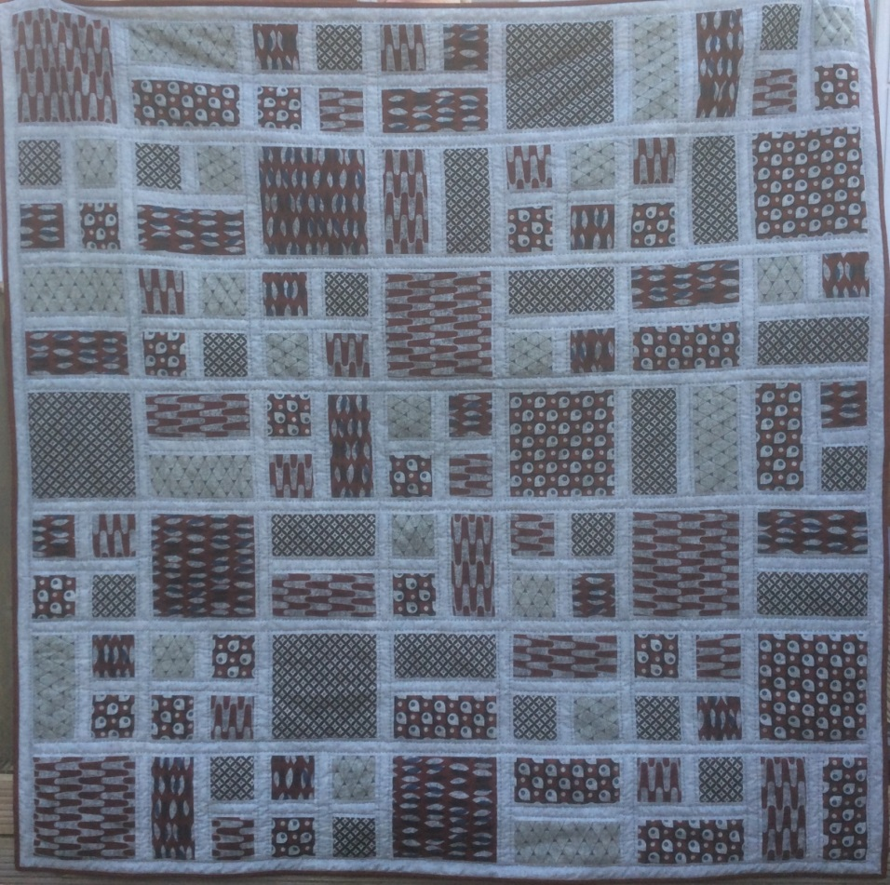

Totally Patched

12 Abdon Close, Highley, Bridgnorth, Shropshire WV16 6DY. E-mail contact@totallypatched.com

01746 862289 [www.totallypatched.com](http://www.totallypatched.com)

**Terms and Conditions – by signing this form you agree to the following:**

* For your credit/debit card details to be securely held by Totally Patched
* For Totally Patched to charge your chosen card £26.50 for 6 payments.
* That you are forming a contract with Totally Patched for 6 months and should you cancel, you understand that you will be charged the full cancellation fee of the outstanding months of the contract in one lump sum.
* In undertaking this contract with us we commit to supply you as per the details stated on your customer copy and supply exact fabrics as per the sample for your duration of the 6 month contract.
* Blocks will be posted out during the third week of each month.
* Please be aware that you are ordering a bespoke product that is cut to order therefore once you have placed your order you are forming a contract with us.



Totally Patched Copy

Please return to us.

**“Quilt with no Name”**

**Block of the Month – Booking Form**

Name:

Address:

Postcode:

Telephone Number:

Email Address:

We suggest that if you’re posting this to us, that you don’t add your card details, please call us with them.

Card Number:

Expiry Date:

Three digit security number (from the back of the card):

WHAT MONTH WOULD YOU LIKE TO RECEIVE YOUR FIRST PACKET? ___________________________________

**Terms and Conditions – by signing this form you agree to the following:**

* For your credit/debit card details to be securely held by Totally Patched
* **For Totally Patched to charge your chosen card £26.50 every month for 6 payments**
* That you are forming a contract with Totally Patched for 6 months and should you cancel, you understand that you will be charged the full cancellation fee of the outstanding months of the contract in one lump sum.
* Please be aware that you are ordering a bespoke product that is cut to order therefore once you have placed your order you are forming a contract with us.

Signed:­­­­­­­­­­­­­­______________________________________ Name : _______________________________________

**What month would you like to start?**

**PLEASE RETURN THIS COPY TO Totally Patched or book on our website**

Totally Patched

12 Abdon Close, Highley, Bridgnorth, Shropshire WV16 6DY. E-mail contact@totallypatched.com

01746 862289 [www.totallypatched.com](http://www.totallypatched.com)