**How to turn off a metered connection**

[**To turn off metered connection on Windows 10, you can follow these steps**](https://www.bing.com/ck/a?!&&p=09322cd1229ce9e2JmltdHM9MTY5OTU3NDQwMCZpZ3VpZD0zYTI2ODQ5OS05ZmRlLTZhY2EtMzJmZS05NzAyOWU3ZjZiOTUmaW5zaWQ9NTc0OQ&ptn=3&hsh=3&fclid=3a268499-9fde-6aca-32fe-97029e7f6b95&psq=this+computer+is+metered&u=a1aHR0cHM6Ly9hcHB1YWxzLmNvbS9ob3ctdG8tdHVybi1vZmYtbWV0ZXJlZC1jb25uZWN0aW9uLW9uLXdpbmRvd3MtMTAv&ntb=1)[**1**](https://www.bing.com/ck/a?!&&p=4fef6bf362c91be4JmltdHM9MTY5OTU3NDQwMCZpZ3VpZD0zYTI2ODQ5OS05ZmRlLTZhY2EtMzJmZS05NzAyOWU3ZjZiOTUmaW5zaWQ9NTc1MA&ptn=3&hsh=3&fclid=3a268499-9fde-6aca-32fe-97029e7f6b95&psq=this+computer+is+metered&u=a1aHR0cHM6Ly9hcHB1YWxzLmNvbS9ob3ctdG8tdHVybi1vZmYtbWV0ZXJlZC1jb25uZWN0aW9uLW9uLXdpbmRvd3MtMTAv&ntb=1)[**2**](https://www.bing.com/ck/a?!&&p=bf6948207d44cdebJmltdHM9MTY5OTU3NDQwMCZpZ3VpZD0zYTI2ODQ5OS05ZmRlLTZhY2EtMzJmZS05NzAyOWU3ZjZiOTUmaW5zaWQ9NTc1MQ&ptn=3&hsh=3&fclid=3a268499-9fde-6aca-32fe-97029e7f6b95&psq=this+computer+is+metered&u=a1aHR0cHM6Ly93d3cuNHdpbmtleS5jb20vd2luZG93cy0xMC9kaXNhYmxlLW1ldGVyZWQtY29ubmVjdGlvbi1vbi13aW5kb3dzLTEwLmh0bWw&ntb=1)[**3**](https://www.bing.com/ck/a?!&&p=6fedaa4636dfe001JmltdHM9MTY5OTU3NDQwMCZpZ3VpZD0zYTI2ODQ5OS05ZmRlLTZhY2EtMzJmZS05NzAyOWU3ZjZiOTUmaW5zaWQ9NTc1Mg&ptn=3&hsh=3&fclid=3a268499-9fde-6aca-32fe-97029e7f6b95&psq=this+computer+is+metered&u=a1aHR0cHM6Ly9hbnN3ZXJzLm1pY3Jvc29mdC5jb20vZW4tdXMvd2luZG93cy9mb3J1bS9hbGwvb25lZHJpdmUtbWV0ZXJlZC1jb25uZWN0aW9uLzhhMGY0NWQ5LTVmZjktNDY4Ny04NDQ2LTc5ZTE2MjIyMWFhZQ&ntb=1)[**4**](https://www.bing.com/ck/a?!&&p=4a7a0529af78afe1JmltdHM9MTY5OTU3NDQwMCZpZ3VpZD0zYTI2ODQ5OS05ZmRlLTZhY2EtMzJmZS05NzAyOWU3ZjZiOTUmaW5zaWQ9NTc1Mw&ptn=3&hsh=3&fclid=3a268499-9fde-6aca-32fe-97029e7f6b95&psq=this+computer+is+metered&u=a1aHR0cHM6Ly9hbnN3ZXJzLm1pY3Jvc29mdC5jb20vZW4tdXMvd2luZG93cy9mb3J1bS9hbGwvbWV0ZXJlZC1uZXR3b3JrLzU5NDQ1NmQ1LTRiNWUtNGUwNC04OTcyLTczNzFiZWIzNjc4Zg&ntb=1):

1. Press Windows key once.
2. Click Settings (the gear icon).
3. Select Network and Internet.
4. Select Wi-Fi or Ethernet (depending on which network connection you want to change as unmetered).
5. Select your network that you are connected to right now.
6. Find metered connection, and turn off.

[Metered connection allows your PC to use a set amount of data when connected to a certain network via ethernet or Wi-Fi. Enabling metered connections prevents the OS from using too much bandwidth](https://www.bing.com/ck/a?!&&p=e0c1d5b2d2a7b15cJmltdHM9MTY5OTU3NDQwMCZpZ3VpZD0zYTI2ODQ5OS05ZmRlLTZhY2EtMzJmZS05NzAyOWU3ZjZiOTUmaW5zaWQ9NTc1NA&ptn=3&hsh=3&fclid=3a268499-9fde-6aca-32fe-97029e7f6b95&psq=this+computer+is+metered&u=a1aHR0cHM6Ly93d3cudGVjaG5ld3N0b2RheS5jb20vd2hhdC1pcy1hLW1ldGVyZWQtY29ubmVjdGlvbi8&ntb=1)[**5**](https://www.bing.com/ck/a?!&&p=e604395c2ae5e469JmltdHM9MTY5OTU3NDQwMCZpZ3VpZD0zYTI2ODQ5OS05ZmRlLTZhY2EtMzJmZS05NzAyOWU3ZjZiOTUmaW5zaWQ9NTc1NQ&ptn=3&hsh=3&fclid=3a268499-9fde-6aca-32fe-97029e7f6b95&psq=this+computer+is+metered&u=a1aHR0cHM6Ly93d3cudGVjaG5ld3N0b2RheS5jb20vd2hhdC1pcy1hLW1ldGVyZWQtY29ubmVjdGlvbi8&ntb=1).

Picture Walkthrough:

-Press Windows key once.

-Click Settings (the gear icon).

-Click Network and settings

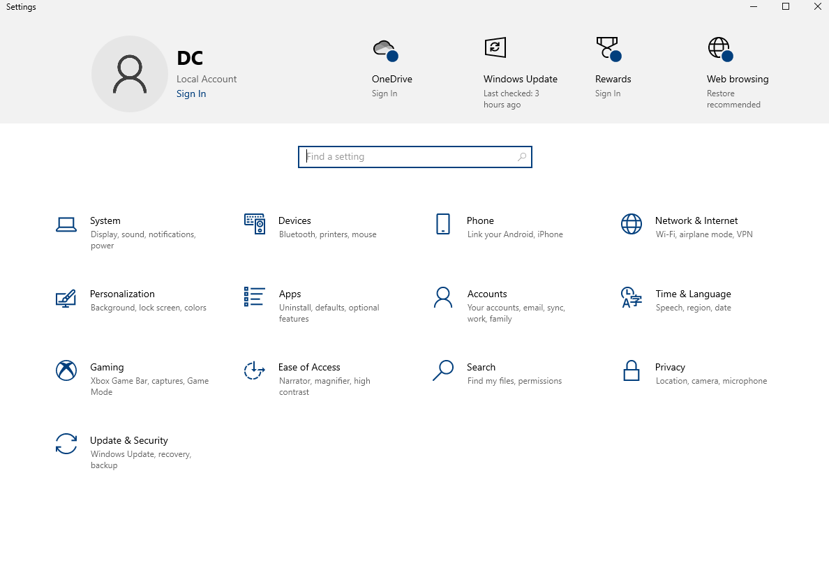

**-Click Show Available Networks**



**-Find your connected network when it pops up**



**-Click on it**

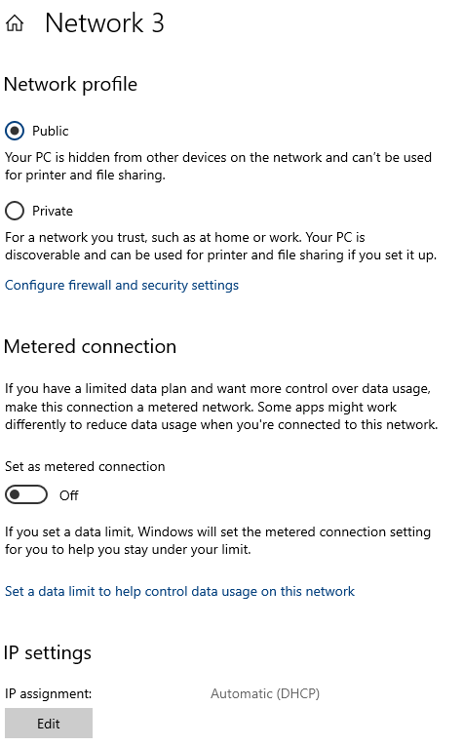

**-Where it says Metered Connection, turn it to OFF.**

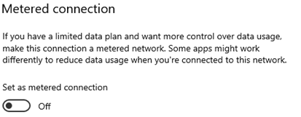

**-You`re Done**