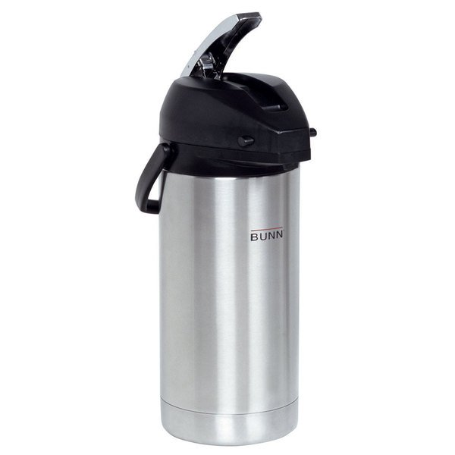**BUNN AIRPOT DAILY CLEANING**

Wipe lid and outside of airpot. Do not use stainless steel polishes or cleaners on any plastic parts. Do not use abrasive cleaners on stainless.

Carefully remove the lid (the back clip can break easily, so weigh whether it’s easier to be cautious when cleaning or carefully removing lid) Remove stem.

Rinse the inside of airpot out with hot water and scrub inside with bottle brush (or dedicated toilet brush). Clean outside of stem with hot cloth and run hot water through inside of stem.

**WEEKLY DISPENSER CLEANING:**

Remove stem from airpot. Fill inside of airpot with hot water and Cafetto Organic Espresso cleaner. Replace stem. Soak for 1-2 hours. Use bottle brush on the inside of dispenser to remove debris. Rinse thoroughly with clean water several times and thoroughly rinse inside of stem.

**PRO TIP: Best practice is to run hot water into airpots before the first brew of the day. Many people find that impractical, so we suggest running a hot water brew cycle into each airpot and leaving them overnight. The morning crew can dump out the hot water and start with warm airpots and it will help residue from building up as quickly on the inside.**

[**Hello@SnakeRiverRoastingCo.com**](mailto:Hello@SnakeRiverRoastingCo.com) **307-734-9446**