Sykik Rider
Biker's camera C6
Operation Instruction

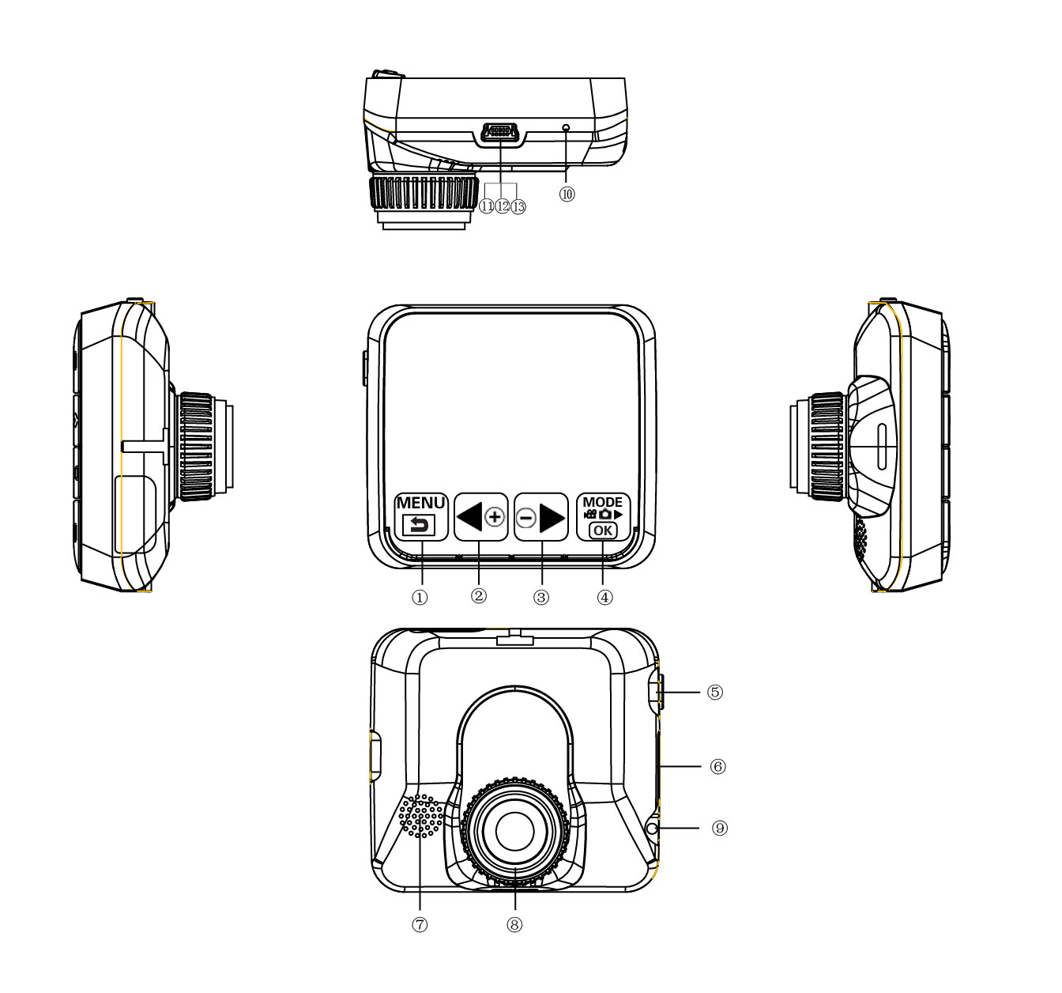
Key Operation :

1. Menu 8. LED

2. Up 9. GPS

3. Down 10. RESET

4. Mode/ REC /OK 11. Camera 1

5. Power On /Off 12. Camera 2

6. TF Card 13. USB Power Supply

7. Speaker

Menu operating instructions

Video recording Mode

In the Video recording Mode, long Press “Menu” button to enter Setup interface.
Press “UP/Down” button to select desired setting, Press “OK” to confirm and Press “Menu” to Exit.

1. Video Resolution

HD 1280*720
D1 720*480
VGA 640*480

2. Time Stamp

Off : Selecting this option the Video file will not display date& time
Date Only : Selecting this option the video file will only display date
Date and Time: Selecting this option the video file will display date& time same time

3. REC Sound

Off: Selecting this option will turn off recording sound

On: Selecting this option will turn on recording sound

4. G-sensitivity

Setting G-sensor sensitivity, Off/ high/Medium/Low

Upon impact the video file name will be saved as EVE.XXXX.AVI under normal circumstances the video file will be saved as REC.XXXX.AVI only REC file will be overwritten by Looping recording

5. Parking Mode

On: selecting this option to turn on Parking mode function

Off : selecting this option to turn off Parking mode function

6. Brightness

Selecting this option to setting Camera Brightness

Setting Mode

In the other Mode, long Press “Menu” button twice to enter Setup interface.
Press UP/Down button to select desired parameter , Press “OK” to confirm and Press “Menu” to Exit.

1. Format
By selecting this option all the files will be deleted

2. Screensaver

Off: Camera LCD will remain on
1 Min: Camera will enter into screensaver mode after 1min without any operation
3 Min: Camera will enter into screensaver mode after 3min without any operation
5 Min: Camera will enter into screensaver mode after 5min without any operation
（Screensaver mode ,Press any button to restore）

3. Beep

On: Selecting this option will turn on operation button sound
Off: Selecting this option will turn off operation button sound

4. Language

English/ French/ Deutsch/Italian/Spanish/Portuguese / T-Chinese/ S-Chinese/ Russian/
Turkish/Korean/Japan
5. Auto off

Off : Camera will remain on
1 Min: Camera will auto Power off after 1min without any operation
3 Min: Camera will auto Power off after 3min without any operation
5 Min: Camera will auto Power off after 5min without any operation

6. Sys. Reset

When encounter system error, selecting this option will restore the system to factory setting

7. Light Frequency

50HZ/60HZ

8. Date Input

1）Press “Up”/Down button to select different Day/Month /Year setting
2）Press “Mode” button to go to next selection
3）Press “REC” button Exit set

9. Time Zone

Cancel

Set: Selecting this option to setting GPS Time Zone

10. Version

Check software version information

Playback Mode

Press “Mode” button to change to Playback mode (Press “OK” button to playback the video file)

- Press Up/Down button to select previous/next Video file

- Press “OK” Play/Stop

1. Delete

Single: Deleted single file
All: Deleted all the files
Select: Select file to deleted

2. Protect

Single Protect single file
All Protect all the file
Select: Select file to be protect

3. Thumbnail /Execute

Select this option to selecte thumbnail function

4. File List /Execute

Select this option to enter File List f

5. Volume

Adjust volume 1~8

GPS Function

Connect the GPS module (Optional Accessory) to the GPS slot ,start recording when Search GPS Signal
LCD will display “GPS “ and the Camera date &time will be update

Playback GPS file
Open GPS Player ( Drplayer )

Open  icon
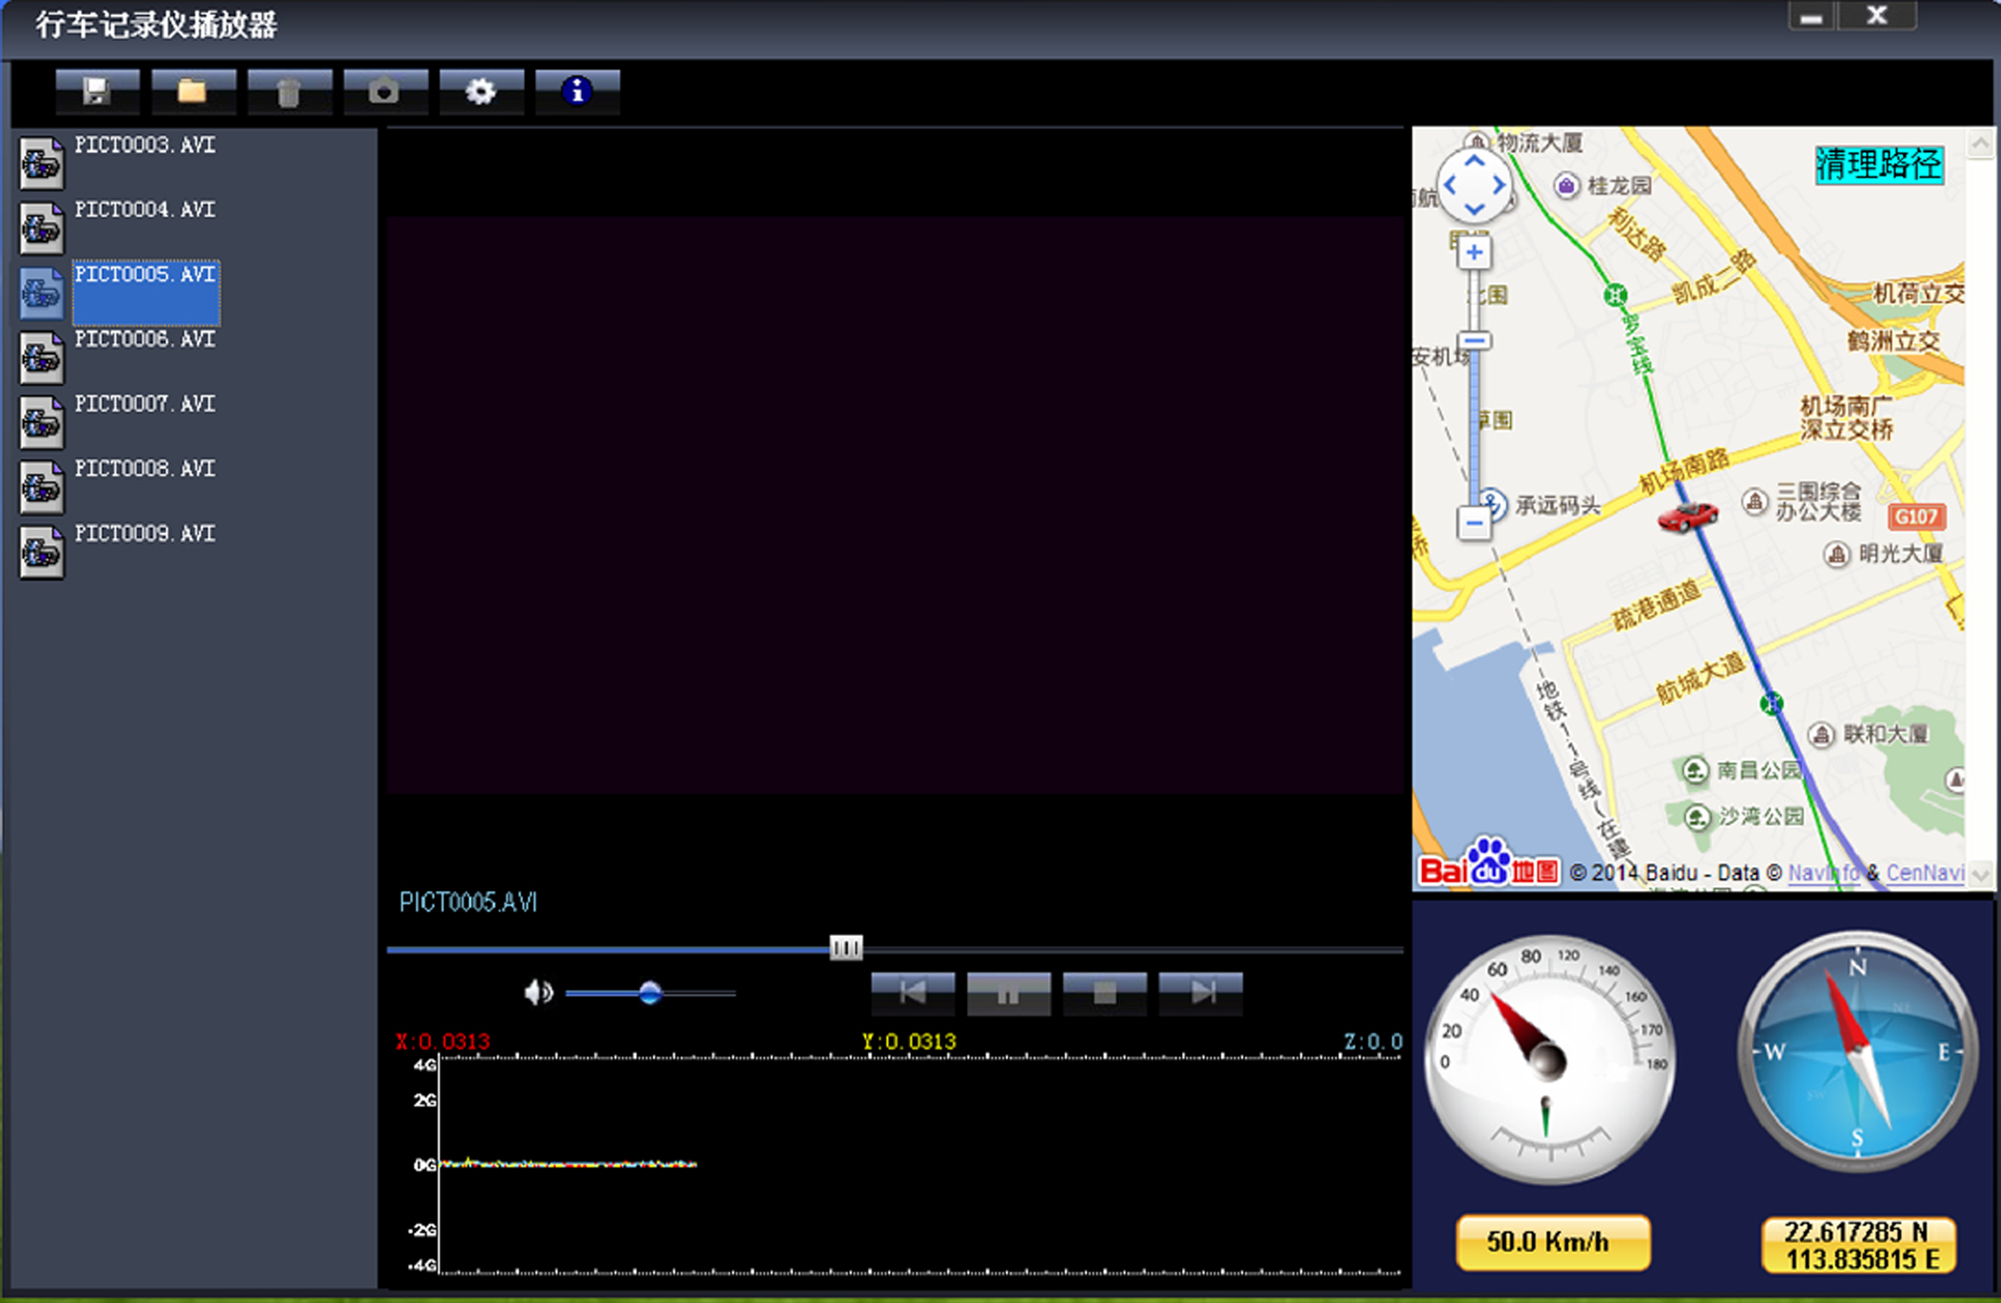
Click  button to select GPS file then Click “Play” button to playing as follow

Camera Change

1) Camera 1 / Camera 2 change: In the other mode ,Press “ Down “ button can change the Camera 1 to Camera 2

2) Camera 2 / Camera 1 change: In the other mode ,Press “ Up “ button can change the Camera 1 to Camera 2

Loop Recording

When TF Card is Full, the Camera will automatically delete existing REC.XXXX.AVI files ,Upon impact the video file will be protected and saved under EVE.XXXX.AVI these files will not be overwritten by normal Loop recording

Parking Mode

When the Car ignition key is off, after 3min of non-operation, the Camera will auto Switched into Parking mode and the video files will be 1FPS

Note :

1) According the need of customers this function is optional

2 ) In order to execute this parking mode option a special 16 pin OBD cable is required (DC input :12-24V ,output :5V-1A)

3) Please seek technical advice from professional maintenance technicians in the auto service center in order to avoid damages due to improper operation to the Camera

Wired Controller (optional Accessory) Function

Camera in the Video recording Standby mode or recording mode, Press any key on the wired Controller ,Camera will auto saved Video file name is (KEY-XXXX.AVI ) the same is (EVE.XXXX.AVI) When TF Card is full only delete Normal Video recording file (REC.XXXX.AVI)

Data Backup

Remove the TF Card from the Camera insert into Card Reader and Connect to the Computer ,you may backup the files into your Computer

Power on test

1）For first time use camera ,please use package accessory USB cable to connect to charger（DC-5V 1A）, then connect to USB slot, power on test normal recording and other function
2）After power on test, you can install and enjoy

Charging the battery

1. Directly connect car cigarettes with the USB interface, to charge battery

2. Use a USB cable to connect the computer with the USB interface, to charge battery

3. Use the USB cable to connect charger the USB interface, to charge battery.

4. The battery level display shows the remaining power of the battery as below:
Low power Not fully charged fully charged

TF Card Installment :

- Insert the TF Card in the TF Card slot according to the indicative direction ,until it softly clicks
2. When removing the TF Card push in the TF Card and gently release to eject it.
Notes:
- Make sure the TF Card are facing the right way ,if it is in the wrong direction ,it may damage the camera and TF Card
- If the TF Card is incompatible with the camera, please try to insert again ,change other TF Card
- Please use the high- speed TF Card. （The Card have CLASS⑩ icon）

Notice:
Suppose the camera is in dead halt due to the improper operation, you can press reset

button to restore the camera will return to Normal

Technical specifications

LCD screen | 2.0 TFT
Camera lens | 120 degrees A+ level high resolution lens
Language | English/French/German/Italian/Spanish/Portuguese/T-Chinese/ S-Chinese/ Russian/ Turkish/Japan
Video format | AVI (MJPG)
Video Resolution | 720*480 *2
Memory Card | TF Card Up to 32GB
Microphone | Built–in
Frequency | 50Hz/60Hz
Battery | Built-in
G-SENSOR | Support
GPS | Support
System | Windows 2000/XP/Vista/windows 7

Notice: Due the camera software update camera function can change, without prior notice

