**A picture containing clipart

Description generated with very high confidence**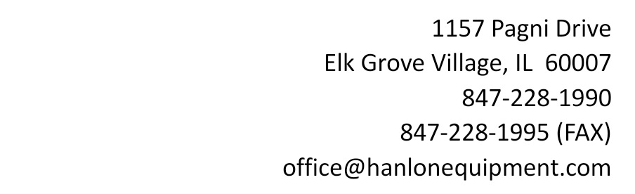

**Credit Card Authorization Form**

I authorize Hanlon Equipment Company to charge my credit card listed below for all welder/generator rental charges (including but not limited to weekly or monthly rental fees, additional welder accessories, fuel, etc.) each billing period. I understand that no prior-notification will be provided unless the date or amount changes.

In the event a welder, cables, guns, or welder accessories are stolen, lost, or otherwise non-returnable, Hanlon Equipment Company shall notify you of the charges for a replacement piece of equipment or parts and will charge your credit card accordingly. A receipt for each payment will be provided to you and the charge will appear on your credit card statement.

| CREDIT CARD INFORMATION |
| --- |
| Card Type: ☐ MasterCard ☐ VISA ☐ Discover ☐ AMEX |
| Cardholder Name (as shown on the card): |
| Card Number: |
| Expiration Date: |
| Cardholder ZIP Code (from the credit card billing address): |
| CVV: |

I understand that this authorization will remain in effect until I cancel it in writing, and I agree to notify Hanlon Equipment Company in writing of any changes in my account information or termination of this authorization at least 15 days prior to the next billing date. If the above noted payment dates fall on a weekend or holiday, I understand that the payments may be executed on the next business day. I acknowledge that the origination of Credit Card transactions to my account must comply with the provisions of U.S. law. I certify that I am an authorized user of this Credit Card and will not dispute these scheduled transactions; so long as the transactions correspond to the terms indicated in this authorization form.

SIGNATURE ________________________________________ DATE _____________________

(Cardholder’s Signature)