Chus Bartolome – 2019 Wire Positioning

Before the growing season: The foliage wire will remain as high as possible and lower foliage wire dropped below the fruiting wire

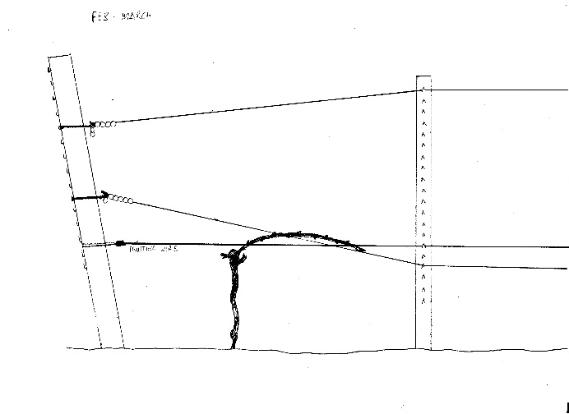

In May:

Lower Foliage Wire: When the new shoots are about 15-20 inches long, the lower foliage wire is moved up 10-12 inches above the fruiting wire.

Upper wire: Once we have done this all the row along, we come back and lower the top foliage wire to below the fruiting wire.

Please note that the chains move according to the wire position on the intermediate posts and may need to be loosened or tightened, but **do not remove the hangers.** The hangers stay in the same hook all the year round.

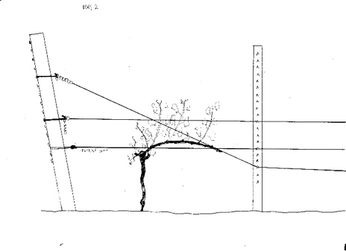

In June the top foliage wire goes up to hold the new growth from the shoots.

In July or August both wires can go up if needed and/or possible.

