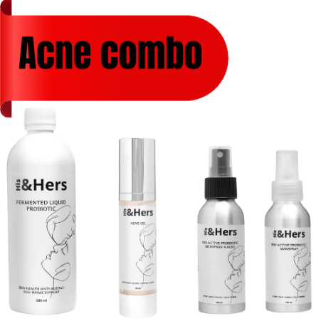
Your All-Age, All-Gender Solution to a Clearer Skin; Long-lasting Beauty inside out!
Let’s be real: acne doesn’t discriminate. Whether you're 15 or 50, a teen navigating high school stress or an adult dealing with hormonal flare-ups, those uninvited face invaders love to show up when least expected.
But guess what? We care. And we’ve got the ultimate solution that doesn’t just treat acne — it respects your skin, naturally, and establishes a long lasting solution since all health starts in the gut anyway.

Introducing the His & Hers Acne Kit
This isn’t your average skincare set, starting with your daily probiotic supply:
- Stubborn spots
- Oily or congested skin
- Annoying "why now?!" breakouts
- Post-acne skin support
All in a gender-neutral, age-friendly, and naturally-powered formula that works with your skin — not against it, especially in cases where you have tried everything.

What’s Inside the Kit?
🔹 Prebiotic-rich Aloe Facewash
A gentle yet powerful daily cleanser that lifts dirt, oil, and bacteria without stripping your skin barrier. Say goodbye to clogged pores and hello to a fresh start every morning and night. The proprietary blend Pre&Probiotic says it all.
🔹 Balancing Probiotic- rich Toner
Formulated to calm inflammation, shrink pores, and balance skin’s ph. It’s the soothing whisper your angry skin has been begging for restoring natural Skin Microbiome with the natural healing effects of Teatree oil for the blemishes.
🔹 Natural Acne Fighting Acne Gel
Packed with potent botanicals, like Aloe, this targeted treatment goes deep to fight acne-causing bacteria while nurturing the skin with the no-oil natural healing of Aloe. No harsh chemicals, no drama — just results. The proprietary blend activated silver is the most potent natural anti-pathogen known to Nature and man.
🔹 Internal use Fermented Liquid Pre&Probiotic
Natural Acne Fighter working inside out . Gut Microbiome to Skin Biome.
This proprietary blend is the most potent natural healer inside out - Nature to man.
✅ Suitable for all skin types
✅ Safe for both men and women
✅ Teen-friendly & mature-skin approved

Skin Problems? We’ve All Been There
Whether it’s your first breakout or your return to clear skin, this kit is designed to work with real-life skin in all its unpredictable glory. Because acne doesn’t follow rules — but now, you’ve got a system that does.
- Hormonal breakouts? ✔️
- Maskne? ✔️
- Stress-related flare-ups? ✔️
- Oil overload or combination chaos? ✔️

Ready to Glow?
Don’t wait for your skin to get worse before you take action. Grab your His & Hers Acne Kit today and say it loud:
“Not today, beauty invaders!”
This is skincare that doesn’t play favourites — it simply works.
https://shop.imsyser.co.za/collections/his-her-skin-care/pro

