ANTI-PATHOGEN STERI DROPS 30 ml
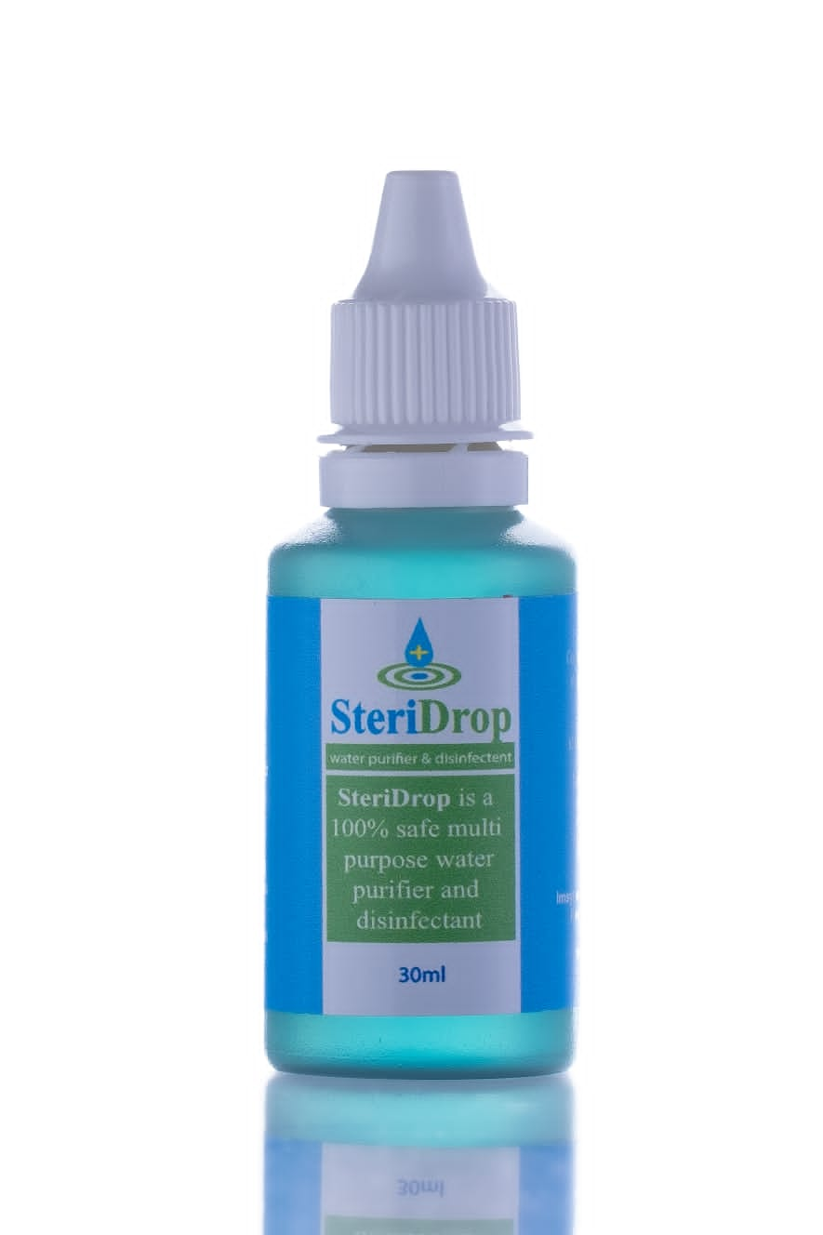

STERIDROP is a water purifier that is effective, easy to use and cheap enough to be accessible to all. Can be used by all outdoor sportsmen, anglers, hunters, travellers, hikers, city dwellers and all rural population to provide safe drinking water that also tastes sweet. In short all people need STERIDROP. STERIDROP is a water purification plant small enough to fit in your pocket!
STERIDROP is a chemical (bactericide, algaecide) which was developed for water purifying. The metal salts interact with impurities, either dissolved or suspended in the water, making it fit for human consumption or recreational purposes. The impurities settle out and can be removed in any number of ways, for instance through filtration. Water contaminated with bacteria and or algae will be disinfected, sterilized and sanitized when STERIDROP is added, making it safe to drink.

EASY TO USE

The chemical is supplied in a small dripper-bottle for easy use. Only one STERIDROP is required to purify one litre of drinking water. For use in rural areas, handy sachets are supplied for use with 25l water (25l containers). It has been used to great effect by thousands of people.
VERSATILE APPLICATIONS

Liquid Solution made up of metal salts. Antipathogen treatment solutions for water, external body health and complete internal health.
Benefits of Ionized STERIDROP (5 to 10 drops to 1 litre water) - 100% Safe, non-toxic and non-chemical:

- Water is purified , tastes better and stays fresh longer.
- Gives you lots of Energy!
- Washes acidic waste from the body – detoxify naturally.
- Builds up the body’s immune system to prevent colds and flu and other contagious diseases.
- Hydrates body 3 times more effectively than conventional water.
- Nutrients are absorbed more efficiently into the body.
- Lose weight naturally
- Promotes regularity.
- Promotes overall health and healing by bringing the body into balance.
- Ionized water scavenges Free Radicals, protecting and minimizing human DNA damage
- There are many clinical instances that many diseases including diabetes mellitus, cancer, arteriosclerosis,
- Atopic diseases, Parkinson’s disease and even pigmentary degeneration of retina were improved by daily intake of ionised water.
- Slows the Aging Process. Provides the body with extra oxygen.
- Kills bacteria.
- Provides excellent relief from mosquito bites & bee stings; poison ivy & poison oak
- Helps heal cuts, blisters, bruises, or rashes faster – no scarring.
- Hair Rinse
- Conditions Skin; relieves chapped hands & dry, itchy skin.
- Effectively removes plaque from teeth.
- Wash vegetables, fruits, meats and fish with it to kill bacteria and extend shelf life.
- Gargle to relieve sore throats or other mouth sores.
- Works as an astringent to pull skin tighter.
- Excellent treatment for acne and eczema.
- Excellent treatment for fungus such as athlete’s foot.
- Promotes plant growth and general health, herbs and wheat grass.
- Better absorption of nutrients with foods cooked with ionized water
- Bactericide.
- SPAS. When put into the Jacuzzi, the chemical acts as a general fungicide and bactericide.
- GASTRO ENTIRITIS treatment.
- DISINFECTANT FOR DENTURES. Use as a sterilizer for dentures. It will decalcify dentures, keeping them clean and fresh.
- Eye Drops. Pollen eyes.

PS Tests have shown that STERIDROP is effective as a water purification method and holds no danger of toxic levels.

Uses/Applications:
- Conditions Skin.(10drops in 100ml aqua’s cream-shake well till light blue)
- Relieves chapped hands & dry, itchy skin. (10 drops in 100ml aqua’s cream shake well till light blue)
- Effectively removes plaque from teeth.(6 drops in glass of water –rinse mouth don’t swallow)
- Wash vegetables, fruits, meats and fish with it to kill bacteria and extend shelf life.(rinse in dilution 20-40 drops to 1 litre water)
- Gargle with it to relieve sore throats or other mouth sores (5 to 10 drops in glass water).
- Wash vegetables, fruits, meats and fish with it to kill bacteria and extend shelf life.(rinse in dilution 20-40 drops to 1 litre water)
- Gargle with it to relieve sore throats or other mouth sores (5 to 10 drops in glass water).
- Excellent treatment for acne and eczema.(Add to cream)
- Excellent treatment for fungus such as athlete’s foot. (40-60 drops in a foot bath)
- Promotes plant growth and general health, herbs and wheat grass(5 to 10 drops to 1 litre of water)
- Extends the life of cut flowers no smelly water (4 – 10 drops in vase of water)
- Bactericide. Adding 1 to 10 drops of STERIDROP to a litre of water, it kills bad bacteria and any pathogens.
- 40 drops in bath water for treatment of fungal ailments e.g., athletes’ foot and thrush.
- Treats Gastro enteritis 12 drops in glass of water for adults
- Stop bleeding and aid in healing process with 15 drops in glass of water and rub on affected area.
- Anti-Septic cream 40drops to 500ml aqueous cream mixed (even works for eczema). Mosquito or insect bites drop directly on affected area
- Dispel effects of alcohol with 3-6 drops in mixers
- Sore throat with 12 drops in glass of water, gargle
- Daily consumption for complete health 1 drop per litre water. Mix in glass of soda, coffee, tea, or any beverages.
- Extend milk freshness with 1 drop per litre
- Nasal congestion dilutes 3 drops with water in a nasal spray bottle
- Helps heal cuts, blisters, bruises, or rashes faster – no scar - apply direct or dilute with a little water
- Provides excellent relief from mosquito bites & bee stings (Apply direct)
- Provides excellent relief from poison ivy & poison oak (Apply direct)
- Hair feels great after rinsing with it (4-6 drops in bath water or mix with shampoo)
- GASTRO. (Dosage - To a glass of water: Adult dosage 3 drops; Children (3 years to 8 years) - 2 drops & Infant’s 1 teaspoon treated water per hour – (One drop of STERIDROP per litre of water)

