Nectre N900
Operating Instructions

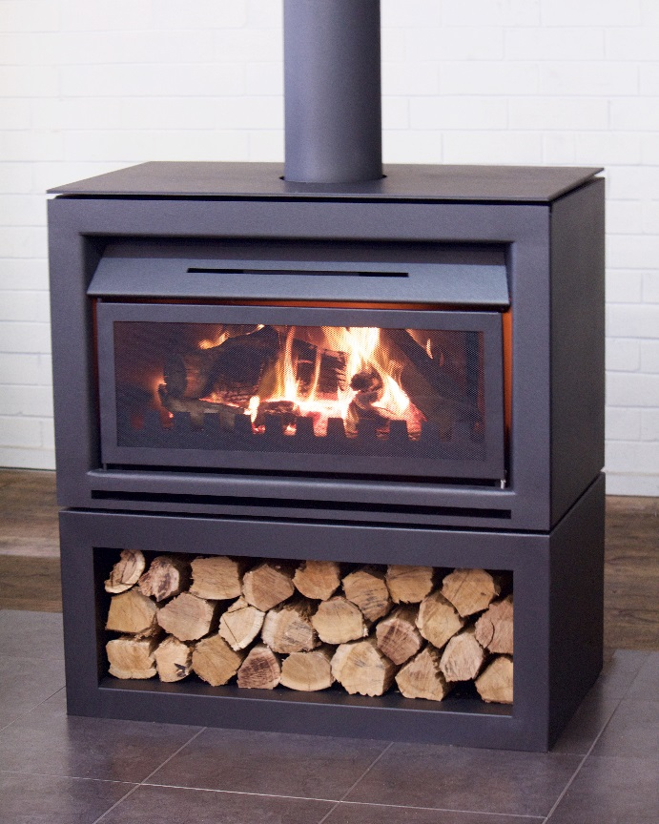
Free Standing
Base
Insert

Keep these instructions for future reference

Glen Dimplex Australia proudly supports the activities of Landcare Australia through its membership of the AHHA

CONTENTS
1. OPERATING 1
1.1. IMPORTANT INFORMATION 1
1.2. GENERAL OPERATION 2
1.2.1. DAMPER 2
1.2.2. SPARK ARRESTOR 3
1.2.3. ASH TRAY 3
1.2.4. FAN 3
1.3. USING THE APPLIANCE FOR THE FIRST TIME 3
1.4. RECOMMENDED FUELS 3
1.5. LIGHTING THE FIRE 3
1.6. RUNNING THE APPLIANCE 4
1.7. BURNING TIPS 4
1.8. ASH REMOVAL 4
1.9. FLUE FIRE 4
1.10. CLEANING PAINT WORK 5
1.11. CLEANING THE FLUE 5
1.12. TROUBLESHOOTING TIPS 5
2. MAINTENANCE AND SERVICING 5
2.1. REPLACING THE FIRE BRICKS 5
2.2. REPLACING DAMPER COMPONENTS 6
2.3. ADJUSTING THE SPARK ARRESTOR 7
2.4. REPLACING THE FAN 8
2.5 REPLACEMENT SPARE PARTS LIST 11

OPERATING
THE OPERATING INSTRUCTIONS IN THIS MANUAL APPLY TO THE NECTRE N900 OPEN FIREPLACE MODELS.

IMPORTANT INFORMATION

Before use of this appliance please read these instructions fully.

WARNING: ANY MODIFICATION OF THE APPLIANCE THAT HAS NOT BEEN APPROVED IN WRITING BY THE TESTING AUTHORITY IS CONSIDERED AS BREACHING AS/NZS 4013.
WARNING: DO NOT USE FLAMMABLE LIQUIDS OR AEROSOLS TO START OR REKINDLE THE FIRE.
WARNING: DO NOT USE FLAMMABLE LIQUIDS OR AEROSOLS IN THE VICINITY OF THIS APPLIANCE WHEN IT IS OPERATING.
WARNING: DO NOT STORE FUEL WITHIN HEATER INSTALLATION CLEARANCES.
WARNING: ALWAYS USE SPARK ARRESTOR WHEN FIRE IS UNATTENDED.
WARNING: ALWAYS OPERATE FIREPLACE WITH DAMPER FULLY OPEN.
WARNING: DO NOT BURN WOOD THAT IS PAINTED; OR IS COATED WITH PLASTIC; OR HAS BEEN TREATED WITH ANY CHEMICAL.
CAUTION: THIS APPLIANCE SHOULD BE MAINTAINED AND OPERATED AT ALL TIMES IN ACCORDANCE WITH THESE INSTRUCTIONS.
The appliance or flue system should not be modified in any way without the written approval of the manufacturer.
Extractor fans or cooker hoods must not be placed in the same room or space as this can cause the appliance to emit smoke into the room.

GENERAL OPERATION

DAMPER
The damper is a critical component of the fireplace and should be treated as such. With the damper open, smoke is able to escape the fireplace and into the flue, with it closed it will prevent cold air from entering the room while the fireplace is inactive.
IT IS VITAL THAT THE DAMPER IS OPEN DURING OPERATION OF THE FIREPLACE. PLEASE CHECK BEFORE EVERY USE.

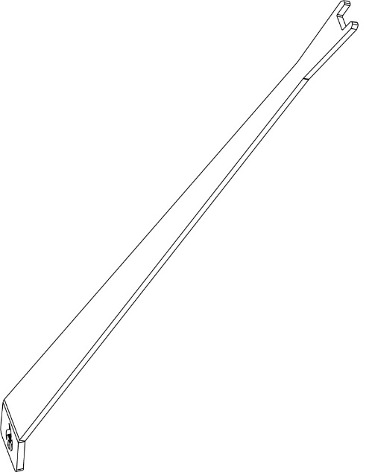
A damper handle for opening and closing the damper is provided with the fireplace

Refer to operating instructions below, along with diagrams to open and close the damper.

- To open the damper, use the tool to push in the adjustment cog and turn to the left until you feel it lock into place.

- To close the damper, push the adjustment cog in and turn to the right until it locks into place.

- Visually inspect the orientation of the damper by looking up into the ceiling of the fireplace, to ensure it is correctly oriented. Vertical is open, horizontal is closed.
CROSS SECTION SIDE VIEW OF DAMPER OPERATION

Locate damper handle on damper cog

Push damper handle towards back of fireplace

Turn damper handle to the left

Release damper handle and allow damper to lock, reverse steps to close damper.

SPARK ARRESTOR

The spark arrestor is designed to prevent any sparks or small debris from escaping the fireplace. It should always be in place when the fireplace is in operation, especially when unattended.
To open the spark arrestor, pull the right side towards you and it will swing open to the left. To close, push closed until the magnetic stop seats against the spark arrestor.
WHEN IN OPERATION SPARK ARRESTOR WILL BE HOT, USE DAMPER TOOL OR HEAT RESISTANT GLOVES TO OPEN.

ASH TRAY

The ash tray will catch ash as it falls through the grate, making cleaning of the fireplace a much simpler task. To remove simply pull the ash tray out towards you and slide back in until fully seated once finished cleaning.

THE ASH TRAY WILL BE HOT DURING OPERATION. USE HEAT RESISTANT GLOVES IF IT IS NECESSARY TO REMOVE.

FAN

The N900 Open Fireplace is fitted with an electric fan to further enhance it’s heating performance.
To operate, ensure the fan is plugged in (built-in installations will be plugged in during install) and use the supplied remote control to select the setting you wish.
The fan has 4 settings: off, low, med and high. Once in operation, to switch between settings press the desired fan output and the fan will slow down momentarily before switching to the new speed.

USING THE APPLIANCE FOR THE FIRST TIME

- For the first few times the appliance is lit, odorous fumes will be given off as the paint cures.
- Do not touch the paint work while it is curing otherwise it can leave a permanent mark on the appliance.
- Keep the room well ventilated until these fumes have cleared.
- Once the paint has cured, this will not re-occur.

RECOMMENDED FUELS

- Burn only seasoned hardwood timber with a moisture content of less than 20%.
- Newly cut wood should be split and allowed to dry/season for 12 to 18 months before use.
- Wood should be stored in an environment protected from the weather to minimise any potential moisture content.
- For best results, it is better to burn several smaller pieces of wood than one large piece at a time.
- Poor quality timber:
  - Causes low combustion efficiency.
  - Produces poor emissions (smoky).
  - Results in additional build-up of creosote (soot) in the flue which will then require regular cleaning and may result in a flue fire.
- Do not burn painted, impregnated/treated wood, manufactured board products or pallet wood.

LIGHTING THE FIRE

- Open the damper and visually inspect to ensure it is open.
- Place firelighters or paper and dry kindling wood on the grate of the fireplace
- Light the paper or firelighters.
- If necessary, leave the spark arrestor open as the fire establishes.
- Once the fire has taken hold add larger pieces of wood. Too many logs may smother the fire.
- Once the fire is established, close the spark arrestor.
- Keeping the fire burning at the rear of the firebox will minimise the chance of any smoke spillage into the room.

DO NOT LEAVE THE APPLIANCE UNATTENDED WHILE THE SPARK ARRESTOR IS OPEN.

RUNNING THE APPLIANCE

RELOAD WITH MORE WOOD

- Open the spark arrestor.
- Rake / break up any existing coals.
- Load wood on top of the glowing coals. Better results will be achieved by loading several smaller pieces of wood rather than one large piece.
- Leave the spark arrestor open for 2 minutes to allow the wood to catch fire. Once lit, close the spark arrestor.

DO NOT OVERLOAD FIREPLACE WITH FUEL

BURNING TIPS

FUEL QUALITY

Use wood with a moisture content of less than 20%. Logs should not feel moist or have moss and fungal growths.
Symptoms of burning wet wood:
- Difficulty starting and keeping a fire burning well
- Smoke and only small flames
- Dirty fire bricks
- Rapid creosote build-up in the flue/chimney
- Low heat output
- Short burn times, and blue/grey smoke from the flue/chimney outlet

FLUE DRAUGHT

The flue has two main functions:
- To safely remove smoke, gases and fumes from the appliance.
- To provide sufficient draught (suction) in the appliance to ensure the fire keeps burning.
Draught is caused by the rising hot air in the flue when the fire has been lit.
The position, height and size of the flue can affect the performance of the flue draught. Refer to installation guide for details on flue installation.
Factors affecting the flue draught include:
- Insufficient flue height
- Trees or other buildings nearby causing turbulence
- High and gusty winds
- Outside temperature and weather conditions
- Blocked flue
For advice on the correction of persistent flue problems consult your supplier/installer for more detail.

ASH REMOVAL

ONLY REMOVE ASH TRAY WHILE FIREPLACE IS INACTIVE.
Excess ashes should be removed when necessary, placed in a non-combustible container and moved outdoors immediately to a location clear of combustible materials.

To remove ashtray, use handle cut-out in the ashtray to pull up and towards you from underneath the grate lip.

CROSS SECTION SIDE VIEW

FLUE FIRE

To prevent flue fires it is recommended that your flue is professionally cleaned once per season at a minimum, subject to the quality of fuel used.

If a flue fire occurs:
- Shut the spark arrestor to prevent any falling debris from spilling out of the fireplace.
- Contact emergency services if flue fire worsens.
- Do not use the appliance after a flue fire until an accredited installer has assessed the cause and any resultant damage.

CLEANING PAINT WORK

- The appliance, when cool, can be cleaned with a damp cloth.
- Over the years, the black paint will fade and can be touched up with Stove Bright metallic black paint.

DO NOT USE ABRASIVE CLEANER OR SCOURING PADS.

CLEANING THE FLUE

Check inside of flue prior to each season for any build-up of creosote (wood tar).
TO CHECK THE FLUE:
- Hold a small mirror on an angle below the flue, with a torch shining towards it, and look for black creosote build-up. It is normal to see a fine black powdery layer, but if built up layers of creosote can be seen, the flue requires cleaning.
TO CLEAN THE FLUE:
- Remove the damper (refer to ‘Replacing the Damper Plate’ under Maintenance & Servicing).
- A flue cleaning brush can be purchased from most wood heater retail outlets or large hardware stores. Alternatively, hire a flue cleaning service to do the job for you (it’s a dirty job).
- With the damper removed, tie a rope to one end of the brush, and drop the rope down the flue (from outside on top of the roof).
- Grab the end of the rope from inside the firebox and pull the brush down through the flue.
- Check the inside of the flue with the mirror and torch.
- Repeat cleaning process if necessary.
- Once the flue is clean, remove any excess creosote from the fireplace.
- Refit the damper plate.
ONLY PULL BRUSH DOWNWARDS THROUGH FLUE, AS PULLING UPWARDS MAY SEPARATE THE FLUE SECTIONS AT THEIR JOINS.

TROUBLESHOOTING TIPS

TROUBLE STARTING THE FIRE
Ash build up in the ashtray can obstruct the slots in the grate and inhibit the fireplace’s ability to draw air through the grate and will make a fire hard to start and/or maintain.
When cleaning, it is best to ensure that the grates are clean, free from any obstructions and the ashtray completely empty.

MAINTENANCE AND SERVICING

REPLACING THE FIRE BRICKS

The fireplace needs fire bricks to increase the thermal mass and guarantee the longevity of the steel firebox. Over time the firebricks may become cracked and crumble away. At this point they should be replaced.
To replace the firebricks:
- Lift and remove the two halves of the grate.
- Angle bottom edge of firebrick resting on shelf towards you and remove from brick retainer.
- Replace with new bricks by angling brick forward and under the brick retainer, allowing bottom edge of brick to rest on lower shelf.
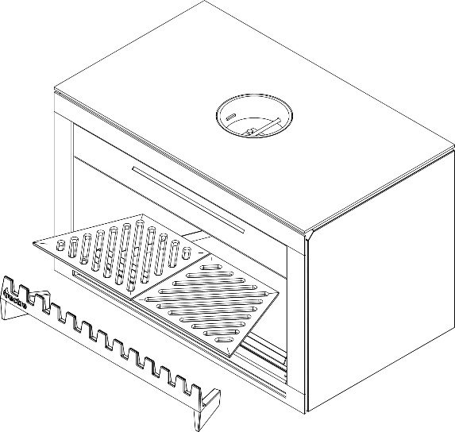
- Reinstall the two halves of grate.

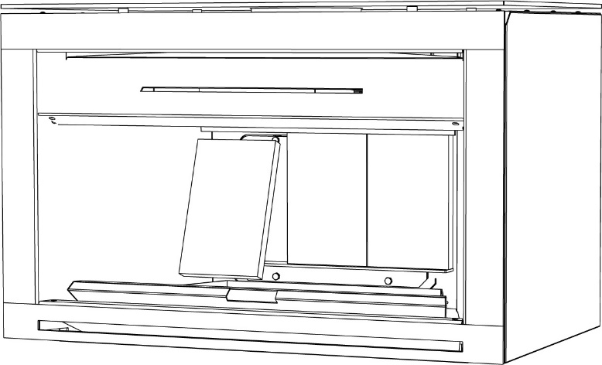

REPLACING DAMPER COMPONENTS

The damper plays a critical role in the safe and efficient operation of the open fireplace. It allows smoke to escape the fireplace during operation and keeps warmth in the house when the fireplace is not in use.
Over time the damper plate may begin to warp, this is normal and will not affect its function. After years of use it may eventually burn through, requiring it to be replaced.

ONLY REMOVE DAMPER WHILE FIREPLACE IS INACTIVE.

TO REMOVE THE DAMPER PLATE:
- Remove any excess ash and coals.
- Orient the damper in its open position.
- Reach up into the opening of the flue to locate the damper plate, finding the 2 bolts and 2 nuts holding the damper plate to the damper rod. Remove these using a 10mm socket and 10mm spanner.
- Remove the damper plate and replace with new one.

TO REMOVE THE DAMPER ROD:
If the damper rod requires replacing as well follow these steps:
- Remove damper plate first.
- Located on the front of the damper rod is a cog to adjust the damper. There is an M4 hex head grub screw holding this in place. Using an M4 hex allen key, remove the grub screw.
- The cog, two washers and spring will slide off the end of the damper rod. Remove and retain these.
- The damper rod will now be free to slide backwards and angled down into the fireplace for removal.
- Replace any components needing replacement and refit damper by reversing the steps.
- Visually and physically inspect the re-installation of the damper rod and plate to ensure correct operation.
SIDE CROSS SECTION VIEW - ASSEMBLED

SIDE CROSS SECTION VIEW - DISASSEMBLED

ISOMETRIC CROSS SECTION VIEW - DISASSEMBLED

ADJUSTING THE SPARK ARRESTOR
The spark arrestor is designed with the ability to be flipped, to reverse which way it opens.

ONLY ADJUST THE SPARK ARRESTOR WHILE THE FIREPLACE IS INACTIVE.

TO FLIP THE ORIENTATION OF THE SPARK ARRESTOR:

- Lift spark arrestor up until the bottom of the hinge rod becomes free of its locating hole.

- Angle bottom edge out and remove the top end of the hinge rod from its locating hole. Pull down to remove.

- Remove spark arrestor stop from its locating hole by pulling upwards.

- Flip spark arrestor so that hinge rod is on the right side and re-install by repeating steps 2 and 1.
- Place spark arrestor stop in its locating hole on the opposite side.

REPLACING THE FAN
The fan installed in the N900 Open Fireplace is rated to high temperatures, but after years of use it may be necessary to replace the fan or its associated receiver.

ONLY REPLACE THE FAN WHILE THE FIREPLACE IS INACTIVE.
TO REPLACE THE FAN AND/OR RECEIVER
- Remove the two halves of the grate.
- Remove the firebricks.
- Using an M8 hex allen key or hex head socket, remove the 4 bolts holding the firebox door in place. It may be necessary to apply WD-40 or equivalent penetrating oil to loosen the threads.
(If the bolts don’t want to budge or the head has been rounded out, don’t stress. Drill out or grind the head off the bolt. The door can still be removed and the bolt and nut will be replaced anyway.)
- Pull the top end of the firebox door towards you and the door should slide up and out.
- Remove and replace the 4 U-fasteners which hold the door bolts.
- Follow the steps below for your applicable model.

FREE STANDING

- After completing “TO REPLACE THE FAN AND/OR RECEIVER” steps 1-6, complete the below steps.
- To remove the fan receiver, using the 10mm socket, undo the 2 nuts holding the receiver cover to its studs.
- Again using the 10mm socket, undo the 2 adjacent nuts holding the fan receiver to the rear assembly.
- Unplug the 2 wiring connectors for the receiver and pull the fan receiver towards you to slide off the studs.
- To remove the fan ducting above the fan, use a 10mm socket and undo the two nuts on the same studs that the fan receiver was on.
- To remove the fan, undo the 1 nut holding it adjacent to the fan receiver bottom stud using a 10mm socket.
- Unplug the 1 wiring connector for the fan and pull the fan assembly towards you to slide off its stud.
- Reverse steps to reinstall the fan assembly and fan receiver.

INSERT/INBUILT

- After completing “TO REPLACE THE FAN AND/OR RECEIVER” steps 1-6, complete the below steps.
- To remove the fan ducting above the fan, use a 10mm socket and undo the two nuts.
- To remove the fan, undo the 1 nut holding it adjacent to the fan receiver bottom stud using a 10mm socket. (Pull the fan housing off its stud, lifting up and out to remove the assembly, unplug the 1 wiring connector.)
- To remove the receiver, using a 10mm socket, undo the 2 nuts holding the ducting outtake to its studs and pull forward to remove, exposing the receiver.
- Pull the receiver assembly through the cut-out in the rear panel and unplug the 2 wiring connectors.
- Reverse steps to reinstall the fan assembly and fan receiver.
REFER TO DIAGRAMS ON PAGES 9 AND 10.

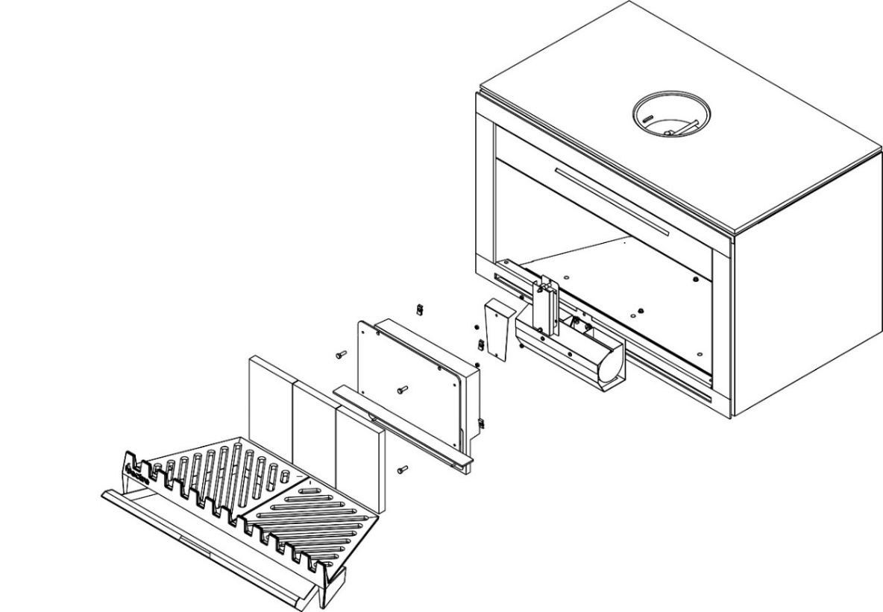
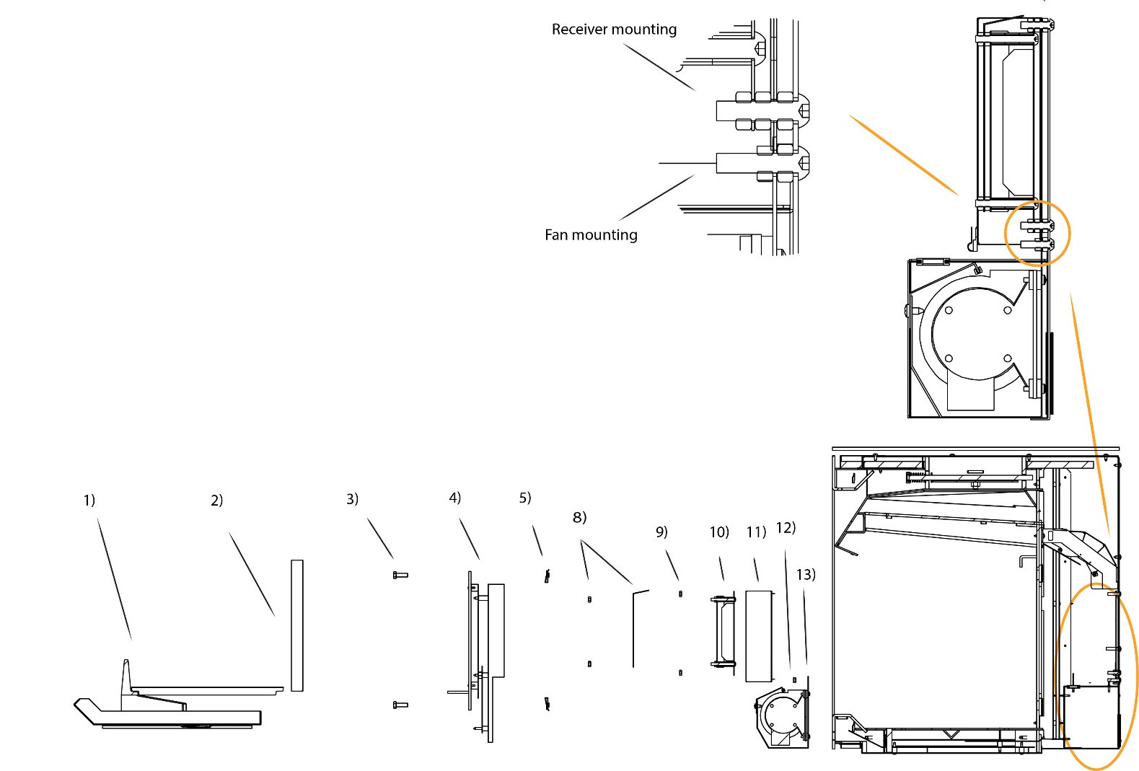
(Numbers correspond to steps in Section 2.4)
FREE STANDING
FAN AND RECEIVER REMOVAL

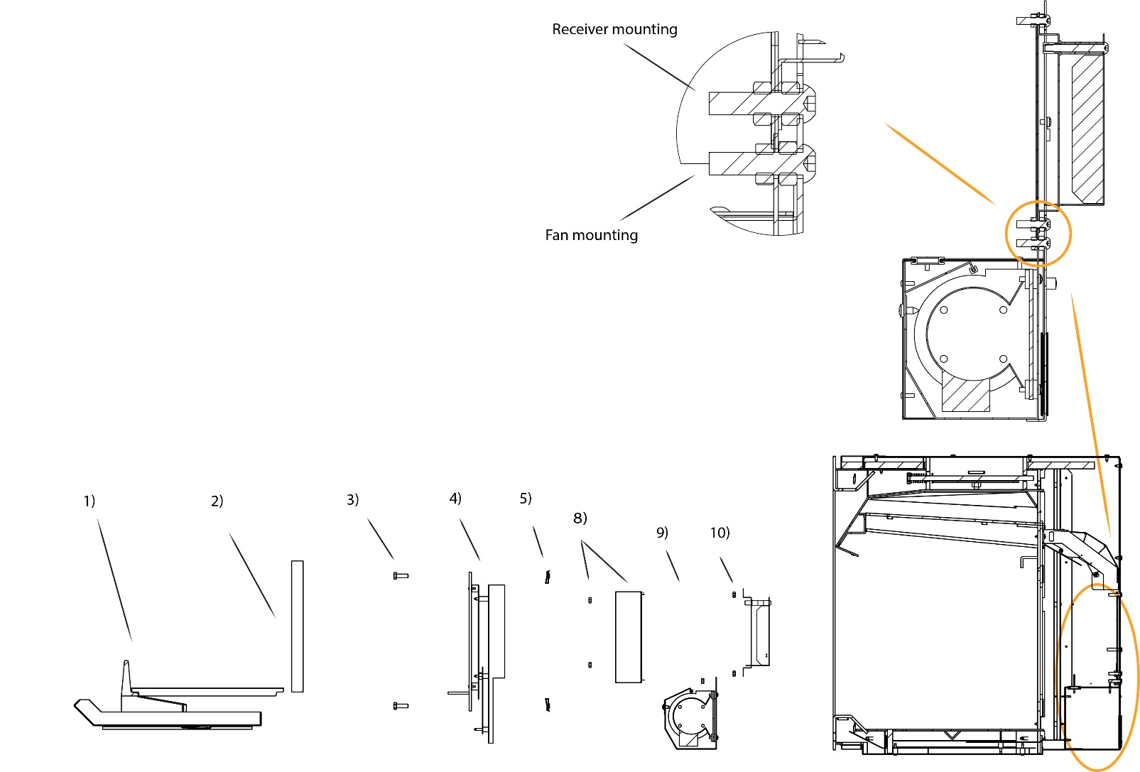
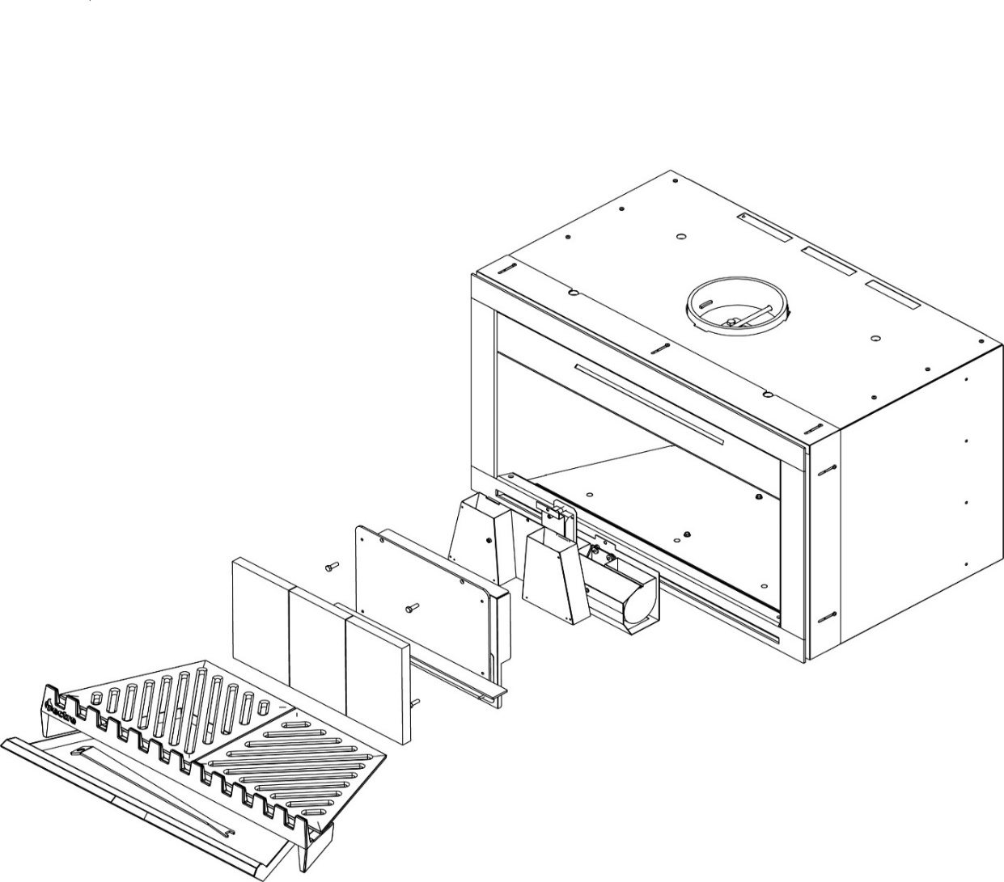
INSERT/INBUILT
FAN AND RECEIVER REMOVAL
(Numbers correspond to steps in Section 2.4)

2.5 REPLACEMENT SPARE PARTS LIST

Part Description | Part Number
Ash Tray | 109-010
Grate | 109-090
Fire Bricks | 109-067
Damper Handle/Fire poker | 109-028
Damper Bolts & Nuts | N920-016
Damper Cog Grub Screw | N920-055
Damper Rod Washers | N920-057
Damper Cog | 109-022
Damper Spring | 109-026
Damper Rod | 109-025
Damper Plate | 109-024
Fan Housing | 109-048
Insert Fan Receiver | 109-144
Free Standing Fan Receiver | 109-114
Fan Remote Control | N900-183

Glen Dimplex Australia Pty Ltd

1340 Ferntree Gully Road,
Scoresby Victoria 3179
Australia
T: 1300 556 816 | F: 1800 058 900
Email: sales@glendimplex.com.au

