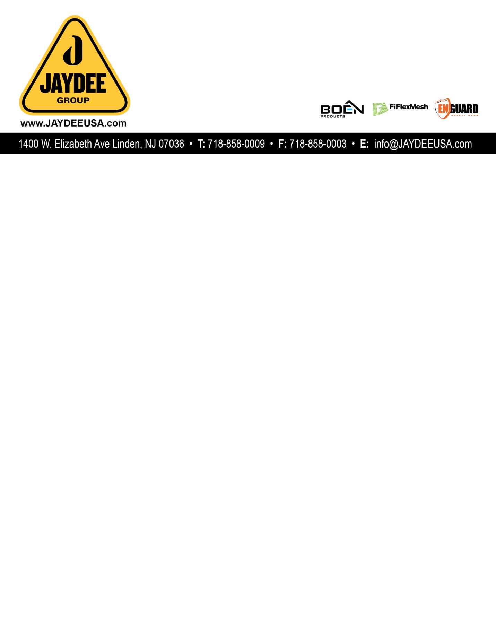

**TECHNICAL DATA SHEET**

**Product:** -PVC Coated Mesh for safety

**Application:**

Safety Mesh

|  |  |
| --- | --- |
| Support Cloth ( DIN 6000 ) | Polyester |
| Specification ( DIN EN 1049-2 ) | 6*6 per inch(panama weave) |
| Yarn (dtex) ( DIN EN ISO 2060 ) | 1000*1000 D |
| Type of Coating | PVC knife coated on both sides |
| Total Weight ( DIN EN ISO 2286-2 ) | 200g/m2 |
| Width ( DIN EN ISO 2286-1) | 5’6’(1m.UP TO 3.2M) |
| Tensile strength ( DIN 53354 ) | 1000/1000 N/5CM |
| Tear strength ( DIN 53356 ) | 280/250 N/5CM |
| Low Temperature-No Crack At | -30℃ |
| Flame Retardant | NFPA701 |
| Special Treatment | UV treatment |

**Packing:** craft paper or PE.

**Features**:

A: UV resistant, FR (NFPA701, B1, M2

B: Cold resistant,

C: Color, weight can be customized