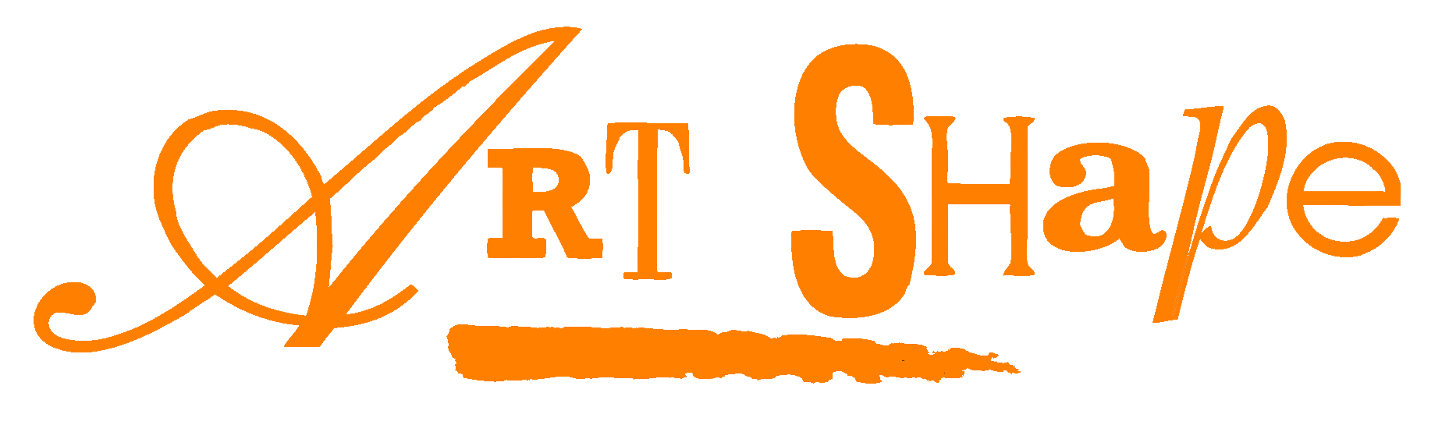

***Inclusive Arts Leadership Course***

***Application Form***

**September 2018**

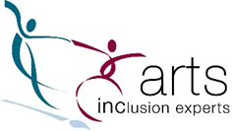

|  |  |
| --- | --- |
| **Section 1: Contact Details** | |
| **Title**  **Full name** | | | |
| **Address** | | | |
|  | | | |
|  | | | |
|  | | | |
|  | | | |
| **Post code** | | **E-mail** | |
| **Tel** | | **Mobile** | |
|  | | **DOB** | |
| Please state where you saw this course advertised: | | | |
| Name of supporting organisation for placement (If already established) | | | |
| Preferred format for programme information and materials (if other than 12 point print): | | | |

|  |
| --- |
| **Section 2: Personal statement** |
| **Abilities, skills, knowledge and experience of teaching or leading sessions (max 100 words)** |
| **Why do you want to join the course? (max 100 words)** |
| **What do you hope to get out of the course? E.g. increased confidence in leadership, understanding approaches relevant to supporting disabled participants etc (max 100 words)** |
| **What excites you most about this opportunity? (max 100 words)** |
| **Are there any specific leadership skills you would like to develop? (max 100 words)** |

|  |
| --- |
| **Section 3: Training and Development** |
| Please give details of your experience including any training and development you've had which supports your application. Include any groups you might be involved in, on the job training, voluntary work as well as formal courses. |
|  |
| Continue on a separate sheet if necessary |

|  |  |  |  |  |
| --- | --- | --- | --- | --- |
| **Section 4**: **Individual support and access requirements** | | | | |
| We want to provide the best experience for you, so if you are successful, we will contact you to discuss any access/ support requirements.  Please indicate below the best method for doing this: | | | | |
| **🞎** | **Phone conversation** | | **🞎** | **Email conversation** |
| **🞎** | **Other (please explain below)** | | | |
|  | | | | |
| If there is someone else we should involve in this discussion please include their contact details below: | | | | |
| **Title**  **Full name** | | | | |
| **Relationship to you** | | | | |
| **Address** | | | | |
|  | | | | |
|  | | | | |
|  | | | | |
| **Post code** | | **E-mail** | | |
| **Tel** | | **Mobile** | | |
|  | | | | |
| **Data Protection** | | | | |
| Art Shape does not pass your data on to third parties unless we have your written permission or there is a legal requirement to do so. Personal data will not be kept on our files for longer than 12 months after your last session. For more detail about our privacy statement please visit our website or contact the office to request a copy.  Please tick the box to be added to our mailing list | | | | |
| Signature: | | |  | |
| Date: | | |  | |
|  | | |  | |

|  |
| --- |
| **Section 5: Course Fees and Concessions** |
| Please tick  Full paying adult £250  Freelancer / Self-employed £150  Student £85  Disabled £65  Adult 60 + £100  Unemployed £50  Low income /part-time less than 20hr per week £85  Please note: evidence for concessions will need to be provided, e.g. student card, proof of benefits,date of birth.etc. |

NB:All applicants will be asked to provide the following documents to prove identity for accreditation purposes:

Drivers licence/passport/other photo ID

Proof of address

Please let us know if you need support/advice with the above on 01452 863855

**Equal opportunities monitoring form**

Art Shape and our partners are fully committed to recruiting, employing and promoting equality of opportunity to all employees and participants.

Capturing equal opportunities information relating to all artists and participants involved in this course will help us to evaluate and learn from this project, and to take steps to improve equality of recruitment in the future.

Please complete the following by ticking the relevant boxes.

I would describe my race or ethnic origin as:

White

Black African

Black Caribbean

Black other: please specify -

Indian

Pakistani

Bangladeshi

Chinese

Other Asian: please specify -

Any other race or ethnic group please specify -

Please Indicate how you would identify your sex/gender -

I am aged between 18 and 65 years Yes No

I have a disability I would like you to know about Yes No

I am registered disabled Yes No