KY-2189RG
Industrial Layer-3 Managed Ethernet Switch

Configuration Manual
Version 1.0
September, 2014

COPYRIGHT NOTICE
Copyright © 2014 DYMEC
All rights reserved.
No part of this publication may be reproduced in any form without the prior written consent of DYMEC.

TRADEMARKS
DYMEC is a registered trademark of K-USA.
All other trademarks belong to their respective owners.

REGULATORY COMPLIANCE STATEMENT
Product(s) associated with this publication complies/comply with all applicable regulations. Please refer to the Technical Specifications section for more details.

WARRANTY
K-USA warrants that all DYMEC products are free from defects in material and workmanship for a specified warranty period from the invoice date (5 years for most products). DYMEC will repair or replace products found by DYMEC to be defective within this warranty period, with shipment expenses apportioned by DYMEC and the distributor. This warranty does not cover product modifications or repairs done by persons other than DYMEC-approved personnel, and this warranty does not apply to DYMEC products that are misused, abused, improperly installed, or damaged by accidents.
Please refer to the Technical Specifications section for the actual warranty period(s) of the product(s) associated with this publication.

DISCLAIMER
Information in this publication is intended to be accurate. DYMEC shall not be responsible for its use or infringements on third-parties as a result of its use. There may occasionally be unintentional errors on this publication. DYMEC reserves the right to revise the contents of this publication without notice.

CONTACT INFORMATION
DYMEC
1107 SE Willow Pl, Blue Springs, MO 64014
Telephone: (816) 988-7861 // Fax: (480) 287-8605
Website: www.DYMEC.com
Technical Support
E-mail: support@DYMEC.com
Sales Contact
E-mail: sales@DYMEC.com

Table of Content
Getting Started 6
1.1 About the KY-2189RG 6
1.2 Software Features 6
1.3 Hardware Specifications 7
Hardware Overview 8
2.1 Front Panel 8
2.1.1 Ports and Connectors 8
2.1.2 LED 9
2.2 Rear Panel 9
2.2 Rear Panel 10
Hardware Installation 11
3.1 DIN-rail Installation 11
3.2 Wall Mounting 12
3.3 Wiring 13
3.3.1 Grounding 14
3.3.2 Redundant Power Inputs 14
3.4 Connection 14
3.4.1 Cables 14
3.4.2 RS-232 console port wiring 16
3.4.3 SFP 17
3.4.4 Ring / Chain 17
Redundancy 21
4.1 Ring 21
4.1.1 Introduction 21
4.1.2 Configurations 21
4.2 Chain 23
4.2.1 Introduction 23
4.2.2 Configurations 23
4.3 MRP 24
4.3.1 Introduction 24
4.3.2 Configurations 24
4.4 STP/RSTP/MSTP 25
4.4.1 STP/RSTP 25
4.4.2 MSTP 29
4.4.3 CIST 32
4.5 Fast Recovery 33
Management 35
5.1 System Information 36
5.2 Front Panel 37
5.3 Basic Settings 37
5.3.1 Basic Settings for System Information 37
5.3.2 Admin Password 38
5.3.3 Authentication Method 39
5.3.4 IP Settings 40
5.3.5 IP Status 42
5.3.6 SNTP 42
5.3.7 Daylight Saving Time 43
5.3.8 RIP 46
5.3.9 VRRP 46
5.3.10 HTTPS 47
5.3.11 SSH 48
5.3.12 LLDP 48
5.3.13 Modbus TCP 52
5.3.14 Backup/Restore Configurations 52
5.3.15 Update Firmware 53
5.4 DHCP Server 53
5.4.1 Settings 53
5.4.2 Dynamic Client List 55
5.4.3 Static Client List 55
5.4.4 DHCP Relay 55
5.5 Port Setting 58
5.5.1 Port Control 58
5.5.2 Port Trunk 60
5.5.3 Loop Protection 65
5.6 VLAN 66
5.6.1 VLAN Membership 66
5.6.2 Port Configurations 67
5.6.3 Private VLAN 77
5.7 SNMP 78
5.7.1 System 79
5.7.2 Trap Configuration 80
5.7.3 SNMP Community Configurations 82
5.7.4 SNMP User Configurations 82
5.7.5 SNMP Group Configurations 84
5.7.6 SNMP View Configurations 85
5.7.7 SNMP Access Configurations 86
5.8 Traffic Prioritization 87
5.8.1 Storm Control 87
5.8.2 Port Classification 87
5.8.3 Port Tag Remaking 89
5.8.4 Port DSCP 90
5.8.5 Port Policing 91
5.8.6 Queue Policing 92
5.8.7 Port Scheduler 93
5.8.8 Port Shaping 96
5.8.9 DSCP-based QoS 97
5.8.10 DSCP Translation 98
5.8.11 DSCP Classification 99
5.8.12 QoS Control List 99
5.8.13 QoS Counters 102
5.8.14 QCL Status 102
5.9 Multicast 104
5.9.1 IGMP Snooping 104
5.10 Security 107
5.10.1 Remote Control Security 107
5.10.2 Device Binding 108
5.10.3 ACL 113
5.10.4 AAA (Authentication, Authorization, and Accounting) 125
5.10.5 NAS (802.1x) 131
5.11 Warning 142
5.11.1 Fault Alarm 142
5.11.2 System Warning 142
5.12 Monitor and Diag 146
5.12.1 MAC Table 146
5.12.2 Port Statistics 149
5.12.3 Port Mirror DYMEC 151
5.12.4 System Log Information 152
5.12.5 VeriPHYCable Diagnostics 153
5.12.6 SFP Monitor 154
5.12.7 Ping 155
5.12.8 IPv6 Ping 156
5.12.9 SFP Type 157
5.13 Synchronization 158
5.13.1 PTP 158
5.14 Factory Defaults 160
5.15 System Reboot 161
Command Line Management 162

Getting Started

About the KY-2189RG
Featuring network redundancy capabilities, the KY-2189RG is a managed Ethernet switch with 8x10/100/1000Base-T(X) ports and 12x100/1000Base-X SFP ports. The device supports Layer-3 routing for higher network performance on large-scale LANs. The hardware Layer-3 switch is optimized to transmit data as fast as Layer-2 switches. With complete support of Ethernet redundancy protocols, Ring (recovery time < 20ms for over 300 connected devices) and MSTP (RSTP/STP compatible) can protect your mission-critical applications from network interruptions or temporary malfunctions. With a wide operating temperature from -40~85ºC, KY-2189RG can be managed centralized via Solar Winds management platform as well as via Web-based interfaces, Telnet and console (CLI). Therefore, the switch is one of the best choice’s for highly-managed Ethernet and fiber Ethernet applications.

Software Features
- Supports Ring (recovery time < 20ms over 300 units of connection) and MSTP (RSTP/STP compatible) for Ethernet redundancy
- Supports Open-Ring to interoperate with other vendors’ ring technology in open architecture
- Supports Chain to allow multiple redundant network rings
- Supports standard IEC 62439-2 MRP (Media Redundancy Protocol) function
- Supports IEEE 1588v2 clock synchronization
- Supports IPv6 new internet protocol version
- Supports Modbus TCP protocol
- Supports IEEE 802.3az Energy-Efficient Ethernet technology
- Provides HTTPS/SSH protocols to enhance network security
- Supports SMTP client
- Supports IP-based bandwidth management
- Supports application-based QoS management
- Supports Device Binding security function
- Supports DOS/DDOS auto prevention
- Supports IGMP v2/v3 (IGMP snooping support) to filter multicast traffic
- Supports SNMP v1/v2c/v3 & RMON & 802.1Q VLAN network management
- Supports ACL, TACACS+ and 802.1x user authentication for security
- Supports 9.6K Bytes Jumbo frame
- Supports multiple notifications for incidents
- Supports management via Web-based interfaces, Telnet, Console (CLI), and Solar Winds
- Supports LLDP Protocol
- Rigid IP-30 housing design
- DIN-Rail and wall mounting capable

Hardware Specifications
- 8 x 10/100/1000Base-T(X) ports
- 12 x 100/1000Base-X with SFP ports
- 1 x console port
- Redundant DC power inputs
- DIN-rail and wall-mounting supported
- Operating Temperature: 40 to 85ºC
- Storage Temperature: -40 to 85ºC
- Operating Humidity: 5% to 95%, non-condensing
- Casing: IP-30
- Dimensions: 96.4 (W) x 105.5 (D) x 154 (H) mm (3.8 x 4.15 x 6.06 inches)

Hardware Overview

Front Panel

Ports and Connectors
The series provides the following ports on the front panel.

Port | Description
SFP port | 12 x 100 /1000Base-X
Copper port | 8 x 10/100/1000Base-T(X)
Console port | 1 console port

1. Power LED
2. Power 1 LED
3. Power 2 LED
4. Ring master LED
5. Ring status LED
6. Fault indicator
7. Console port
8. SFP ports
9. LED for the linking status of SFP ports
10. Ethernet ports
11. Link/ACT LED for LAN ports
12. Reset button

LED
LED | Color | Status | Description
PWR | Green | On | DC power on
PW1 | Green | On | DC power module 1 activated
PW2 | Green | On | DC power module 2 activated
R.M | Green | On | Ring Master
Ring | Green | On | Ring enabled
Ring | Green | Blinking | Ring structure is broken
Fault | Amber | On | Faulty relay (power failure or port malfunctioning)
10/100/1000Base-T(X) Fast Ethernet ports
LNK/ACT | Green | On | Port is running at 1000Mbps
Speed | Amber | On | Port is running at 10/100Mbps
SFP
LNK/ACT | Green | On | Port is linked
LNK/ACT | Green | Blinking | Transmitting data

Rear Panel
Below are the top panel components of the KY-2189RGseries:
1. Terminal blocks: PWR1, PWR2 (12-48V DC), relay output
2. Ground wire. For more information on how to ground the switch, please refer to 3.3.1 Grounding.
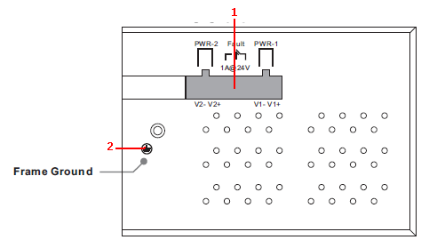

Rear Panel
On the rear panel of the switch sit three sets of screw holes. The two sets placed in triangular patterns on both ends of the rear panel are used for wall-mounting (red boxes in the figure below) and the set of four holes in the middle are used for Din-rail installation (blue box in the figure below). For more information on installation, please refer to 3.1 Din-rail Installation.

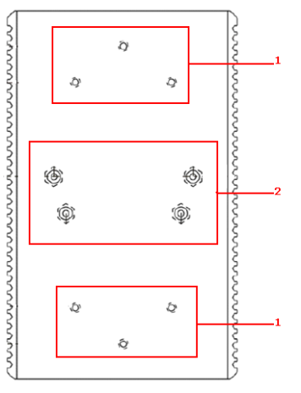
- Wall-mount screw holes
- Din-rail screw holes

Hardware Installation

DIN-rail Installation
Each switch comes with a DIN-rail kit to allow you to fasten the switch to a DIN-rail in any environments.

DIN-rail Kit Measurement (Unit = mm)

Installing the switch on the DIN-rail is easy. First, screw the Din-rail kit onto the back of the switch, right in the middle of the back panel. Then slide the switch onto a DIN-rail from the Din-rail kit and make sure the switch clicks into the rail firmly.
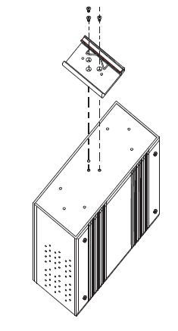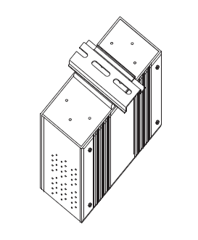

Wall Mounting
Besides Din-Rail, the switch can be fixed to the wall via the wall mount kits, which can also be found in the package.

Wall-Mount Kit Measurement (Unit = mm)

To mount the switch onto the wall, follow the steps:
1. Screw the two pieces of wall-mount kits onto both ends of the rear panel of the switch. A total of six screws are required, as shown below.
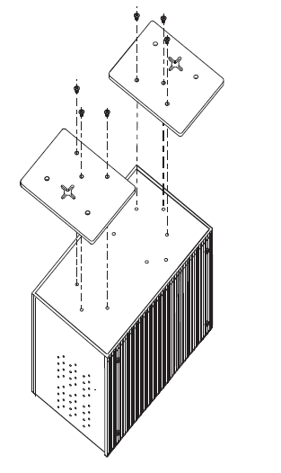
2. Use the switch, with wall mount plates attached, as a guide to mark the correct locations of the four screws.

3. Insert four screw heads through the large parts of the keyhole-shaped apertures, and then slide the switch downwards. Tighten the four screws for added stability.

Note: Instead of screwing the screws in all the way, leave about 2 mm to allow room for sliding the wall mount panel between the wall and the screws.

Wiring

WARNING
Do not disconnect modules or wires unless power has been switched off or the area is known to be non-hazardous. The devices may only be connected to the supply voltage shown on the type plate.
ATTENTION
- Be sure to disconnect the power cord before installing and/or wiring your switches.
- Calculate the maximum possible current in each power wire and common wire. Observe all electrical codes dictating the maximum current allowable for each wire size.
- If the current goes above the maximum ratings, the wiring could overheat, causing serious damage to your equipment.
- Use separate paths to route wiring for power and devices. If power wiring and device wiring paths must cross, make sure the wires are perpendicular at the intersection point.
- Do not run signal or communications wiring and power wiring through the same wire conduit. To avoid interference, wires with different signal characteristics should be routed separately.
- You can use the type of signal transmitted through a wire to determine which wires should be kept separate. The rule of thumb is that wiring sharing similar electrical characteristics can be bundled together
- You should separate input wiring from output wiring
- It is advised to label the wiring to all devices in the system

Grounding
Grounding and wire routing help limit the effects of noise due to electromagnetic interference (EMI). Run the ground connection from the ground screw to the grounding surface prior to connecting devices.

Fault Relay
The two sets of relay contacts of the 6-pin terminal block connector are used to detect user-configured events. The two wires attached to the fault contacts form an open circuit when a user-configured when an event is triggered. If a user-configured event does not occur, the fault circuit remains closed.

Redundant Power Inputs
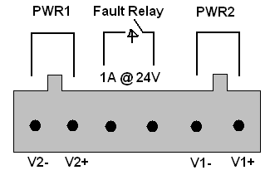
The switch has two sets of power inputs, power input 1 and power input 2. The top two contacts and the bottom two contacts of the 6-pin terminal block connector on the switch’s top panel are used for the two digital inputs. Follow the steps below to wire redundant power inputs.
Step 1: insert the negative/positive DC wires into the V-/V+ terminals, respectively.
Step 2: to keep the DC wires from pulling loose, use a small flat-blade screwdriver to tighten the wire-clamp screws on the front of the terminal block connector.
Step 3: insert the plastic terminal block connector prongs into the terminal block receptor on the switch’s top panel.

Connection

Cables

10/100/1000BASE-T(X) Pin Assignments
The device has standard Ethernet ports. According to the link type, the switch uses CAT 3, 4, 5,5e UTP cables to connect to any other network devices (PCs, servers, switches, routers, or hubs). Please refer to the following table for cable specifications.

Cable Types and Specifications:
Cable | Type | Max. Length | Connector
10BASE-T | Cat. 3, 4, 5 100-ohm | UTP 100 m (328 ft) | RJ-45
100BASE-TX | Cat. 5 100-ohm UTP | UTP 100 m (328 ft) | RJ-45
1000BASE-T | Cat. 5/Cat. 5e 100-ohm UTP | UTP 100 m (328ft) | RJ-45

With 10/100/1000Base-T(X) cables, pins 1 and 2 are used for transmitting data, and pins 3 and 6 are used for receiving data.

10/100Base-T(X) RJ-45 Pin Assignments :
Pin Number | Assignment
1 | TD+
2 | TD-
3 | RD+
4 | Not used
5 | Not used
6 | RD-
7 | Not used
8 | Not used

1000Base-T RJ-45 Pin Assignments :
Pin Number | Assignment
1 | BI_DA+
2 | BI_DA-
3 | BI_DB+
4 | BI_DC+
5 | BI_DC-
6 | BI_DB-
7 | BI_DD+
8 | BI_DD-

The series also supports auto MDI/MDI-X operation. You can use a cable to connect the switch to a PC. The tables below show the MDI and MDI-X port pin outs.

10/100Base-T(X) MDI/MDI-X Pin Assignments :
Pin Number | MDI port | MDI-X port
1 | TD+(transmit) | RD+(receive)
2 | TD-(transmit) | RD-(receive)
3 | RD+(receive) | TD+(transmit)
4 | Not used | Not used
5 | Not used | Not used
6 | RD-(receive) | TD-(transmit)
7 | Not used | Not used
8 | Not used | Not used

1000Base-T MDI/MDI-X Pin Assignments :
Pin Number | MDI port | MDI-X port
1 | BI_DA+ | BI_DB+
2 | BI_DA- | BI_DB-
3 | BI_DB+ | BI_DA+
4 | BI_DC+ | BI_DD+
5 | BI_DC- | BI_DD-
6 | BI_DB- | BI_DA-
7 | BI_DD+ | BI_DC+
8 | BI_DD- | BI_DC-
Note: “+” and “-” signs represent the polarity of the wires that make up each wire pair.

RS-232 console port wiring
The series can be managed via console ports using a RS-232 cable which can be found in the package. You can connect the port to a PC via the RS-232 cable with a DB-9 female connector. The DB-9 female connector of the RS-232 cable should be connected the PC while the other end of the cable (RJ-45 connector) should be connected to the console port of the switch.

PC pin out (male) assignment | RS-232 with DB9 female connector | DB9 to RJ 45
Pin #2 RD | Pin #2 TD | Pin #2
Pin #3 TD | Pin #3 RD | Pin #3
Pin #5 GD | Pin #5 GD | Pin #5
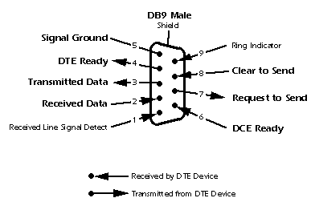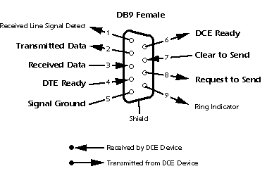

SFP
The switch comes with fiber optical ports that utilize SFP connectors. The fiber optical ports are in multi-mode (0 to 550M, 850 nm with 50/125 µm, 62.5/125 µm fiber) and single-mode with LC connectors. Please remember that the TX port of Switch A should be connected to the RX port of Switch B.
Switch A Switch B
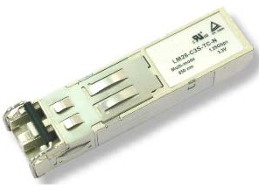
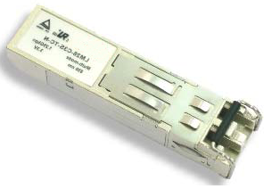



Ring / Chain

Ring
You can connect three or more switches to form a ring topology to gain network redundancy capabilities through the following steps.
1. Connect each switch to form a daisy chain using an Ethernet cable.
2. Set one of the connected switches to be the master and make sure the port setting of each connected switch on the management page corresponds to the physical ports connected. For information about the port setting, please refer to 4.1.2 Configurations.
3. Connect the last switch to the first switch to form a ring topology.

Coupling Ring
If you already have two Ring topologies and would like to connect the rings, you can form them into a coupling ring. All you need to do is select two switches from each ring to be connected, for example, switch A and B from Ring 1 and switch C and D from ring 2. Decide which port on each switch to be used as the coupling port and then link them together, for example, port 1 of switch A to port 2 of switch C and port 1 of switch B to port 2 of switch D. Then, enable Coupling Ring option by checking the checkbox on the management page and select the coupling ring in correspondence to the connected port. For more information on port setting, please refer to 4.1.2 Configurations. Once the setting is completed, one of the connections will act as the main path while the other will act as the backup path.

Dual Homing
If you want to connect your ring topology to a RSTP network environment, you can use dual homing. Choose two switches (Switch A & B) from the ring for connecting to the switches in the RSTP network (core switches). The connection of one of the switches (Switch A or B) will act as the primary path, while the other will act as the backup path that is activated when the primary path connection fails.

Chain
When connecting multiple Rings to meet your expansion demand, you can create an Chain topology through the following steps.
1. Select two switches from the chain (Switch A & B) that you want to connect to the Ring and connect them to the switches in the ring (Switch C & D).
2. In correspondence to the port connected to the ring, configure an edge port for both of the connected switches in the chain by checking the box in the management page (see 4.1.2 Configurations).
3. Once the setting is completed, one of the connections will act as the main path, and the other as the backup path.

Redundancy
Redundancy for minimized system downtime is one of the most important concerns for industrial networking devices. Hence, DYMEC has developed proprietary redundancy technologies including Ring and Open-Ring featuring faster recovery time than existing redundancy technologies widely used in commercial applications, such as STP, RSTP, and MSTP. DYMEC’s proprietary redundancy technologies not only support different networking topologies, but also assure the reliability of the network.

Ring

Introduction
Ring is DYMEC's proprietary redundant ring technology, with recovery time of less than 10 milliseconds and up to 250 nodes. The ring protocols identify one switch as the master of the network, and then automatically block packets from traveling through any of the network’s redundant loops. In the event that one branch of the ring gets disconnected from the rest of the network, the protocol automatically readjusts the ring so that the part of the network that was disconnected can reestablish contact with the rest of the network. The Ring redundant ring technology can protect mission-critical applications from network interruptions or temporary malfunction with its fast recover technology.

Configurations
Ring supports three ring topologies: Ring Master, Coupling Ring, and Dual Homing. You can configure the settings in the interface below.

Label | Description
Redundant Ring | Check to enable Ring topology.
Ring Master | Only one ring master is allowed in a ring. However, if more than one switches are set to enable Ring Master, the switch with the lowest MAC address will be the active ring master and the others will be backup masters.
1st Ring Port | The primary port when the switch is ring master
2nd Ring Port | The backup port when the switch is ring master
Coupling Ring | Check to enable Coupling Ring. Coupling Ring can divide a big ring into two smaller rings to avoid network topology changes affecting all switches. It is a good method for connecting two rings.
Coupling Port | Ports for connecting multiple rings. A coupling ring needs four switches to build an active and a backup link.  Links formed by the coupling ports will run in active/backup mode.
Dual Homing | Check to enable Dual Homing. When Dual Homing is enabled, the ring will be connected to normal switches through two RSTP links (ex: backbone Switch). The two links work in active/backup mode, and connect each ring to the normal switches in RSTP mode.
Apply | Click to apply the configurations.
Note: due to heavy loading, setting one switch as ring master and coupling ring at the same time is not recommended.

Chain

Introduction
Chain is DYMEC’s revolutionary network redundancy technology which enhances network redundancy for any backbone networks, providing ease-of-use and maximum fault-recovery swiftness, flexibility, compatibility, and cost-effectiveness in a set of network redundancy topologies. The self-healing Ethernet technology designed for distributed and complex industrial networks enables the network to recover in less than 20ms for up to 300 switches if at any time a segment of the chain fails.
Chain allows multiple redundant rings of different redundancy protocols to join and function together as a large and the most robust network topologies. It can create multiple redundant networks beyond the limitations of current redundant ring technologies.

Configurations
Chain is very easy to configure and manage. Only one edge port of the edge switch needs to be defined. Other switches beside them just need to have Chain enabled.

Label | Description
Enable | Check to enable Chain function
1st Ring Port | The first port connecting to the ring
2nd Ring Port | The second port connecting to the ring
Edge Port | An Chain topology must begin with edge ports. The ports with a smaller switch MAC address will serve as the backup link and RM LED will light up.

MRP

Introduction
MRP (Media Redundancy Protocol) is an industry standard for high-availability Ethernet networks. MRP allowing Ethernet switches in ring configuration to recover from failure rapidly to ensure seamless data transmission. A MRP ring (IEC 62439) can support up to 50 devices and will enable a back-up link in 80ms (adjustable to max. 200ms/500ms).

Configurations
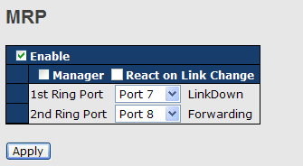

Label | Description
Enable | Enables the MRP function
Manager | Every MRP topology needs a MRP manager. One MRP topology can only have a Manager. If two or more switches are set to be Manager, the MRP topology will fail.
React on Link Change  (Advanced mode) | Faster mode. Enabling this function will cause MRP topology to converge more rapidly. This function only can be set in MRP manager switch.
1st Ring Port | Chooses the port which connects to the MRP ring
2nd Ring Port | Chooses the port which connects to the MRP ring

STP/RSTP/MSTP

STP/RSTP
STP (Spanning Tree Protocol), and its advanced versions RSTP (Rapid Spanning Tree Protocol) and MSTP (Multiple Spanning Tree Protocol), are designed to prevent network loops and provide network redundancy. Network loops occur frequently in large networks as when two or more paths run to the same destination, broadcast packets may get in to an infinite loop and hence causing congestion in the network. STP can identify the best path to the destination, and block all other paths. The blocked links will stay connected but inactive. When the best path fails, the blocked links will be activated. Compared to STP which recovers a link in 30 to 50 seconds, RSTP can shorten the time to 5 to 6 seconds.

STP Bridge Status
This page shows the status for all STP bridge instance.
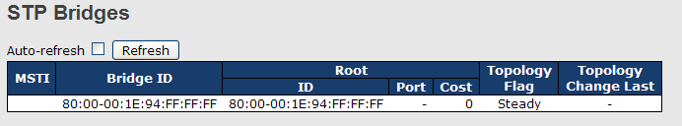

Label | Description
MSTI | The bridge instance. You can also link to the STP detailed bridge status.
Bridge ID | The bridge ID of this bridge instance.
Root ID | The bridge ID of the currently selected root bridge.
Root Port | The switch port currently assigned the root port role.
Root Cost | Root path cost. For a root bridge, this is zero. For other bridges, it is the sum of port path costs on the least cost path to the Root Bridge.
Topology Flag | The current state of the Topology Change Flag for the bridge instance.
Topology Change Last | The time since last Topology Change occurred.
Refresh | Click to refresh the page immediately.
Auto-refresh | Check this box to enable an automatic refresh of the page at regular intervals.

STP Port Status
This page displays the STP port status for the currently selected switch.
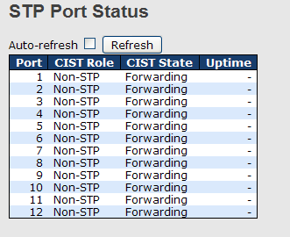

Label | Description
Port | The switch port number to which the following settings will be applied.
CIST Role | The current STP port role of the CIST port. The values include: AlternatePort, BackupPort, RootPort, and DesignatedPort.
State | The current STP port state of the CIST port. The values include: Blocking, Learning, and Forwarding.
Uptime | The time since the bridge port is last initialized
Refresh | Click to refresh the page immediately.
Auto-refresh | Check this box to enable an automatic refresh of the page at regular intervals.

STP Statistics
This page displays the STP port statistics for the currently selected switch.
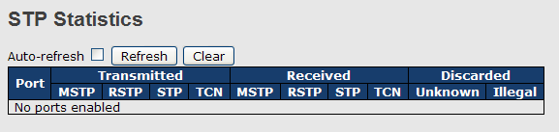
Label | Description
Port | The switch port number to which the following settings will be applied.
RSTP | The number of RSTP configuration BPDUs received/transmitted on the port
STP | The number of legacy STP configuration BPDUs received/transmitted on the port
TCN | The number of (legacy) topology change notification BPDUs received/transmitted on the port
Discarded Unknown | The number of unknown spanning tree BPDUs received (and discarded) on the port.
Discarded Illegal | The number of illegal spanning tree BPDUs received (and discarded) on the port.
Refresh | Click to refresh the page immediately
Auto-refresh | Check to enable an automatic refresh of the page at regular intervals

STP Bridge Configurations
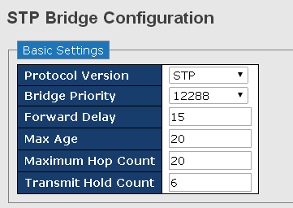

Label | Description
Protocol Version | The version of the STP protocol. Valid values include STP, RSTP and MSTP.
Bridge Priority | Every switch participating in a STP network is assigned with a numerical value called bridge priority value. Bridge priority value decides which Switch can become Root Bridge. You can lower value to make that switch elected as the Root Switch.
Forward Delay | The delay used by STP bridges to transit root and designated ports to forwarding (used in STP compatible mode). The range of valid values is 4 to 30 seconds.
Max Age | The maximum time the information transmitted by the root bridge is considered valid. The range of valid values is 6 to 40 seconds, and Max Age must be <= (FwdDelay-1)*2.
Maximum Hop Count | This defines the initial value of remaining hops for MSTI information generated at the boundary of an MSTI region. It defines how many bridges a root bridge can distribute its BPDU information to. The range of valid values is 4 to 30 seconds, and MaxAge must be <= (FwdDelay-1)*2.
Transmit Hold Count | The number of BPDUs a bridge port can send per second. When exceeded, transmission of the next BPDU will be delayed. The range of valid values is 1 to 10 BPDUs per second.
Save | Click to save changes.
Reset | Click to undo any changes made locally and revert to previously saved values.

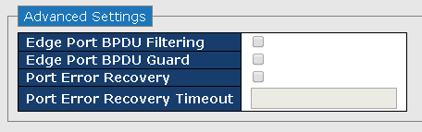

Label | Description
Edge Port BPDU Filtering | Configures whether a port explicitly configured as Edge will transmit and receive BPDUs
Edge Port BPDU Guard | Configures whether a port explicitly configured as Edge will disable itself upon reception of a BPDU. Disabled ports enter the error-disabled state and are removed from the active topology
Port Error Recovery | Configures whether a port in the error-disabled state will be automatically enabled after the Port Error Recovery Timeout. If recovery is disabled, ports have to be manually disabled and then re-enabled for normal STP operation. The error-disabled state is also cleared by a system reboot.
Port Error Recovery Timeout | Configure the time that must pass before a port in the error-disabled state is automatically re-enabled. Valid values are  between 30 and 86400 seconds (24 hours).

MSTP
Since the recovery time of STP and RSTP takes seconds, which are unacceptable in some industrial applications, MSTP was developed. The technology supports multiple spanning trees within a network by grouping and mapping multiple VLANs into different spanning-tree instances, known as MSTIs, to form individual MST regions. Each switch is assigned to an MST region. Hence, each MST region consists of one or more MSTP switches with the same VLANs, at least one MST instance, and the same MST region name. Therefore, switches can use different paths in the network to effectively balance loads.

Port Settings
This page allows you to examine and change the configurations of current MSTI ports. A MSTI port is a virtual port, which is instantiated separately for each active CIST (physical) port for each MSTI instance configured and applicable for the port. The MSTI instance must be selected before MSTI port configuration options are displayed.
This page contains MSTI port settings for physical and aggregated ports. The aggregation settings are stack global.
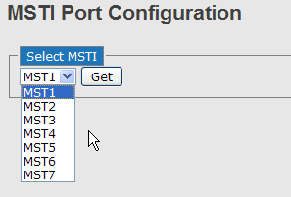
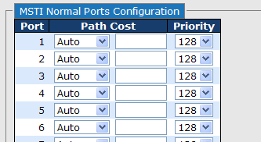
Label | Description
Port | The switch port number of the corresponding STP CIST (and MSTI) port
Path Cost | Configures the path cost incurred by the port. Auto will set the path cost according to the physical link speed by using the 802.1D-recommended values. Specific allows you to enter a user-defined value. The path cost is used when establishing an active topology for the network. Lower path cost ports are chosen as forwarding ports in favor of higher path cost ports. The range of valid values is 1 to 200000000.
Priority | Configures the priority for ports having identical port costs. (See above).
Save | Click to save changes.
Reset | Click to undo any changes made locally and revert to previously saved values.

Mapping
This page allows you to examine and change the configurations of current STP MSTI bridge instance.
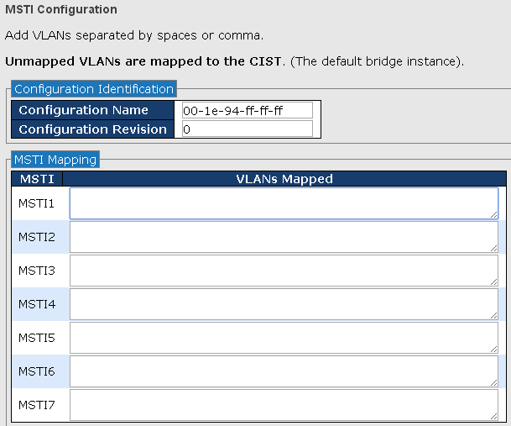

Label | Description
Configuration Name | The name which identifies the VLAN to MSTI mapping. Bridges must share the name and revision (see below), as well as the VLAN-to-MSTI mapping configurations in order to share spanning trees for MSTIs (intra-region). The name should not exceed 32 characters.
Configuration Revision | Revision of the MSTI configuration named above. This must be an integer between 0 and 65535.
MSTI | The bridge instance. The CIST is not available for explicit mapping, as it will receive the VLANs not explicitly mapped.
VLANS Mapped | The list of VLANs mapped to the MSTI. The VLANs must be separated with commas and/or space. A VLAN can only be mapped to one MSTI. An unused MSTI will be left empty (ex. without any mapped VLANs).
Save | Click to save changes.
Reset | Click to undo any changes made locally and revert to previously saved values.

Priority
This page allows you to examine and change the configurations of current STP MSTI bridge instance priority.
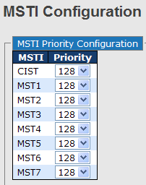

Label | Description
MSTI | The bridge instance. CIST is the default instance, which is always active.
Priority | Indicates bridge priority. The lower the value, the higher the priority. The bridge priority, MSTI instance number, and the 6-byte MAC address of the switch forms a bridge identifier.
Save | Click to save changes
Reset | Click to undo any changes made locally and revert to previously saved values

CIST
With the ability to cross regional boundaries, CIST is used by MSTP to communicate with other MSTP regions and with any RSTP and STP single-instance spanning trees in the network. Any boundary port, that is, if it is connected to another region, will automatically belongs solely to CIST, even if it is assigned to an MSTI. All VLANs that are not members of particular MSTIs are members of the CIST.

Port Settings
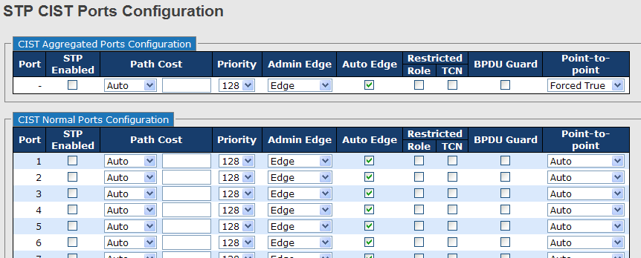

Label | Description
Port | The switch port number to which the following settings will be applied.
STP Enabled | Check to enable STP for the port
Path Cost | Configures the path cost incurred by the port. Auto will set the path cost according to the physical link speed by using the 802.1D-recommended values. Specific allows you to enter a user-defined value. The path cost is used when establishing an active topology for the network. Lower path cost ports are chosen as forwarding ports in favor of higher path cost ports. The range of valid values is 1 to 200000000.
Priority | Configures the priority for ports having identical port costs. (See above).
OpenEdge (setate flag) | A flag indicating whether the port is connected directly to edge devices or not (no bridges attached). Transiting to the forwarding state is faster for edge ports (operEdge set to true) than other ports.
AdminEdge | Configures the operEdge flag to start as set or cleared.(the initial operEdge state when a port is initialized).
AutoEdge | Check to enable the bridge to detect edges at the bridge port automatically. This allows operEdge to be derived from whether BPDUs are received on the port or not.
Restricted Role | When enabled, the port will not be selected as root port for CIST or any MSTI, even if it has the best spanning tree priority vector. Such a port will be selected as an alternate port after the root port has been selected. If set, spanning trees will lose connectivity. It can be set by a network administrator to prevent bridges outside a core region of the network from influencing the active spanning tree topology because those bridges are not under the full control of the administrator. This feature is also known as Root Guard.
Restricted TCN | When enabled, the port will not propagate received topology change notifications and topology changes to other ports. If set, it will cause temporary disconnection after changes in an active spanning trees topology as a result of persistent incorrectly learned station location information. It is set by a network administrator to prevent bridges outside a core region of the network from causing address flushing in that region because those bridges are not under the full control of the administrator or is the physical link state for the attached LANs transitions frequently.
Point2Point | Configures whether the port connects to a point-to-point LAN rather than a shared medium. This can be configured automatically or set to true or false manually. Transiting to forwarding state is faster for point-to-point LANs than for shared media.
Save | Click to save changes.
Reset | Click to undo any changes made locally and revert to previously saved values.

Fast Recovery
Fast recovery mode can be set to connect multiple ports to one or more switches. The device with fast recovery mode will provide redundant links. Fast recovery mode supports 12 priorities. Only the first priority will be the active port, and the other ports with different priorities will be backup ports.

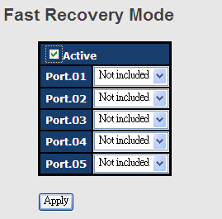

Label | Description
Active | Activate fast recovery mode
Port | Ports can be set to 12 priorities. Only the port with the highest priority will be the active port. 1st Priority is the highest.
Apply | Click to activate the configurations.

Management
The switch can be controlled via a built-in web server which supports Internet Explorer (Internet Explorer 5.0 or above versions) and other Web browsers such as Chrome. Therefore, you can manage and configure the switch easily and remotely. You can also upgrade firmware via a Web browser. The Web management function not only reduces network bandwidth consumption, but also enhances access speed and provides a user-friendly viewing screen.
Note: By default, IE5.0 or later version do not allow Java applets to open sockets. You need to modify the browser setting separately in order to enable Java applets for network ports.

Management via Web Browser
Follow the steps below to manage your switch via a Web browser
System Login
- Launch an Internet Explorer.
- Type http:// and the IP address of the switch. Press Enter.
- The login screen appears.
- Type in the username and password. The default username and password is admin.
- Click Enter or OK button and the main interface of the management page appears.

Note: you can use the following default values:
IP Address: 192.168.10.1
Subnet Mask: 255.255.255.0
Default Gateway: 192.168.10.254
User Name: admin
Password: admin

After logging in, you will see the information of the switch as below.

On the left hand side of the management interface shows links to various settings. Clicking on the links will bring you to individual configuration pages.

System Information

Click on System Information on the left panel will show the detail of the system such as device name, description, MAC address, and firmware version.

Front Panel
You will see the image of the device front panel on the right hand side of the window. The green port means the port in use. Click on the port will bring up a window containing the details of the port.

Basic Settings
The Basic Settings page allows you to configure the basic functions of the switch.

Basic Settings for System Information
This page shows the general information of the switch.

Label | Description
System Name | An administratively assigned name for the managed node. By convention, this is the node's fully-qualified domain name. A domain name is a text string consisting of alphabets (A-Z, a-z), digits (0-9), and minus sign (-). Space is not allowed to be part of the name. The first character must be an alpha character. And the first or last character must not be a minus sign. The allowed string length is 0 to 255.
System Description | Description of the device
System Location | The physical location of the node (e.g., telephone closet, 3rd floor). The allowed string length is 0 to 255, and only ASCII characters from 32 to 126 are allowed.
System Contact | The textual identification of the contact person for this managed node, together with information on how to contact this person. The allowed string length is 0 to 255, and only ASCII characters from 32 to 126 are allowed.

Admin Password
This page allows you to configure the system password required to access the web pages or log in from CLI.
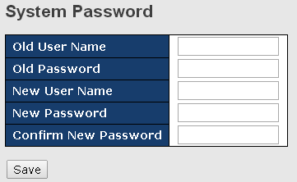

Label | Description
Old Password | The existing password. If this is incorrect, you cannot set the new password.
New Password | The new system password. The allowed string length is 0 to 31, and only ASCII characters from 32 to 126 are allowed.
Confirm New Password | Re-type the new password.

Authentication Method
This page allows you to configure how a user is authenticated when he/she logs into the switch via one of the management interfaces.
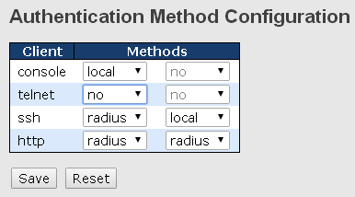

Label | Description
Client | The management client for which the configuration below applies.
Methods | Authentication Method can be set to one of the following values:  None: authentication is disabled and login is not possible.  Local: local user database on the switch is used for authentication.  Radius: a remote RADIUS server is used for authentication.
Save | Click to save changes
Reset | Click to undo any changes made locally and revert to previously saved values

IP Settings
This page allows you to configure IP information for the switch. You can configure the settings of the device operating in host or router mode.
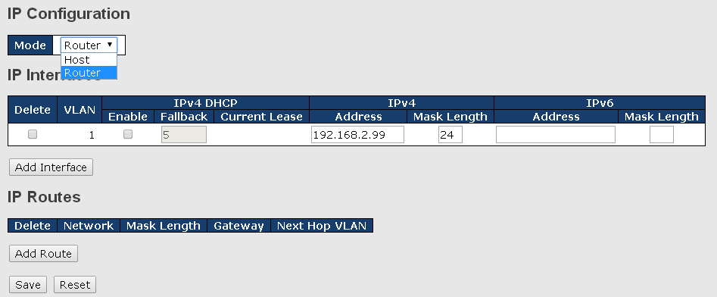

Label | Description
Mode | Configure whether the IP stack should act as a host or a router. In Host mode, IP traffic between interfaces will not be routed. In Router mode traffic is routed between all interfaces.
IP Interface | You can configure the information of IPv4 and IPv6 in this section. IPv4 DHCP configurations include:  Enable: check to enable IPv4 DHCP function.  Fallback: specifies the number of seconds for trying to obtain a DHCP lease.  Current Lease: For DHCP interfaces with an active lease, the column shows the current interface address, as provided by the DHCP server.  IPv4 configurations include:  Address: shows the IPv4 address of the interface in dotted decimal notation. If DHCP is enabled, this field is not used. The field may also be left blank if IPv4 operation on the interface is not desired.  Mask Length: the IPv4 network mask, in number of bits (prefix length). Valid values are between 0 and 30 bits for an IPv4 address. If DHCP is enabled, this field is not used. The field may also be left blank if IPv4 operation on the interface is not desired.  IPv6 Address  IPv6 configurations include:  Address: shows the address of the interface. A IPv6 address is in 128-bit records represented as eight fields of up to four hexadecimal digits with a colon separating each field (:). For example, fe80::21:cff:fe03:4dc7. The symbol :: is a special syntax that can be used as a shorthand way of representing multiple 16-bit groups of contiguous zeros; but it can appear only once. It can also represent a legally valid IPv4 address. For example: 192.1.2.34. The field may be left blank if IPv6 operation on the interface is not desired.  Mask Length: the IPv6 network mask, in number of bits (prefix length). Valid values are between 1 and 128 bits for a IPv6 address. The field may be left blank if IPv6 operation on the interface is not desired.
IP Routes | Delete: Select this option to delete an existing IP route.  Network: The destination IP network or host address of this route. Valid format is dotted decimal notation or a valid IPv6 notation. A default route can use the value0.0.0.0or IPv6:: notation.  Mask Length: The destination IP network or host mask, in number of bits (prefix length). It defines how much of a network address that must match, in order to qualify for this route. Valid values are between 0 and 32 bits respectively 128 for IPv6 routes. Only a default route will have a mask length of 0 (as it will match anything).  Gateway: The IP address of the IP gateway. Valid format is dotted decimal notation or a valid IPv6 notation. Gateway and Network must be of the same type.  Next Hop VLAN: The VLAN ID (VID) of the specific IPv6 interface associated with the gateway. The given VID ranges from 1 to 4094 and will be effective only when the corresponding IPv6 interface is valid. If the IPv6 gateway address is link-local, it must specify the next hop VLAN for the gateway. If the IPv6 gateway address is not link-local, system ignores the next hop VLAN for the gateway.

IP Status
This page will show the IP details of the device based on the settings you made in the IP Setting section.
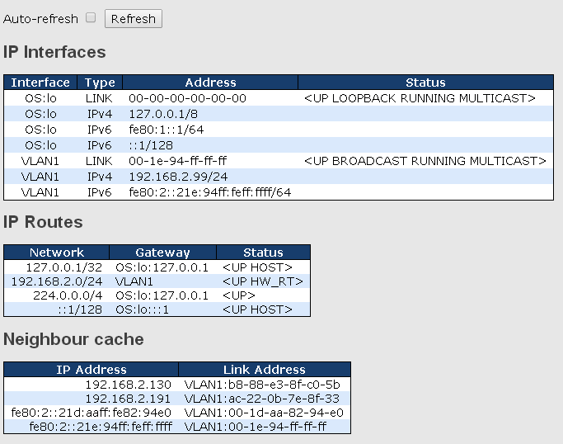

SNTP
SNTP (Simple Network Time Protocol) is a protocol able to synchronize the time on your system to the clock on the Internet. It will synchronize your computer system time with a server that has already been synchronized by a source such as a radio, satellite receiver or modem.
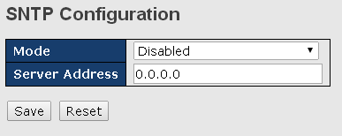

Label | Description
Mode | Enable or disable the use of SNTP server
Server Address | Input the IP address of the SNTP server if enabled.

Daylight Saving Time
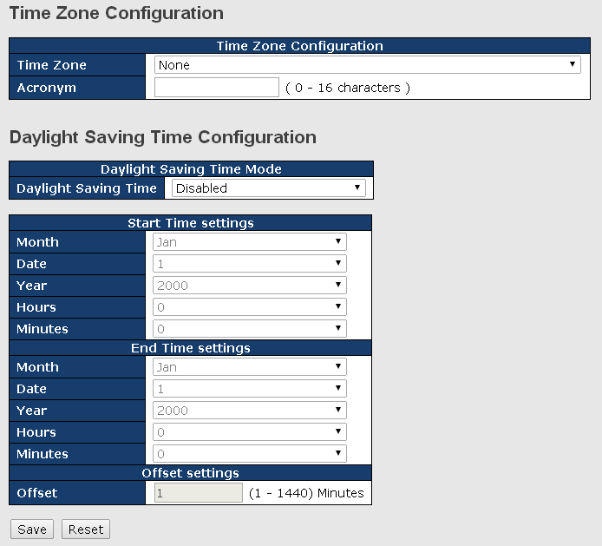

Label | Description
Time Zone Configuration | Time Zone: Set the switch location time zone. The following table lists the different location time zone for your reference.  Acronym: User can set the acronym of the time zone. This is a User configurable acronym to identify the time zone. (Range: Up to 16 alpha-numeric characters and can contain '-', '_' or '.')
Daylight Saving Time Configuration | Daylight Saving Time Mode: Enable or disable daylight saving time function. This is used to set the clock forward or backward according to the configurations set below for a defined Daylight Saving Time duration. Select 'Disable' to disable the Daylight Saving Time configuration. Select 'Recurring' and configure the Daylight Saving Time duration to repeat the configuration every year. Select 'Non-Recurring' and configure the Daylight Saving Time duration for single time configuration. ( Default : Disabled )  Start Time Settings: Set up the start time of the daylight saving time period.  End Time Settings: Set up the ending time of the daylight saving time period.  Offset Settings: Set up the offset time.

Local Time Zone | Conversion from UTC | Time at 12:00 UTC
November Time Zone | - 1 hour | 11 am
Oscar Time Zone | -2 hours | 10 am
ADT - Atlantic Daylight | -3 hours | 9 am
AST - Atlantic Standard  EDT - Eastern Daylight | -4 hours | 8 am
EST - Eastern Standard  CDT - Central Daylight | -5 hours | 7 am
CST - Central Standard  MDT - Mountain Daylight | -6 hours | 6 am
MST - Mountain Standard  PDT - Pacific Daylight | -7 hours | 5 am
PST - Pacific Standard  ADT - Alaskan Daylight | -8 hours | 4 am
ALA - Alaskan Standard | -9 hours | 3 am
HAW - Hawaiian Standard | -10 hours | 2 am
Nome, Alaska | -11 hours | 1 am
CET - Central European  FWT - French Winter  MET - Middle European  MEWT - Middle European Winter  SWT - Swedish Winter | +1 hour | 1 pm
EET - Eastern European, USSR Zone 1 | +2 hours | 2 pm
BT - Baghdad, USSR Zone 2 | +3 hours | 3 pm
ZP4 - USSR Zone 3 | +4 hours | 4 pm
ZP5 - USSR Zone 4 | +5 hours | 5 pm
ZP6 - USSR Zone 5 | +6 hours | 6 pm
WAST - West Australian Standard | +7 hours | 7 pm
CCT - China Coast, USSR Zone 7 | +8 hours | 8 pm
JST - Japan Standard, USSR Zone 8 | +9 hours | 9 pm
EAST - East Australian Standard GST  Guam Standard, USSR Zone 9 | +10 hours | 10 pm
IDLE - International Date Line  NZST - New Zealand Standard  NZT - New Zealand | +12 hours | Midnight

RIP
RIP (Routing Information Protocol) is one of the protocols which may be used by routers to exchange network topology information. It is characterized as an “interior” gateway protocol, and is typically used in small to medium-sized networks. A router running RIP sends the contents of its routing table to each of its adjacent routers every 30 seconds. When a route is removed from the routing table it is flagged as unusable by the receiving routers after 180 seconds, and removed from their tables after an additional 120 seconds. You can choose to enable or disable RIP in the section.
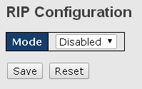

VRRP
A VRRP (Virtual Router Redundancy Protocol) is a computer networking protocol aimed to eliminate the single point of failure by automatically assigning available IP routers to participating hosts. Using a virtual router ID (VRID) address and virtual router IP (VRIP) address to represent itself, a virtual router consists of two or more physical routers, including one master router and one or more backup routers. All routers in the virtual router group share the same VRID and VRIP. The master router provides primary routing and the backup routers monitor the status of the master router and become active if the master router fails.
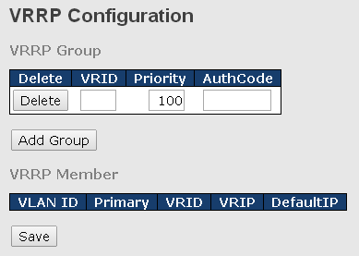
Label | Description
VRRP Group | VRRP combines a group of routers (including a master and multiple backups) on a LAN into a virtual router called VRRP group.  Delete: Click the button if you want to delete an entry from the table.  VRID: Enter a unique ID number for this virtual router. The range of valid values is 1 to 255.  Priority: VRRP determines the role (master or backup) of each router in a VRRP group by priority. A router with a higher priority is more likely to become the master. VRRP priority is in the range of 0 to 255, and the greater the number, the higher the priority. Priorities 1 to 254 are configurable. Priority 0 is reserved for special uses and priority 255 is for the IP address owner. The router acting as the IP address owner in a VRRP group always has the running priority 255 and acts as the master as long as it works properly.  AuthCode: Enter the authorization code for the VRRP group  Add Group: Click the button if you want to add a new entry
VRRP Member | Shows the information of the VRRP members, including the VLAN ID of the device, primary status, VRID, VRIP, and defult IP.

HTTPS
You can configure the HTTPS mode in the following page.
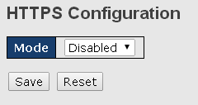

Label | Description
Mode | Indicates the selected HTTPS mode. When the current connection is HTTPS, disabling HTTPS will automatically redirect web browser to an HTTP connection. The modes include:  Enabled: enable HTTPS.  Disabled: disable HTTPS.
Save | Click to save changes
Reset | Click to undo any changes made locally and revert to previously saved values

SSH
SSH (Secure Shell) is a cryptographic network protocol intended for secure data transmission and remote access by creating a secure channel between two networked PCs. You can configure the SSH mode in the following page.
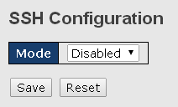

Label | Description
Mode | Indicates the selected SSH mode. The modes include:  Enabled: enable SSH.  Disabled: disable SSH.
Save | Click to save changes
Reset | Click to undo any changes made locally and revert to previously saved values

LLDP
Configurations
LLDP (Link Layer Discovery Protocol) provides a method for networked devices to receive and/or transmit their information to other connected devices on the network that are also using the protocols, and to store the information that is learned about other devices. This page allows you to examine and configure current LLDP port settings.
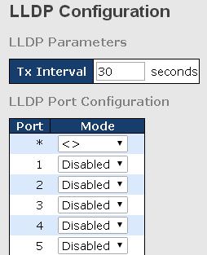

Label | Description
Tx Interval | Sets the transmit interval, which is the interval between regular transmissions of LLDP advertisements.
Port | The switch port number to which the following settings will be applied.
Mode | Indicates the selected LLDP mode  Rx only: the switch will not send out LLDP information, but LLDP information from its neighbors will be analyzed.  Tx only: the switch will drop LLDP information received from its neighbors, but will send out LLDP information.  Disabled: the switch will not send out LLDP information, and will drop LLDP information received from its neighbors.  Enabled: the switch will send out LLDP information, and will analyze LLDP information received from its neighbors.

Neighbors
This page provides a status overview for all LLDP neighbors. The following table contains information for each port on which an LLDP neighbor is detected. The columns include the following information:
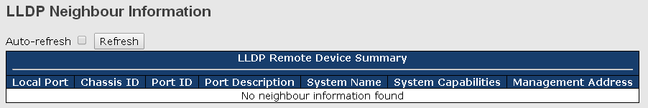

Label | Description
Local Port | The port that you use to transmits and receives LLDP frames.
Chassis ID | The identification number of the neighbor sending out the LLDP frames.
Port ID | The identification of the neighbor port
Port Description | The description of the port advertised by the neighbor.
System Name | The name advertised by the neighbor.
System Capabilities | Description of the neighbor's capabilities. The capabilities include:  1. Other  2. Repeater  3. Bridge  4. WLAN Access Point  5. Router  6. Telephone  7. DOCSIS Cable Device  8. Station Only  9. Reserved  When a capability is enabled, a (+) will be displayed. If the capability is disabled, a (-) will be displayed.
Management Address | The neighbor's address which can be used to help network management. This may contain the neighbor's IP address.
Refresh | Click to refresh the page immediately
Auto-refresh | Check to enable an automatic refresh of the page at regular intervals

Statistics
This page provides an overview of all LLDP traffic. Two types of counters are shown. Global counters will apply settings to the whole switch stack, while local counters will apply settings to specified switches.
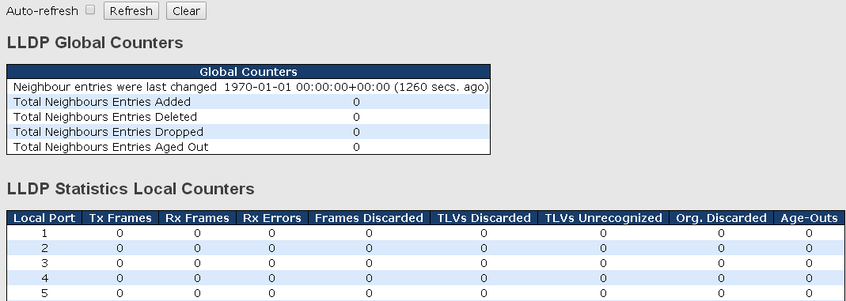

Global Counters
Label | Description
Neighbor entries were last changed at | Shows the time when the last entry was deleted or added.
Total Neighbors Entries Added | Shows the number of new entries added since switch reboot
Total Neighbors Entries Deleted | Shows the number of new entries deleted since switch reboot
Total Neighbors Entries Dropped | Shows the number of LLDP frames dropped due to full entry table
Total Neighbors Entries Aged Out | Shows the number of entries deleted due to expired time-to-live

Local Counters
Label | Description
Local Port | The port that receives or transmits LLDP frames
Tx Frames | The number of LLDP frames transmitted on the port
Rx Frames | The number of LLDP frames received on the port
Rx Errors | The number of received LLDP frames containing errors
Frames Discarded | If a port receives an LLDP frame, and the switch's internal table is full, the LLDP frame will be counted and discarded. This situation is known as "too many neighbors" in the LLDP standard. LLDP frames require a new entry in the table if Chassis ID or Remote Port ID is not included in the table. Entries are removed from the table when a given port links down, an LLDP shutdown frame is received, or when the entry ages out.
TLVs Discarded | Each LLDP frame can contain multiple pieces of information, known as TLVs (Type Length Value). If a TLV is malformed, it will be counted and discarded.
TLVs Unrecognized | The number of well-formed TLVs, but with an unknown type value
Org. Discarded | The number of organizationally TLVs received
Age-Outs | Each LLDP frame contains information about how long the LLDP information is valid (age-out time). If no new LLDP frame is received during the age-out time, the LLDP information will be removed, and the value of the age-out counter will be incremented.
Refresh | Click to refresh the page immediately
Clear | Click to clear the local counters. All counters (including global counters) are cleared upon reboot.
Auto-refresh | Check to enable an automatic refresh of the page at regular intervals

Modbus TCP
Modbus TCP uses TCP/IP and Ethernet to carry the data of the Modbus message structure between compatible devices. The protocol is commonly used in SCADA systems for communications between a human-machine interface (HMI) and programmable logic controllers. This page enables you to enable and disable Modbus TCP support of the switch.
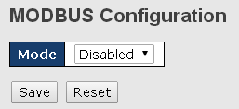

Label | Description
Mode | Shows the existing status of the Modbus TCP function

Backup/Restore Configurations
You can save switch configurations as a file or load a previously stored configuration file to the device to restore to old settings. The configuration file is in XML format. You can click “Save configuration” to save existing settings as a file and store in your local PC.
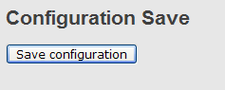

Choose the configuration file from a drive and click “Upload”. The file will be loaded to the device.

Update Firmware
This page allows you to update the firmware of the switch. Simply choose the firmware file you want to use and click “Upload”. The file will be loaded to the device.

DHCP Server
The switch provides DHCP server functions. By enabling DHCP, the switch will become a DHCP server and dynamically assigns IP addresses and related IP information to network clients.

    - Settings
This page allows you to set up DHCP settings for the switch. You can check the Enabled checkbox to activate the function. Once the box is checked, you will be able to input information in each column.
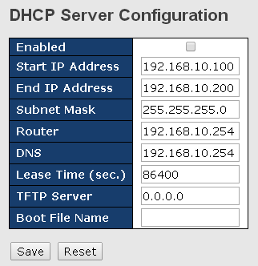

Label | Description
Enabled | Check to enable the DHCP Server function. If enabled, the switch will be the DHCP server on your local network
Start IP Address | The beginning of the dynamic IP address range. The lowest IP address in the range is considered the start IP address. For example, if the range is from 192.168.1.100 to 192.168.1.200, 192.168.1.100 will be the start IP address.
End IP Address | The end of the dynamic IP address range. The highest IP address in the range is considered the end IP address. For example, if the range is from 192.168.1.100 to 192.168.1.200, 192.168.1.200 will be the end IP address
Subnet Mask | The subnet mask for the dynamic IP assign range
Gateway | The gateway of your network
DNS | The DNS IP of your network
Lease Time (sec.) | The length of time that the client may use the IP address it has been assigned. The time is measured in seconds.
TFTP Server | The IP address of the FTFP where you put the configuration file or where you want to restore the switch to previous settings.
Boot File Name | The boot file is used by the clients to identify the boot image. Enter the boot file name you receive.
Apply | Click to apply the configurations

    - Dynamic Client List
When DHCP server functions are activated, the switch will collect DHCP client information and display in the following table. You can assign the specific IP address which is in the assigned dynamic IP range to the specific port. When the device is connecting to the port and asks for dynamic IP assigning, the system will assign the IP address that has been assigned before in the connected device
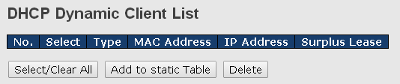

Label | Description
MAC Address | Displays the MAC address of a given host.
IP Address | Displays the IP address that the client obtains from the DHCP server
Surplus Lease | The Remaining time for a corresponding IP address lease.

    - Static Client List
You can manually add clients to your DHCP server that obtain the same IP address each time they start up by entering the MAC address and IP address of the client in the page and add it as a static client.
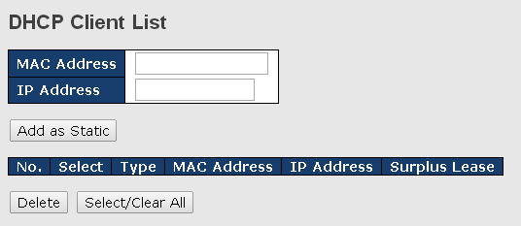

    - DHCP Relay
DHCP relay is used to forward and transfer DHCP messages between the clients and the server when they are not in the same subnet domain. You can configure the function in this page.
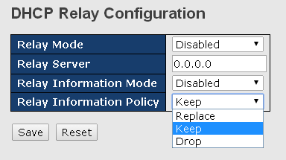

Label | Description
Relay Mode | Indicates the existing DHCP relay mode. The modes include:  Enabled: activate DHCP relay. When DHCP relay is enabled, the agent forwards and transfers DHCP messages between the clients and the server when they are not in the same subnet domain to prevent the DHCP broadcast message from flooding for security considerations.  Disabled: disable DHCP relay
Relay Server | Indicates the DHCP relay server IP address. A DHCP relay agent is used to forward and transfer DHCP messages between the clients and the server when they are not in the same subnet domain.
Relay Information Mode | Indicates the existing DHCP relay information mode. The format of DHCP option 82 circuit ID format is "[vlan_id][module_id][port_no]". The first four characters represent the VLAN ID, and the fifth and sixth characters are the module ID. In stand-alone devices, the module ID always equals to 0; in stacked devices, it means switch ID. The last two characters are the port number. For example, "00030108" means the DHCP message received form VLAN ID 3, switch ID 1, and port No. 8. The option 82 remote ID value equals to the switch MAC address.  The modes include:  Enabled: activate DHCP relay information. When DHCP relay information is enabled, the agent inserts specific information (option 82) into a DHCP message when forwarding to a DHCP server and removes it from a DHCP message when transferring to a DHCP client. It only works when DHCP relay mode is enabled.  Disabled: disable DHCP relay information
Relay Information Policy | Indicates the policies to be enforced when receiving DHCP relay information. When DHCP relay information mode is enabled, if the agent receives a DHCP message that already contains relay agent information, it will enforce the policy. The Replace option is invalid when relay information mode is disabled. The policies includes:  Replace: replace the original relay information when a DHCP message containing the information is received.  Keep: keep the original relay information when a DHCP message containing the information is received.  Drop: drop the package when a DHCP message containing the information is received.

The relay statistics shows the information of relayed packets of the switch.
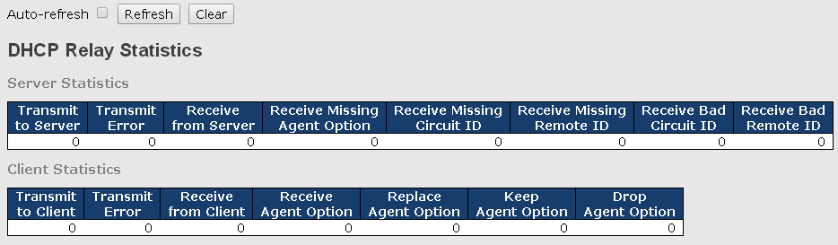

Label | Description
Transmit to Sever | The number of packets relayed from the client to the server
Transmit Error | The number of packets with errors when being sent to clients
Receive from Server | The number of packets received from the server
Receive Missing Agent Option | The number of packets received without agent information
Receive Missing Circuit ID | The number of packets received with Circuit ID
Receive Missing Remote ID | The number of packets received with the Remote ID option missing.
Receive Bad Circuit ID | The number of packets whose Circuit ID do not match the known circuit ID
Receive Bad Remote ID | The number of packets whose Remote ID do not match the known Remote ID
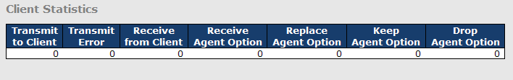

Label | Description
Transmit to Client | The number of packets relayed from the server to the client
Transmit Error | The number of packets with errors when being sent to servers
Receive from Client | The number of packets received from the server
Receive Agent Option | The number of received packets containing relay agent information
Replace Agent Option | The number of packets replaced when received messages contain relay agent information.
Keep Agent Option | The number of packets whose relay agent information is retained
Drop Agent Option | The number of packets dropped when received messages contain relay agent information.

Port Setting
Port Setting allows you to manage individual ports of the switch, including traffic, power, and trunks.

    - Port Control
This page shows current port configurations. Ports can also be configured here.
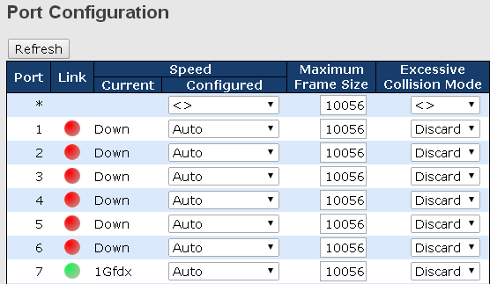
Label | Description
Port | The switch port number to which the following settings will be applied.
Link | The current link state is shown by different colors. Green indicates the link is up and red means the link is down.
Current Link Speed | Indicates the current link speed of the port
Configured Link Speed | The drop-down list provides available link speed options for a given switch port  Auto selects the highest speed supported by the link partner  Disabled disables switch port configuration  <> configures all ports
Flow Control | When Auto is selected for the speed, the flow control will be negotiated to the capacity advertised by the link partner.  When a fixed-speed setting is selected, that is what is used. Current Rx indicates whether pause frames on the port are obeyed, and Current Tx indicates whether pause frames on the port are transmitted. The Rx and Tx settings are determined by the result of the last auto-negotiation.  You can check the Configured column to use flow control. This setting is related to the setting of Configured Link Speed.
Maximum Frame Size | You can enter the maximum frame size allowed for the switch port in this column, including FCS. The allowed range is 1518 bytes to 9600 bytes.
Excessive  Collision Mode | Configures port transmit collision behavior. Discard: Discard frame after a certain amount of collisions (default). Restart: Restart backoff algorithm after a certain amount of collisions.
Save | Click to save changes
Reset | Click to undo any changes made locally and revert to previously saved values
Refresh | Click to refresh the page. Any changes made locally will be undone.
    - Port Trunk
A port trunk is a group of ports that have been grouped together to function as one logical path. This method provides an economical way for you to increase the bandwidth between the switch and another networking device. In addition, it is useful when a single physical link between the devices is insufficient to handle the traffic load. This page allows you to configure the aggregation hash mode and the aggregation group.

Configurations
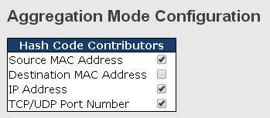

Label | Description
Source MAC Address | Calculates the destination port of the frame. You can check this box to enable the source MAC address, or uncheck to disable. By default, Source MAC Address is enabled.
Destination MAC Address | Calculates the destination port of the frame. You can check this box to enable the destination MAC address, or uncheck to disable. By default, Destination MAC Address is disabled.
IP Address | Calculates the destination port of the frame. You can check this box to enable the IP address, or uncheck to disable. By default, IP Address is enabled.
TCP/UDP Port Number | Calculates the destination port of the frame. You can check this box to enable the TCP/UDP port number, or uncheck to disable. By default, TCP/UDP Port Number is enabled.

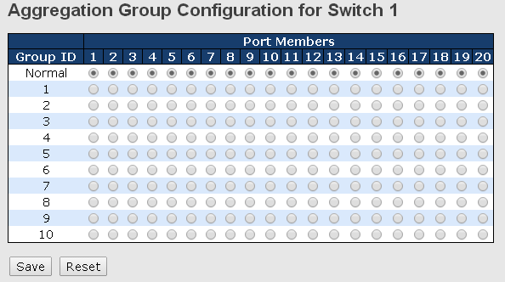

Label | Description
Group ID | Indicates the ID of each aggregation group. Normal means no aggregation. Only one group ID is valid per port.
Port Members | Lists each switch port for each group ID. Select a radio button to include a port in an aggregation, or clear the radio button to remove the port from the aggregation. By default, no ports belong to any aggregation group. Only full duplex ports can join an aggregation and the ports must be in the same speed in each group.

LACP
LACP (Link Aggregation Control Protocol) trunks are similar to static port trunks, but they are more flexible because LACP is compliant with the IEEE 802.3ad standard. Hence, it is interoperable with equipment from other vendors that also comply with the standard. This page allows you to enable LACP functions to group ports together to form single virtual links and change associated settings, thereby increasing the bandwidth between the switch and other LACP-compatible devices.
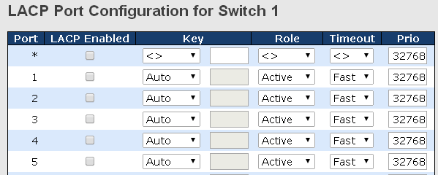

Label | Description
Port | Indicates the ID of each aggregation group. Normal indicates there is no aggregation. Only one group ID is valid per port.
LACP Enabled | Lists each switch port for each group ID. Check to include a port in an aggregation, or clear the box to remove the port from the aggregation. By default, no ports belong to any aggregation group. Only full duplex ports can join an aggregation and the ports must be in the same speed in each group.
Key | The Key value varies with the port, ranging from 1 to 65535. Auto will set the key according to the physical link speed (10Mb = 1, 100Mb = 2, 1Gb = 3). Specific allows you to enter a user-defined value. Ports with the same key value can join in the same aggregation group, while ports with different keys cannot.
Role | Indicates LACP activity status. Active will transmit LACP packets every second, while Passive will wait for a LACP packet from a partner (speak if spoken to).
Timeout | You can change the LACP timer rate to modify the duration of the LACP timeout by changing between Fast and Slow.
Prio | Set the port priority. The higher the priority value the lower the priority.
Save | Click to save changes
Reset | Click to undo changes made locally and revert to previous values

LACP System Status
This page provides a status overview for all LACP instances.
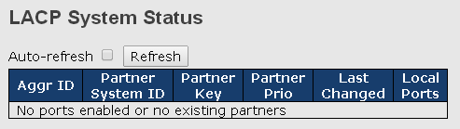

Label | Description
Aggr ID | The aggregation ID is associated with the aggregation instance. For LLAG, the ID is shown as 'isid:aggr-id' and for GLAGs as 'aggr-id'
Partner System ID | System ID (MAC address) of the aggregation partner
Partner Key | When connecting the device to other manufactures’ devices, you may need to configure LACP partner key. Partner key is the operational key value assigned to the port associated with this link by the Partner.
Partner Priority | Configures the priority of the partner.
Last Changed | The time since this aggregation is changed.
Local Ports | Indicates which ports belong to the aggregation of the switch/stack. The format is: “Switch ID:Port”.
Refresh | Click to refresh the page immediately
Auto-refresh | Check to enable an automatic refresh of the page at regular intervals

LACP Port Status
This page provides an overview of the LACP status for all ports.
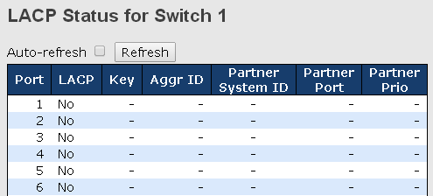
Label | Description
Port | Switch port number
LACP | Yes means LACP is enabled and the port link is up. No: LACP is not enabled or the port link is down. Backup:the port cannot join in the aggregation group unless other ports are removed. The LACP status is disabled.
Key | The key assigned to the port. Only ports with the same key can be aggregated
Aggr ID | The aggregation ID assigned to the aggregation group
Partner System ID | The partner’s system ID (MAC address)
Partner Port | The partner’s port number associated with the port
Partner Prio | Shows the priority of the partner.
Refresh | Click to refresh the page immediately
Auto-refresh | Check to enable an automatic refresh of the page at regular intervals

LACP Port Statistics
This page provides an overview of the LACP statistics for all ports.
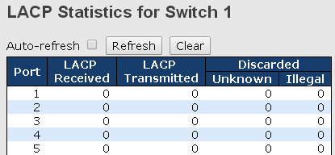

Label | Description
Port | Switch port number
LACP Transmitted | The number of LACP frames sent from each port
LACP Received | The number of LACP frames received at each port
Discarded | The number of unknown or illegal LACP frames discarded at each port.
Refresh | Click to refresh the page immediately
Auto-refresh | Check to enable an automatic refresh of the page at regular intervals
Clear | Click to clear the counters for all ports
    - Loop Protection
This feature prevents loop attack. When receiving loop packets, the port will be disabled automatically, preventing the loop attack from affecting other network devices.

Configuration
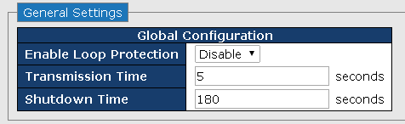

Label | Description
Enable Loop Protection | Activate loop protection functions (as a whole)
Transmission Time | The interval between each loop protection PDU sent on each port. The valid value is 1 to 10 seconds.
Shutdown Time | The period (in seconds) for which a port will be kept disabled when a loop is detected (shutting down the port). The valid value is 0 to 604800 seconds (7 days). A value of zero will keep a port disabled permanently (until the device is restarted).

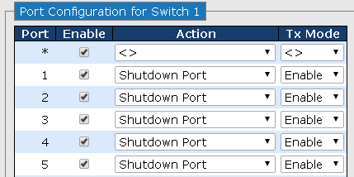

Label | Description
Port | Switch port number
Enable | Activate loop protection functions (as a whole)
Action | Configures the action to take when a loop is detected. Valid values include Shutdown Port, Shutdown Port, and Log or Log Only.
Tx Mode | Controls whether the port is actively generating loop protection PDUs or only passively look for looped PDUs.

Loop Protection Status
This page shows the Loop protection information you made in the configuration page.
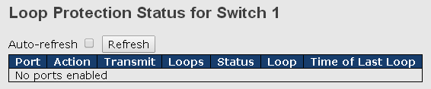

Label | Description
Port | Switch port number
Action | Shows the action to occur based on your setting.
Transmit | Shows the transmit mode based on your setting.
Loops | The number of loops detected on this interface since the last system boot or since statistics were cleared.
Status | The current loop protection status of the port.
Loop | Whether a loop is currently detected on the port.
Time of Last Loop | The time of the last loop event detected.

VLAN
    - VLAN Membership
A VLAN (Virtual LAN) is a logical LAN based on a physical LAN with links that does not consist of a physical (wired or wireless) connection between two computing devices but is implemented using methods of network virtualization. A VLAN can be created by partitioning a physical LAN into multiple logical LANs using a VLAN ID. You can assign switch ports to a VLAN and add new VLANs in this page.

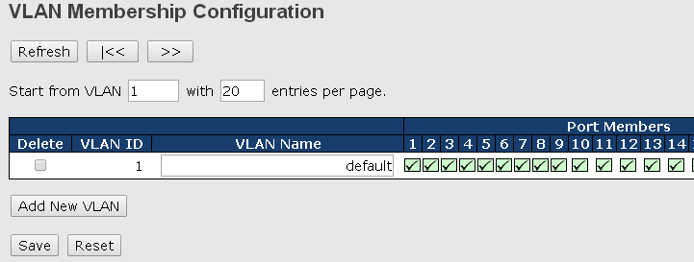

Label | Description
Delete | Check to delete the entry. It will be deleted during the next save.
VLAN ID | The VLAN ID for the entry
MAC Address | The MAC address for the entry
Port Members | Checkmarks indicate which ports are members of the entry. Check or uncheck as needed to modify the entry
Add New VLAN | Click to add a new VLAN ID. An empty row is added to the table, and the VLAN can be configured as needed. Valid values for a VLAN ID are 1 through 4095.  After clicking Save, the new VLAN will be enabled on the selected switch stack but contains no port members.  A VLAN without any port members on any stack will be deleted when you click Save.  Click Delete to undo the addition of new VLANs.

    - Port Configurations
This page allows you to set up VLAN ports individually.
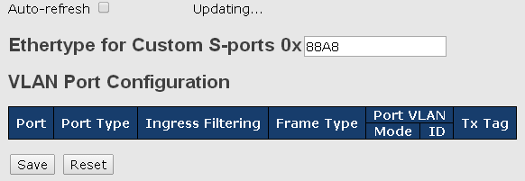

Label | Description
Ethertype for customer S-Ports | This field specifies the Ethertype used for custom S-ports. This is a global setting for all custom S-ports. Custom Ethertype enables you to change the Ethertype value on a port to any value to support network devices that do not use the standard 0x8100 Ethertype field value on 802.1Q-tagged or 802.1p-tagged frames. When Port Type is set to S-custom-port, the EtherType (also known as TPID) of all frames received on the port is changed to the specified value. By default, the EtherType is set to 0x88a8 (IEEE 802.1ad)
Port | The switch port number to which the following settings will be applied.
Port type | Port can be one of the following types: Unaware, Customer (C-port), Service (S-port), Custom Service (S-custom-port).  C-port: each frame is assigned to the VLAN indicated in the VLAN tag, and the tag is removed.  S-port: the EtherType of all received frames is changed to 0x88a8 to indicate that double-tagged frames are being forwarded across the switch. The switch will pass these frames on to the VLAN indicated in the outer tag. It will not strip the outer tag, nor change any components of the tag other than the EtherType field.  S-custom-port: the EtherType of all received frames is changed to value set in the Ethertype for Custom S-ports field to indicate that double-tagged frames are being forwarded across the switch. The switch will pass these frames on to the VLAN indicated in the outer tag. It will not strip the outer tag, nor change any components of the tag other than the EtherType field.  Unaware: all frames are classified to the Port VLAN ID and tags are not removed
Ingress Filtering | Enable ingress filtering on a port by checking the box. This parameter affects VLAN ingress processing. If ingress filtering is enabled and the ingress port is not a member of the classified VLAN of the frame, the frame will be discarded. By default, ingress filtering is disabled (no check mark).
Frame Type | Determines whether the port accepts all frames or only tagged/untagged frames. This parameter affects VLAN ingress processing. If the port only accepts tagged frames, untagged frames received on the port will be discarded. By default, the field is set to All.
Port VLAN Mode | The allowed values are None or Specific. This parameter affects VLAN ingress and egress processing.  If None is selected, a VLAN tag with the classified VLAN ID is inserted in frames transmitted on the port. This mode is normally used for ports connected to VLAN-aware switches. Tx tag should be set to Untag_pvid when this mode is used.  If Specific (the default value) is selected, a port VLAN ID can be configured (see below). Untagged frames received on the port are classified to the port VLAN ID. If VLAN awareness is disabled, all frames received on the port are classified to the port VLAN ID. If the classified VLAN ID of a frame transmitted on the port is different from the port VLAN ID, a VLAN tag with the classified VLAN ID will be inserted in the frame.
Port VLAN ID | Configures the VLAN identifier for the port. The allowed range of the values is 1 through 4095. The default value is 1.  Note: The port must be a member of the same VLAN as the port VLAN ID.
Tx Tag | Determines egress tagging of a port. Untag_pvid: all VLANs except the configured PVID will be tagged. Tag_all: all VLANs are tagged. Untag_all: all VLANs are untagged.

Introduction of Port Types

Below is a detailed description of each port type, including Unaware, C-port, S-port, and S-custom-port.
 | Ingress action | Egress action
Unaware  The function of Unaware can be used for 802.1QinQ (double tag). | When the port receives untagged frames, an untagged frame obtains a tag (based on PVID) and is forwarded.  When the port receives tagged frames:  1. If the tagged frame contains a TPID of 0x8100, it will become a double-tag frame and will be forwarded.  2. If the TPID of tagged frame is not 0x8100 (ex. 0x88A8), it will be discarded. | The TPID of a frame transmitted by Unaware port will be set to 0x8100.  The final status of the frame after egressing will also be affected by the Egress Rule.
C-port | When the port receives untagged frames, an untagged frame obtains a tag (based on PVID) and is forwarded.  When the port receives tagged frames:  1. If the tagged frame contains a TPID of 0x8100, it will be forwarded.  2. If the TPID of tagged frame is not 0x8100 (ex. 0x88A8), it will be discarded. | The TPID of a frame transmitted by C-port will be set to 0x8100.
S-port | When the port receives untagged frames, an untagged frame obtains a tag (based on PVID) and is forwarded.  When the port receives tagged frames:  1. If the tagged frame contains a TPID of 0x8100, it will be forwarded.  2. If the TPID of tagged frame is not 0x88A8 (ex. 0x8100), it will be discarded. | The TPID of a frame transmitted by S-port will be set to 0x88A8.
S-custom-port | When the port receives untagged frames, an untagged frame obtains a tag (based on PVID) and is forwarded.  When the port receives tagged frames:  1. If the tagged frame contains a TPID of 0x8100, it will be forwarded.  2. If the TPID of tagged frame is not 0x88A8 (ex. 0x8100), it will be discarded. | The TPID of a frame transmitted by S-custom-port will be set to a self-customized value, which can be set by the user via Ethertype for Custom S-ports.

Below are the illustrations of different port types:
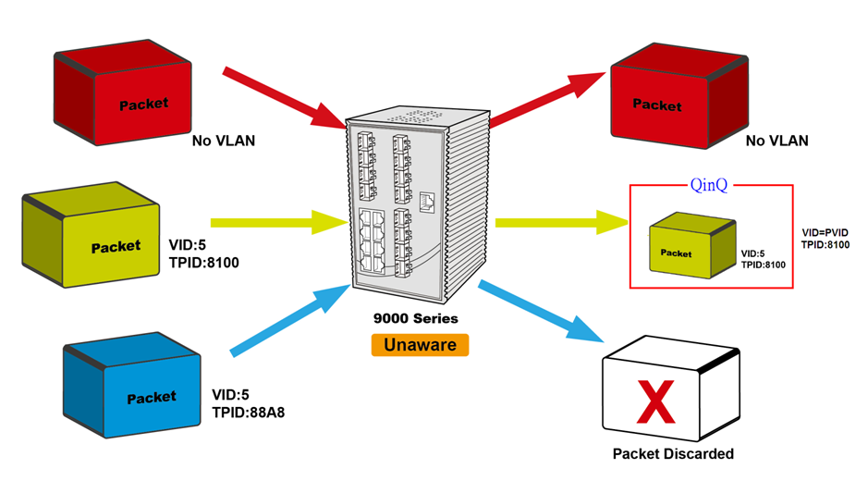
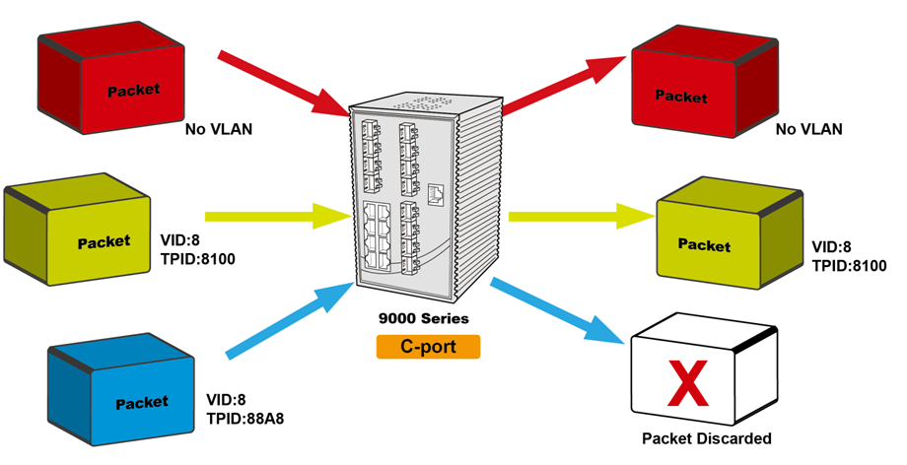

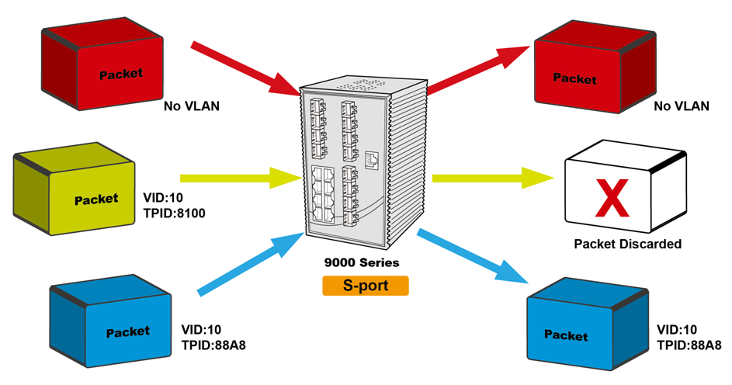
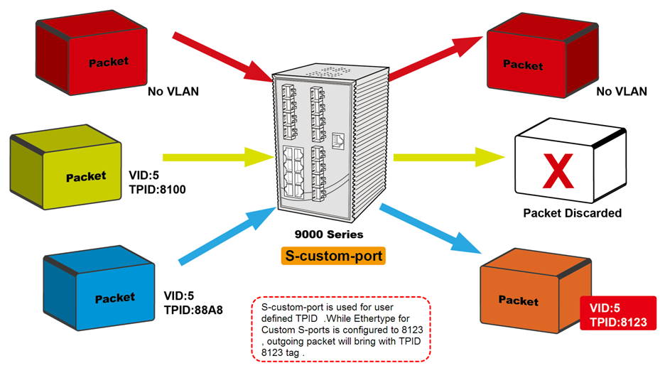

Examples of VLAN Settings
VLAN Access Mode:

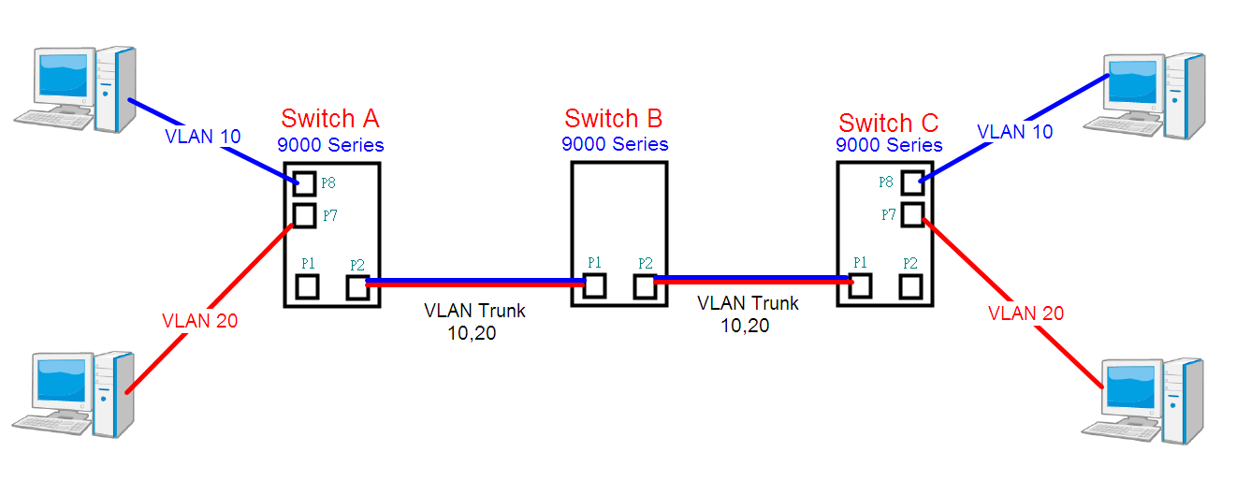

Switch A,
Port 7 is VLAN Access mode = Untagged 20
Port 8 is VLAN Access mode = Untagged 10

Below are the switch settings.
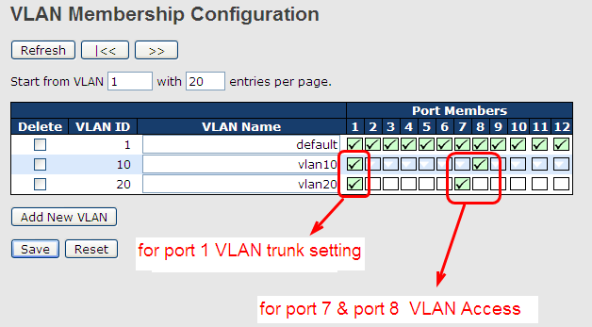
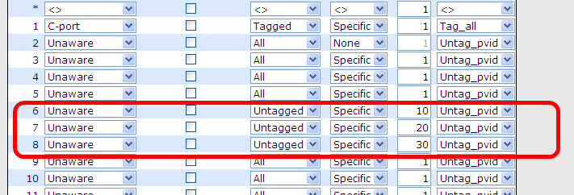

VLAN 1Q Trunk Mode:

Switch B,
Port 1 = VLAN 1Qtrunk mode = tagged 10, 20
Port 2 = VLAN 1Qtrunk mode = tagged 10, 20

Below are the switch settings.
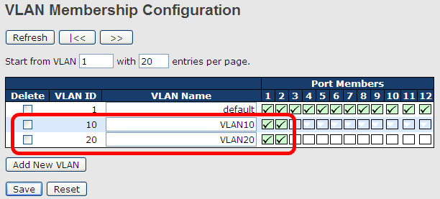
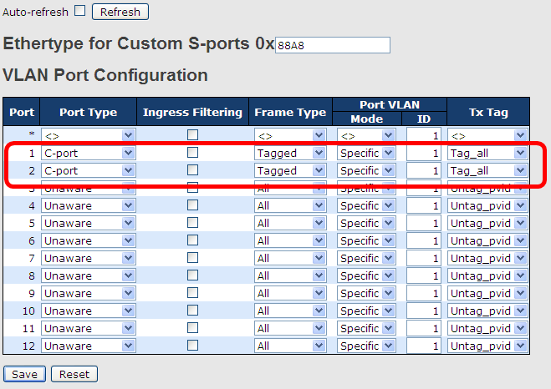

VLAN Hybrid Mode:
Port 1 VLAN Hybrid mode = untagged 10
Tagged 10, 20

Below are the switch settings. 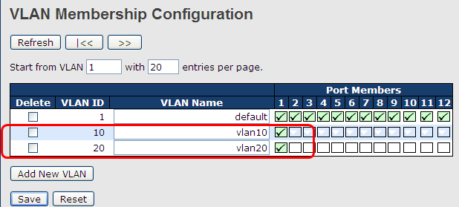
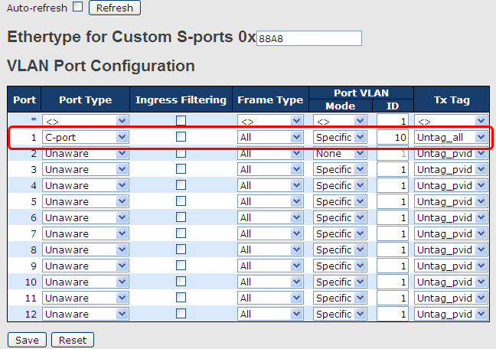

VLAN QinQ Mode:
VLAN QinQ mode is usually adopted when there are unknown VLANs, as shown in the figure below.

VLAN “X” = Unknown VLAN
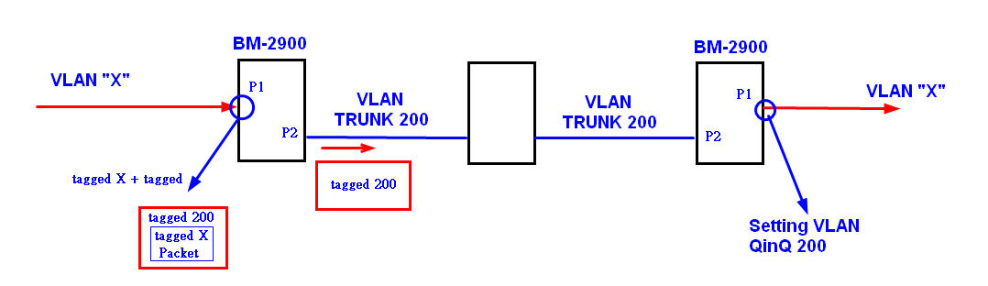

KY-2189RG Series Port 1 VLAN Settings:
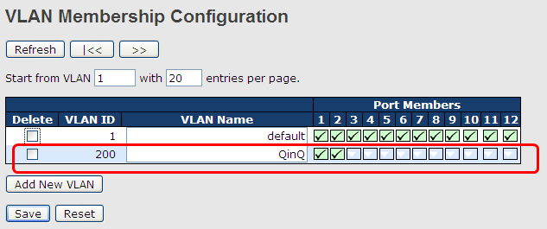
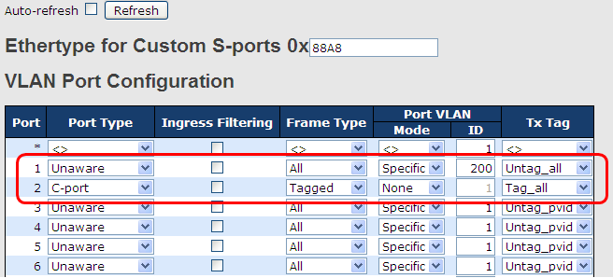

VLAN ID Settings
When setting the management VLAN, only the same VLAN ID port can be used to control the switch.

VLAN Settings:
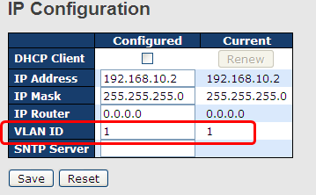

    - Private VLAN
A private VLAN contains switch ports that can only communicate with a given "uplink". The restricted ports are called private ports. Each private VLAN typically contains many private ports and a single uplink. The switch forwards all frames received on a private port out the uplink port, regardless of VLAN ID or destination MAC address. A port must be a member of both a VLAN and a private VLAN to be able to forward packets. This page allows you to configure private VLAN memberships for the switch. By default, all ports are VLAN unaware and members of VLAN 1 and private VLAN 1.

Membership Configuration
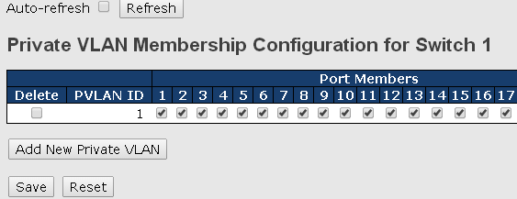

Label | Description
Delete | Check to delete the entry. It will be deleted during the next save.
PVLAN ID | Indicates the ID of this particular private VLAN.
Port Members | A row of check boxes for each port is displayed for each private VLAN ID. You can check the box to include a port in a private VLAN. To remove or exclude the port from the private VLAN, make sure the box is unchecked. By default, no ports are members, and all boxes are unchecked.

Port Isolation
A private VLAN is defined as a pairing of a primary VLAN with a secondary VLAN. A promiscuous port is a port that can communicate with all other private VLAN port types via the primary VLAN and any associated secondary VLANs, whereas isolated ports can communicate only with a promiscuous port.
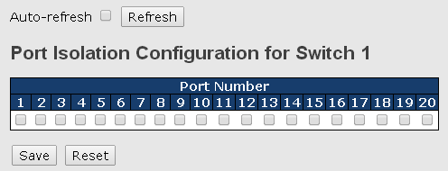

Label | Description
Port Members | A check box is provided for each port of a private VLAN.  When checked, port isolation is enabled for that port.  When unchecked, port isolation is disabled for that port.  By default, port isolation is disabled for all ports.

SNMP
SNMP (Simple Network Management Protocol) is a protocol for managing devices on IP networks. It is mainly used network management systems to monitor the operational status of networked devices. In an event-triggered situation, traps and notifications will be sent to administrators.

    - System
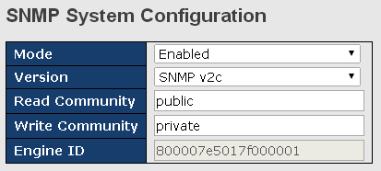

Label | Description
Mode | Indicates existing SNMP mode. Possible modes include:  Enabled: enable SNMP mode  Disabled: disable SNMP mode
Version | Indicates the supported SNMP version. Possible versions include:  SNMP v1: supports SNMP version 1.  SNMP v2c: supports SNMP version 2c.  SNMP v3: supports SNMP version 3.
Read Community | Indicates the read community string to permit access to SNMP agent. The allowed string length is 0 to 255, and only ASCII characters from 33 to 126 are allowed.  The field only suits to SNMPv1 and SNMPv2c. SNMPv3 uses USM for authentication and privacy and the community string will be associated with SNMPv3 community table.
Write Community | Indicates the write community string to permit access to SNMP agent. The allowed string length is 0 to 255, and only ASCII characters from 33 to 126 are allowed.  The field only suits to SNMPv1 and SNMPv2c. SNMPv3 uses USM for authentication and privacy and the community string will be associated with SNMPv3 community table.
Engine ID | Indicates the SNMPv3 engine ID. The string must contain an even number between 10 and 64 hexadecimal digits, but all-zeros and all-'F's are not allowed. Change of the Engine ID will clear all original local users.
    - Trap Configuration
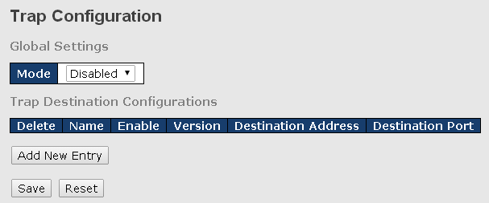
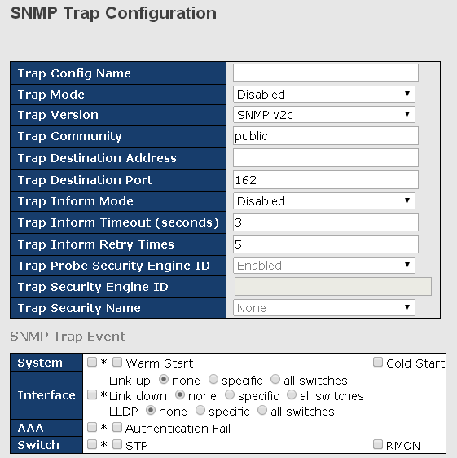

Label | Description
Trap Mode | Indicates existing SNMP trap mode. Possible modes include:  Enabled: enable SNMP trap mode  Disabled: disable SNMP trap mode
Trap Version | Indicates the supported SNMP trap version. Possible versions include:  SNMP v1: supports SNMP trap version 1  SNMP v2c: supports SNMP trap version 2c  SNMP v3: supports SNMP trap version 3
Trap Community | Indicates the community access string when sending SNMP trap packets. The allowed string length is 0 to 255, and only ASCII characters from 33 to 126 are allowed.
Trap Destination Address | Indicates the SNMP trap destination address
Trap Destination Port | This is the SNMP Trap destination port used by the SNMP Trap option for event notification. You can optionally change the IP port on which to send the SNMP trap, this must be the actual port on which the SNMP trap host listens. The typical, well-known port for SNMP traps is 162 (default).
Trap Inform Mode | Indicates the SNMP trap inform mode. Possible modes include:  Enabled: enable SNMP trap inform mode  Disabled: disable SNMP trap inform mode
Trap Inform Timeout(seconds) | Configures the SNMP trap inform timeout. The allowed range is 0 to 2147.
Trap Inform Retry Times | Configures the retry times for SNMP trap inform. The allowed range is 0 to 255.
Trap Probe Security Engine ID | Indicates the SNMP trap probe security engine ID mode of operation. Possible values  are:  Enabled: Enable SNMP trap probe security engine ID mode of operation.  Disabled: Disable SNMP trap probe security engine ID mode of operation.  When is enabled, the ID will be probed automatically. Otherwise, the ID specified in this field is used.
Trap Security Engine ID | Indicates the SNMP trap security engine ID. SNMPv3 sends traps and informs use USM for authentication and privacy. A unique engine ID for these traps and informs is needed. When "Trap Probe Security  Engine ID" is enabled, the ID will be probed automatically. Otherwise, the ID specified in this field is used. The string must contain an even number (in hexadecimal format) with number of digits between 10 and 64, but all-zeros and all-'F's are not allowed.
Trap Security Name | Indicates the SNMP trap security name. SNMPv3 traps and informs using USM for authentication and privacy. A unique security name is needed when traps and informs are enabled

    - SNMP Community Configurations
You can define access to the SNMP data on your devices by creating one or more SNMP communities. An SNMP community is the group that devices and management stations running SNMP belong to. It helps define where information is sent. A SNMP device or agent may belong to more than one SNMP community. It will not respond to requests from management stations that do not belong to one of its communities. This page allows you to configure SNMPv3 community table. The entry index key is Community.
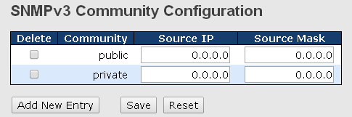

Label | Description
Delete | Check to delete the entry. It will be deleted during the next save.
Community | Indicates the community access string to permit access to SNMPv3 agent. The allowed string length is 1 to 32, and only ASCII characters from 33 to 126 are allowed.
Source IP | Indicates the SNMP source address
Source Mask | Indicates the SNMP source address mask

    - SNMP User Configurations
Each SNMP user has a specified username, a group to which the user belongs, authentication password, authentication protocol, privacy protocol, and privacy password. When you create a user, you must associate it with an SNMP group. The user then inherits the security model of the group. This page allows you to configure the SNMPv3 user table. The entry index keys are Engine ID and User Name.
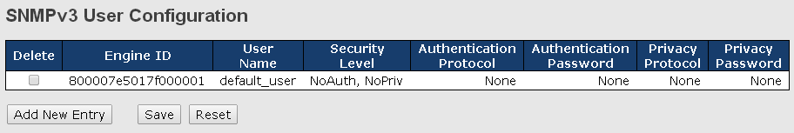

Label | Description
Delete | Check to delete the entry. It will be deleted during the next save.
Engine ID | An octet string identifying the engine ID that this entry should belong to. The string must contain an even number between 10 and 64 hexadecimal digits, but all-zeros and all-'F's are not allowed. The SNMPv3 architecture uses User-based Security Model (USM) for message security and View-based Access Control Model (VACM) for access control. For the USM entry, the usmUserEngineID and usmUserName are the entry keys. In a simple agent, usmUserEngineID is always that agent's own snmpEngineID value. The value can also take the value of the snmpEngineID of a remote SNMP engine with which this user can communicate. In other words, if user engine ID is the same as system engine ID, then it is local user; otherwise it's remote user.
User Name | A string identifying the user name that this entry should belong to. The allowed string length is 1 to 32, and only ASCII characters from 33 to 126 are allowed.
Security Level | Indicates the security model that this entry should belong to. Possible security models include:  NoAuth, NoPriv: no authentication and none privacy  Auth, NoPriv: Authentication and no privacy  Auth, Priv: Authentication and privacy  The value of security level cannot be modified if the entry already exists, which means the value must be set correctly at the time of entry creation.
Authentication Protocol | Indicates the authentication protocol that this entry should belong to. Possible authentication protocols include:  None: no authentication protocol  MD5: an optional flag to indicate that this user is using MD5 authentication protocol  SHA: an optional flag to indicate that this user is using SHA authentication protocol  The value of security level cannot be modified if the entry already exists, which means the value must be set correctly at the time of entry creation.
Authentication Password | A string identifying the authentication pass phrase. For MD5 authentication protocol, the allowed string length is 8 to 32. For SHA authentication protocol, the allowed string length is 8 to 40. Only ASCII characters from 33 to 126 are allowed.
Privacy Protocol | Indicates the privacy protocol that this entry should belong to. Possible privacy protocols include:  None: no privacy protocol  DES: an optional flag to indicate that this user is using DES authentication protocol
Privacy Password | A string identifying the privacy pass phrase. The allowed string length is 8 to 32, and only ASCII characters from 33 to 126 are allowed.

    - SNMP Group Configurations
An SNMP group is an access control policy for you to add users. Each SNMP group is configured with a security model, and is associated with an SNMP view. A user within an SNMP group should match the security model of the SNMP group. These parameters specify what type of authentication and privacy a user within an SNMP group uses. Each SNMP group name and security model pair must be unique. This page allows you to configure the SNMPv3 group table. The entry index keys are Security Model and Security Name.
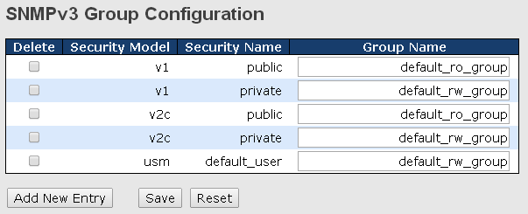

Label | Description
Delete | Check to delete the entry. It will be deleted during the next save.
Security Model | Indicates the security model that this entry should belong to. Possible security models included:  v1: Reserved for SNMPv1.  v2c: Reserved for SNMPv2c.  usm: User-based Security Model (USM).
Security Name | A string identifying the security name that this entry should belong to. The allowed string length is 1 to 32, and only ASCII characters from 33 to 126 are allowed.
Group Name | A string identifying the group name that this entry should belong to. The allowed string length is 1 to 32, and only ASCII characters from 33 to 126 are allowed.

    - SNMP View Configurations
The SNMP v3 View table specifies the MIB object access requirements for each View Name. You can specify specific areas of the MIB that can be accessed or denied based on the entries or create and delete entries in the View table in this page. The entry index keys are View Name and OID Subtree.
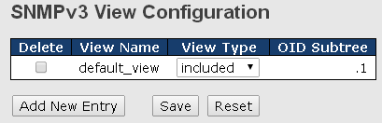

Label | Description
Delete | Check to delete the entry. It will be deleted during the next save.
View Name | A string identifying the view name that this entry should belong to. The allowed string length is 1 to 32, and only ASCII characters from 33 to 126 are allowed.
View Type | Indicates the view type that this entry should belong to. Possible view types include:  Included: an optional flag to indicate that this view subtree should be included.  Excluded: An optional flag to indicate that this view subtree should be excluded.  Generally, if an entry's view type is Excluded, it should exist another entry whose view type is Included, and its OID subtree oversteps the Excluded entry.
OID Subtree | The OID defining the root of the subtree to add to the named view. The allowed OID length is 1 to 128. The allowed string content is digital number or asterisk (*).

    - SNMP Access Configurations
This page allows you to configure SNMPv3 access table. The entry index keys are Group Name, Security Model, and Security Level.
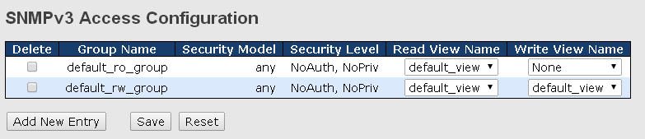

Label | Description
Delete | Check to delete the entry. It will be deleted during the next save.
Group Name | A string identifying the group name that this entry should belong to. The allowed string length is 1 to 32, and only ASCII characters from 33 to 126 are allowed.
Security Model | Indicates the security model that this entry should belong to. Possible security models include:  any: Accepted any security model (v1|v2c|usm).  v1: Reserved for SNMPv1.  v2c: Reserved for SNMPv2c.  usm: User-based Security Model (USM).
Security Level | Indicates the security model that this entry should belong to. Possible security models include:  NoAuth, NoPriv: no authentication and no privacy  Auth, NoPriv: Authentication and no privacy  Auth, Priv: Authentication and privacy
Read View Name | The name of the MIB views defining the MIB objects for which this request may request the current values. The allowed string length is 1 to 32, and only ASCII characters from 33 to 126 are allowed.
Write View Name | The name of the MIB views defining the MIB objects for which this request may potentially SET new values. The allowed string length is 1 to 32, and only ASCII characters from 33 to 126 are allowed.

Traffic Prioritization
    - Storm Control
A LAN storm occurs when packets flood the LAN, creating excessive traffic and degrading network performance. Errors in the protocol-stack implementation, mistakes in network configuration, or users issuing a denial-of-service attack can cause a storm. Storm control prevents traffic on a LAN from being disrupted by a broadcast, multicast, or unicast storm on a port. In this page, you can specify the rate at which packets are received for unicast, multicast, and broadcast traffic. The unit of the rate can be either pps (packets per second) or kpps (kilo packets per second).
Note: frames sent to the CPU of the switch are always limited to approximately 4 kpps. For example, broadcasts in the management VLAN are limited to this rate. The management VLAN is configured on the IP setup page.
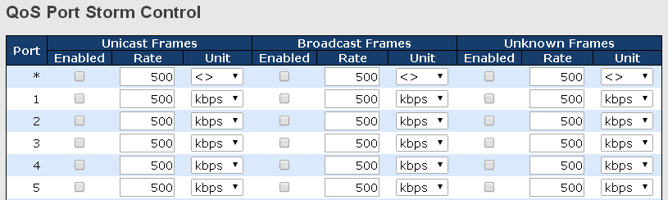

Label | Description
Frame Type | Frame types supported by the Storm Control function, including Unicast, Multicast, and Broadcast.
Enabled | Enables or disables the given frame type
Rate | The rate is packet per second (pps), configure the rate as 1K, 2K, 4K, 8K, 16K, 32K, 64K, 128K, 256K, 512K, or 1024K.  The 1 kpps is actually 1002.1 pps.

    - Port Classification
QoS (Quality of Service) is a method to achieve efficient bandwidth utilization between devices by prioritizing frames according to individual requirements and transmit the frames based on their importance. Frames in higher priority queues receive a bigger slice of bandwidth than those in a lower priority queue.
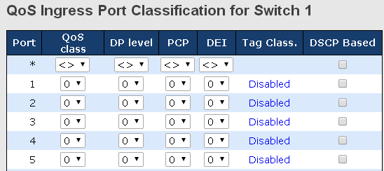

Label | Description
Port | The port number for which the configuration below applies
QoS Class | Controls the default QoS class  All frames are classified to a QoS class. There is a one to one mapping between QoS class, queue, and priority. A QoS class of 0 (zero) has the lowest priority.  If the port is VLAN aware and the frame is tagged, then the frame is classified to a QoS class that is based on the PCP value in the tag as shown below. Otherwise the frame is classified to the default QoS class.  PCP value: 0 1 2 3 4 5 6 7  QoS class: 1 0 2 3 4 5 6 7  If the port is VLAN aware, the frame is tagged, and Tag Class is enabled, then the frame is classified to a QoS class that is mapped from the PCP and DEI value in the tag. Otherwise the frame is classified to the default QoS class.  The classified QoS class can be overruled by a QCL entry.  Note: if the default QoS class has been dynamically changed, then the actual default QoS class is shown in parentheses after the configured default QoS class.
DP level | Controls the default Drop Precedence Level  All frames are classified to a DP level.  If the port is VLAN aware and the frame is tagged, then the frame is classified to a DP level that is equal to the DEI value in the tag. Otherwise the frame is classified to the default DP level.  If the port is VLAN aware, the frame is tagged, and Tag Class is enabled, then the frame is classified to a DP level that is mapped from the PCP and DEI value in the tag. Otherwise the frame is classified to the default DP level.  The classified DP level can be overruled by a QCL entry.
PCP | Controls the default PCP value  All frames are classified to a PCP value.  If the port is VLAN aware and the frame is tagged, then the frame is classified to the PCP value in the tag. Otherwise the frame is classified to the default PCP value.
DEI | Controls the default DEI value  All frames are classified to a DEI value.  If the port is VLAN aware and the frame is tagged, then the frame is classified to the DEI value in the tag. Otherwise the frame is classified to the default DEI value.
Tag Class | Shows the classification mode for tagged frames on this port  Disabled: Use default QoS class and DP level for tagged frames  Enabled: Use mapped versions of PCP and DEI for tagged frames  Click on the mode to configure the mode and/or mapping  Note: this setting has no effect if the port is VLAN unaware. Tagged frames received on VLAN-unaware ports are always classified to the default QoS class and DP level.
DSCP Based | Click to enable DSCP-based QoS Ingress Port Classification

    - Port Tag Remaking
You can set QoS egress queues on a port such as classifying data and marking it according to its priority and the policies. Packets will then travel across the switch’s internal paths carrying their assigned QoS tag markers. At the egress port, these markers are read and used to determine which queue each data packet is forwarded to. When the traffic does not conform to the conditions set in a policer command, you can remark the traffic.
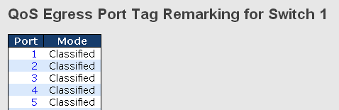

Label | Description
Port | The switch port number to which the following settings will be applied. Click on the port number to configure tag remarking
Mode | Shows the tag remarking mode for this port  Classified: use classified PCP/DEI values  Default: use default PCP/DEI values  Mapped: use mapped versions of QoS class and DP level

    - Port DSCP
DSCP (Differentiated Services Code Point) is a measure of QoS. It can classify data packets by using the 6-bit DS field in the IP header so you can manage each traffic class differently and efficiently, thereby achieving optimized use of network bandwidth. DSCP-enabled routers on the network will read the DSCP value of the data packet and put the packet into different queues before transmission, such as high priority and most efficient transmission. With such QoS functions, you can ensure low-latency for critical traffic. This page allows you to configure DSCP settings for each port.
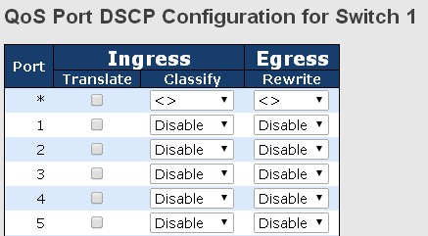

Label | Description
Port | Shows the list of ports for which you can configure DSCP Ingress and Egress settings.
Ingress | In Ingress settings you can change ingress translation and classification settings for individual ports.  There are two configuration parameters available in Ingress:  Translate: check to enable the function  Classify: includes four values  Disable: no Ingress DSCP classification  DSCP=0: classify if incoming (or translated if enabled) DSCP is 0.  Selected: classify only selected DSCP whose classification is enabled as specified in DSCP Translation window for the specific DSCP.  All: classify all DSCP
Egress | Port egress rewriting can be one of the following options:  Disable: no Egress rewrite  Enable: rewrite enabled without remapping  Remap DP Unaware: DSCP from the analyzer is remapped and the frame is remarked with a remapped DSCP value. The remapped DSCP value is always taken from the 'DSCP Translation->Egress Remap DP0' table.  Remap DP Aware: DSCP from the analyzer is remapped and the frame is remarked with a remapped DSCP value. Depending on the DP level of the frame, the remapped DSCP value is either taken from the 'DSCP Translation->Egress Remap DP0' table or from the 'DSCP Translation->Egress Remap DP1' table.

    - Port Policing
Policing is a traffic regulation mechanism for limiting the rate of traffic streams, thereby controlling the maximum rate of traffic sent or received on an interface. When the traffic rate exceeds the configured maximum rate, policing drops or remarks the excess traffic. This page allows you to configure Policer for all switch ports.

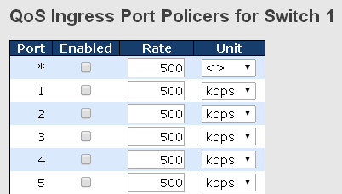

Label | Description
Port | The port number for which the configuration below applies
Enabled | Check to enable the policer for individual switch ports
Rate | Configures the rate of each policer. The default value is 500. This value is restricted to 100 to 1000000 when the Unit is kbps or fps, and is restricted to 1 to 3300 when the Unit is Mbps or kfps.
Unit | Configures the unit of measurement for each policer rate as kbps, Mbps, fps, or kfps. The default value is kbps.

    - Queue Policing
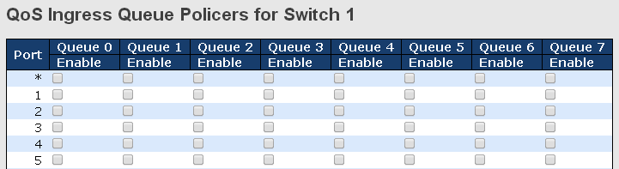

Label | Description
Port | The port number for which the configuration below applies.
Enable(E) | Check to enable queue policer for individual switch ports
Rate | Configures the rate of each queue policer. The default value is 500. This value is restricted to 100 to 1000000 when the Unit is kbps, and is restricted to 1 to 3300 when the Unit is Mbps.  This field is only shown if at least one of the queue policers is enabled.
Unit | Configures the unit of measurement for each queue policer rate as kbps or Mbps. The default value is kbps.  This field is only shown if at least one of the queue policers is enabled.

    - Port Scheduler
Port scheduling can solve performance degradation during network congestions. The schedulers allow switches to maintain separate queues for packets from each source and prevent specific traffic to use up all bandwidth. This page allows you to configure Scheduler and Shapers for individual ports.

This page provides an overview of QoS Egress Port Schedulers for all switch ports.
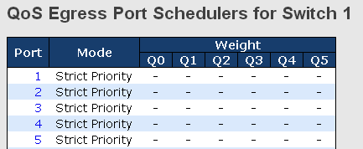

QoS Egress Port Scheduler and Shaper
Strict Priority
Strict Priority uses queues based only priority. When traffic arrives at the device, traffic on the highest priority queue will be transmitted first, followed by traffic on lower priorities. If there is always some content in the highest priority queue, then the other packets in the rest of queues will not be sent until the highest priority queue is empty. The SP algorithm is preferred when the received packets contain high priority data, such as voice and video.
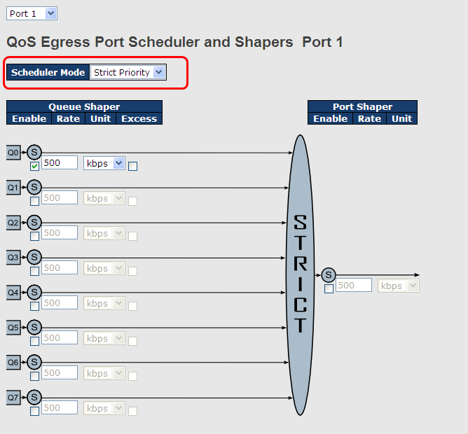

Label | Description
Scheduler Mode | Two scheduling modes are available: Strict Priority or Weighted
Queue Shaper Enable | Check to enable queue shaper for individual switch ports
Queue Shaper Rate | Configures the rate of each queue shaper. The default value is 500. This value is restricted to 100 to 1000000 when the Unit is kbps", and it is restricted to 1 to 3300 when the Unit is Mbps.
Queues Shaper Unit | Configures the rate for each queue shaper. The default value is 500. This value is restricted to 100 to 1000000 when the Unit is kbps, and it is restricted to 1 to 3300 when the Unit is Mbps.
Queue Shaper Excess | Allows the queue to use excess bandwidth
Port Shaper Enable | Check to enable port shaper for individual switch ports
Port Shaper Rate | Configures the rate of each port shaper. The default value is 500 This value is restricted to 100 to 1000000 when the Unit is kbps, and it is restricted to 1 to 3300 when the Unit is Mbps.
Port Shaper Unit | Configures the unit of measurement for each port shaper rate as kbps or Mbps. The default value is kbps.

Weighted
Weighted scheduling will deliver traffic on a rotating basis. It can guarantee each queue’s minimum bandwidth based on their bandwidth weight when there is traffic congestion. Only when a port has more traffic than it can handle will this mode be activated. A queue is given an amount of bandwidth regardless of the incoming traffic on that port. Queue with larger weights will have more guaranteed bandwidth than others with smaller weights.
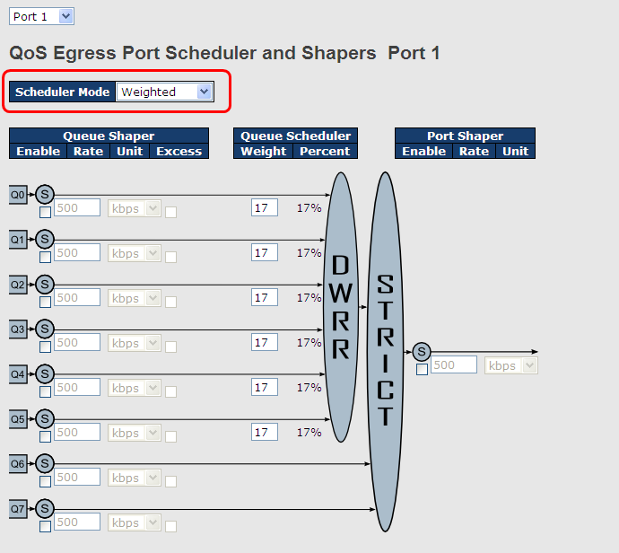

Label | Description
Scheduler Mode | Two scheduling modes are available: Strict Priority or Weighted
Queue Shaper Enable | Check to enable queue shaper for individual switch ports
Queue Shaper Rate | Configures the rate of each queue shaper. The default value is 500. This value is restricted to 100 to 1000000 when the Unit is kbps, and it is restricted to 1 to 3300 when the Unit is Mbps.
Queues Shaper Unit | Configures the rate of each queue shaper. The default value is 500. This value is restricted to 100 to 1000000 when the Unit" is kbps, and it is restricted to 1 to 3300 when the Unit is Mbps.
Queue Shaper Excess | Allows the queue to use excess bandwidth
Queue Scheduler Weight | Configures the weight of each queue. The default value is 17. This value is restricted to 1 to 100. This parameter is only shown if Scheduler Mode is set to Weighted.
Queue Scheduler Percent | Shows the weight of the queue in percentage. This parameter is only shown if Scheduler Mode is set to Weighted.
Port Shaper Enable | Check to enable port shaper for individual switch ports
Port Shaper Rate | Configures the rate of each port shaper. The default value is 500. This value is restricted to 100 to 1000000 when the Unit is kbps, and it is restricted to 1 to 3300 when the Unit is Mbps.
Port Shaper Unit | Configures the unit of measurement for each port shaper rate as kbps or Mbps. The default value is kbps.

    - Port Shaping
Port shaping enables you to limit traffic on a port, thereby controlling the amount of traffic passing through the port. With port shaping, you can shape the aggregate traffic through an interface to a rate that is less than the line rate for that interface. When configuring port shaping on an interface, you specify a value indicating the maximum amount of traffic allowable for the interface. This value must be less than the maximum bandwidth for that interface.
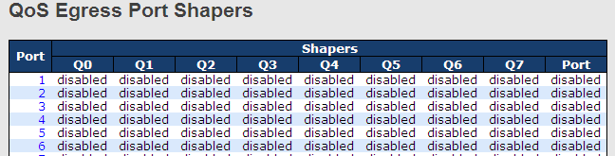

Label | Description
Port | The switch port number to which the following settings will be applied. Click on the port number to configure the shapers
Mode | Shows disabled or actual queue shaper rate - e.g. "800 Mbps"
Q0~Q7 | Shows disabled or actual port shaper rate - e.g. "800 Mbps"

    - DSCP-based QoS
This page allows you to configure DSCP-based QoS Ingress Classification settings for all ports.
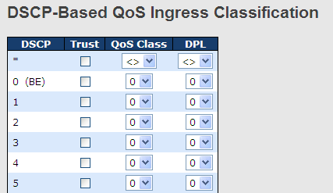

Label | Description
DSCP | Maximum number of supported DSCP values is 64
Trust | Check to trust a specific DSCP value. Only frames with trusted DSCP values are mapped to a specific QoS class and drop precedence level. Frames with untrusted DSCP values are treated as a non-IP frame.
QoS Class | QoS class value can be any number from 0-7.
DPL | Drop Precedence Level (0-1)

    - DSCP Translation
This page allows you to configure basic QoS DSCP translation settings for all switches. DSCP translation can apply to Ingress or Egress.
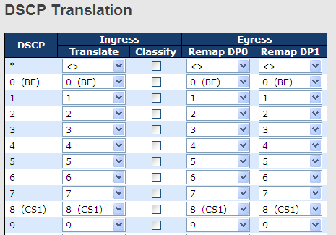

Label | Description
DSCP | Maximum number of supported DSCP values is 64 and valid DSCP value ranges from 0 to 63.
Ingress | Ingress DSCP can be first translated to new DSCP before using the DSCP for QoS class and DPL map.  There are two configuration parameters for DSCP Translation -  1. Translate: Enables ingress translation of DSCP values based on the specified classification method. DSCP can be translated to any of (0-63) DSCP values.  2. Classify: Enable Classification at ingress side as defined in the QoS Port DSCP Configuration table.
Egress | Configurable engress parameters include;  Remap DP0: Re-maps DP0 field to selected DSCP value. DP0  indicates a drop precedence with a low priority. You can select the DSCP value from a selected menu to which you want to remap. DSCP value ranges from 0 to 63.  Remap DP1: Re-maps DP1 field to selected DSCP value. DP1 indicates a drop precedence with a high priority. You can select the DSCP value from a selected menu to which you want to remap. DSCP value ranges from 0 to 63.

    - DSCP Classification
This page allows you to configure the mapping of QoS class and Drop Precedence Level to DSCP value.
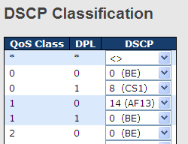

Label | Description
QoS Class | Actual QoS class
DPL | Actual Drop Precedence Level
DSCP | Select the classified DSCP value (0-63)

    - QoS Control List
This page shows all the QCE (Quality Control Entries) for a given QCL. You can edit or add new QoS control entries in this page. A QCE consists of several parameters. These parameters vary with the frame type you select.
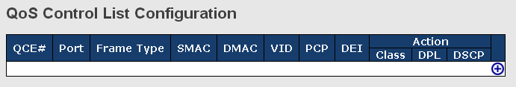
Click on the “+” at the right hand side of the table will bring up a another page with detailed configurations (as shown below).
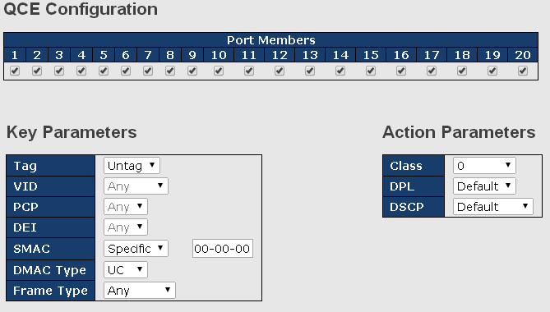

Label | Description
Port Members | Check to include the port in the QCL entry. By default, all ports are included.
Key Parameters | Key configurations include:  Tag: value of tag, can be Any, Untag or Tag.  VID: valid value of VLAN ID from 1 to 4095  Any: can be a specific value or a range of VIDs.  PCP: Priority Code Point, can be specific numbers (0, 1, 2, 3, 4, 5, 6, 7), a range (0-1, 2-3, 4-5, 6-7, 0-3, 4-7) or Any  DEI: Drop Eligible Indicator, can be any of values between 0 and 1 or Any  SMAC: Source MAC Address, can be 24 MS bits (OUI) or Any  DMAC Type: Destination MAC type, can be unicast (UC), multicast (MC), broadcast (BC) or Any  Frame Type can be the following values: Any, Ethernet, LLC, SNAP, IPv4, and IPv6  Note: all frame types are explained below.
Any | Allow all types of frames
Ethernet | Valid Ethernet values can range from 0x600 to 0xFFFF or Any' but excluding 0x800(IPv4) and 0x86DD(IPv6). The default value is Any.
LLC | SSAP Address: valid SSAP (Source Service Access Point) values can range from 0x00 to 0xFF or Any. The default value is Any.  DSAP Address: valid DSAP (Destination Service Access Point) values can range from 0x00 to 0xFF or Any. The default value is Any.  Control Valid Control: valid values can range from 0x00 to 0xFF or Any. The default value is Any.
SNAP | PID: valid PID (Ethernet type) values can range from 0x00 to 0xFFFF or Any. The default value is Any.
IPv4 | Protocol: (0-255, TCP or UDP) or any  Source IP: specific Source IP address in value/mask format or any. IP and mask are in the format of x.y.z.w where x, y, z, and w are decimal numbers between 0 and 255. When the mask is converted to a 32-bit binary string and read from left to right, all bits following the first zero must also be zero.  DSCP (Differentiated Code Point): can be a specific value, a range, or Any. DSCP values are in the range 0-63 including BE, CS1-CS7, EF or AF11-AF43.  IP Fragment: Ipv4 frame fragmented options include 'yes', 'no', and 'any'.  Sport Source TCP/UDP Port: (0-65535) or Any, specific value or port range applicable for IP protocol UDP/TCP  D port Destination TCP/UDP Port: (0-65535) or Any, specific value or port range applicable for IP protocol UDP/TCP
IPv6 | Protocol: (0-255, TCP or UDP) or Any  Source IP: (a.b.c.d) or Any, 32 LS bits  DSCP (Differentiated Code Point): can be a specific value, a range, or Any. DSCP values are in the range 0-63 including BE, CS1-CS7, EF or AF11-AF43.  Sport Source TCP/UDP port: (0-65535) or Any, specific value or port range applicable for IP protocol UDP/TCP  D port Destination TCP/UDP port: (0-65535) or Any, specific value or port range applicable for IP protocol UDP/TCP
Action Parameters | Class QoS class: (0-7) or Default  Valid Drop Precedence Level value can be (0-1) or Default.  Valid DSCP value can be (0-63, BE, CS1-CS7, EF or AF11-AF43) or Default.  Default means that the default classified value is not modified by this QCE.

    - QoS Counters
This page shows information on the number of packets sent and received at each queue.
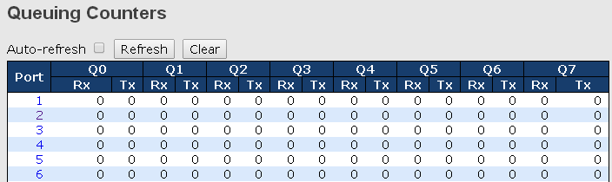

Label | Description
Port | The switch port number to which the following settings will be applied.
Q1-Q7 | There are 8 QoS queues per port. Q0 is the lowest priority
Rx / Tx | The number of received and transmitted packets per queue

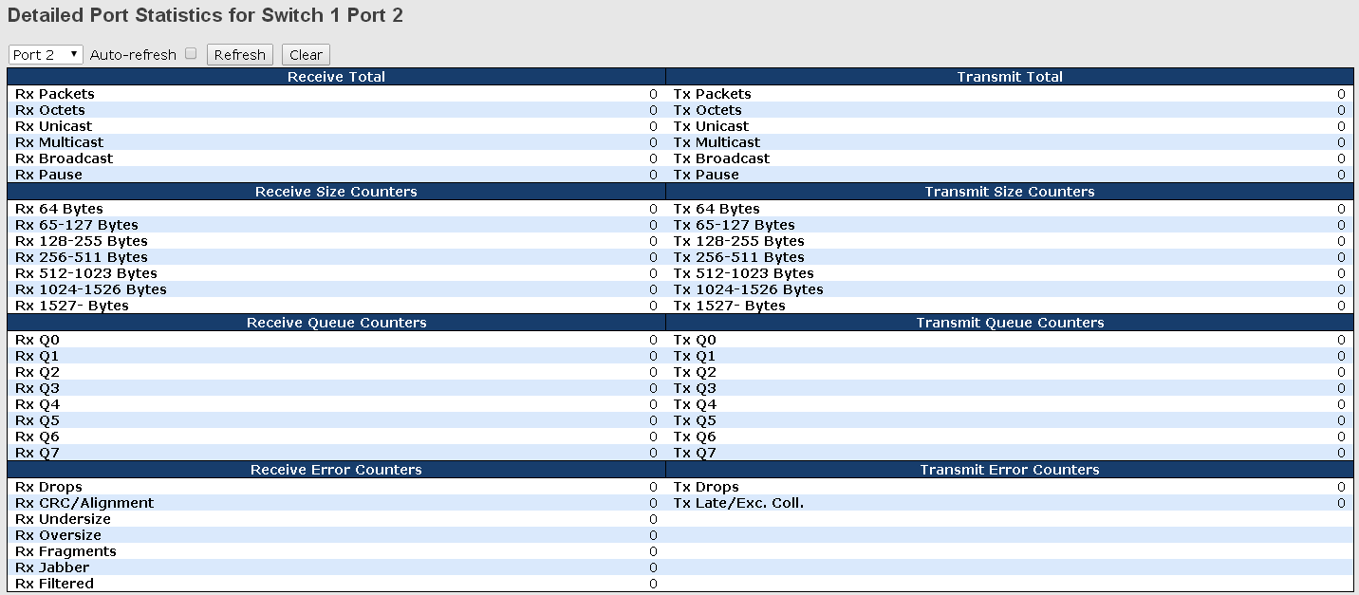

    - QCL Status
This page shows the QCL status by different QCL users. Each row describes the QCE that is defined. A conflict will occur if a specific QCE is not applied to the hardware due to hardware limitations. The maximum number of QCEs is 256 on each switch.
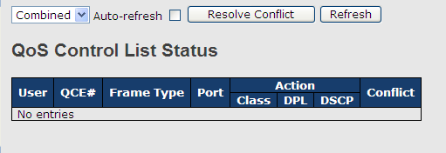

Label | Description
User | Indicates the QCL user
QCE# | Indicates the index of QCE
Frame Type | Indicates the type of frame to look for incoming frames. Possible frame types are:  Any: the QCE will match all frame type.  Ethernet: Only Ethernet frames (with Ether Type 0x600-0xFFFF) are allowed.  LLC: Only (LLC) frames are allowed.  SNAP: Only (SNAP) frames are allowed.  IPv4: the QCE will match only IPV4 frames.  IPv6: the QCE will match only IPV6 frames.
Port | Indicates the list of ports configured with the QCE.
Action | Indicates the classification action taken on ingress frame if parameters configured are matched with the frame's content.  There are three action fields: Class, DPL, and DSCP.  Class: Classified QoS; if a frame matches the QCE, it will be put in the queue.  DPL: Drop Precedence Level; if a frame matches the QCE, then DP level will set to a value displayed under DPL column.  DSCP: if a frame matches the QCE, then DSCP will be classified with the value displayed under DSCP column.
Conflict | Displays the conflict status of QCL entries. As hardware resources are shared by multiple applications, resources required to add a QCE may not be available. In that case, it shows conflict status as Yes, otherwise it is always No. Please note that conflict can be resolved by releasing the hardware resources required to add the QCL entry by pressing Resolve Conflict button.

Multicast
    - IGMP Snooping
Basic Configuration
IGMP (Internet Group Management Protocol) snooping monitors the IGMP traffic between hosts and multicast routers. The switch uses what IGMP snooping learns to forward multicast traffic only to interfaces that are connected to interested receivers. This conserves bandwidth by allowing the switch to send multicast traffic to only those interfaces that are connected to hosts that want to receive the traffic, instead of flooding the traffic to all interfaces in the VLAN. This page allows you to set up IGMP snooping configurations.
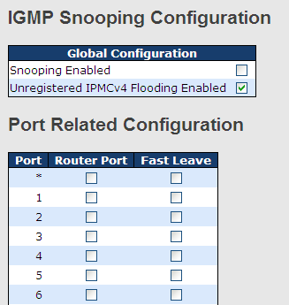

Label | Description
Snooping Enabled | Check to enable global IGMP snooping
Unregistered IPMCv4Flooding enabled | Check to enable unregistered IPMC traffic flooding
Router Port | Specifies which ports act as router ports. A router port is a port on the Ethernet switch that leads towards the Layer 3 multicast device or IGMP querier.  If an aggregation member port is selected as a router port, the whole aggregation will act as a router port.
Fast Leave | Check to enable fast leave on the port
VLAN Configurations
If a VLAN is not IGMP snooping-enabled, it floods multicast data and control packets to the entire VLAN in hardware. When snooping is enabled, IGMP packets are trapped to the CPU. Data packets are mirrored to the CPU in addition to being VLAN flooded. The CPU then installs hardware resources, so that subsequent data packets can be switched to desired ports in hardware without going to the CPU.
Each page shows up to 99 entries from the VLAN table, depending on the value in the Entries Per Page field. By default, the page will show the first 20 entries from the beginning of the VLAN table. The first displayed will be the one with the lowest VLAN ID found in the VLAN Table.
The VLAN field allows the user to select the starting point in the VLAN Table. Clicking Refresh will update the displayed table starting from that or the next closest VLAN Table match.
The >> button will use the last entry of the currently displayed entry as a basis for the next lookup. When the end is reached, the text No more entries is shown in the displayed table. Use the |<< button to start over.
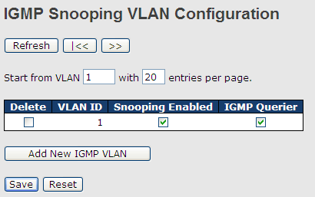

Label | Description
Delete | Check to delete the entry. The designated entry will be deleted during the next save.
VLAN ID | The VLAN ID of the entry
IGMP Snooping Enable | Check to enable IGMP snooping for individual VLAN. Up to 32 VLANs can be selected.
IGMP Querier | Check to enable the IGMP Querier in the VLAN

Status
This page provides IGMP snooping status.
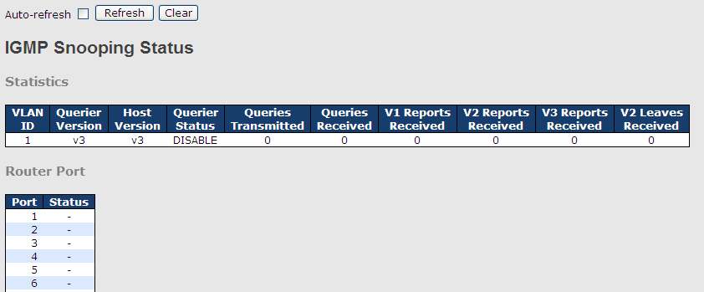

Label | Description
VLAN ID | The VLAN ID of the entry
Querier Version | Active Querier version
Host Version | Active Host version
Querier Status | Shows the Querier status as ACTIVE or IDLE
Querier Receive | The number of transmitted Querier
V1 Reports Receive | The number of received V1 reports
V2 Reports Receive | The number of received V2 reports
V3 Reports Receive | The number of received V3 reports
V2 Leave Receive | The number of received V2 leave packets
Refresh | Click to refresh the page immediately
Clear | Clear all statistics counters
Auto-refresh | Check to enable an automatic refresh of the page at regular intervals
Port | Switch port number
Status | Indicates whether a specific port is a router port or not

Groups Information of IGMP Snooping
Information about entries in the IGMP Group Table is shown in this page. The IGMP Group Table is sorted first by VLAN ID, and then by group.
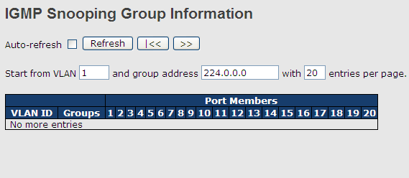

Label | Description
VLAN ID | The VLAN ID of the group
Groups | The group address of the group displayed
Port Members | Ports under this group

Security
    - Remote Control Security
Remote Control Security allows you to limit remote access to the management interface. When enabled, requests of the client which is not in the allowed list will be rejected.
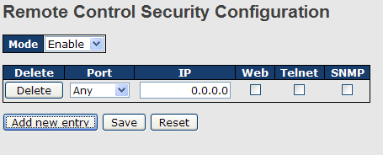

Label | Description
Port | Port number of the remote client
IP Address | IP address of the remote client. 0.0.0.0 means “any IP”.
Web | Check to enable management via a Web interface
Telnet | Check to enable management via a Telnet interface
SNMP | Check to enable management via a SNMP interface
Delete | Check to delete entries
    - Device Binding
Device binding is DYMEC’s proprietary technology which binds the IP/MAC address of a device with a specified Ethernet port. If the IP/MAC address of the device connected to the Ethernet port does not conform to the binding requirements, the device will be locked for security concerns. Device binding also provides security functions via alive checking, streaming check, and DoS/DDoS prevention.

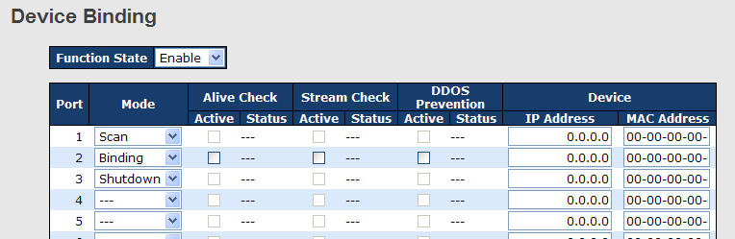

Label | Description
Mode | Indicates the device binding operation for each port. Possible modes are:  ---: disable  Scan: scans IP/MAC automatically, but no binding function  Binding: enables binding. Under this mode, any IP/MAC that does not match the entry will not be allowed to access the network.  Shutdown: shuts down the port (No Link)
Alive Check Active | Check to enable alive check. When enabled, switch will ping the device continually.
Alive Check Status | Indicates alive check status. Possible statuses are:  ---: disable  Got Reply: receive ping reply from device, meaning the device is still alive  Lost Reply: not receiving ping reply from device, meaning the device might have been dead.
Stream Check Active | Check to enable stream check. When enabled, the switch will detect the stream change (getting low) from the device.
Stream Check Status | Indicates stream check status. Possible statuses are:  ---: disable  Normal: the stream is normal.  Low: the stream is getting low.
DDoS Prevention Acton | Check to enable DDOS prevention. When enabled, the switch will monitor the device against DDOS attacks.
DDoS Prevention Status | Indicates DDOS prevention status. Possible statuses are:  ---: disable  Analyzing: analyzes packet throughput for initialization  Running: analysis completes and ready for next move  Attacked: DDOS attacks occur
Device IP Address | Specifies IP address of the device
Device MAC Address | Specifies MAC address of the device

Advanced Configurations

Alias IP Address
This page provides alias IP address configuration. Some devices might have more than one IP addresses. You could specify other IP addresses here.
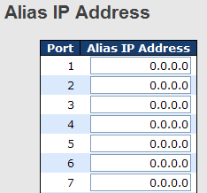

Label | Description
Alias IP Address | Specifies alias IP address. Keep 0.0.0.0 if the device does not have an alias IP address.

Keep-Alive Check
Keep-Alive Checking monitors the real-time status of the device connected to the port. Keep-Alive-checking packets will be sent to the device to probe if the device is running. If the switch receives no response from the device, actions will be taken according to your configurations.
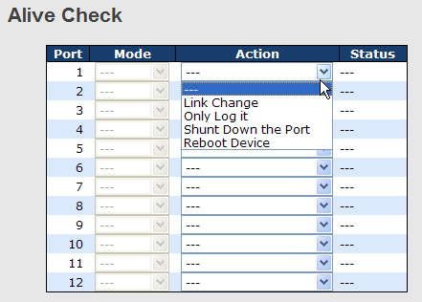

Label | Description
Link Change | Disables or enables the port
Only log it | Simply sends logs to the log server
Shunt Down the Port | Disables the port
Reboot Device | Disables or enables PoE power

DDoS Prevention
The switch can monitor ingress packets, and perform actions when DDOS attack occurred on this port. When network traffic from a specific device increases significantly in a short period of time, the switch will lock the IP address of that device to protect the network from attacks. You can configure DDoS prevention on this page to achieve maximum protection.
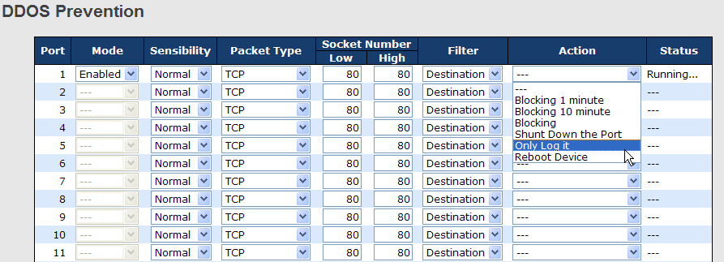

Label | Description
Mode | Enables or disables DDOS prevention of the port
Sensibility | Indicates the level of DDOS detection. Possible levels are:  Low: low sensibility  Normal: normal sensibility  Medium: medium sensibility  High: high sensibility
Packet Type | Indicates the types of DDoS attack packets to be monitored. Possible types are:  RX Total: all ingress packets  RX Unicast: unicast ingress packets  RX Multicast: multicast ingress packets  RX Broadcast: broadcast ingress packets  TCP: TCP ingress packets  UDP: UDP ingress packets
Socket Number | If packet type is UDP (or TCP), please specify the socket number here. The socket number can be a range, from low to high. If the socket number is only one, please fill the same number in the low and high fields.
Filter | If packet type is UDP (or TCP), please choose the socket direction (Destination/Source).
Action | Indicates the action to take when DDOS attacks occur. Possible actions are:  ---: no action  Blocking 1 minute: blocks the forwarding for 1 minute and log the event  Blocking 10 minute: blocks the forwarding for 10 minutes and log the event  Blocking: blocks and logs the event  Shunt Down the Port: shuts down the port (No Link) and logs the event  Only Log it: simply logs the event  Reboot Device: if PoE is supported, the device can be rebooted. The event will be logged.
Status | Indicates the DDOS prevention status. Possible statuses are:  ---: disables DDOS prevention  Analyzing: analyzes packet throughput for initialization  Running: analysis completes and ready for next move  Attacked: DDOS attacks occur

Device Description
This page allows you to configure device description settings.
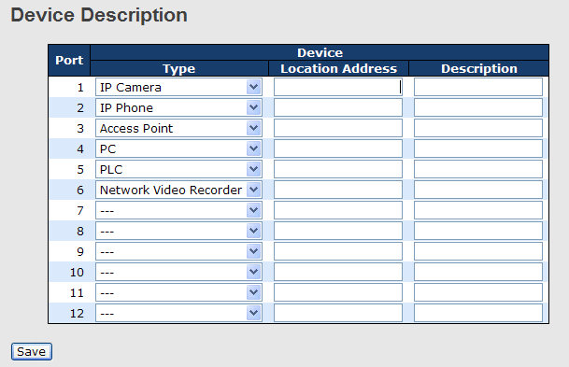

Label | Description
Device Type | Indicates device types. Possible types are:  ---: no specification  IP Camera  IP Phone  Access Point  PC  PLC  Network Video Recorder
Location Address | Indicates location information of the device. The information can be used for Google Mapping.
Description | Device descriptions

Stream Check
Stream check monitors the consistency of real-time network traffic from the device bound with the port. When the traffic changes sharply all of a sudden, an alert will be issued. This page allows you to configure stream check settings.
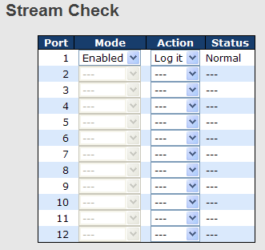

Label | Description
Mode | Enables or disables stream monitoring of the port
Action | Indicates the action to take when the stream gets low. Possible actions are:  ---: no action  Log it: simply logs the event

    - ACL
An ACL (Access Control List) is a list of permissions attached to an object. An ACL specifies which users or system processes are authorized to access the objects and what operations are allowed on given objects.

Port Configuration
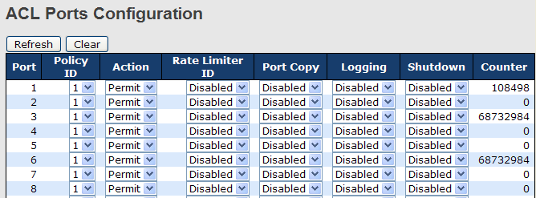
Label | Description
Port | The switch port number to which the following settings will be applied
Policy ID | Select to apply a policy to the port. The allowed values are 1 to 8. The default value is 1.
Action | Select to Permit to permit or Deny to deny forwarding. The default value is Permit.
Rate Limiter ID | Select a rate limiter for the port. The allowed values are Disabled or numbers from 1 to 15. The default value is Disabled.
Port Copy | Select which port frames are copied to. The allowed values are Disabled or a specific port number. The default value is Disabled.
Logging | Specifies the logging operation of the port. The allowed values are:  Enabled: frames received on the port are stored in the system log  Disabled: frames received on the port are not logged  The default value is Disabled. Please note that system log memory capacity and logging rate is limited.
Shutdown | Specifies the shutdown operation of this port. The allowed values are:  Enabled: if a frame is received on the port, the port will be disabled.  Disabled: port shut down is disabled.  The default value is Disabled.
Counter | Counts the number of frames that match this ACE.

Rate Limiters
This page allows you to define the rate limits applied to a port.
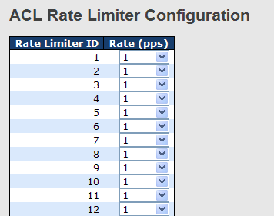
Label | Description
Rate Limiter ID | The rate limiter ID for the settings contained in the same row.
Rate | The rate unit is packet per second (pps), which can be configured as 1, 2, 4, 8, 16, 32, 64, 128, 256, 512, 1K, 2K, 4K, 8K, 16K, 32K, 64K, 128K, 256K, 512K, or 1024K.  The 1 kpps is actually 1002.1 pps.

ACL Control List
An ACE (Access Control Entry) is an element in an access control list (ACL). An ACL can have zero or more ACEs. Each ACE controls or monitors access to an object based on user-defined configurations. Each ACE consists of several parameters which vary with the frame type you have selected.
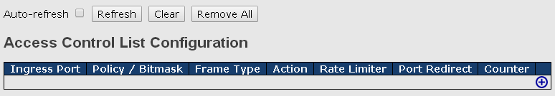
Click on the “+” at the right hand side of the table will bring up a another page with detailed configurations (as shown below).
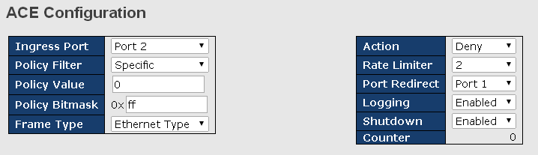

Label | Description
Ingress Port | Indicates the ingress port to which the ACE will apply.  Any: the ACE applies to any port  Port n: the ACE applies to this port number, where n is the number of the switch port.  Policy n: the ACE applies to this policy number, where n can range from 1 to 8.
Policy Filter | Specifies the policy number filter for this ACE.  Any: No policy filter is specified. (policy filter status is “don't-care".)  Specific: If you want to filter a specific policy with this ACE, choose this value. Two fields for entering a policy value and bitmask appear.  Policy Value: When "Specific" is selected for the policy filter, you can enter a specific policy value. The allowed range is 0 to 255  Policy Bitmask: When "Specific" is selected for the policy filter, you can enter a specific policy bitmask. The allowed range is 0x0 to 0xff.
Frame Type | Indicates the frame type of the ACE. These frame types are mutually exclusive.  Any: any frame can match the ACE.  Ethernet Type: only Ethernet Type frames can match this ACE.  ARP: only ARP frames can match the ACE. Notice the ARP frames will not match the ACE with Ethernet type.  IPv4: only IPv4 frames can match the ACE. Notice the IPv4 frames will not match the ACE with Ethernet type.
Action | Specifies the action to take when a frame matches the ACE.  Permit: takes action when the frame matches the ACE.  Deny: drops the frame matching the ACE.
Rate Limiter | Specifies the rate limiter in number of base units. The allowed range is 1 to 15. Disabled means the rate limiter operation is disabled.
Port Copy | Frames matching the ACE are copied to the port number specified here. The allowed range is the same as the switch port number range. Disabled means the port copy operation is disabled.
Logging | Specifies the logging operation of the ACE. The allowed values are:  Enabled: frames matching the ACE are stored in the system log.  Disabled: frames matching the ACE are not logged.  Please note that system log memory capacity and logging rate is limited.
Shutdown | Specifies the shutdown operation of the ACE. The allowed values are:  Enabled: if a frame matches the ACE, the ingress port will be disabled.  Disabled: port shutdown is disabled for the ACE.
Counter | Indicates the number of times the ACE matched by a frame.

Frame Type as Ethernet Type
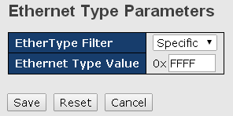

Label | Description
EtherType Filter | Specify the Ethernet type filter for this ACE, including:  Any: No EtherType filter is specified (EtherType filter status is "don't-care").  Specific: If you want to filter a specific EtherType filter with this ACE, you can enter a specific EtherType value. A field for entering a EtherType value appears.
Ethernet Type Value | When "Specific" is selected for the EtherType filter, you can enter a specific EtherType value. The allowed range is 0x600 to 0xFFFF. A frame that hits this ACE matches this EtherType value.

Frame Type as ARP
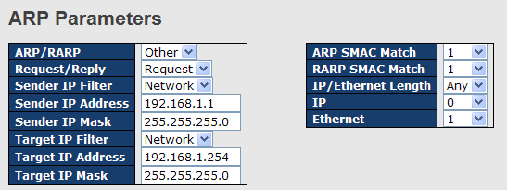

Label | Description
ARP/RARP | Specifies the available ARP/RARP opcode (OP) flag for the ACE  Any: no ARP/RARP OP flag is specified (OP is "don't-care").  ARP: frame must have ARP/RARP opcode set to ARP  RARP: frame must have ARP/RARP opcode set to RARP.  Other: frame has unknown ARP/RARP Opcode flag.
Request/Reply | Specifies the available ARP/RARP opcode (OP) flag for the ACE  Any: no ARP/RARP OP flag is specified (OP is "don't-care").  Request: frame must have ARP Request or RARP Request OP flag set.  Reply: frame must have ARP Reply or RARP Reply OP flag.
Sender IP Filter | Specifies the sender IP filter for the ACE  Any: no sender IP filter is specified (sender IP filter is "don't-care").  Host: sender IP filter is set to Host. Specify the sender IP address in the SIP Address field that appears.  Network: sender IP filter is set to Network. Specify the sender IP address and sender IP mask in the SIP Address and SIP Mask fields that appear.
Sender IP Address | When Host or Network is selected for the sender IP filter, you can enter a specific sender IP address in dotted decimal notation.
Sender IP Mask | When Network is selected for the sender IP filter, you can enter a specific sender IP mask in dotted decimal notation.
Target IP Filter | Specifies the target IP filter for the specific ACE  Any: no target IP filter is specified (target IP filter is "don't-care").  Host: target IP filter is set to Host. Specify the target IP address in the Target IP Address field that appears.  Network: target IP filter is set to Network. Specify the target IP address and target IP mask in the Target IP Address and Target IP Mask fields that appear.
Target IP Address | When Host or Network is selected for the target IP filter, you can enter a specific target IP address in dotted decimal notation.
Target IP Mask | When Network is selected for the target IP filter, you can enter a specific target IP mask in dotted decimal notation.
ARP SMAC Match | Specifies whether frames will meet the action according to their sender hardware address field (SHA) settings.  0: ARP frames where SHA is not equal to the SMAC address  1: ARP frames where SHA is equal to the SMAC address  Any: any value is allowed ("don't-care").
RARP SMAC Match | Specifies whether frames will meet the action according to their target hardware address field (THA) settings.  0: RARP frames where THA is not equal to the SMAC address  1: RARP frames where THA is equal to the SMAC address  Any: any value is allowed ("don't-care")
IP/Ethernet Length | Specifies whether frames will meet the action according to their ARP/RARP hardware address length (HLN) and protocol address length (PLN) settings.  0: ARP/RARP frames where the HLN is equal to Ethernet (0x06) and the (PLN) is equal to IPv4 (0x04) must not match this entry.  1: ARP/RARP frames where the HLN is equal to Ethernet (0x06) and the (PLN) is equal to IPv4 (0x04) must match this entry.  Any: any value is allowed ("don't-care").
IP | Specifies whether frames will meet the action according to their ARP/RARP hardware address space (HRD) settings.  0: ARP/RARP frames where the HLD is equal to Ethernet (1) must not match this entry.  1: ARP/RARP frames where the HLD is equal to Ethernet (1) must match this entry.  Any: any value is allowed ("don't-care").
Ethernet | Specifies whether frames will meet the action according to their ARP/RARP protocol address space (PRO) settings.  0: ARP/RARP frames where the PRO is equal to IP (0x800) must not match this entry.  1: ARP/RARP frames where the PRO is equal to IP (0x800) must match this entry.  Any: any value is allowed ("don't-care").

Frame Type as IPv4
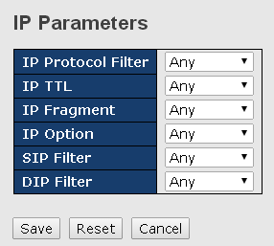
Label | Description
IP Protocol Filter | Specifies the IP protocol filter for the ACE  Any: no IP protocol filter is specified ("don't-care").  Specific: if you want to filter a specific IP protocol filter with the ACE, choose this value. A field for entering an IP protocol filter appears.  ICMP: selects ICMP to filter IPv4 ICMP protocol frames. Extra fields for defining ICMP parameters will appear. For more details of these fields, please refer to the help file.  UDP: selects UDP to filter IPv4 UDP protocol frames. Extra fields for defining UDP parameters will appear. For more details of these fields, please refer to the help file.  TCP: selects TCP to filter IPv4 TCP protocol frames. Extra fields for defining TCP parameters will appear. For more details of these fields, please refer to the help file.
IP TTL | Specifies the time-to-live settings for the ACE  Zero: IPv4 frames with a time-to-live value greater than zero must not be able to match this entry.  Non-zero: IPv4 frames with a time-to-live field greater than zero must be able to match this entry.  Any: any value is allowed ("don't-care").
IP Fragment | Specifies the fragment offset settings for the ACE. This includes settings of More Fragments (MF) bit and Fragment Offset (FRAG OFFSET) for an IPv4 frame.  No: IPv4 frames whose MF bit is set or the FRAG OFFSET field is greater than zero must not be able to match this entry.  Yes: IPv4 frames whose MF bit is set or the FRAG OFFSET field is greater than zero must be able to match this entry.  Any: any value is allowed ("don't-care").
IP Option | Specifies the options flag settings for the ACE  No: IPv4 frames whose options flag is set must not be able to match this entry.  Yes: IPv4 frames whose options flag is set must be able to match this entry.  Any: any value is allowed ("don't-care").
SIP Filter | Specifies the source IP filter for this ACE  Any: no source IP filter is specified (Source IP filter is "don't-care").  Host: source IP filter is set to Host. Specify the source IP address in the SIP Address field that appears.  Network: source IP filter is set to Network. Specify the source IP address and source IP mask in the SIP Address and SIP Mask fields that appear.
DIP Filter | Specifies the destination IP filter for the ACE  Any: no destination IP filter is specified (destination IP filter is "don't-care").  Host: destination IP filter is set to Host. Specify the destination IP address in the DIP Address field that appears.  Network: destination IP filter is set to Network. Specify the destination IP address and destination IP mask in the DIP Address and DIP Mask fields that appear.

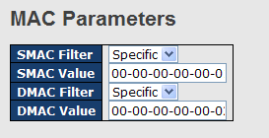

Label | Description
SMAC Filter | (Only displayed when the frame type is Ethernet Type or ARP.)  Specifies the source MAC filter for the ACE.  Any: no SMAC filter is specified (SMAC filter status is "don't-care").  Specific: if you want to filter a specific source MAC address with the ACE, choose this value. A field for entering an SMAC value appears.
SMAC Value | When Specific is selected for the SMAC filter, you can enter a specific source MAC address. The legal format is "xx-xx-xx-xx-xx-xx". Frames matching the ACE will use this SMAC value.
DMAC Filter | Specifies the destination MAC filter for this ACE  Any: no DMAC filter is specified (DMAC filter status is "don't-care").  MC: frame must be multicast.  BC: frame must be broadcast.  UC: frame must be unicast.  Specific: If you want to filter a specific destination MAC address with the ACE, choose this value. A field for entering a DMAC value appears.
DMAC Value | When Specific is selected for the DMAC filter, you can enter a specific destination MAC address. The legal format is "xx-xx-xx-xx-xx-xx". Frames matching the ACE will use this DMAC value.

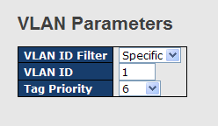

Label | Description
VLAN ID Filter | Specifies the VLAN ID filter for the ACE  Any: no VLAN ID filter is specified (VLAN ID filter status is "don't-care").  Specific: if you want to filter a specific VLAN ID with the ACE, choose this value. A field for entering a VLAN ID number appears.
VLAN ID | When Specific is selected for the VLAN ID filter, you can enter a specific VLAN ID number. The allowed range is 1 to 4095. Frames matching the ACE will use this VLAN ID value.
Tag Priority | Specifies the tag priority for the ACE. A frame matching the ACE will use this tag priority. The allowed number range is 0 to 7. Any means that no tag priority is specified (tag priority is "don't-care").

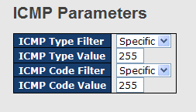
Label | Description
ICMP Type Filter | Specifies the ICMP filter for the ACE  Any: no ICMP filter is specified (ICMP filter status is "don't-care").  Specific: if you want to filter a specific ICMP filter with the ACE, you can enter a specific ICMP value. A field for entering an ICMP value appears.
ICMP Type Value | When Specific is selected for the ICMP filter, you can enter a specific ICMP value. The allowed range is 0 to 255. A frame matching the ACE will use this ICMP value.
ICMP Code Filter | Specifies the ICMP code filter for the ACE  Any: no ICMP code filter is specified (ICMP code filter status is "don't-care").  Specific: if you want to filter a specific ICMP code filter with the ACE, you can enter a specific ICMP code value. A field for entering an ICMP code value appears.
ICMP Code Value | When Specific is selected for the ICMP code filter, you can enter a specific ICMP code value. The allowed range is 0 to 255. A frame matching the ACE will use this ICMP code value.

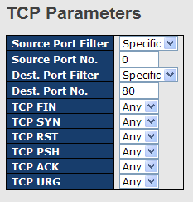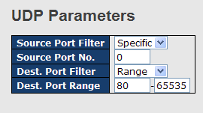

Label | Description
TCP/UDP Source Filter | Specifies the TCP/UDP source filter for the ACE  Any: no TCP/UDP source filter is specified (TCP/UDP source filter status is "don't-care").  Specific: if you want to filter a specific TCP/UDP source filter with the ACE, you can enter a specific TCP/UDP source value. A field for entering a TCP/UDP source value appears.  Range: if you want to filter a specific TCP/UDP source range filter with the ACE, you can enter a specific TCP/UDP source range. A field for entering a TCP/UDP source value appears.
TCP/UDP Source No. | When Specific is selected for the TCP/UDP source filter, you can enter a specific TCP/UDP source value. The allowed range is 0 to 65535. A frame matching the ACE will use this TCP/UDP source value.
TCP/UDP Source Range | When Range is selected for the TCP/UDP source filter, you can enter a specific TCP/UDP source range value. The allowed range is 0 to 65535. A frame matching the ACE will use this TCP/UDP source value.
TCP/UDP Destination Filter | Specifies the TCP/UDP destination filter for the ACE  Any: no TCP/UDP destination filter is specified (TCP/UDP destination filter status is "don't-care").  Specific: if you want to filter a specific TCP/UDP destination filter with the ACE, you can enter a specific TCP/UDP destination value. A field for entering a TCP/UDP destination value appears.  Range: if you want to filter a specific range TCP/UDP destination filter with the ACE, you can enter a specific TCP/UDP destination range. A field for entering a TCP/UDP destination value appears.
TCP/UDP Destination Number | When Specific is selected for the TCP/UDP destination filter, you can enter a specific TCP/UDP destination value. The allowed range is 0 to 65535. A frame matching the ACE will use this TCP/UDP destination value.
TCP/UDP Destination Range | When Range is selected for the TCP/UDP destination filter, you can enter a specific TCP/UDP destination range value. The allowed range is 0 to 65535. A frame matching the ACE will use this TCP/UDP destination value.
TCP FIN | Specifies the TCP FIN ("no more data from sender") value for the ACE.  0: TCP frames where the FIN field is set must not be able to match this entry.  1: TCP frames where the FIN field is set must be able to match this entry.  Any: any value is allowed ("don't-care").
TCP SYN | Specifies the TCP SYN ("synchronize sequence numbers") value for the ACE  0: TCP frames where the SYN field is set must not be able to match this entry.  1: TCP frames where the SYN field is set must be able to match this entry.  Any: any value is allowed ("don't-care").
TCP PSH | Specifies the TCP PSH ("push function") value for the ACE  0: TCP frames where the PSH field is set must not be able to match this entry.  1: TCP frames where the PSH field is set must be able to match this entry.  Any: any value is allowed ("don't-care").
TCP ACK | Specifies the TCP ACK ("acknowledgment field significant") value for the ACE  0: TCP frames where the ACK field is set must not be able to match this entry.  1: TCP frames where the ACK field is set must be able to match this entry.  Any: any value is allowed ("don't-care").
TCP URG | Specifies the TCP URG ("urgent pointer field significant") value for the ACE  0: TCP frames where the URG field is set must not be able to match this entry.  1: TCP frames where the URG field is set must be able to match this entry.  Any: any value is allowed ("don't-care").

ACL Status
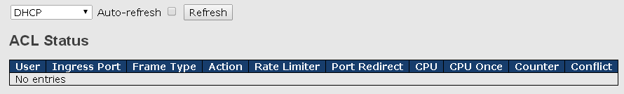

    - AAA (Authentication, Authorization, and Accounting)
An AAA server is an application that provides authentication, authorization, and accounting services for attempted access to a network. An AAA server can reside in a dedicated computer, an Ethernet switch, an access point or a network access server. The current standard by which devices or applications communicate with an AAA server is RADIUS (Remote Authentication Dial-In User Service). RADIUS is a protocol used between the switch and the authentication server. This page allows you to configure common settings for an authentication server.
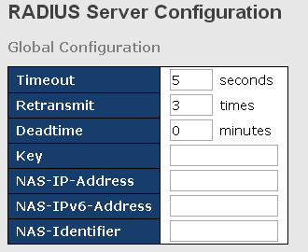

Label | Description
Timeout | The timeout, which can be set to a number between 3 and 3600 seconds, is the maximum time to wait for a reply from a server.  If the server does not reply within this time frame, we will consider it to be dead and continue with the next enabled server (if any).  RADIUS servers are using the UDP protocol, which is unreliable by design. In order to cope with lost frames, the timeout interval is divided into 3 subintervals of equal length. If a reply is not received within the subinterval, the request is transmitted again. This algorithm causes the RADIUS server to be queried up to 3 times before it is considered to be dead.
Retransmit | The number of times the switch tries to connect to a RADIUS server.
Dead Time | The dead time, which can be set to a number between 0 and 3600 seconds, is the period during which the switch will not send new requests to a server that has failed to respond to a previous request. This will stop the switch from continually trying to contact a server that it has already determined as dead.  Setting the dead time to a value greater than 0 (zero) will enable this feature, but only if more than one server has been configured.
NAS-IP-Address | Indicates the identifying IP Address of the NAS which is requesting authentication of the user, and SHOULD be unique to the NAS within the scope of the RADIUS server.
NAS-ID | Network Access Server identifier (NAS-ID) for the interface. The NAS-ID is sent to the RADIUS server by the controller (as a RADIUS client) using the authentication request, which is used to classify users to different groups. You can enter up to 32 alphanumeric characters.

When a user requests network connection, a RADIUS client which receives the request will perform an initial access negotiation with the user to obtain identity/password information. The client then passes the information to a RADIUS server as part of an authentication/authorization request.
The RADIUS server matches data from the authentication/authorization request with information in a trusted database. If a match is found and the user's credentials are correct, the RADIUS server sends an accept message to the client to grant access. If a match is not found or a problem is found with the user's credentials, the server returns a reject message to deny access. The NAD then establishes or terminates the user's connection. The NAD may then forward accounting information to the RADIUS server to document the transaction; the RADIUS server may store or forward this information as needed to support billing for the services provided.
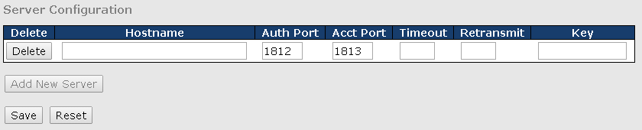

Label | Description
Delete | Click to delete an entry from the table.
Hostname | Specifies the host name of the RADIUS server. The maximum supported length for the AAA RADIUS hostname is 40 characters.
Auth Port | The authentication port which specifies the UDP port used to connect the RADIUS server for authentication. The default is 1812.
Acct Port | The UDP port to use on the RADIUS accounting server. If the port is set to 0 (zero), the default port (1813) is used on the RADIUS accounting server.
Key | The shared secret between the switch and the RADIUS server.
Timeout | The time to wait for the RADIUS server to respond.
Retransmit | The number of times the switch tries to connect to a RADIUS server.

RADIUS Overview
This page provides information about the status of the RADIUS server configurable on the authentication configuration page.
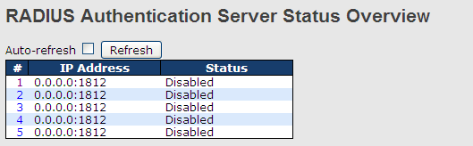

Label | Description
# | The RADIUS server number. Click to navigate to detailed statistics of the server
IP Address | The IP address and UDP port number (in <IP Address>:<UDP Port> notation) of the server
Status | The current status of the server. This field has one of the following values:  Disabled: the server is disabled.  Not Ready: the server is enabled, but IP communication is not yet up and running.  Ready: the server is enabled, IP communications are built, and the RADIUS module is ready to accept access attempts.  Dead (X seconds left): access attempts are made to this server, but it does not reply within the configured timeout. The server has temporarily been disabled, but will be re-enabled when the dead-time expires. The number of seconds left before this occurs is displayed in parentheses. This state is only reachable when more than one server is enabled.

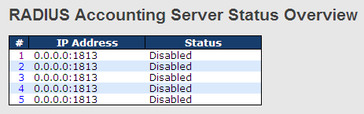

Label | Description
# | The RADIUS server number. Click to navigate to detailed statistics of the server
IP Address | The IP address and UDP port number (in <IP Address>:<UDP Port> notation) of the server
Status | The current status of the server. This field has one of the following values:  Disabled: the server is disabled.  Not Ready: the server is enabled, but IP communication is not yet up and running.  Ready: the server is enabled, IP communication is up and running and the RADIUS module is ready to accept accounting attempts.  Dead (X seconds left): accounting attempts are made to this server, but it does not reply within the configured timeout. The server has temporarily been disabled, but will be re-enabled when the dead-time expires. The number of seconds left before this occurs is displayed in parentheses. This state is only reachable when more than one server is enabled.

RADIUS Details
This page shows the access statistics of the authentication and accounting servers. Use the server drop-down list to switch between the backend servers to show related details.
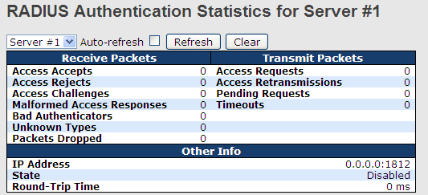
Label | Description
Packet Counters | RADIUS authentication server packet counters. There are seven ‘receive’ and four ‘transmit’ counters.  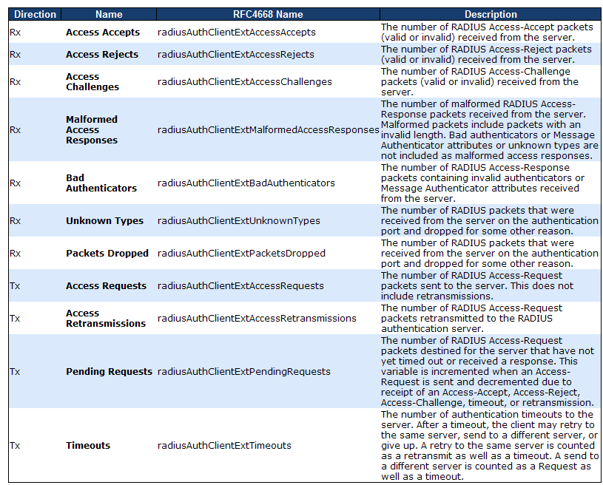
Other Info | This section contains information about the state of the server and the latest round-trip time.  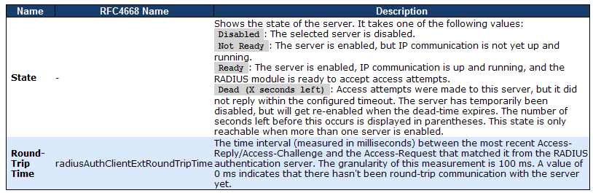

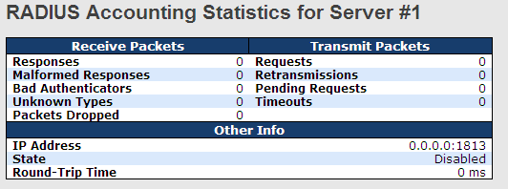

Label | Description
Packet Counters | RADIUS accounting server packet counters. There are five ‘receive’ and four ‘transmit’ counters. 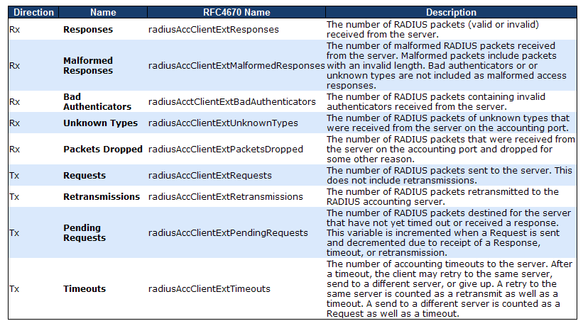
Other Info | This section contains information about the state of the server and the latest round-trip time. 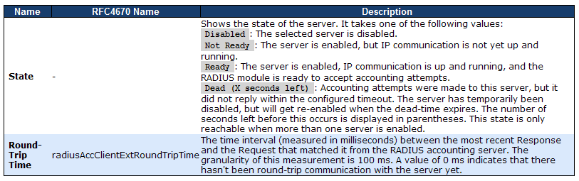

    - NAS (802.1x)
A NAS (Network Access Server) is an access gateway between an external communications network and an internal network. For example, when the user dials into the ISP, he/she will be given access to the Internet after being authorized by the access server. The authentication between the client and the server include IEEE 802.1X- and MAC-based.
The IEEE 802.1X standard defines a port-based access control procedure that prevents unauthorized access to a network by requiring users to first submit credentials for authentication. One or more backend servers (RADIUS) determine whether the user is allowed access to the network.
MAC-based authentication allows for authentication of more than one user on the same port, and does not require the users to have special 802.1X software installed on their system. The switch uses the users' MAC addresses to authenticate against the backend server. As intruders can create counterfeit MAC addresses, MAC-based authentication is less secure than 802.1X authentication.

Overview of 802.1X (Port-Based) Authentication
In an 802.1X network environment, the user is called the supplicant, the switch is the authenticator, and the RADIUS server is the authentication server. The switch acts as the man-in-the-middle, forwarding requests and responses between the supplicant and the authentication server. Frames sent between the supplicant and the switch is special 802.1X frames, known as EAPOL (EAP Over LANs) frames which encapsulate EAP PDUs (RFC3748). Frames sent between the switch and the RADIUS server is RADIUS packets. RADIUS packets also encapsulate EAP PDUs together with other attributes like the switch's IP address, name, and the supplicant's port number on the switch. EAP is very flexible as it allows for different authentication methods, like MD5-Challenge, PEAP, and TLS. The important thing is that the authenticator (the switch) does not need to know which authentication method the supplicant and the authentication server are using, or how many information exchange frames are needed for a particular method. The switch simply encapsulates the EAP part of the frame into the relevant type (EAPOL or RADIUS) and forwards it.
When authentication is complete, the RADIUS server sends a special packet containing a success or failure indication. Besides forwarding the result to the supplicant, the switch uses it to open up or block traffic on the switch port connected to the supplicant.
Note: in an environment where two backend servers are enabled, the server timeout is configured to X seconds (using the authentication configuration page), and the first server in the list is currently down (but not considered dead), if the supplicant retransmits EAPOL Start frames at a rate faster than X seconds, it will never be authenticated because the switch will cancel on-going backend authentication server requests whenever it receives a new EAPOL Start frame from the supplicant. Since the server has not failed, (because the X seconds have not expired), the same server will be contacted when the next backend authentication server request from the switch. This scenario will loop forever. Therefore, the server timeout should be smaller than the supplicant's EAPOL Start frame retransmission rate.

Overview of MAC-Based Authentication
Unlike 802.1X, MAC-based authentication is not a standard, but merely a best-practices method adopted by the industry. In MAC-based authentication, users are called clients, and the switch acts as the supplicant on behalf of clients. The initial frame (any kind of frame) sent by a client is snooped by the switch, which in turn uses the client's MAC address as both username and password in the subsequent EAP exchange with the RADIUS server. The 6-byte MAC address is converted to a string in the following form "xx-xx-xx-xx-xx-xx", that is, a dash (-) is used as separator between the lower-cased hexadecimal digits. The switch only supports the MD5-Challenge authentication method, so the RADIUS server must be configured accordingly.
When authentication is complete, the RADIUS server sends a success or failure indication, which in turn causes the switch to open up or block traffic for that particular client, using static entries into the MAC Table. Only then will frames from the client be forwarded on the switch. There are no EAPOL frames involved in this authentication, and therefore, MAC-based authentication has nothing to do with the 802.1X standard.
The advantage of MAC-based authentication over 802.1X is that several clients can be connected to the same port (e.g. through a 3rd party switch or a hub) and still require individual authentication, and that the clients do not need special supplicant software to authenticate. The disadvantage is that MAC addresses can be spoofed by malicious users, equipment whose MAC address is a valid RADIUS user can be used by anyone, and only the MD5-Challenge method is supported.
802.1X and MAC-Based authentication configurations consist of two sections: system- and port-wide.

Configuration
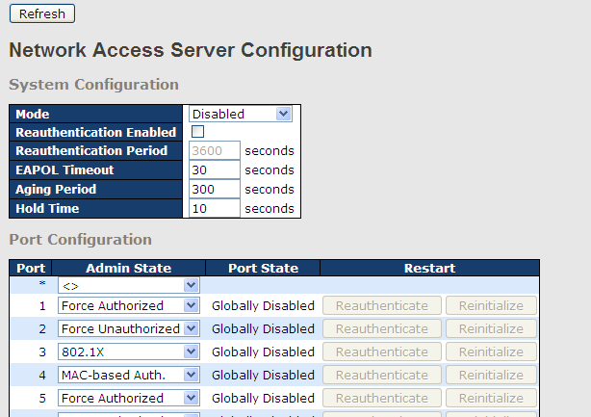

Label | Description
Mode | Indicates if 802.1X and MAC-based authentication is globally enabled or disabled on the switch. If globally disabled, all ports are allowed to forward frames.
Reauthentication Enabled | If checked, clients are reauthenticated after the interval specified by the Reauthentication Period. Reauthentication for 802.1X-enabled ports can be used to detect if a new device is plugged into a switch port.  For MAC-based ports, reauthentication is only useful if the RADIUS server configuration has changed. It does not involve communication between the switch and the client, and therefore does not imply that a client is still present on a port (see Age Period below).
Reauthentication Period | Determines the period, in seconds, after which a connected client must be re-authenticated. This is only active if the Reauthentication Enabled checkbox is checked. Valid range of the value is 1 to 3600 seconds.
EAPOL Timeout | Determines the time for retransmission of Request Identity EAPOL frames.  Valid range of the value is 1 to 65535 seconds. This has no effect for MAC-based ports.
Age Period | This setting applies to the following modes, i.e. modes using the Port Security functionality to secure MAC addresses:  MAC-Based Auth.:  When the NAS module uses the Port Security module to secure MAC addresses, the Port Security module needs to check for activity on the MAC address in question at regular intervals and free resources if no activity is seen within a given period of time. This parameter controls exactly this period and can be set to a number between 10 and 1000000 seconds.  For ports in MAC-based Auth. mode, reauthentication does not cause direct communications between the switch and the client, so this will not detect whether the client is still attached or not, and the only way to free any resources is to age the entry.
Hold Time | This setting applies to the following modes, i.e. modes using the Port Security functionality to secure MAC addresses:  MAC-Based Auth.:  If a client is denied access - either because the RADIUS server denies the client access or because the RADIUS server request times out (according to the timeout specified on the "Configuration→Security→AAA" page) - the client is put on hold in Unauthorized state. The hold timer does not count during an on-going authentication.  The switch will ignore new frames coming from the client during the hold time.  The hold time can be set to a number between 10 and 1000000 seconds.
Port | The port number for which the configuration below applies
Admin State | If NAS is globally enabled, this selection controls the port's authentication mode. The following modes are available:  Force Authorized  In this mode, the switch will send one EAPOL Success frame when the port link is up, and any client on the port will be allowed network access without authentication.  Force Unauthorized  In this mode, the switch will send one EAPOL Failure frame when the port link is up, and any client on the port will be disallowed network access.  Port-based 802.1X  In an 802.1X network environment, the user is called the supplicant, the switch is the authenticator, and the RADIUS server is the authentication server. The authenticator acts as the man-in-the-middle, forwarding requests and responses between the supplicant and the authentication server. Frames sent between the supplicant and the switch are special 802.1X frames, known as EAPOL (EAP Over LANs) frames which encapsulate EAP PDUs (RFC3748). Frames sent between the switch and the RADIUS server is RADIUS packets. RADIUS packets also encapsulate EAP PDUs together with other attributes like the switch's IP address, name, and the supplicant's port number on the switch. EAP is very flexible as it allows for different authentication methods, like MD5-Challenge, PEAP, and TLS. The important thing is that the authenticator (the switch) does not need to know which authentication method the supplicant and the authentication server are using, or how many information exchange frames are needed for a particular method. The switch simply encapsulates the EAP part of the frame into the relevant type (EAPOL or RADIUS) and forwards it.  When authentication is complete, the RADIUS server sends a special packet containing a success or failure indication. Besides forwarding the result to the supplicant, the switch uses it to open up or block traffic on the switch port connected to the supplicant.  Note: in an environment where two backend servers are enabled, the server timeout is configured to X seconds (using the authentication configuration page), and the first server in the list is currently down (but not considered dead), if the supplicant retransmits EAPOL Start frames at a rate faster than X seconds, it will never be authenticated because the switch will cancel on-going backend authentication server requests whenever it receives a new EAPOL Start frame from the supplicant. Since the server has not failed (because the X seconds have not expired), the same server will be contacted when the next backend authentication server request from the switch This scenario will loop forever. Therefore, the server timeout should be smaller than the supplicant's EAPOL Start frame retransmission rate.  a. Single 802.1X  In port-based 802.1X authentication, once a supplicant is successfully authenticated on a port, the whole port is opened for network traffic. This allows other clients connected to the port (for instance through a hub) to piggy-back on the successfully authenticated client and get network access even though they are not authenticated individually. To overcome this security breach, use the Single 802.1X variant.  Single 802.1X is not yet an IEEE standard, but features many of the same characteristics as port-based 802.1X. In Single 802.1X, at most one supplicant can get authenticated on the port at a time. Normal EAPOL frames are used in the communications between the supplicant and the switch. If more than one supplicant are connected to a port, the one that comes first when the port's link is connected will be the first one considered. If that supplicant does not provide valid credentials within a certain amount of time, the chance will be given to another supplicant. Once a supplicant is successfully authenticated, only that supplicant will be allowed access. This is the most secure of all the supported modes. In this mode, the Port Security module is used to secure a supplicant's MAC address once successfully authenticated.  b. Multi 802.1X  In port-based 802.1X authentication, once a supplicant is successfully authenticated on a port, the whole port is opened for network traffic. This allows other clients connected to the port (for instance through a hub) to piggy-back on the successfully authenticated client and get network access even though they are not authenticated individually. To overcome this security breach, use the Multi 802.1X variant.  Multi 802.1X is not yet an IEEE standard, but features many of the same characteristics as port-based 802.1X. In Multi 802.1X, one or more supplicants can be authenticated on the same port at the same time. Each supplicant is authenticated individually and secured in the MAC table using the Port Security module.  In Multi 802.1X it is not possible to use the multicast BPDU MAC address as the destination MAC address for EAPOL frames sent from the switch to the supplicant, since that would cause all supplicants attached to the port to reply to requests sent from the switch. Instead, the switch uses the supplicant's MAC address, which is obtained from the first EAPOL Start or EAPOL Response Identity frame sent by the supplicant. An exception to this is when no supplicants are attached. In this case, the switch sends EAPOL Request Identity frames using the BPDU multicast MAC address as destination - to wake up any supplicants that might be on the port.  The maximum number of supplicants that can be attached to a port can be limited using the Port Security Limit Control functionality.  MAC-based Auth.  Unlike port-based 802.1X, MAC-based authentication is not a standard, but merely a best-practices method adopted by the industry. In MAC-based authentication, users are called clients, and the switch acts as the supplicant on behalf of clients. The initial frame (any kind of frame) sent by a client is snooped by the switch, which in turn uses the client's MAC address as both username and password in the subsequent EAP exchange with the RADIUS server. The 6-byte MAC address is converted to a string in the following form "xx-xx-xx-xx-xx-xx", that is, a dash (-) is used as separator between the lower-cased hexadecimal digits. The switch only supports the MD5-Challenge authentication method, so the RADIUS server must be configured accordingly.  When authentication is complete, the RADIUS server sends a success or failure indication, which in turn causes the switch to open up or block traffic for that particular client, using the Port Security module. Only then will frames from the client be forwarded on the switch. There are no EAPOL frames involved in this authentication, and therefore, MAC-based authentication has nothing to do with the 802.1X standard.  The advantage of MAC-based authentication over port-based 802.1X is that several clients can be connected to the same port (e.g. through a 3rd party switch or a hub) and still require individual authentication, and that the clients don't need special supplicant software to authenticate. The advantage of MAC-based authentication over 802.1X-based authentication is that the clients do not need special supplicant software to authenticate. The disadvantage is that MAC addresses can be spoofed by malicious users - equipment whose MAC address is a valid RADIUS user can be used by anyone. Also, only the MD5-Challenge method is supported. The maximum number of clients that can be attached to a port can be limited using the Port Security Limit Control functionality.
Port State | The current state of the port. It can undertake one of the following values:  Globally Disabled: NAS is globally disabled.  Link Down: NAS is globally enabled, but there is no link on the port.  Authorized: the port is in Force Authorized or a single-supplicant mode and the supplicant is authorized.  Unauthorized: the port is in Force Unauthorized or a single-supplicant mode and the supplicant is not successfully authorized by the RADIUS server.  X Auth/Y Unauth: the port is in a multi-supplicant mode. Currently X clients are authorized and Y are unauthorized.
Restart | Two buttons are available for each row. The buttons are only enabled when authentication is globally enabled and the port's Admin State is in an EAPOL-based or MAC-based mode.  Clicking these buttons will not cause settings changed on the page to take effect.  Reauthenticate: schedules a reauthentication whenever the quiet-period of the port runs out (EAPOL-based authentication). For MAC-based authentication, reauthentication will be attempted immediately.  The button only has effect on successfully authenticated clients on the port and will not cause the clients to be temporarily unauthorized.  Reinitialize: forces a reinitialization of the clients on the port and hence a reauthentication immediately. The clients will transfer to the unauthorized state while the reauthentication is in progress.
NAS Switch Status
This page shows the information on current NAS port statuses.
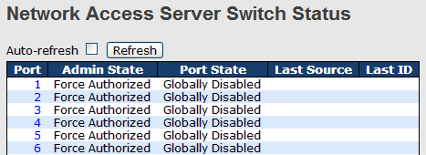

Label | Description
Port | The switch port number. Click to navigate to detailed 802.1X statistics of each port.
Admin State | The port’s current administrative state. Refer to NAS Admin State for more details regarding each value.
Port State | The current state of the port. Refer to NAS Port State for more details regarding each value.
Last Source | The source MAC address carried in the most recently received EAPOL frame for EAPOL-based authentication, and the most recently received frame from a new client for MAC-based authentication.
Last ID | The user name (supplicant identity) carried in the most recently received Response Identity EAPOL frame for EAPOL-based authentication, and the source MAC address from the most recently received frame from a new client for MAC-based authentication.

NAS Port Status
This page provides detailed IEEE 802.1X statistics for a specific switch port using port-based authentication. For MAC-based ports, only the statistics of selected backend server statistics will be shown. Use the drop-down list to select which port details to be displayed.
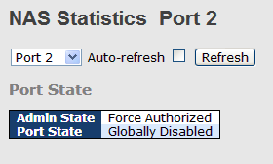

Label | Description
Admin State | The port's current administrative state. Refer to NAS Admin State for more details regarding each value.
Port State | The current state of the port. Refer to NAS Port State for more details regarding each value.
EAPOL Counters | These supplicant frame counters are available for the following administrative states:  • Force Authorized  • Force Unauthorized  • 802.1X  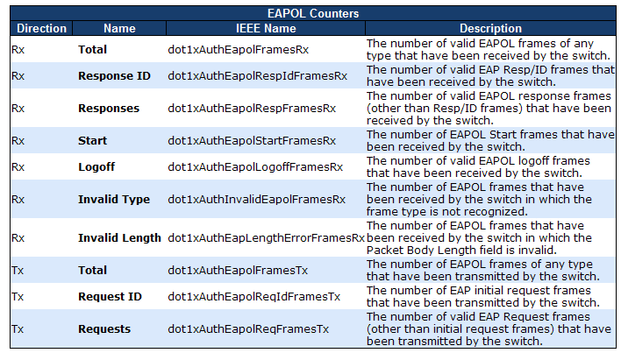
Backend Server Counters | These backend (RADIUS) frame counters are available for the following administrative states:  • 802.1X  • MAC-based Auth.  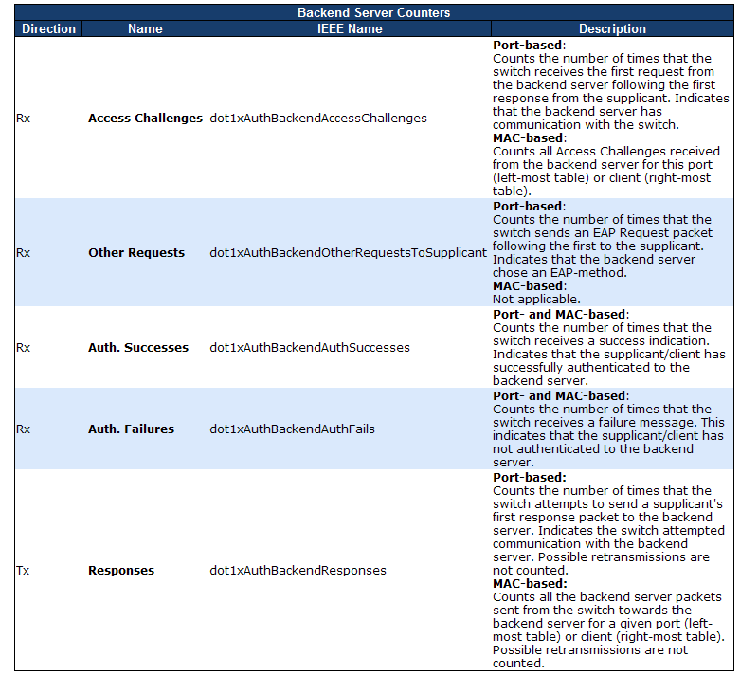
Last Supplicant/Client Info | Information about the last supplicant/client that attempts to authenticate. This information is available for the following administrative states:  • 802.1X  • MAC-based Auth.  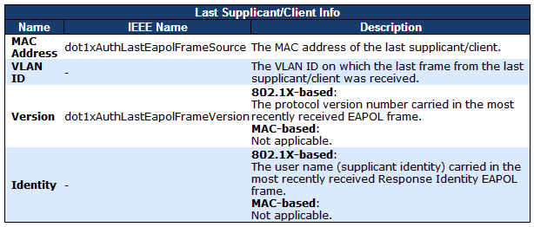

Warning
    - Fault Alarm
When any selected fault event happens, the Fault LED on the switch panel will light up and the electric relay will signal at the same time. The following pages allow you to set up alert conditions based on your needs for individual switch ports, including actions to be taken during disconnection and power failure.
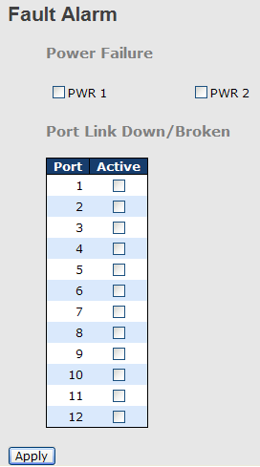

    - System Warning

SYSLOG Setting
SYSLOG is a protocol that allows a device to send event notification messages across IP networks to event message collectors. It permits separation of the software that generates messages from the system that stores them and the software that reports and analyzes them. As Syslog messages are UDP-based, the sender and receiver will not be aware of it if the packet is lost due to network disconnection and no UDP packet will be resent.
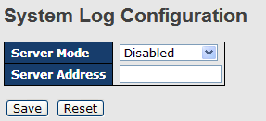

Label | Description
Server Mode | Indicates existing server mode. When the mode operation is enabled, the syslog message will be sent to syslog server. The syslog protocol is based on UDP communications and received on UDP port 514 and the syslog server will not send acknowledgments back to the sender since UDP is a connectionless protocol and it does not provide acknowledgments. The syslog packet will always be sent even if the syslog server does not exist. Possible modes are:  Enabled: enable server mode  Disabled: disable server mode
SYSLOG Server IP Address | Indicates the IPv4 host address of syslog server. If the switch provides DNS functions, it also can be a host name.

SMTP Setting
SMTP (Simple Mail Transfer Protocol) is a protocol for transmitting e-mails across the Internet. By setting up SMTP alert, the device will send a notification e-mail when a user-defined event occurs.
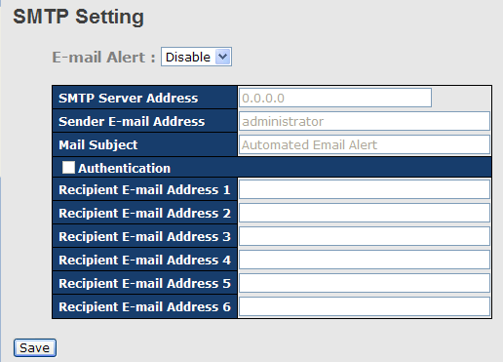

Label | Description
E-mail Alarm | Enables or disables transmission of system warnings by e-mail
Sender E-mail Address | SMTP server IP address
Mail Subject | Subject of the mail
Authentication | - Username: the authentication username  - Password: the authentication password  - Confirm Password: re-enter password
Recipient E-mail Address | The recipient's e-mail address. A mail allows for 6 recipients.
Apply | Click to activate the configurations
Help | Shows help file

Event Selection
The device supports both SYSLOG and SMTP alerts. Check the corresponding box to enable the system event warning method you want. Please note that the checkboxes will gray out if SYSLOG or SMTP is disabled.
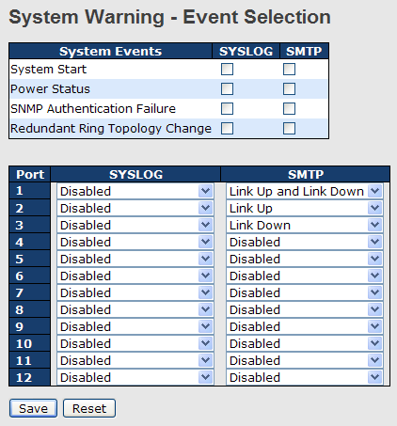

Label | Description
System Cold Start | Sends out alerts when the system is restarted
Power Status | Sends out alerts when power is up or down
SNMP Authentication Failure | Sends out alert when SNMP authentication fails
Redundant Ring Topology Change | Sends out alerts when Ring topology changes
Port Event  SYSLOG / SMTP event | - Disable  - Link Up  - Link Down  - Link Up & Link Down

Monitor and Diagnostics
    - MAC Table
A MAC address tablet is a table in a network switch that maps MAC addresses to ports. The switch uses the table to determine which port the incoming packet should be forwarded to. Entries in a MAC address table fall into two types: dynamic and static entries. Entries in a static MAC table are added or removed manually and cannot age out by themselves. Entries in a dynamic MAC tablet will age out after a configured aging time. Such entries can be added by learning or manual configuration.

Configuration
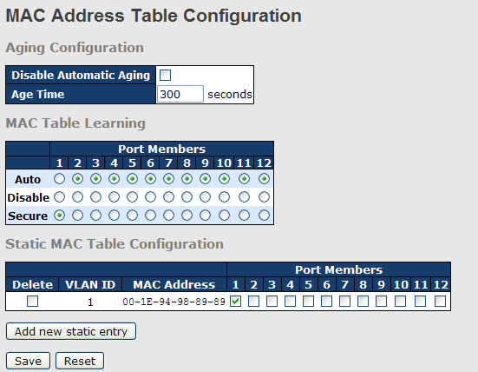

Aging Configuration
Aging enables the switch to track only active MAC addresses on the network and flush out MAC addresses that are no longer used, thereby keeping the table current. By default, aged entries are removed after 300 seconds. You can configure aging time by entering a value in the Age Time box in seconds. The allowed range is 10 to 1000000 seconds. You can also disable the automatic aging of dynamic entries by checking Disable Automatic Aging.

MAC Table Learning
The switch can add the address and port on which the packet was received to the MAC table if the address does not exist in the table by examining the source address of each packet received on a port. This is called learning. It allows the MAC table to expand dynamically. If the learning mode for a given port is grayed out, it means another module is in control of the mode, and thus the user cannot change the configurations. An example of such a module is MAC-Based authentication under 802.1X.
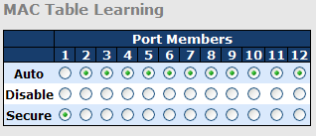

Label | Description
Auto | Learning is done automatically as soon as a frame with unknown SMAC is received.
Disable | No learning is done.
Secure | Only static MAC entries are learned, all other frames are dropped.  Note: make sure the link used for managing the switch is added to the static Mac table before changing to secure learning mode, otherwise the management link will be lost and can only be restored by using another non-secure port or by connecting to the switch via the serial interface.

Static MAC Table Configurations
This tablet shows the static entries in the MAC table which can contain up to 64 entries. Using static MAC address entries can reduce broadcast packets remarkably and are suitable for networks where network devices seldom change. You can manage the entries in this page. The MAC table is sorted first by VLAN ID and then by MAC address.
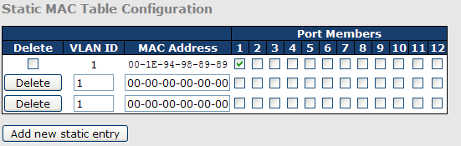

Label | Description
Delete | Check to delete an entry. It will be deleted during the next save.
VLAN ID | The VLAN ID for the entry
MAC Address | The MAC address for the entry
Port Members | Checkmarks indicate which ports are members of the entry. Check or uncheck to modify the entry.
Adding New Static Entry | Click to add a new entry to the static MAC table. You can specify the VLAN ID, MAC address, and port members for the new entry. Click Save to save the changes.

MAC Table
Each page shows up to 999 entries from the MAC table, with a default value of 20, selected by the Entries Per Page input field. When first visited, the web page will show the first 20 entries from the beginning of the MAC Table. The first displayed will be the one with the lowest VLAN ID and the lowest MAC address found in the MAC Table.

Each page shows up to 999 entries from the MAC table, with a default value of 20, selected by the Entries Per Page input field. When first visited, the web page will show the first 20 entries from the beginning of the MAC Table. The first displayed will be the one with the lowest VLAN ID and the lowest MAC address found in the MAC Table.

The Start from MAC address and VLAN fields allow the user to select the starting point in the MAC table. Clicking Refresh will update the displayed table starting from that or the closest next MAC table matches. In addition, the two input fields will – upon clicking Refresh - assume the value of the first displayed entry, allows for continuous refresh with the same start address.
The >> button will use the last entry of the currently displayed VLAN/MAC address pairs as a basis for the next lookup. When it reaches the end, the text "no more entries" is shown in the displayed table. Use the |<< button to start over.
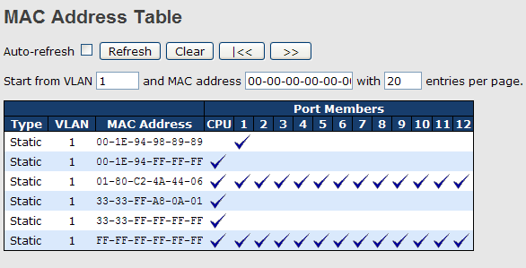

Label | Description
Type | Indicates whether the entry is a static or dynamic entry
MAC address | The MAC address of the entry
VLAN | The VLAN ID of the entry
Port Members | The ports that are members of the entry.

    - Port Statistics

Traffic Overview
This page provides an overview of general traffic statistics for all switch ports.
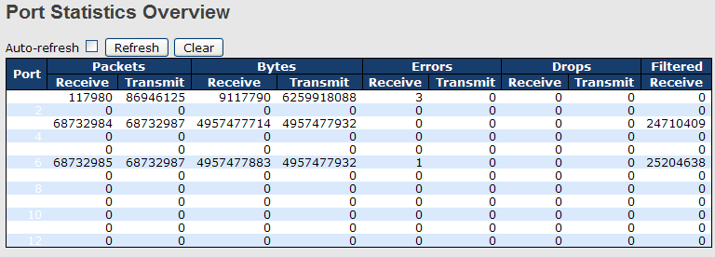

Label | Description
Port | The switch port number to which the following settings will be applied.
Packets | The number of received and transmitted packets per port
Bytes | The number of received and transmitted bytes per port
Errors | The number of frames received in error and the number of incomplete transmissions per port
Drops | The number of frames discarded due to ingress or egress congestion
Filtered | The number of received frames filtered by the forwarding process
Auto-refresh | Check to enable an automatic refresh of the page at regular intervals.
Refresh | Updates the counter entries, starting from the current entry ID.
Clear | Flushes all counters entries

Detailed Statistics
This page provides detailed traffic statistics for a specific switch port. Use the port drop-down list to decide the details of which switch port to be displayed.
The displayed counters include the total number for receive and transmit, the size for receive and transmit, and the errors for receive and transmit.

Detailed Statistics – Total Receive & Transmit
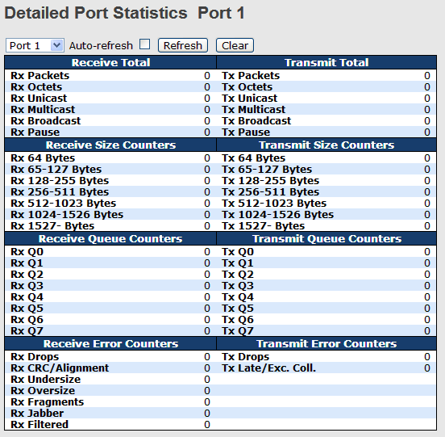
Label | Description
Rx and Tx Packets | The number of received and transmitted (good and bad) packets
Rx and Tx Octets | The number of received and transmitted (good and bad) bytes, including FCS, except framing bits
Rx and Tx Unicast | The number of received and transmitted (good and bad) unicast packets
Rx and Tx Multicast | The number of received and transmitted (good and bad) multicast packets
Rx and Tx Broadcast | The number of received and transmitted (good and bad) broadcast packets
Rx and Tx Pause | The number of MAC Control frames received or transmitted on this port that have an opcode indicating a PAUSE operation
Rx Drops | The number of frames dropped due to insufficient receive buffer or egress congestion
Rx CRC/Alignment | The number of frames received with CRC or alignment errors
Rx Undersize | The number of short¹ frames received with a valid CRC
Rx Oversize | The number of long² frames received with a valid CRC
Rx Fragments | The number of short¹ frames received with an invalid CRC
Rx Jabber | The number of long² frames received with an invalid CRC
Rx Filtered | The number of received frames filtered by the forwarding process
Tx Drops | The number of frames dropped due to output buffer congestion
Tx Late / Exc.Coll. | The number of frames dropped due to excessive or late collisions
1. Short frames are frames smaller than 64 bytes.
2. Long frames are frames longer than the maximum frame length configured for this port.

    - Port Mirror
The Port mirror function will copy the traffic of one port to another port on the same switch to allow the network analyzer attached to the mirror port to monitor and analyze packets. The function is useful for troubleshooting. To solve network problems, selected traffic can be copied or mirrored to a mirror port where a frame analyzer can be attached to analyze the frame flow.
The traffic to be copied to the mirror port can be all frames received on a given port (also known as ingress or source mirror or all frames transmitted on a given port (also known as egress or destination mirror. The port to which the monitored traffic is copied is called mirror port.
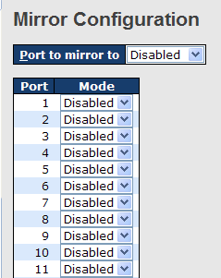

Label | Description
Port | The switch port number to which the following settings will be applied.
Mode | Drop-down list for selecting a mirror mode.  Rx only: only frames received on this port are mirrored to the mirror port. Frames transmitted are not mirrored.  Tx only: only frames transmitted from this port are mirrored to the mirror port. Frames received are not mirrored.  Disabled: neither transmitted nor received frames are mirrored.  Enabled: both received and transmitted frames are mirrored to the mirror port.  Note: for a given port, a frame is only transmitted once. Therefore, you cannot mirror Tx frames to the mirror port. In this case, mode for the selected mirror port is limited to Disabled or Rx nly.

    - System Log Information
This page provides switch system log information.
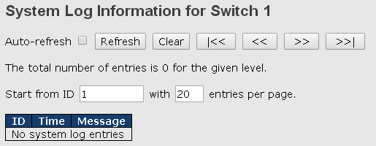

Label | Description
Auto-refresh | Check this box to enable an automatic refresh of the page at regular intervals.
Refresh | Updates system log entries, starting from the current entry ID
Clear | Flushes all system log entries
|<< | Updates system log entries, starting from the first available entry ID
<< | Updates system log entries, ending at the last entry currently displayed
>> | Updates system log entries, starting from the last entry currently displayed.
>>| | Updates system log entries, ending at the last available entry ID.
ID | The ID (>= 1) of the system log entry
Level | The level of the system log entry. The following level types are supported:  Info: provides general information  Warning: provides warning for abnormal operation  Error: provides error message  All: enables all levels
Time | The time of the system log entry
Message | The MAC address of the switch

    - VeriPHY Cable Diagnostics
You can perform cable diagnostics for all ports or selected ports to diagnose any cable faults (short, open etc.) and feedback a distance to the fault. Simply select the port from the drop-down list and click Start to run the diagnostics. This will take approximately 5 seconds. If all ports are selected, this can take approximately 15 seconds. When completed, the page refreshes automatically, and you can view the cable diagnostics results in the cable status table. Note that VeriPHY diagnostics is only accurate for cables 7 - 140 meters long. 10 and 100 Mbps ports will be disconnected while running VeriPHY diagnostics. Therefore, running VeriPHY on a 10 or 100 Mbps management port will cause the switch to stop responding until VeriPHY is completed.
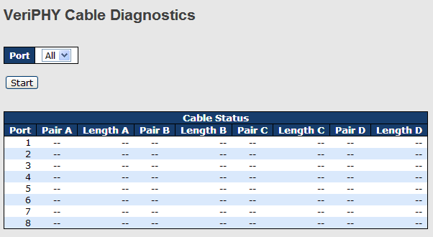

Label | Description
Port | The port for which VeriPHY Cable Diagnostics is requested
Cable Status | Port: port number  Pair: the status of the cable pair  Length: the length (in meters) of the cable pair

    - SFP Monitor
SFP modules with DDM (Digital Diagnostic Monitor) function can measure the temperature of the apparatus, helping you monitor the status of connection and detect errors immediately. You can manage and set up event alarms through this page by inputting a value that will trigger event alarm when the temperature reaches the threshold.

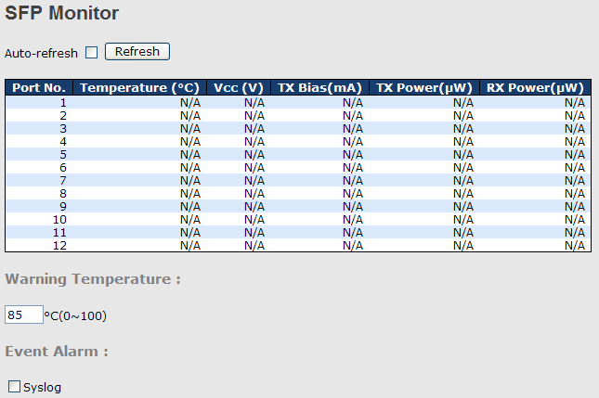

    - Ping
This command sends ICMP echo request packets to another node on the network. Using the ping command, you can see if another site on the network can be reached.
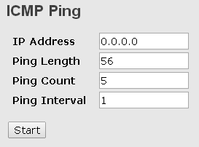

Label | Description
IP Address | The destination IP Address
Ping Length | The payload size of the ICMP packet. Values range from 8 to 1400 bytes.
Ping Count | Define the number of pings that will be sent. Please enter an integer value.
Ping Interval | Specifies the interval between pings that are sent to the destination address.

After you press Start, five ICMP packets will be transmitted, and the sequence number and round trip time will be displayed upon reception of a reply. The page refreshes automatically until responses to all packets are received, or until a timeout occurs.
PING6 server ::10.10.132.20
64 bytes from ::10.10.132.20: icmp_seq=0, time=0ms
64 bytes from ::10.10.132.20: icmp_seq=1, time=0ms
64 bytes from ::10.10.132.20: icmp_seq=2, time=0ms
64 bytes from ::10.10.132.20: icmp_seq=3, time=0ms
64 bytes from ::10.10.132.20: icmp_seq=4, time=0ms
Sent 5 packets, received 5 OK, 0 bad

    - IPv6 Ping
This page enables you to ping IPv6 address to verify the connectivity from this device to an IPv6 device by performing an ICMP for IPv6 echo test.
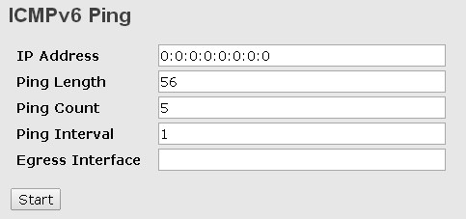

Label | Description
IP Address | The destination IP Address. You must specify this address in hexadecimal using 16-bit values between colons
Ping Length | The payload size of the ICMP packet. Values range from 8 to 1400 bytes.
Ping Count | Define the number of pings that will be sent. Please enter an integer value.
Ping Interval | Specifies the interval between pings that are sent to the destination address.
Egress Interface | Specifies a physical interface over which you can verify connectivity. If you specify a physical interface, such as an Ethernet interface, you must also specify the port number of the interface. If you specify a virtual interface, such as a VE, you must specify the number associated with the VE.

PING6 server: 192.168.10.1
Send to
Send to
Send to
Send to
Send to
Sent 5 packets, received 0 OK, 0 bad

    - SFP Type
This page shows the details of the SFP port. For each port, the summary displays the SFP type, the vendor name and serial number.
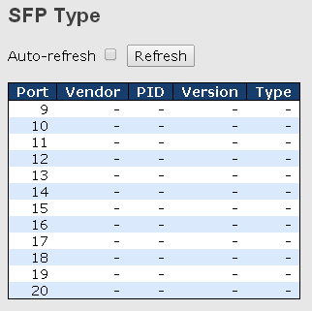

Synchronization
    - PTP
PTP External Clock Mode is a protocol for synchronizing clocks throughout a computer network. On a local area network, it achieves clock accuracy in the sub-microsecond range, making it suitable for measurement and control systems.

Clock Configuration
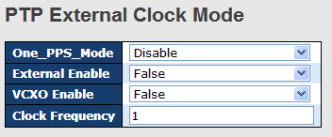

Label | Description
One_pps_mode | The box allows you to select One_pps_mode configurations.  The following values are possible:  Output: enable the 1 pps clock output  Input: enable the 1 pps clock input  Disable: disable the 1 pps clock in/out-put
External Enable | The box allows you to configure external clock output.  The following values are possible:  True: enable external clock output  False: disable external clock output
VCXO_Enable | The box allows you to configure the external VCXO rate adjustment.  The following values are possible:  True: enable external VCXO rate adjustment  False: disable external VCXO rate adjustment
Clock Frequency | The box allows you to set clock frequency.  The range of values is 1 - 25000000 (1 - 25MHz).

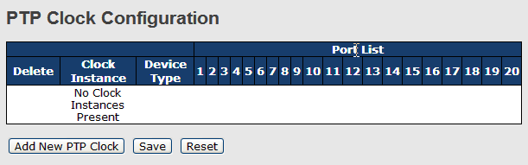

Label | Description
Delete | Check this box and click Save to delete the clock instance
Clock Instance | Indicates the instance of a particular clock instance [0..3]  Click on the clock instance number to edit the clock details
Device Type | Indicates the type of the clock instance. There are five device types.  Ord-Bound: ordinary/boundary clock  P2p Transp: peer-to-peer transparent clock  E2e Transp: end-to-end transparent clock  Master Only: master only  Slave Only: slave only
Port List | Set check mark for each port configured for this Clock Instance.
2 Step Flag | Static member defined by the system; true if two-step Sync events and Pdelay_Resp events are used
Clock Identity | Shows a unique clock identifier
One Way | If true, one-way measurements are used. This parameter applies only to a slave. In one-way mode no delay measurements are performed, i.e. this is applicable only if frequency synchronization is needed. The master always responds to delay requests.
Protocol | Transport protocol used by the PTP protocol engine  Ethernet PTP over Ethernet multicast  ip4multi PTP over IPv4 multicast  ip4uni PTP over IPv4 unicast  Note: IPv4 unicast protocol only works in Master Only and Slave Only clocks  For more information, please refer to Device Type.  In a unicast Slave Only clock, you also need to configure which master clocks to request Announce and Sync messages from.  For more information, please refer to Unicast Slave Configuration
VLAN Tag Enable | Enables VLAN tagging for PTP frames  Note: Packets are only tagged if the port is configured for vlan tagging. i.e:  Port Type != Unaware and PortVLAN mode == None, and the port is member of the VLAN.
VID | VLAN identifiers used for tagging the PTP frames
PCP | Priority code point values used for PTP frames

Status
This page shows the status of the PTP function based on the settings you made in the configuration page.
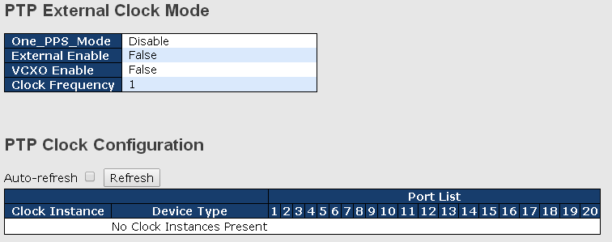

Factory Defaults
This function is to force the switch back to the original factory settings. To reset the switch, select Reset to Factory Defaults from the drop-down list and click Yes. Only the IP configuration is retained.
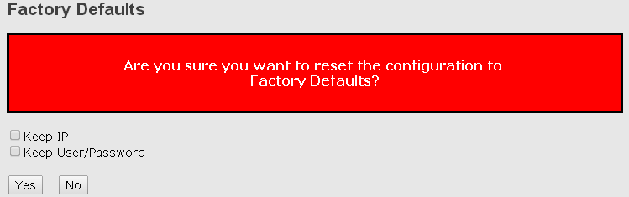

Label | Description
Yes | Click to reset the configuration to factory defaults
No | Click to return to the Port State page without resetting

System Reboot
You can reset the stack switch on this page. After reset, the system will boot normally as if you have powered on the devices.
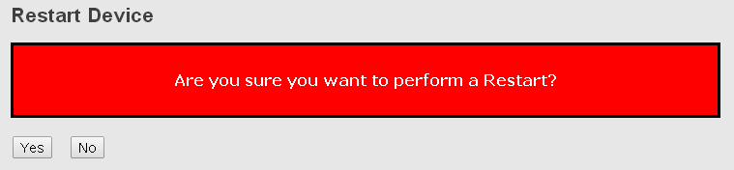

Label | Description
Yes | Click to reboot device
No | Click to return to the Port State page without rebooting

Command Line Management
Besides Web-based management, the switch also supports CLI management. You can use console or telnet to manage the switch by CLI.
CLI Management by RS-232 Serial Console (115200, 8, none, 1, none)
Before configuring RS-232 serial console, connect the RS-232 port of the switch to your PC Com port using a RJ45 to DB9-F cable.

Follow the steps below to access the console via RS-232 serial cable.
Step 1: On Windows desktop, click on Start -> Programs -> Accessories -> Communications -> Hyper Terminal
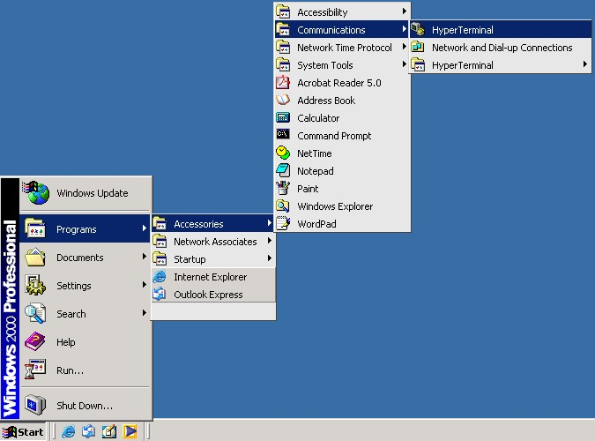

Step 2. Input a name for the new connection.
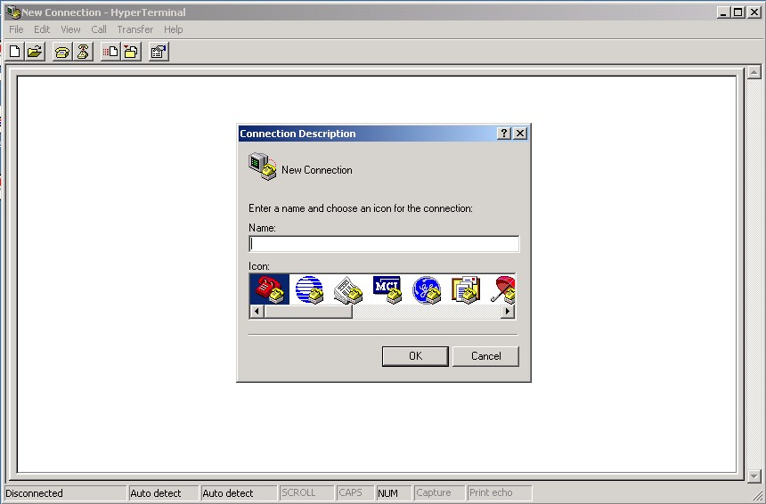

Step 3. Select a COM port in the drop-down list.
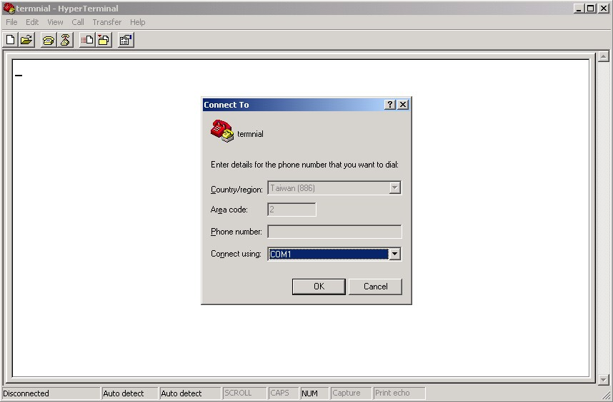

Step 4. A pop-up window that indicates COM port properties appears, including bits per second, data bits, parity, stop bits, and flow control.
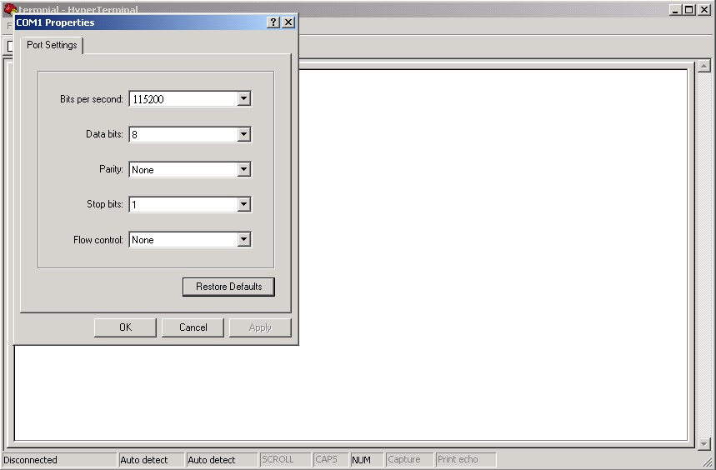

Step 5. The console login screen will appear. Use the keyboard to enter the Username and Password (same as the password for Web browsers), then press Enter.

CLI Management by Telnet
You can use TELNET to configure the switch. The default values are:
IP Address: 192.168.10.1
Subnet Mask: 255.255.255.0
Default Gateway: 192.168.10.254
User Name: admin
Password: admin

Follow the steps below to access console via Telnet.
Step 1. Telnet to the IP address of the switch from the Run window by inputting commands (or from the MS-DOS prompt) as below.

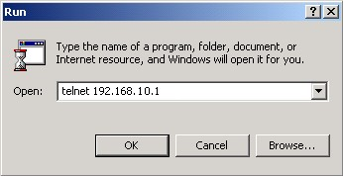

Step 2. The Login screen will appear. Use the keyboard to enter the Username and Password (same as the password for Web browser), and then press Enter.

Command Groups
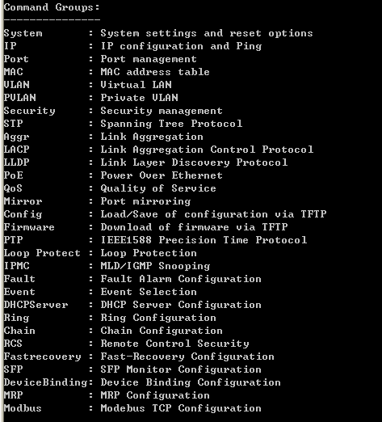

System
System> | Configuration [all] [<port_list>]
System> | Reboot
System> | Restore Default [keep_ip]
System> | Contact [<contact>]
System> | Name [<name>]
System> | Location [<location>]
System> | Description [<description>]
System> | Password <password>
System> | Username [<username>]
System> | Timezone [<offset>]
System> | Log [<log_id>] [all|info|warning|error] [clear]
IP
IP> | Configuration
IP> | DHCP [enable | disable]
IP> | Setup [<ip_addr>] [<ip_mask>] [<ip_router>] [<vid>]
IP> | Ping <ip_addr_string> [<ping_length>]
IP> | SNTP [<ip_addr_string>]

Port
port> | Configuration [<port_list>] [up|down]
port> | Mode [<port_list>] [auto|10hdx|10fdx|100hdx|100fdx|1000fdx|sfp_auto_ams]
port> | Flow Control [<port_list>] [enable | disable]
port> | State [<port_list>] [enable | disable]
port> | MaxFrame [<port_list>] [<max_frame>]
port> | Power [<port_list>] [enable | disable|actiphy|dynamic]
port> | Excessive [<port_list>] [discard|restart]
port> | Statistics [<port_list>] [<command>] [up|down]
port> | VeriPHY [<port_list>]
port> | SFP [<port_list>]

MAC
MAC> | Configuration [<port_list>]
MAC> | Add <mac_addr> <port_list> [<vid>]
MAC> | Delete <mac_addr> [<vid>]
MAC> | Lookup <mac_addr> [<vid>]
MAC> | Agetime [<age_time>]
MAC> | Learning [<port_list>] [auto|disable|secure]
MAC> | Dump [<mac_max>] [<mac_addr>] [<vid>]
MAC> | Statistics [<port_list>]
MAC> | Flush

VLAN
VLAN> | Configuration [<port_list>]
VLAN> | PVID [<port_list>] [<vid>|none]
VLAN> | FrameType [<port_list>] [all|tagged|untagged]
VLAN> | IngressFilter [<port_list>] [enable | disable]
VLAN> | tx_tag [<port_list>] [untag_pvid|untag_all|tag_all]
VLAN> | PortType [<port_list>] [unaware|c-port|s-port|s-custom-port]
VLAN> | EtypeCustomSport [<etype>]
VLAN> | Add <vid>|<name> [<ports_list>]
VLAN> | Forbidden Add <vid>|<name> [<port_list>]
VLAN> | Delete <vid>|<name>
VLAN> | Forbidden Delete <vid>|<name>
VLAN> | Forbidden Lookup [<vid>] [(name <name>)]
VLAN> | Lookup [<vid>] [(name <name>)] [combined|static|nas|all]
VLAN> | Name Add <name> <vid>
VLAN> | Name Delete <name>
VLAN> | Name Lookup [<name>]
VLAN> | Status [<port_list>] [combined|static|nas|mstp|all|conflicts]

Private VLAN
PVLAN> | Configuration [<port_list>]
PVLAN> | Add <pvlan_id> [<port_list>]
PVLAN> | Delete <pvlan_id>
PVLAN> | Lookup [<pvlan_id>]
PVLAN> | Isolate [<port_list>] [enable | disable]

Security
Security > | Switch Switch security setting
Security > | Network Network security setting
Security > | AAA Authentication, Authorization and Accounting setting

Security Switch
Security/switch> | Password <password>
Security/switch> | Auth Authentication
Security/switch> | SSH Secure Shell
Security/switch> | HTTPS Hypertext Transfer Protocol over  Secure Socket Layer
Security/switch> | RMON Remote Network MonitDYMEC

Security Switch Authentication
Security/switch/auth> | Configuration
Security/switch/auth> | Method [console|telnet|ssh|web] [none|local|radius] [enable | disable]

Security Switch SSH
Security/switch/ssh> | Configuration
Security/switch/ssh> | Mode [enable | disable]

Security Switch HTTPS
Security/switch/ssh> | Configuration
Security/switch/ssh> | Mode [enable | disable]

Security Switch RMON
Security/switch/rmon> | Statistics Add <stats_id> <data_source>
Security/switch/rmon> | Statistics Delete <stats_id>
Security/switch/rmon> | Statistics Lookup [<stats_id>]
Security/switch/rmon> | History Add <history_id> <data_source> [<interval>] [<buckets>]
Security/switch/rmon> | History Delete <history_id>
Security/switch/rmon> | History Lookup [<history_id>]
Security/switch/rmon> | Alarm Add <alarm_id> <interval> <alarm_variable> [absolute|delta]<rising_threshold> <rising_event_index> <falling_threshold> <falling_event_index> [rising|falling|both]
Security/switch/rmon> | Alarm Delete <alarm_id>
Security/switch/rmon> | Alarm Lookup [<alarm_id>]

Security Network
Security/Network> | Psec Port Security Status
Security/Network> | NAS Network Access Server (IEEE 802.1X)
Security/Network> | ACL Access Control List
Security/Network> | DHCP Dynamic Host Configuration Protocol

Security Network Psec
Security/Network/Psec> | Switch [<port_list>]
Security/Network/Psec> | Port [<port_list>]

Security Network NAS
Security/Network/NAS> | Configuration [<port_list>]
Security/Network/NAS> | Mode [enable | disable]
Security/Network/NAS> | State [<port_list>] [auto|authorized|unauthorized|macbased]
Security/Network/NAS> | Reauthentication [enable | disable]
Security/Network/NAS> | ReauthPeriod [<reauth_period>]
Security/Network/NAS> | EapolTimeout [<eapol_timeout>]
Security/Network/NAS> | Agetime [<age_time>]
Security/Network/NAS> | Holdtime [<hold_time>]
Security/Network/NAS> | Authenticate [<port_list>] [now]
Security/Network/NAS> | Statistics [<port_list>] [clear|eapol|radius]

Security Network ACL
Security/Network/ACL> | Configuration [<port_list>]
Security/Network/ACL> | Action [<port_list>] [permit|deny] [<rate_limiter>][<port_redirect>] [<mirror>] [<logging>] [<shutdown>]
Security/Network/ACL> | Policy [<port_list>] [<policy>]
Security/Network/ACL> | Rate [<rate_limiter_list>] [<rate_unit>] [<rate>]
Security/Network/ACL> | Add [<ace_id>] [<ace_id_next>][(port <port_list>)] [(policy <policy> <policy_bitmask>)][<tagged>] [<vid>] [<tag_prio>] [<dmac_type>][(etype [<etype>] [<smac>] [<dmac>]) |  (arp [<sip>] [<dip>] [<smac>] [<arp_opcode>] [<arp_flags>]) |  (ip [<sip>] [<dip>] [<protocol>] [<ip_flags>]) |  (icmp [<sip>] [<dip>] [<icmp_type>] [<icmp_code>] [<ip_flags>]) |  (udp [<sip>] [<dip>] [<sport>] [<dport>] [<ip_flags>]) |  (tcp [<sip>] [<dip>] [<sport>] [<dport>] [<ip_flags>] [<tcp_flags>])]  [permit|deny] [<rate_limiter>] [<port_redirect>] [<mirror>] [<logging>][<shutdown>]
Security/Network/ACL> | Delete <ace_id>
Security/Network/ACL> | Lookup [<ace_id>]
Security/Network/ACL> | Clear
Security/Network/ACL> | Status [combined|static|loop_protect|dhcp|ptp|ipmc|conflicts]
Security/Network/ACL> | Port State [<port_list>] [enable | disable]

Security Network DHCP
Security/Network/DHCP> | Configuration
Security/Network/DHCP> | Mode [enable | disable]
Security/Network/DHCP> | Server [<ip_addr>]
Security/Network/DHCP> | Information Mode [enable | disable]
Security/Network/DHCP> | Information Policy [replace|keep|drop]
Security/Network/DHCP> | Statistics [clear]

Security Network AAA
Security/Network/AAA> | Configuration
Security/Network/AAA> | Timeout [<timeout>]
Security/Network/AAA> | Deadtime [<dead_time>]
Security/Network/AAA> | RADIUS [<server_index>] [enable | disable] [<ip_addr_string>] [<secret>] [<server_port>]
Security/Network/AAA> | ACCT_RADIUS [<server_index>] [enable | disable] [<ip_addr_string>] [<secret>] [<server_port>]
Security/Network/AAA> | Statistics [<server_index>]

STP
STP> | Configuration
STP> | Version [<stp_version>]  Non-certified release, v
STP> | Txhold [<holdcount>]lt 15:15:15, Dec 6 2007
STP> | MaxAge [<max_age>]
STP> | FwdDelay [<delay>]
STP> | bpduFilter [enable | disable]
STP> | bpduGuard [enable | disable]
STP> | recovery [<timeout>]
STP> | CName [<config-name>] [<integer>]
STP> | Status [<msti>] [<port_list>]
STP> | Msti Priority [<msti>] [<priority>]
STP> | Msti Map [<msti>] [clear]
STP> | Msti Add <msti> <vid>
STP> | Port Configuration [<port_list>]
STP> | Port Mode [<port_list>] [enable | disable]
STP> | Port Edge [<port_list>] [enable | disable]
STP> | Port AutoEdge [<port_list>] [enable | disable]
STP> | Port P2P [<port_list>] [enable | disable|auto]
STP> | Port RestrictedRole [<port_list>] [enable | disable]
STP> | Port RestrictedTcn [<port_list>] [enable | disable]
STP> | Port bpduGuard [<port_list>] [enable | disable]
STP> | Port Statistics [<port_list>]
STP> | Port Mcheck [<port_list>]
STP> | Msti Port Configuration [<msti>] [<port_list>]
STP> | Msti Port Cost [<msti>] [<port_list>] [<path_cost>]
STP> | Msti Port Priority [<msti>] [<port_list>] [<priority>]

Aggr
Aggr> | Configuration
Aggr> | Add <port_list> [<aggr_id>]
Aggr> | Delete <aggr_id>
Aggr> | Lookup [<aggr_id>]
Aggr> | Mode [smac|dmac|ip|port] [enable | disable]

LACP
LACP> | Configuration [<port_list>]
LACP> | Mode [<port_list>] [enable | disable]
LACP> | Key [<port_list>] [<key>]
LACP> | Role [<port_list>] [active|passive]
LACP> | Status [<port_list>]
LACP> | Statistics [<port_list>] [clear]

LLDP
LLDP> | Configuration [<port_list>]
LLDP> | Mode [<port_list>] [enable | disable]
LLDP> | Statistics [<port_list>] [clear]
LLDP> | Info [<port_list>]

PoE
PoE> | Configuration [<port_list>]
PoE> | Mode [<port_list>] [disabled|poe|poe+]
PoE> | Priority [<port_list>] [low|high|critical]
PoE> | Mgmt_mode [class_con|class_res|al_con|al_res|lldp_res|lldp_con]
PoE> | Maximum_Power [<port_list>] [<port_power>]
PoE> | Status
PoE> | Primary_Supply [<supply_power>]

QoS
QoS> | DSCP Map [<dscp_list>] [<class>] [<dpl>]
QoS> | DSCP Translation [<dscp_list>] [<trans_dscp>]
QoS> | DSCP Trust [<dscp_list>] [enable | disable]
QoS> | DSCP Classification Mode [<dscp_list>] [enable | disable]
QoS> | DSCP Classification Map [<class_list>] [<dpl_list>] [<dscp>]
QoS> | DSCP EgressRemap [<dscp_list>] [<dpl_list>] [<dscp>]
QoS> | Storm Unicast [enable | disable] [<packet_rate>]
QoS> | Storm Multicast [enable | disable] [<packet_rate>]
QoS> | Storm Broadcast [enable | disable] [<packet_rate>]
QoS> | QCL Add [<qce_id>] [<qce_id_next>]  [<port_list>]  [<tag>] [<vid>] [<pcp>] [<dei>] [<smac>] [<dmac_type>]  [(etype [<etype>]) |  (LLC [<DSAP>] [<SSAP>] [<control>]) |  (SNAP [<PID>]) |  (ipv4 [<protocol>] [<sip>] [<dscp>] [<fragment>] [<sport>] [<dport>]) |  (ipv6 [<protocol>] [<sip_v6>] [<dscp>] [<sport>] [<dport>])]  [<class>] [<dp>] [<classified_dscp>]
QoS> | QCL Delete <qce_id>
QoS> | QCL Lookup [<qce_id>]
QoS> | QCL Status [combined|static|conflicts]
QoS> | QCL Refresh

Mirror
Mirror> | Configuration [<port_list>]
Mirror> | Port [<port>|disable]
Mirror> | Mode [<port_list>] [enable | disable|rx|tx]

Dot1x
Dot1x> | Configuration [<port_list>]
Dot1x> | Mode [enable | disable]
Dot1x> | State [<port_list>] [macbased|auto|authorized|unauthorized]
Dot1x> | Authenticate [<port_list>] [now]
Dot1x> | Reauthentication [enable | disable]
Dot1x> | Period [<reauth_period>]
Dot1x> | Timeout [<eapol_timeout>]
Dot1x> | Statistics [<port_list>] [clear|eapol|radius]
Dot1x> | Clients [<port_list>] [all|<client_cnt>]
Dot1x> | Agetime [<age_time>]
Dot1x> | Holdtime [<hold_time>]

IGMP
IGMP> | Configuration [<port_list>]
IGMP> | Mode [enable | disable]
IGMP> | State [<vid>] [enable | disable]
IGMP> | Querier [<vid>] [enable | disable]
IGMP> | Fastleave [<port_list>] [enable | disable]
IGMP> | Router [<port_list>] [enable | disable]
IGMP> | Flooding [enable | disable]
IGMP> | Groups [<vid>]
IGMP> | Status [<vid>]

ACL
ACL> | Configuration [<port_list>]
ACL> | Action [<port_list>] [permit|deny] [<rate_limiter>] [<port_copy>]  [<logging>] [<shutdown>]  Policy [<port_list>] [<policy>]
ACL> | Rate [<rate_limiter_list>] [<packet_rate>]
ACL> | Add [<ace_id>] [<ace_id_next>] [switch | (port <port>) | (policy <policy>)]  [<vid>] [<tag_prio>] [<dmac_type>]  [(etype [<etype>] [<smac>] [<dmac>]) |  (arp [<sip>] [<dip>] [<smac>] [<arp_opcode>] [<arp_flags>]) |  (ip [<sip>] [<dip>] [<protocol>] [<ip_flags>]) |  (icmp [<sip>] [<dip>] [<icmp_type>] [<icmp_code>] [<ip_flags>]) |  (udp [<sip>] [<dip>] [<sport>] [<dport>] [<ip_flags>]) |  (tcp [<sip>] [<dip>] [<sport>] [<dport>] [<ip_flags>] [<tcp_flags>])]  [permit|deny] [<rate_limiter>] [<port_copy>] [<logging>] [<shutdown>]  Delete <ace_id>
ACL> | Lookup [<ace_id>]
ACL> | Clear

Mirror
Mirror> | Configuration [<port_list>]
Mirror> | Port [<port>|disable]
Mirror> | Mode [<port_list>] [enable | disable|rx|tx]

Config
Config> | Save <ip_server> <file_name>
Config> | Load <ip_server> <file_name> [check]

Firmware
Firmware> | Load <ip_addr_string> <file_name>

SNMP
SNMP> | Trap Inform Retry Times [<retries>]
SNMP> | Trap Probe Security Engine ID [enable | disable]
SNMP> | Trap Security Engine ID [<engineid>]
SNMP> | Trap Security Name [<security_name>]
SNMP> | Engine ID [<engineid>]
SNMP> | Community Add <community> [<ip_addr>] [<ip_mask>]
SNMP> | Community Delete <index>
SNMP> | Community Lookup [<index>]
SNMP> | User Add <engineid> <user_name> [MD5|SHA] [<auth_password>] [DES]  [<priv_password>]
SNMP> | User Delete <index>
SNMP> | User Changekey <engineid> <user_name> <auth_password> [<priv_password>]
SNMP> | User Lookup [<index>]
SNMP> | Group Add <security_model> <security_name> <group_name>
SNMP> | Group Delete <index>
SNMP> | Group Lookup [<index>]
SNMP> | View Add <view_name> [included|excluded] <oid_subtree>
SNMP> | View Delete <index>
SNMP> | View Lookup [<index>]
SNMP> | Access Add <group_name> <security_model> <security_level>  [<read_view_name>] [<write_view_name>]  Access Delete <index>
SNMP> | Access Lookup [<index>]

Firmware
Firmware> | Load <ip_addr_string> <file_name>

PTP
PTP> | Configuration [<clockinst>]
PTP> | PortState <clockinst> [<port_list>] [enable | disable|internal]
PTP> | ClockCreate <clockinst> [<devtype>] [<twostep>] [<protocol>] [<oneway>] [<clockid>] [<tag_enable>] [<vid>] [<prio>]
PTP> | ClockDelete <clockinst> [<devtype>]
PTP> | DefaultDS <clockinst> [<priority1>] [<priority2>] [<domain>]
PTP> | CurrentDS <clockinst>
PTP> | ParentDS <clockinst>
PTP> | Timingproperties <clockinst> [<utcoffset>] [<valid>] [<leap59>] [<leap61>] [<timetrac>] [<freqtrac>] [<ptptimescale>] [<timesource>]
PTP> | PTP PortDataSet <clockinst> [<port_list>] [<announceintv>] [<announceto>] [<syncintv>] [<delaymech>] [<minpdelayreqintv>] [<delayasymmetry>] [<ingressLatency>]
PTP> | LocalClock <clockinst> [update|show|ratio] [<clockratio>]
PTP> | Filter <clockinst> [<def_delay_filt>] [<period>] [<dist>]
PTP> | Servo <clockinst> [<displaystates>] [<ap_enable>] [<ai_enable>] [<ad_enable>] [<ap>] [<ai>] [<ad>]
PTP> | SlaveTableUnicast <clockinst>
PTP> | UniConfig <clockinst> [<index>] [<duration>] [<ip_addr>]
PTP> | ForeignMasters <clockinst> [<port_list>]
PTP> | EgressLatency [show|clear]
PTP> | MasterTableUnicast <clockinst>
PTP> | ExtClockMode [<one_pps_mode>] [<ext_enable>] [<clockfreq>] [<vcxo_enable>]
PTP> | OnePpsAction [<one_pps_clear>]
PTP> | DebugMode <clockinst> [<debug_mode>]
PTP> | Wireless mode <clockinst> [<port_list>] [enable | disable]
PTP> | Wireless pre notification <clockinst> <port_list>
PTP> | Wireless delay <clockinst> [<port_list>] [<base_delay>] [<incr_delay>]

Loop Protect
Loop Protect> | Configuration
Loop Protect> | Mode [enable | disable]
Loop Protect> | Transmit [<transmit-time>]
Loop Protect> | Shutdown [<shutdown-time>]
Loop Protect> | Port Configuration [<port_list>]
Loop Protect> | Port Mode [<port_list>] [enable | disable]
Loop Protect> | Port Action [<port_list>] [shutdown|shut_log|log]
Loop Protect> | Port Transmit [<port_list>] [enable | disable]
Loop Protect> | Status [<port_list>]

IPMC
IPMC> | Configuration [igmp]
IPMC> | Mode [igmp] [enable | disable]
IPMC> | Flooding [igmp] [enable | disable]
IPMC> | VLAN Add [igmp] <vid>
IPMC> | VLAN Delete [igmp] <vid>
IPMC> | State [igmp] [<vid>] [enable | disable]
IPMC> | Querier [igmp] [<vid>] [enable | disable]
IPMC> | Fastleave [igmp] [<port_list>] [enable | disable]
IPMC> | Router [igmp] [<port_list>] [enable | disable]
IPMC> | Status [igmp] [<vid>]
IPMC> | Groups [igmp] [<vid>]
IPMC> | Version [igmp] [<vid>]

Fault
Fault> | Alarm PortLinkDown [<port_list>] [enable | disable]
Fault> | Alarm PowerFailure [pwr1|pwr2|pwr3] [enable | disable]

Event
Event> | Configuration
Event> | Syslog SystemStart [enable | disable]
Event> | Syslog PowerStatus [enable | disable]
Event> | Syslog SnmpAuthenticationFailure [enable | disable]
Event> | Syslog RingTopologyChange [enable | disable]
Event> | Syslog Port [<port_list>] [disable|linkup|linkdown|both]
Event> | SMTP SystemStart [enable | disable]
Event> | SMTP PowerStatus [enable | disable]
Event> | SMTP SnmpAuthenticationFailure [enable | disable]
Event> | SMTP RingTopologyChange [enable | disable]
Event> | SMTP Port [<port_list>] [disable|linkup|linkdown|both]

DHCPServer
DHCPServer> | Mode [enable | disable]
DHCPServer> | Setup [<ip_start>] [<ip_end>] [<ip_mask>] [<ip_router>] [<ip_dns>] [<ip_tftp>] [<lease>] [<bootfile>]

Ring
Ring> | Mode [enable | disable]
Ring> | Master [enable | disable]
Ring> | 1stRingPort [<port>]
Ring> | 2ndRingPort [<port>]
Ring> | Couple Mode [enable | disable]
Ring> | Couple Port [<port>]
Ring> | Dualhoming Mode [enable | disable]
Ring> | Dualhoming Port [<port>]

Chain
Chain> | Configuration
Chain> | Mode [enable | disable]
Chain> | 1stUplinkPort [<port>]
Chain> | 2ndUplinkPort [<port>]
Chain> | EdgePort [1st|2nd|none]

RCS
RCS> | Mode [enable | disable]
RCS> | Add [<ip_addr>] [<port_list>] [web_on|web_off] [telnet_on|telnet_off] [snmp_on|snmp_off]
RCS> | Del <index>
RCS> | Configuration

FastReocvery
FastRecovery> | Mode [enable | disable]
FastRecovery> | Port [<port_list>] [<fr_priority>]

SFP
SFP> | syslog [enable | disable]
SFP> | temp [<temperature>]
SFP> | Info

DeviceBinding
Devicebinding> | Mode [enable | disable]
Devicebinding> | Port Mode [<port_list>] [disable|scan|binding|shutdown]
Devicebinding> | Port DDOS Mode [<port_list>] [enable | disable]
Devicebinding> | Port DDOS Sensibility [<port_list>] [low|normal|medium|high]
Devicebinding> | Port DDOS Packet [<port_list>] [rx_total|rx_unicast|rx_multicast|rx_broadcast|tcp|udp]
Devicebinding> | Port DDOS Low [<port_list>] [<socket_number>]
Devicebinding> | Port DDOS High [<port_list>] [<socket_number>]
Devicebinding> | Port DDOS Filter [<port_list>] [source|destination]
Devicebinding> | Port DDOS Action [<port_list>] [do_nothing|block_1_min|block_10_mins|block|shutdown|only_log|reboot_device]
Devicebinding> | Port DDOS Status [<port_list>]
Devicebinding> | Port Alive Mode [<port_list>] [enable | disable]
Devicebinding> | Port Alive Action [<port_list>] [do_nothing|link_change|shutdown|only_log|reboot_device]
Devicebinding> | Port Alive Status [<port_list>]
Devicebinding> | Port Stream Mode [<port_list>] [enable | disable]
Devicebinding> | Port Stream Action [<port_list>] [do_nothing|only_log]
Devicebinding> | Port Stream Status [<port_list>]
Devicebinding> | Port Addr [<port_list>] [<ip_addr>] [<mac_addr>]
Devicebinding> | Port Alias [<port_list>] [<ip_addr>]
Devicebinding> | Port DeviceType [<port_list>] [unknown|ip_cam|ip_phone|ap|pc|plc|nvr]
Devicebinding> | Port Location [<port_list>] [<device_location>]
Devicebinding> | Port Description [<port_list>] [<device_description>]

MRP
MRP> | Configuration
MRP> | Mode [enable | disable]
MRP> | Manager [enable | disable]
MRP> | React [enable | disable]
MRP> | 1stRingPort [<mrp_port>]
MRP> | 2ndRingPort [<mrp_port>]
MRP> | Parameter MRP_TOPchgT [<value>]
MRP> | Parameter MRP_TOPNRmax [<value>]
MRP> | Parameter MRP_TSTshortT [<value>]
MRP> | Parameter MRP_TSTdefaultT [<value>]
MRP> | Parameter MRP_TSTNRmax [<value>]
MRP> | Parameter MRP_LNKdownT [<value>]
MRP> | Parameter MRP_LNKupT [<value>]
MRP> | Parameter MRP_LNKNRmax [<value>]

Modbus
Modbus> | Status
Modbus> | Mode [enable | disable]

