USER MANUAL

Dunavox Balance & Joy range

Balance models:  
DXB-24.51B.TO  
DXB-26.69DB.TO  
DXB-42.100DB.TO  
DXB-65.154DB.TO

Joy models :  
DXJ-24.51B  
DXJ-26.69DB  
DXJ-42.100DB  
DXJ-65.154DB  
  
Flow model:  
DAUF-39.119DB.TO

Thank you for buying this appliance and putting your trust in Dunavox. We have designed this product with the greatest care and hope it will be proud and long-term addition to your house. If you have any questions about your appliance, please let us know; we are happy to help you!

**WARNING!**

The information in this document is subject to modification without any prior notice.

We offer no guarantee for our wine cooler if it is being used for any purpose other than that for which it was specifically designed. We cannot be held responsible for any error in this manual.Is not responsible or liable for any spoilage or damage to wines or any other contents incidental or consequential to possible defects of the wine cellar. Warranty applies to the wine cooler only and not to the content of the appliance.

This appliance is not intended for use by persons (including children) with reduced physical, sensory or mental capabilities, or lack of experience and knowledge, unless they have been given supervision or instruction concerning use of the appliance by a person being responsible for their safety. Children shall not play with the appliance. Cleaning and user maintenance shall not be made by children without supervision.

Children should be supervised to ensure that they do not play with the appliance.

Please don't put such as acidic items, flammable and explosive goods into wine cooler.

This equipment is intended for the storage and display of non-potentially hazardous bottled or canned products only.

This appliance is intended to be used exclusively for the storage of wine.

This refrigerating appliance is not suitable for freezing foodstuffs.

This appliance is intended to be used in household and similar applications such as

* Staff kitchen areas in shops, offices and other working environments;
* Farm houses and by clients in hotels, motels and other residential type environments;
* Bed and breakfast type environments;
* Catering and similar non-retail applications.
* The appliance is for indoor use only.

**DANGER: Risk of child entrapment.**

**Before you throw away your old wine cooler:**

* Take off the door.
* Leave the shelves in place.
* When disposing of the appliance, do so only at an authorized waste disposal centre.

**R600a WARNINGS:**

For your safety observe the following recommendations.

* This appliance contains a small quantity of R600a refrigerant which is environmentally friendly, but flammable.  It does not damage the ozone layer, nor does it increase the greenhouse effect.
* During transportation and installation, ensure that the tubing of the refrigerant circuit is not damaged.
* Avoid using or manipulating sharp objects near by the appliances.
* Leaking refrigerant can ignite and may damage the eyes.
* In the event any damage does occur, avoid exposure to open fires and any device which creates a spark.  Disconnect the appliance from the mains power.
* Thoroughly ventilate the room in which the appliance is located for several minutes.
* Notify Customer Service for necessary action and advice.
* The room for installing the appliance must be at least 1 cubic metre per 8 grams of refrigerant.  The refrigerant quantity contained in this appliance is listed above in grams; it is also noted on the Rating Plate of the appliance.
* WARNING: To avoid a hazard due to instability of the appliance, it must be fixed in accordance with the instructions.
* The symbol is a warning and indicates the refrigerant and insulation blowing gas are flammable.
* Warning: Risk of fire / flammable materials
* WARNING — Do not store explosive substances such as aerosol cans with a flammable propellant in this appliance.
* WARNING —When positioning the appliance, ensure the supply cord is not trapped or damaged.
* WARNING —Do not locate multiple portable socket-outlets or portable power supplies at the rear of the appliance.
* WARNING — The refrigerant and insulation blowing gas are flammable. When disposing of the appliance, do so only at an authorized waste disposal centre. Do not expose to flame.

**It is hazardous for anyone other than an Authorised Service Person to carry out servicing or repairs to this appliance.**

* WARNING: Keep clear of obstruction all ventilation openings in the appliance enclosure or in the structure for building-in.
* WARNING: Do not use mechanical devices or other means to accelerate the defrosting process, other than those recommended by the manufacturer.
* WARNING: Do not damage the refrigerant circuit.
* WARNING: Do not use electrical appliances inside the food storage compartments of the appliance, unless they are of the type recommended by the manufacturer.
* WARNING: If you do not use the machine for a long time, please unplug the power plug from the socket or switch off the power supply.
* WARNING: Children should be supervised to ensure that they do not play with the appliance;
* WARNING: Do not use extension cords or ungrounded (two prong) adapters;
* WARNING: If the supply cord is damaged, it must be replaced by the manufacturer,
* Its service agent or similar qualified person in order to avoid hazard.

**Allow 24 hours before switching on the appliance. During this time we recommend that you leave the door open to clear any residual odors.**

**BEFORE LOADING & PLUGGING IN THE WINE COOLER**

**Recommendations:**

The location you have selected for your wine cooler should:

● be unencumbered and well ventilated;

● be well away from any heat source and direct sunlight;

● not be too damp (laundry, pantry, bathroom etc.);

● have a flat floor;

● have a standard and reliable electricity supply (standard socket to country standards, linked to the ground), it is NOT recommended to use a multi-socket or extension lead;

● have a surge protector fitted to the electrical outlet;

**Notes:**

●DXB-24.51B.TO / DXJ-24.51B / DXB-26.69DB.TO / DXJ-26.69DB / DXB-42.100DB.T / DXJ-42.100DB / DXB-65.154DB.TO / DXJ-65.154DB models are for built-in ONLY.

●DAUF-39.119DB.TO model is built-in undercounter or free-standing.

Wine cooler should be placed where the ambient temperature is proper (Please view the end of manual). If the temperature is above or below this range, it will affect the performance of the appliance. Placing in cold or hot temperature conditions may cause cooler's temperatures fluctuating, and it will not reach the ideal one.

**Grounding instructions:**

The wine cellar must be grounded. Grounding reduces the risk of electrical shock. The wine cooler is equipped with a power cord having a grounding wire and plug. The wine cooler plug must be plugged into a properly affixed and grounded electrical outlet.

**Note:**  In locations where there is frequent lightning, it is advisable to use surge protectors.

Improper use of the grounding plug can result in the risk of electric shock. Consult a qualified electrician or service person if the grounding instructions are not completely understood.

If the supply cord is damaged, it must be replaced by a qualified person to avoid electrical hazard.

**INSTALLING YOUR WINE CELLAR**

Unpack and remove all the protection and adhesive strips from the packaging around and inside the wine cellar.

The wine cellar must be positioned such that the plug is accessible. Release the power cord. Move your wine cellar to its final location. The wine cooler should be installed in a suitable place where the compressor will not be subject to physical contact.

**Leveling your wine cooler:** Appliance must be leveled BEFORE loading your wines.

Your wine cellar is equipped with 4 adjustable feet to facilitate easy leveling. We recommend that you tighten the back feet to the maximum and adjust the front feet to level the wine cellar.

**Note:** The glass door is bigger than the appliance and breaks when the appliance is put on floor without legs. Do not place the appliance directly on the floor when it is not supported by legs or external support.

**Note:** The ventilation cannot work properly when the ventilation grids are covered. The appliance can overheat. **Do not cover the ventilation grids.**

**Note**: Storing opened bottles in the appliance can cause leakage and mold in the wine cooler. Do not store bottles that have been opened.

**Note:** Always fix the appliance to the cabinet.

**INSTALLATION INSTRUCTIONS FOR BUILT IN WINE CELLARS:** (IN COLUMN) ***FRONT AND BACK VENTING WINE CELLARS ONLY.***

1. “Built in” wine cellars are front and rear venting but are not designed to be fully integrated behind a joinery door.

2. Please follow the installation diagram when installing built-in wine cellars. No less than the minimum installation dimension, or it will affect the venting of cooler.

3. Built-in wine cellars draw air from right of ventilation frame and expel through left of ventilation frame under the front door.

4. “Built in” wine cellars have a power switch located on the control panel, so power point location is not critical.

5. The wine cellar requires a standard 220-240 volt/10-amp power point. (Or according to different countries specifications).

6. The power cord is 2.0m in length and is fixed on the right side at the back when looking from front of cabinet.

7. As with most appliances of today, the wine cellar has sensitive electronic components which are susceptible to damage through lightning and electricity supply faults. It is therefore advised to use a power surge protector to avoid problems of this nature.

In Hot climate zone, an air vent or grid, with a minimum ventilation size of 200mm x 40mm MUST be cut out at the rear top of the back partitioning or at the top of either side of the partitioning, allowing cool fresh air full access to flow into the 30mm gap located at the rear of the cabinet.

This air vent or grid must not be opened on the same side as other appliances such as ovens or an area that is sealed and without access to fresh cool air. Failing to comply with the above specifications could result in WARRANTY void.

**INSTALLATION DRAWINGS FOR BUILT IN WINE CELLARS:** (IN COLUMN) ***FRONT VENTING WINE CELLARS ONLY.***

**Note: The appliance must be positioned so that the plug is accessible after installed.**

**Installation drawings**

It is built-in model inside cabinet, the cabinet should come with good ventilation space and no backplane, otherwise it will affect the wine cooler working normally. (Installation drawing as below)

**DXB-24.51B.TO /** **DXJ-24.51B**

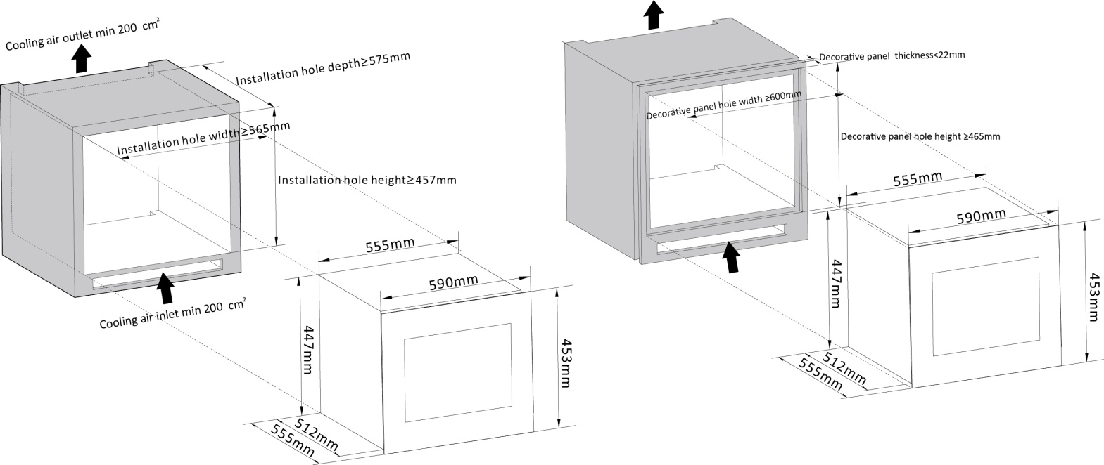

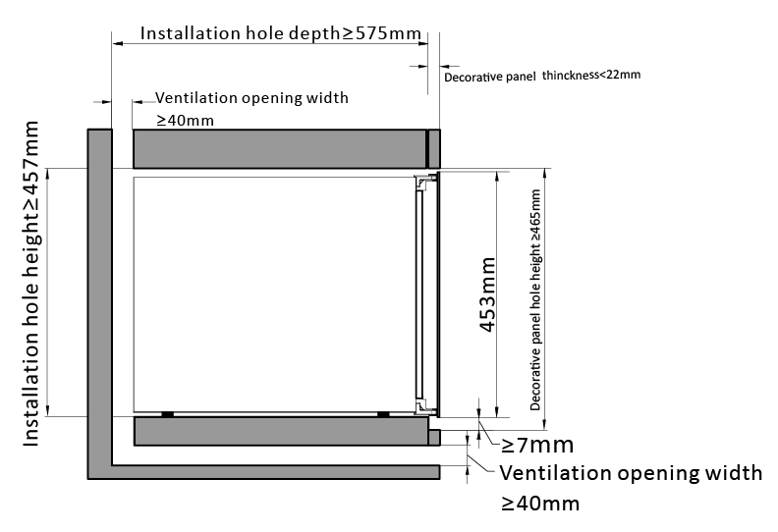

**DXB-26.69DB.TO /** **DXJ-26.69DB**

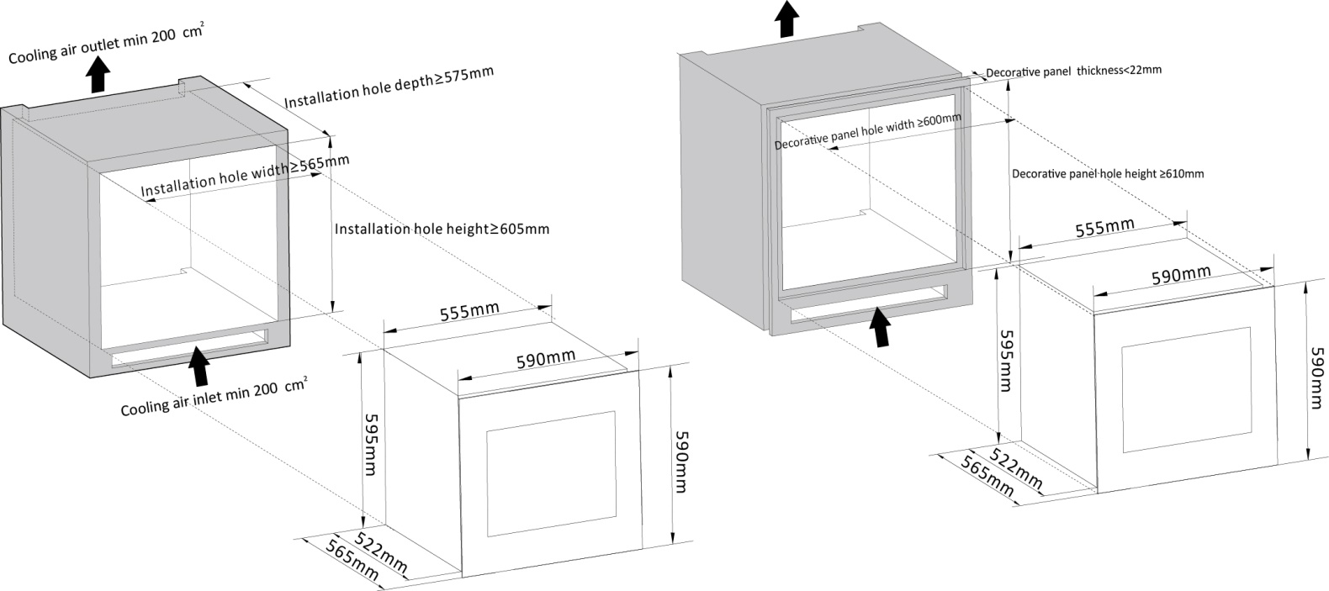

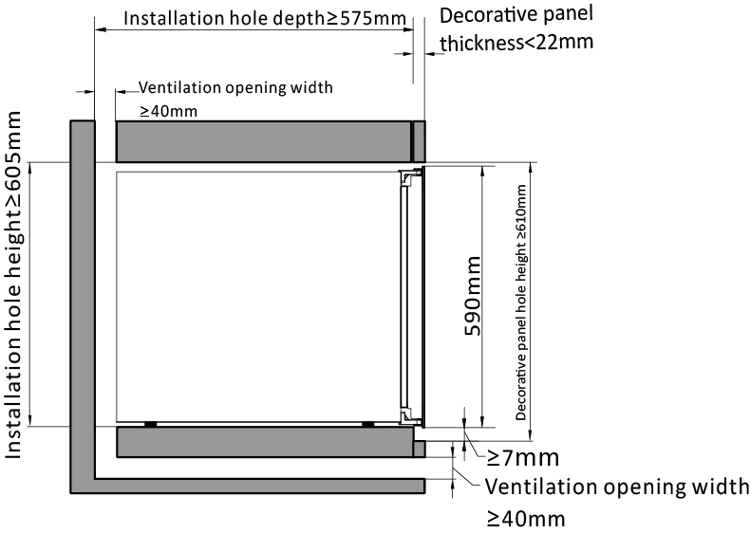

**DXB-42.100DB.TO /** **DXJ-42.100DB**

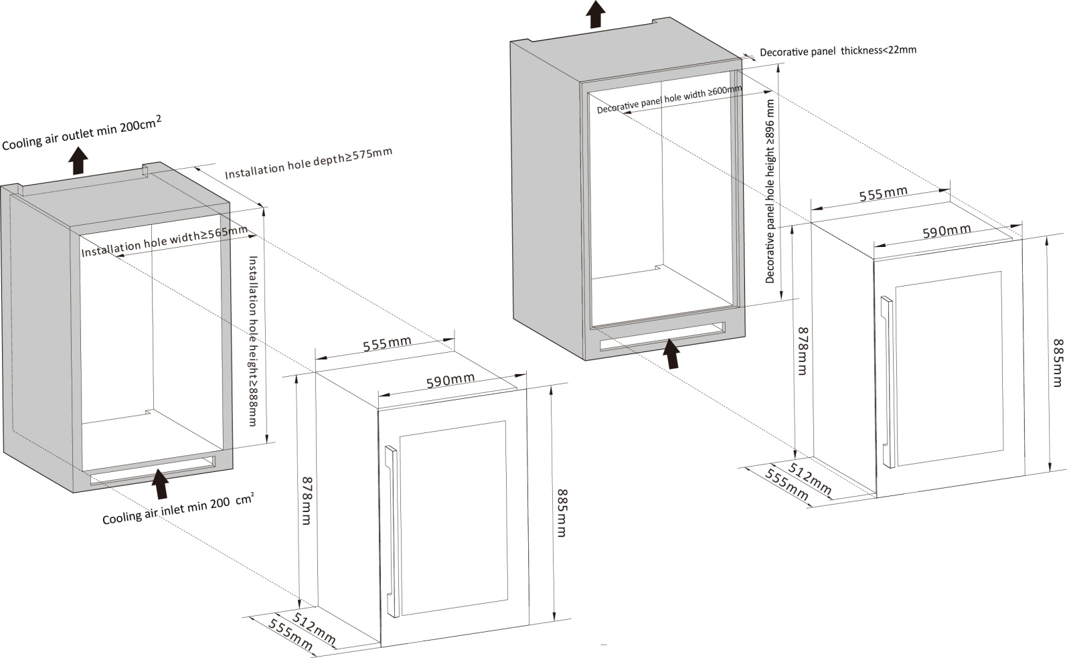

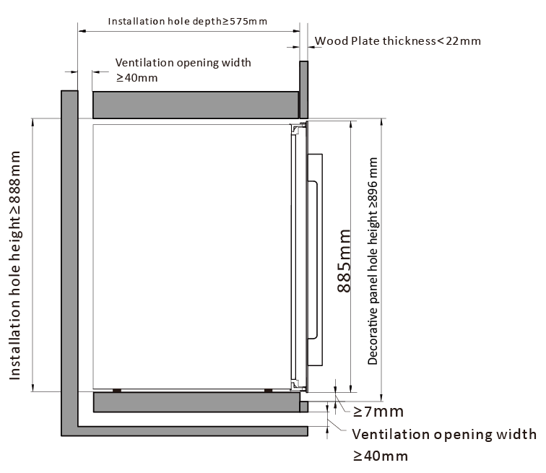

**DXB-65.154DB.TO /** **DXJ-65.154DB**

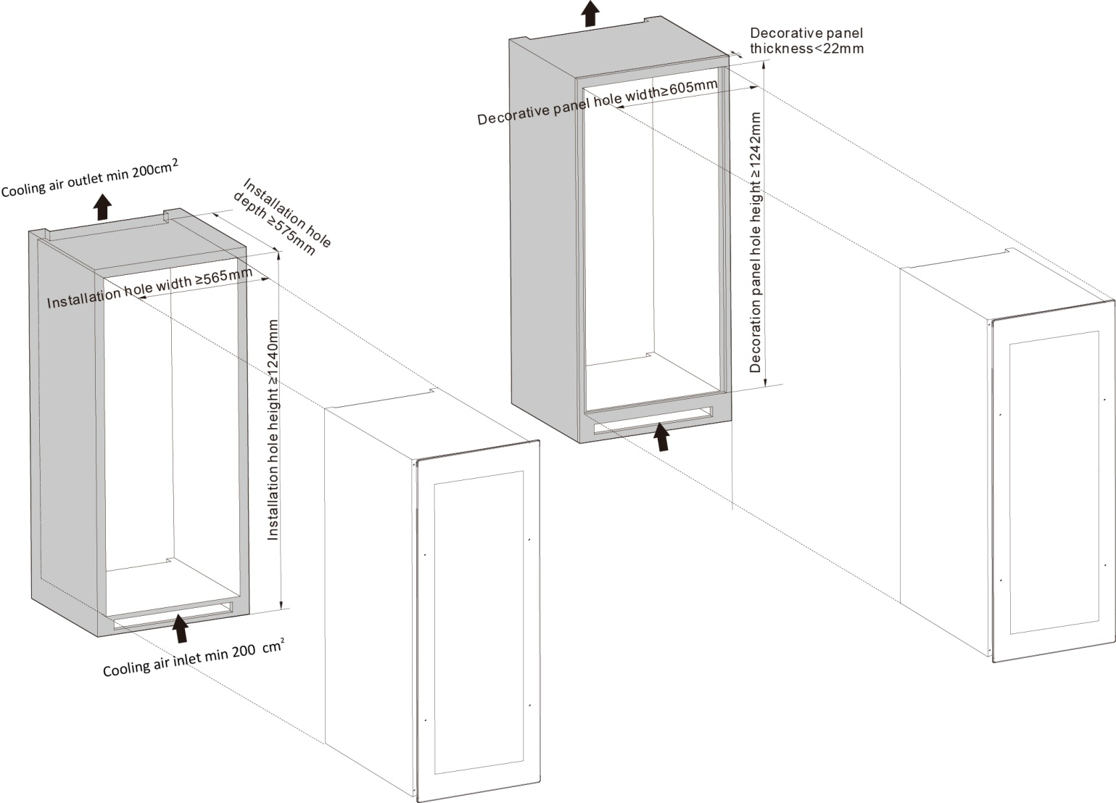

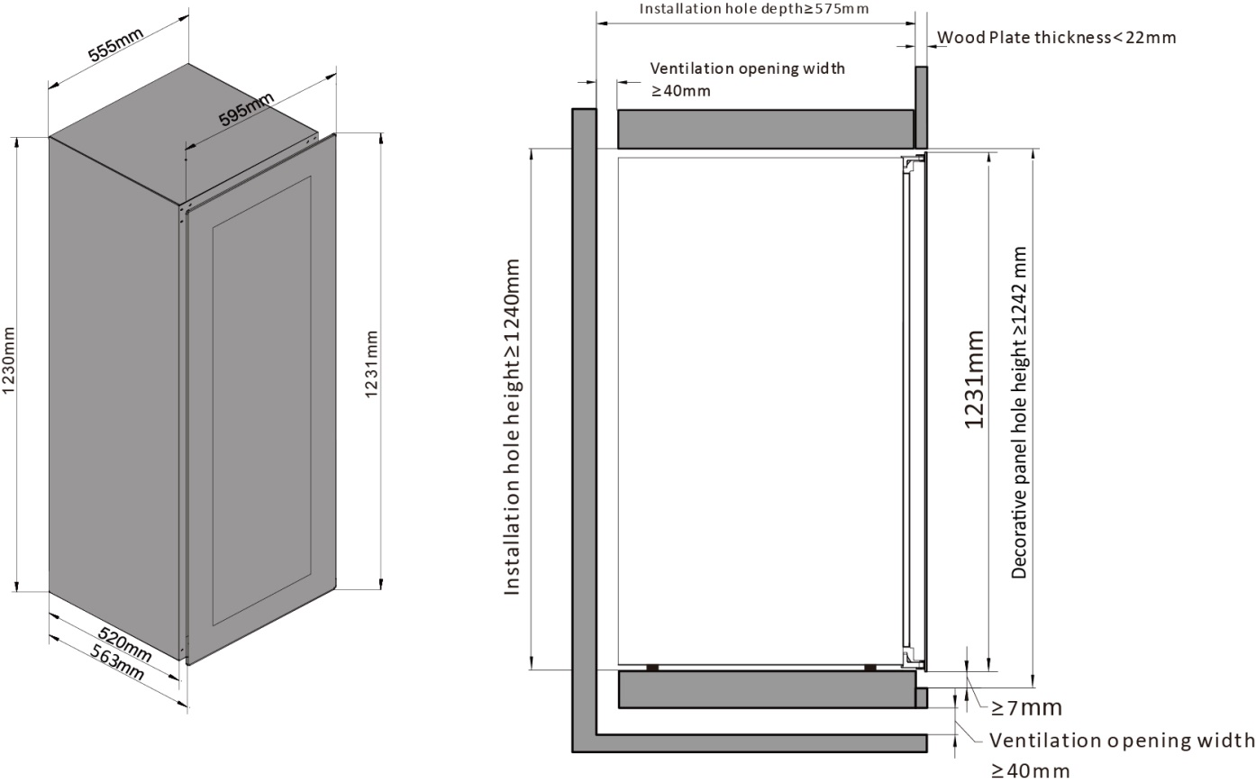

**DAUF-39.119DB.TO**

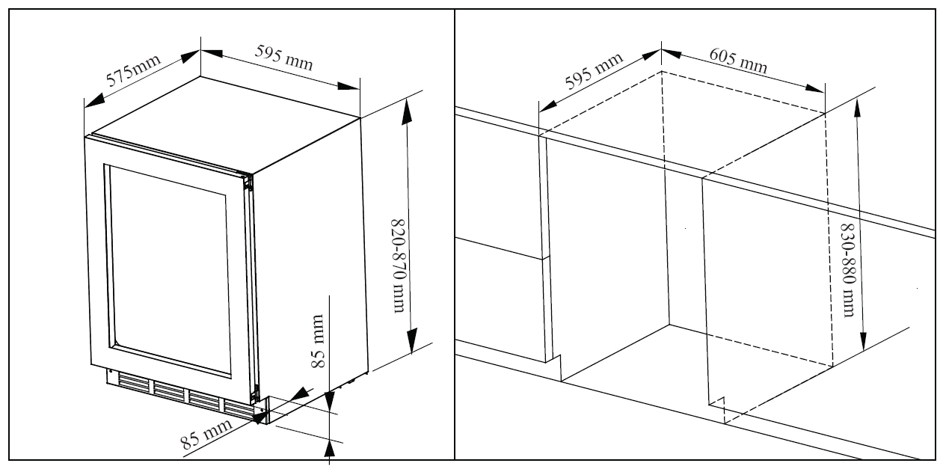

**OPEN ANGLE SIZE DRAWINGS:**

**DXB-24.51B.TO /** **DXJ-24.51B / DXB-42.100DB.TO /** **DXJ-42.100DB**

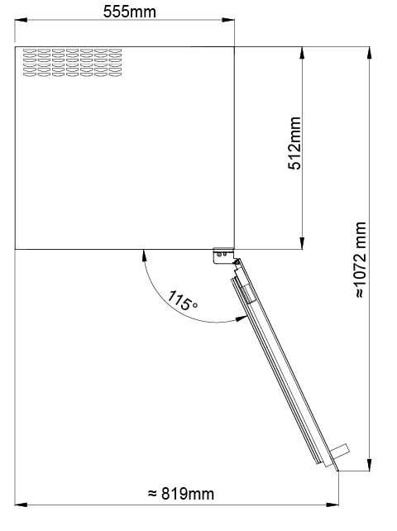

**DXB-26.69DB.TO /** **DXJ-26.69DB / DXB-42.100DB.TO /** **DXJ-42.100DB**

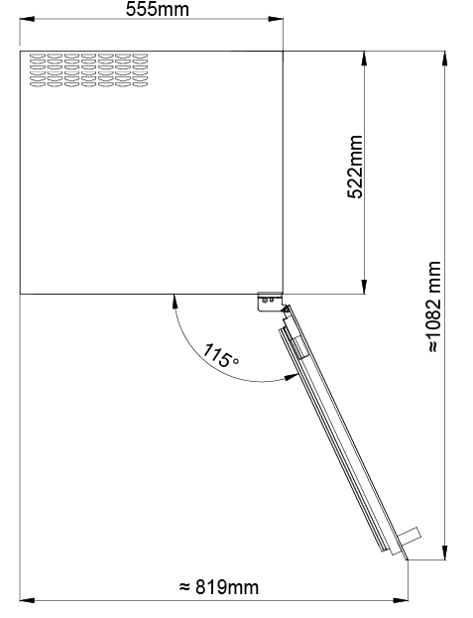

**DAUF-39.119DB.TO**

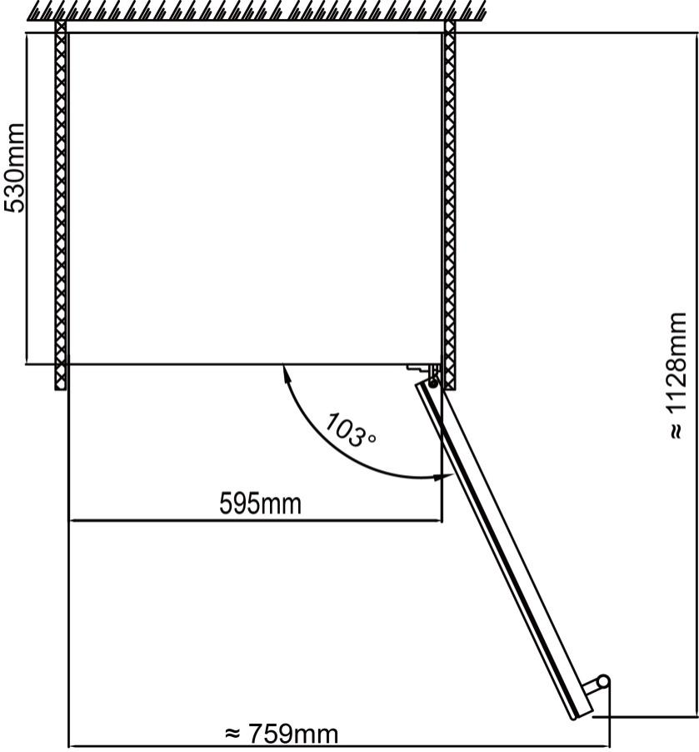

**Ventilation**

**DXB-24.51B.TO / DXJ-24.51B / DXB-42.100DB.TO / DXJ-42.100DB / DXB-26.69DB.TO / DXJ-26.69DB**

**models use a rear ventilation system.**

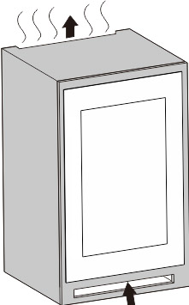

**DAUF-39.119DB.TO model ventilates through the front grille. Never cover the grille of the winecooler.**

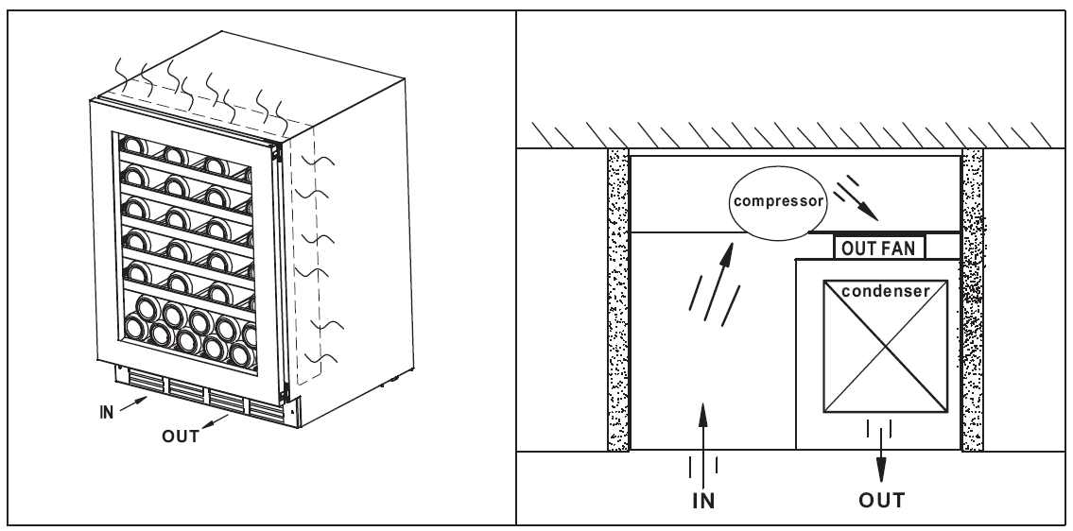

**TURNING ON YOUR WINE CELLAR**

Plug in and switch on the cellar by pressing on the power button **for a few seconds.**

When you use the wine cooler for the first time (or restart the wine cellar after having it shut off for a long time), there will be a few degrees variance between the temperature you have selected and the one indicated on the LED readout. This is normal and it is due to the length of the activation time. Once the wine cooler is running for a few hours everything will stabilize.

***Important: If the unit is unplugged, power is lost, or turned off, wait 3 to 5 minutes before restarting the unit. The wine cooler will not start if you attempt to restart before this time delay.***

**Operating Noises**

To reach the desired temperature settings, Our wine cooler, like all wine coolers operating with compressors and fans, may produce the following types of noises. These noises are normal and may occur as follows:

● Gurgling sound - caused by the refrigerant flowing through the appliance’s coils.

● Cracking/popping sounds - resulting from the contraction and expansion of the refrigerant gas to produce cold.

● Fan operating sound - to circulate the air within the wine cellar.

*An individual’s perception of noise is directly linked to the environment in which the wine cooler is located, as well the specific type of models. Our wine cooler are in line with international standards for such appliance. We will always do its utmost to satisfy its customers but will not retake possession of the goods due to complaints based on normal operating noise occurrences.*

**LOADING YOUR WINE CELLAR**

You may load your wine bottles in single or double rows while taking note of the following: if you do not have enough bottles to fill your wine cellar, it is better to distribute the load throughout the wine cellar so as to avoid “all on top” or “all below” type loads.

● Do remove or relocate adjustable wooden shelves to accommodate larger type of bottles or increase the capacity of the cellar by stacking the bottles up when necessary. (See removing shelves)

● Keep smalls gap between the walls and the bottles to allow air circulation. Like an underground cellar air circulation is important to prevent mould and for a better homogeneous temperature within the cellar.

● Do not over load your wine cellar to facilitate air circulation.

● Do not stack more than 1.5 rows of standard 0.75L bottles per shelves to facilitate air circulation

● Avoid obstructing the internal fans (located inside on the back panel of the wine cellar).

● Do not slide the shelves outwards beyond the fixed position to prevent the bottles from falling.

● Do not pull out more than one loaded shelf at a time as this may cause the wine cellar to tilt forward.

● Do not cover the wooden shelves with alloy foil or other materials, as it will obstruct air circulation.

● Do not move your wine cellar while it is loaded with wines. This might distort the body of the wine cellar and cause back injury.

**TYPES OF REGULATION**

Please note that depending on the loading and settings chosen it takes about 24 hours for the wine cellar to see the temperature stabilizing.

During this time LED seems to move erratically in particular. It is normal and this process occurs whenever the setting is modified and/or whenever a large amount of bottles are added to the cellar.

Designed to store and mature all wines: red, white and sparkling. These wine cellars reproduce the ideal conditions for wine storage, at a constant recommended temperature of 12ºC. They can also be set to provide ideal serving temperature for full enjoyment of the wine’s qualities. Unless stated by the wine maker on the bottle.

**TEMPERATURE SETTINGS**

***Important: The LED displays by default the actual internal air temperature.***

The temperature of the power, before all Settings will be resumed after the electricity to power the preset temperature. The appliance comes with a temperature memory function.

*It is important to understand that there is a difference between the air temperature inside the wine cellar and the actual temperature of the wine:*You will need to wait approximately 12 hours before noticing the effects of temperature adjustment due to the critical mass within a full wine cooler.

Once the temperature is set, it is strongly advised not adjust frequently. The thermostat will maintain the temperature inside the wine cellar within a +/- 2.5ºC range. But the thermal inertia of the wine and the glass is such that within this temperature range, the actual temperature of the wine will only fluctuate 0.5ºC to 1ºC.

**DXB-26.69DB.TO /** **DXJ-26.69DB display operation instructions:**

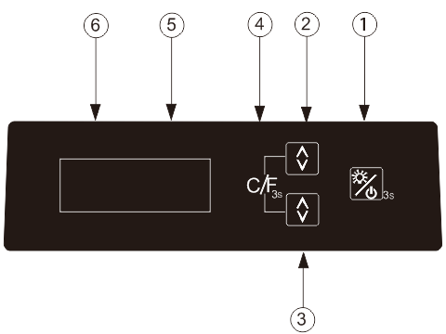

* **①**Lamp & Power Button:

When power cord connected: press and hold for 3 seconds, power is turned on, the machine starts.In the machine power-on-state: press this button, LED lights on; Press once again, LED lights off. (If there is a door light switch, the light will be on only when the light is turned off and the door is opened, and the light will be off when the door is closed. If you want the light to stay on, just turn it on. The door lamp switch will not be controlled.)

In the machine power-on-state: press and hold for 3 seconds, power is turned off, the machine is off.

* **②**Upper zone temperature setting button:

Setting the upper zone temperature in window from 10 to 20 degree Celsius, by each single touch.

* **③**Lower zone temperature setting button:：

Setting the lower zone temperature in window from 5 to 12 degree Celsius, by each single touch.

* **④**C/F display conversion button:

Converting the degrees Celsius / Fahrenheit display in windows , by simultaneously pressing and hold for 3 seconds②③.

**DXB-24.51B.TO /** **DXJ-24.51B** **display operation instructions:**

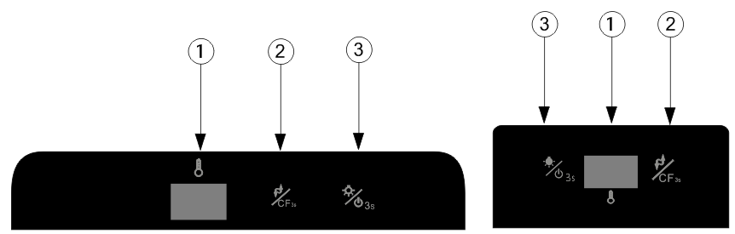

* ① Display Window:

Display the measured temperature inside the wine cooler;

* ② Cycle Button(Temperature control / Fahrenheit Celsius conversion)：

Each time, the temperature inside will drop 1 ℃, until reduced to a minimum, and then a return to the highest temperature.

Press for 3 seconds, the window to achieve Celsius / Fahrenheit display conversion

* ③ Cycle Button(Power switch / light switch conversion)：

In standby mode: press and hold for 3 seconds, power is turned on, the machine starts

In the boot state: short press this button, LED lights on / off switch .

(If there is a door light switch, the light will be on only when the light is turned off and the door is opened, and the light will be off when the door is closed.If you want the light to stay on, just turn it on. The door lamp switch will not be controlled.)

(If it is a lamp with multiple colors, change one color each time you press it.)

In the boot state: press the button for 3 seconds, the power is off, the whole machine is closed.

**DXB-42.100DB.TO / DXJ-42.100DB display operation instructions:**

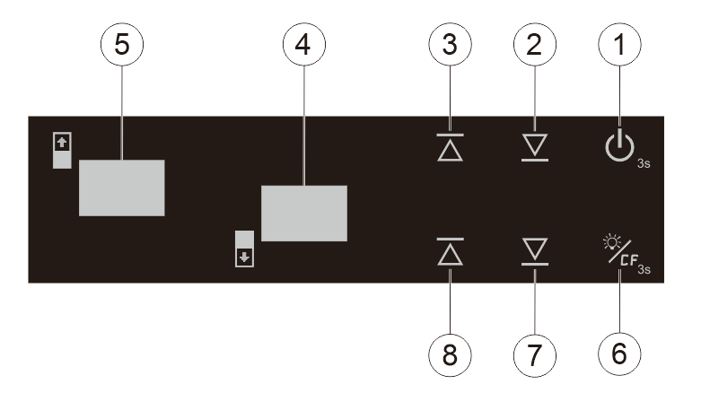

* ① “ON/OFF” the power button :

Press the button 3 seconds to power off (Window ⑤ digital countdown displays 3, 2, 1,). Press again (without delay), the power turns on.

* ② Upper zone temperature setting down button :

Press one time, window ⑤ the set value will reduce 1 degree Celsius in the original setting temperature, the setting range according to customer requirements.

* ③ Upper zone temperature setting up button:

Press one time, window ⑤ the set value will increase 1 degree Celsius in the original setting temperature, the setting range according to customer requirements.

* ④ Window :

Display lower zone temperature.

* ⑤ Window:

Display upper zone temperature

* ⑥ Lamp button:

Press the button and the lamp turns on, the lamp will turn off once press again.

(If there is a door light switch, the light will be on only when the light is turned off and the door is opened, and the light will be off when the door is closed.If you want the light to stay on, just turn it on. The door lamp switch will not be controlled.)

(If it is a lamp with multiple colors, change one color each time you press it.)

* ⑥ C/F display conversion function keys:

Set the conversion degrees Celsius / Fahrenheit display, each press this button, the display window will be into degrees Celsius or Fahrenheit

* ⑦ Lower zone temperature setting down button:

press one time, window ④ the set value will reduce 1 degree Celsius in the original setting temperature, the setting range accordingly to customer requirements.

* ⑧ Lower zone temperature setting up button:

press one time, window ④the set value will increase 1 degree Celsius in the original setting temperature, the setting range accordingly to customer requirements.

**DXB-42.100DB.TO / DXJ-42.100DB display operation instructions:**

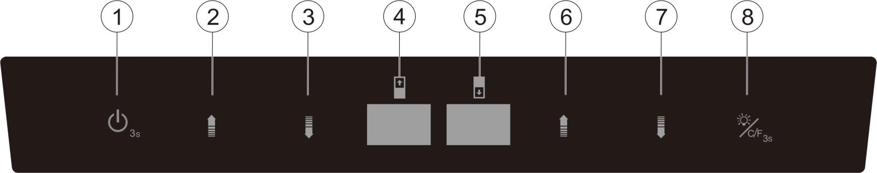

* ① “ON/OFF” the power button :

Press the button 3 seconds to power off (Window ④ digital countdown displays 3, 2, 1,). Press again (without delay), the power turns on.

* ② Upper zone temperature setting up button:

Press one time, window ④ the set value will increase 1 degree Celsius in the original setting temperature, the setting range according to customer requirements.

* ③ Upper zone temperature setting down button :

Press one time, window ④ the set value will reduce 1 degree Celsius in the original setting temperature, the setting range according to customer requirements.

* ④ Window :

Display upper zone temperature.

* ⑤ Window:

Display lower zone temperature

* ⑥ Lower zone temperature setting up button:

press one time, window ⑤ the set value will increase 1 degree Celsius in the original setting temperature, the setting range accordingly to customer requirements.

* ⑦ Lower zone temperature setting down button:

press one time, window ⑤ the set value will reduce 1 degree Celsius in the original setting temperature, the setting range accordingly to customer requirements.

* ⑧ Lamp button:

Press the button and the lamp turns on, the lamp will turn off once press again.

* ⑧ C/F display conversion function keys:

Set the conversion degrees Celsius / Fahrenheit display, each press this button, the display

window will be into degrees Celsius or Fahrenheit

**IMPORTANT INFORMATION ABOUT TEMPERATURE**

Your wine cooler has been designed to guarantee optimum conditions for storing and/or serving your wines.

All wines mature at the same temperature, which is a constant temperature set between 12ºC to 14ºC. Only the temperature of “dégustation” (wine appreciation) varies according to the type of wines. This being said and as it is for natural cellars used by wine producers for long period of storage, it is not the exact temperature that is important, but its consistency. In other words, as long as the temperature of your wine cellar is constant (between 12ºC to 14ºC) your wines will be stored in perfect conditions.

**DEFROSTING/CONDENSATION/ HYGROMETRY/ VENTILATION**

Your wine cellar is designed with “Auto-cycle” defrost system. During “Off-cycle” the refrigerated surfaces of the wine cellar defrost automatically. Defrost water from the wine cellar storage compartment drains automatically and part of it goes into a drainage container, which is located at the back of the wine cellar next to the compressor. The heat is transferred from the compressor and evaporates any condensation that has collected in the pan. Part of the remaining water is collected within the wine cellar for humidity purposes.

This system enables the creation of the correct humidity level inside your wine cellar required by the natural cork to maintain a long-lasting seal.

**Manual defrosting is recommended every 6-12 months.**

**Notes:** *The water collected by condensation, is therefore recycled. Under extremely dry environmental conditions, you may have to add some water into the water container provided with your wine cellar*.

All units are equipped with a double-glazed glass door that has a third internal acrylic layer to minimize condensation on the glass door.

The wine cellar is not totally sealed; fresh air admission is permitted through the drainpipe. Air is circulated through the cellar by means of a fan / fans and the hollow shelves.

**Notes:** *During the refrigerating cycle, heat is given off and disperses through the external surfaces of the wine cellar. Avoid touching the surfaces during those cycles.*

**ADJUSTABLE WOODEN SHELVES**

Shelf installation and taking instruction:

Sliding wooden shelf installation and taking instruction:

Shelf taking: According to below instruction drawing to pull out the shelf to support bracket ① , press two sides of sliding roller buckles and pull out the shelf following the arrow mark ② .Shelf installation: According to below instruction drawing to push in the shelf alignment with two sides of sliding roller following the arrow mark ③ .



**REVERSIBILITY OF THE DOOR**

**Warning:** To avoid accidents during the process of changing the door, we recommend that you get assistance. The glass door is heavy and may cause injury if dropped. Please turn off the power before reversing the door.

1. Use knife/screwdriver to pry the six trunk-nails from left side of cabinet. Please be careful, don’t hurt the hands and don’t damage the surface of cabinet (Picture 1)

2. Open the door, use Phillips screwdriver to loosen the screws of upper and lower door hinge, and then remove the door (Picture 2)

3. Then use hexagon wrench to loosen the screws of upper and lower door hinge, remove the door hinge, and then install upper door hinge at lower opposite side, install lower door hinge at upper opposite side (Picture 3)

4. The upper and lower ends of the removed door are directly aligned with the door hinges on the left side of the cabinet, adjust the door, and tighten the upper and lower screws with a Phillips screwdriver to complete the door replacement. Then install six trunk-nails to right side (Picture 4 & Picture 5)

5. After closing the door, check whether the probe on the door frame is aligned with the metal plate on the cabinet. If it is not aligned, loosen the screws on the upper and lower door hinges and adjust the door until it is aligned (Picture 6)

6. Plug in the power, find the press sign, and slowly press twice, if the door can be opened, the reversible door is successful.



**Installation Instruction:**



1. Put the wine cooler into the cabinet, then adjust the wine cooler to make it steady. Open the door, take out the fixed plate , 2pcs Inner Hexagon Screws ,and Inner Hexagon Screwdriver from accessory bag , then use the inner hexagon screwdriver to tighten the fixed plate on the lower left side of wine cooler.
2. Take out 3pcs Phillips screws from accessory bag , use Phillips screwdriver to tighten the fixed plate on the lower left side of wine cooler(1pcs screw) , then tighten the other 2pcs Phillips screws on the upper door hinge and lower door hinge.

**OPERATION ANOMALIES**

Ensure that there is power to the electrical supply plug by connecting another electrical appliance to it. Check fuse, if any. Make sure that the door is closed properly.

If your wine cellar appears to be malfunctioning, unplug it and contact your after sales service. Any intervention on the cold circuit should be performed by a refrigeration technician who should carry out an inspection of the circuit sealing system. Similarly, any intervention on the electrical circuit should be performed by a qualified electrician.

**Notes:** *Any intervention performed by a non- authorized technician We will lead to the warranty being considered as null and void.*

**WARRANTY**

This product comes with a warranty period of 3 years. You can extend the warranty of your compressor up to 5 years if you register your appliance via the following link:

dunavox.com/product-registration

The warranty does not cover:

* Damage in transit or when moving the appliance.
* Any damages caused from negligence, accident, improper use, improper installation/service or use for purposes other than those described in the instruction manual.
* Damage caused by connecting your product to the wrong power source.
* Damage from power failure.
* Faulty installation or modification made during installation.
* Damage caused by unauthorized repair.
* Any damages resulting from force majeure, fire disaster or natural disaster.
* Alterations to the product without express permission from the manufacturer.
* Parts such as light, removable shelves, or plastic.
* Any spoilage or damage to wines or any other contents incidental or consequential to possible defects of the unit.

The warranty clauses and specifications are subject to change without notice.

**Conformity**

This appliance is designed and tested according to the following regulations and directives:

|  |
| --- |
| LVD 2014/35/EU |
| EMC 2014/30/EU |
| ERP (EU)2017/1369 2009/125/EC |
| RoHS 2015/863 |
| CB |