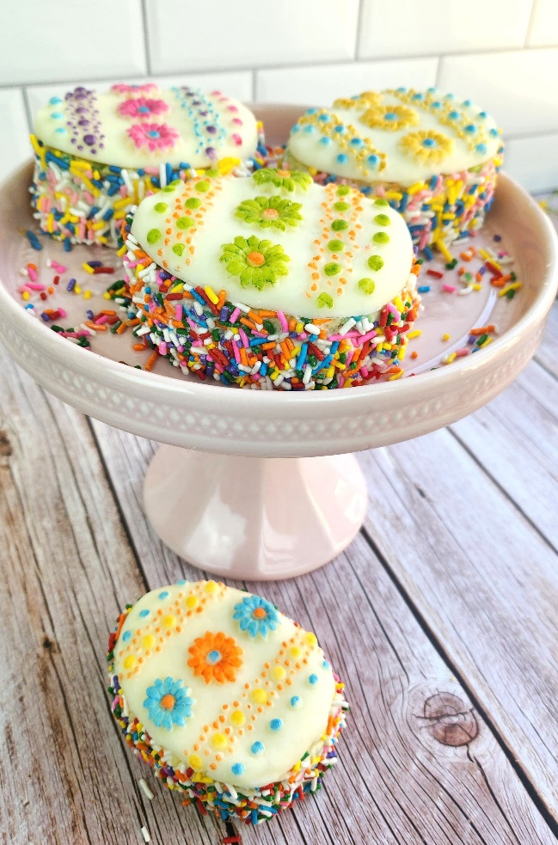

**ROLLED BUTTERCREAM**

**Sugar Cove Sweets by Brittany Bolus**

Ingredients

2 Sticks Butter

2 Lbs Powdered Sugar

1 Tsp Clear Vanilla Extract

4 Tbsp Light Corn Syrup

2 Tsp White Gel Food Coloring

Salt to Taste

Instructions

1. First, Add the Butter, Powdered Sugar, Corn Syrup, and Vanilla Extract to a stand mixer with

the paddle attachment.

2. Cover bowl to avoid a powdered sugar explosion!

3. Next, start on low and add the white gel food coloring and salt to taste. I recommend about

1/4 teaspoon of salt!

4. Increase speed to medium-low as a delicious ball of buttercream forms.

5. Roll out between 2 sheets of parchment or wax paper. You can use cornstarch to prevent any

sticking!

6. Lastly, you can start using immediately, store in an air-tight container in the refrigerator (up to

a month), or store in the freezer (up to 3 months)! When you are ready to use, take out

and thaw to room temperature and it's ready to go!