Customers ordering Seadoo MPEM Modules that replaced their old module numbers:
278000262
1993 SP, SPX, SPI, GTS, GTX
278000070
1994 GTS, GTX, SP, SPI, SPX
DO NOT WIRE THE MODULE UP BASED ON THE LOCATION OF THE WIRES. WIRE THE MODULE BASED ON THE COLORS OF THE WIRE ONLY. THE ONLY DIFFERENCE IN THE WIRE COLORS BETWEEN OURS AND THE STOCK MODULE IS THE OEM MODULE HAS A RED/PURPLE (FEMALE TERMINAL) WITH A PURPLE (FEMALE TERMINAL) BRANCH OFF, WHILE OUR AFTERMARKET MODULE HAS A RED/WHITE (FEMALE TERMINAL) WITH PURPLE (FEMALE TERMINAL) BRANCH OFF.
RD/PUR (female terminal) or RD/WHT (female terminal) goes to panel. The PUR (female terminal) wire that branches off from the RD/PUR (female terminal) or RD/WHT (female terminal) goes to the power trim if it is applicable to your model.
RD (Ring Terminal) goes to Starter Solenoid.
YEL/RD (Ring Terminal) goes to Starter Solenoid.
BLK/WHT (Ring Terminal) goes to Starter Solenoid.
BLK/YEL (female terminal) goes to Stop Switch. BLK/WHT (female terminal) branches off from BLK/YEL (female terminal), BLK/WHT (female terminal) goes to Start Switch.
BLK/RED (male terminal) goes to Ignition Coil.
RED (female terminal) goes to Voltage Regulator/Rectifier.
BLK (Ring Terminal) goes to Ground. BLK (Ring Terminal) that branches off from BLK (Ring Terminal) is also Ground.

Customer ordering Seadoo MPEM Modules that replaced their old module:
278000200 ONLY
1992 SP, XP, GTS, GTX
Please be aware that 278000200 is the older style module that has relays instead of fuses that the new modules have. This aftermarket module has fuses, just like module 278000262 and module 278000070. If you have relays on your module, our module will work fine. Module 278000200 now current supersedes to the later number 278000070. If you were to attempt to order a 278000200 module, the dealer would send you a 278000070 module.

DO NOT WIRE THE MODULE UP BASED ON THE LOCATION OF THE WIRES. WIRE THE MODULE BASED ON THE COLORS OF THE WIRE ONLY. THE ONLY DIFFERENCE IN THE WIRE COLORS BETWEEN OURS AND THE STOCK MODULE IS THE OEM MODULE HAS A PURPLE (FEMALE TERMINAL) WITH A RED/PURPLE (FEMALE TERMINAL) BRANCH OFF, WHILE OUR AFTERMARKET MODULE HAS A RED/WHITE (FEMALE TERMINAL) WITH PURPLE (FEMALE TERMINAL) BRANCH OFF.
PUR (female terminal) or RD/WHT (female terminal) goes to panel. The RED/ PUR (female terminal) wire that branches off from the PUR (female terminal) or RD/WHT (female terminal) goes to the power trim if it is applicable to your model.
RED (Ring Terminal) goes to Starter Solenoid. The OEM module had a RED wire with fuses and a RED/WHITE with fuses going into a single ring terminal. The aftermarket module no longer requires fuses and both wires. DO NOT ATTEMPT TO SPLICE AND WIRE UP THE RD/WHT (FEMALE TERMINAL) THAT GOES TO THE PANEL. AS STATED ABOVE THE RD/WHT GOES TO THE PANEL. IT DOES NOT GO TO THE STARTER SOLENOID!
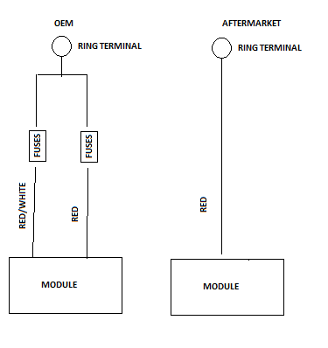
YEL/RD (Ring Terminal) goes to Starter Solenoid.
BLK/WHT (Ring Terminal) goes to Starter Solenoid.
BLK/YEL (female terminal) goes to Stop Switch. BLK/WHT (female terminal) branches off from BLK/YEL (female terminal), BLK/WHT (female terminal) goes to Start Switch.
BLK/RED (male terminal) goes to Ignition Coil.
RED (female terminal) goes to Voltage Regulator/Rectifier.
BLK (Ring Terminal) goes to Ground. BLK (Ring Terminal) that branches off from BLK (Ring Terminal) is also Ground.
