**Plain Hook & S-Shape Hand-Made Clasps from Wire**

(Craft Wire Project #49b)

**Hook Clasp**

1. Cut a 2 ¼” piece of 16- or 18-gauge wire.

2. Follow the steps in the photo below.

3. If desired, hammer the clasp to work-harden or to create texture.

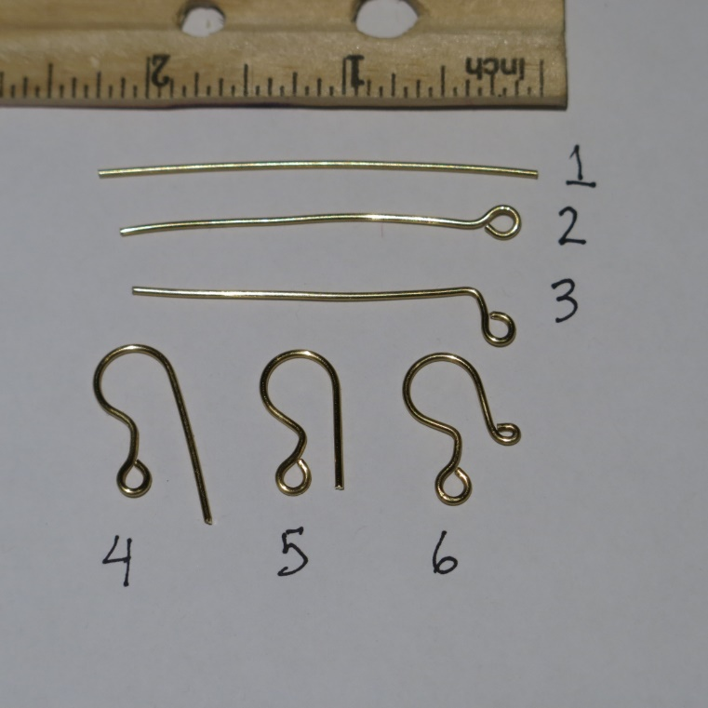

**S-Shape Clasp**

1. Cut a 2 ½” piece of 18- or 16-gauge wire. Note: This length is based on using a 5mm. mandrel. Adjust the length for different mandrel sizes.

2. Flush-cut both ends (cut off any pointy parts so you have flat ends).

3. Make a small loop on each end of the wire, with your round-nose pliers. The loops should be going in opposite directions.

4. Hold the wire so the right-side loop is facing down & the left-side loop is facing up.

5. Use 5mm. bailing pliers or other 5mm. mandrel. Place mandrel above & just to the left of the right-side loop.

6. Bend the wire from the left up & over the mandrel towards the right-side loop & all the way over until it touches the edge of the right-side loop.

7. What used to be the left-side loop should now be on the right side, facing down. Place the mandrel above & just to the left of this loop, & repeat Step 6.

8. Make sure the small loops meet at the center bar.

9. Hammer the component to strengthen (and flatten a bit, if you like the way it looks).

10. Make the S-shape into a clasp by opening one side of the S a little bit.

11. To make the loop end of the clasp, start with a large loop on one side, and make a double, smaller loop on the other side.

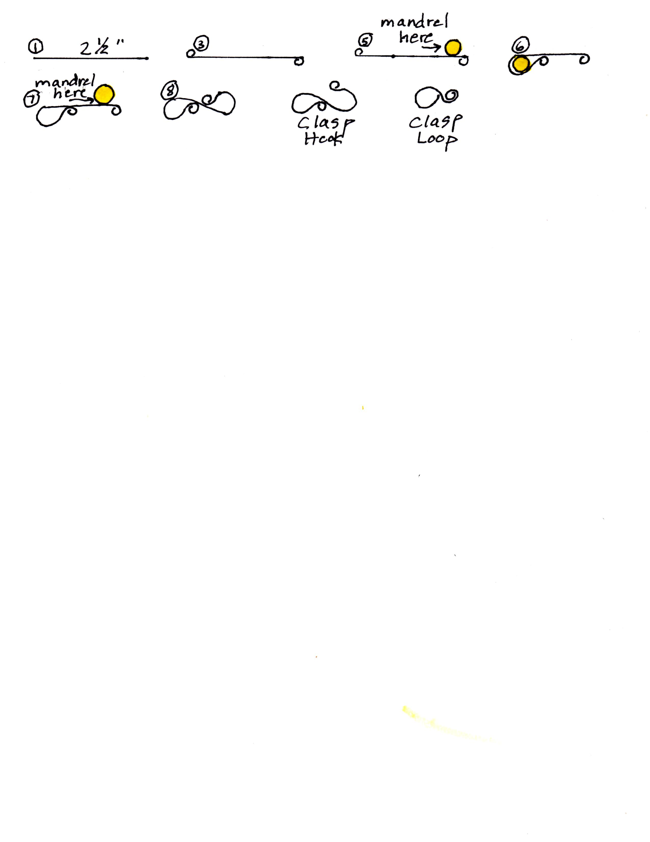

©2021 Susan Ryza [**www.susanryza.com**](http://www.susanryza.com) 1/4/21