**Wire & Metal Shapes Earrings**

(Metalwork Project #451)

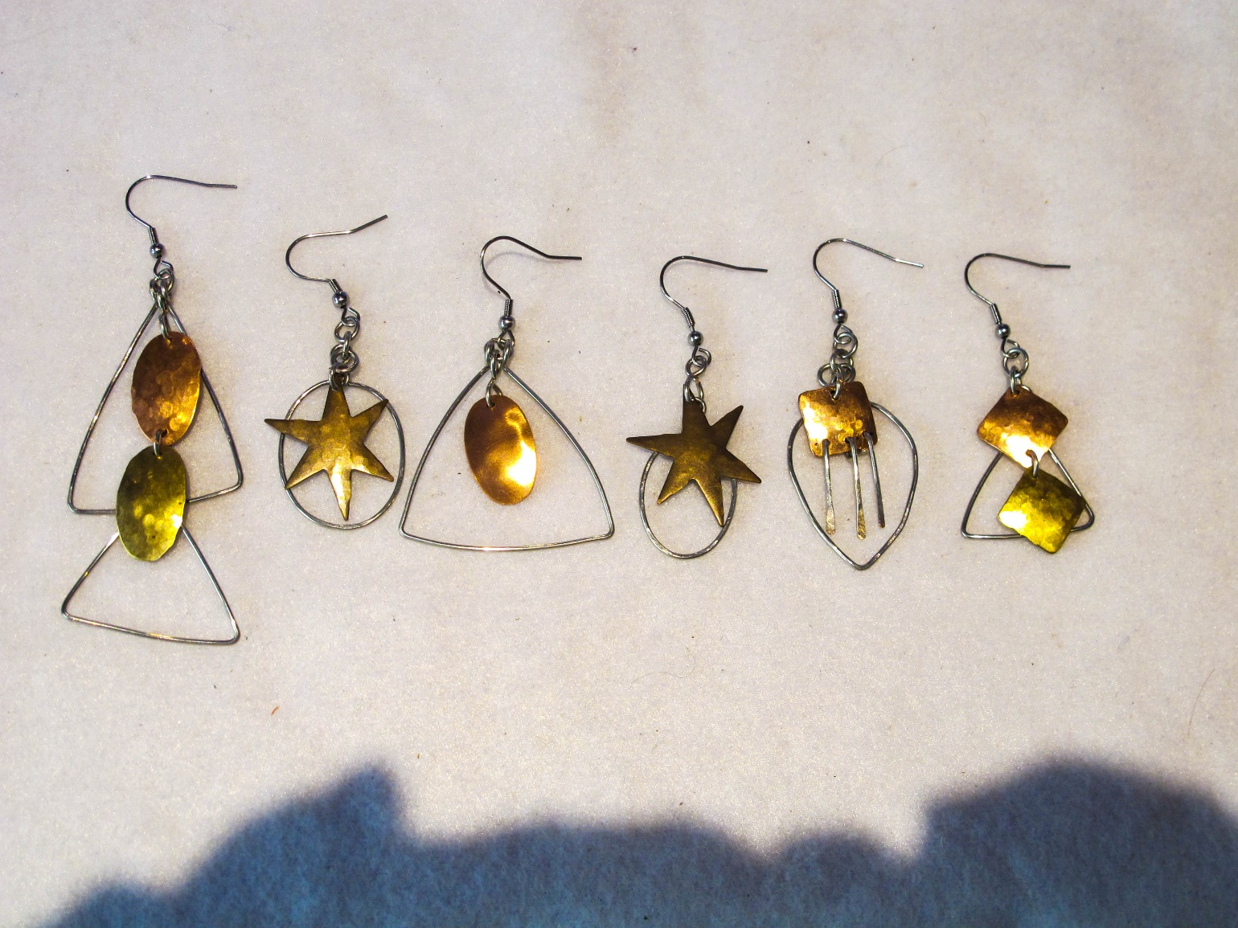

**Materials Needed:**

Earring wires

24-gauge metal blanks or 24-gauge sheet metal

18-gauge wire

**Tools Needed:**

Wire flush cutter

2 pairs of Chain-nose pliers

Round-nose pliers

Metal hole punch

Dapping block

Steel bench block

Chasing hammer

Ball peen hammer

Other texturing hammers (optional)

Metal shears

3mm. bailing pliers or 3mm. knitting needle or other mandrel

Plastic shape mandrels (optional)

File

Fine tip Sharpie

**Instructions**

NOTE: Make 2 of everything at the same time so you are sure to have matching earrings.

**Make the Wire Shape(s) (Example: Irregular triangle)**

1. Cut about 5“ of wire.

2. Bend wire over tip of round-nose pliers to create sides. Use round-nose pliers in stead of chain-nose to create rounded corners.

3. Cross sides over each other.

4. Bend about ½” of shorter side over longer side.

5. Wrap bent piece around longer piece. Trim off excess wire.

6. Cut longer side to about ½”.

7. Form into loop.

You can do the same thing to make other wire shapes, such as round or oval.

Earrings can have one or more wire shapes.

**Prepare the Metal Piece(s)**

1. Cut your own shape from sheet metal or use pre-made shapes.

2. To cut your own, draw the shape you want to cut on your metal sheet. Use metal shears to cut out the shape. File any sharp edges. Proceed to next steps as with pre-cut shapes.

3. Use ball peen or other hammer(s) to texture the metal.

4. Use dapping block to round the shape.

5. Mark a dot with the Sharpie where you want to punch a hole. Make sure the hole is quite close to the edge. Punch one hole at the top if the piece will hang alone. Punch holes on top and bottom if something will hang from the bottom of the piece.

6. Carefully line up the punch with the marked hole and punch out the hole(s).

**Make Jump Rings**

1. Wrap the wire around the 3mm. bailing pliers or mandrel to make a coil of 6 or 7 rounds.

2. Remove the coil from the mandrel.

3. Cut rings off individually.

**Assemble the Earrings**

1. Hang a jump ring from an earring wire.

2. Hang a metal piece and a wire shape from another jump ring and then hang the second jump ring from the first one. The wire shape should be behind the metal piece.

3. If desired, hang another jump ring from the bottom of the metal piece with a second metal piece and/or a second wire shape.

**Dangles (optional)**

1. Punch holes across the bottom of a metal piece.

2. Cut 1” pieces of wire, as many as needed for the number of punched holes.

3. Hammer one end of each wire piece to make a paddle shape.

4. Smooth round with file.

5. Make a loop at the other end, perpendicular to the flat paddle.

6. Hang dangles from the punched holes.

©2022 Susan Ryza [**www.susanryza.com**](http://www.susanryza.com) 4/21/22

.