Mixed Knots Macrame Bracelet with Button Closure
(Macrame Project #442)

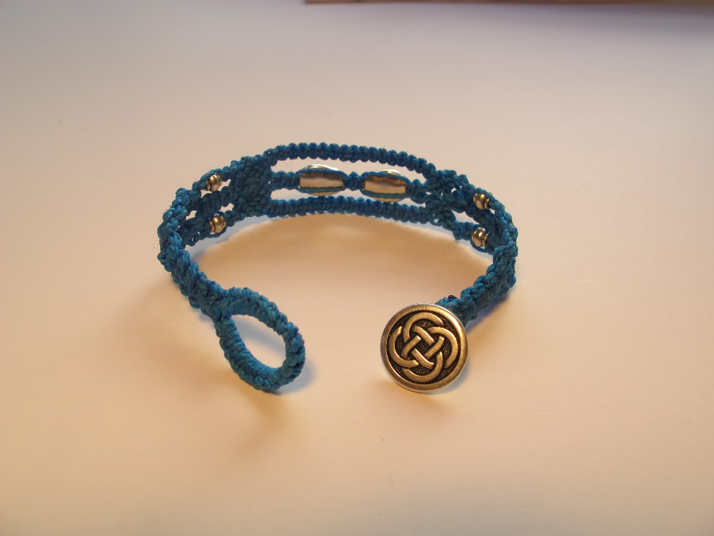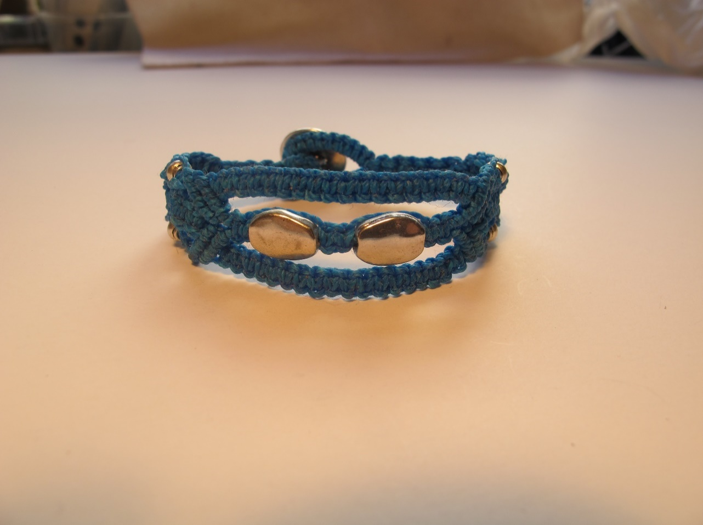

Materials Needed
13 yds. of cord (waxed polyester or Superlon TEX 400)
(1) ½” to ¾” button with shank
6-10 beads with holes large enough to fit on 2 strands of cord

Tools Needed
Macrame board or clip board
T-pins
Scissors
Ruler
Cigarette lighter to melt cord ends, or G-S Hypo Cement

Instructions
1. Cut 5 cords, 6 feet long each, plus 1 cord, 8 feet long.

CREATING THE CLASP LOOP
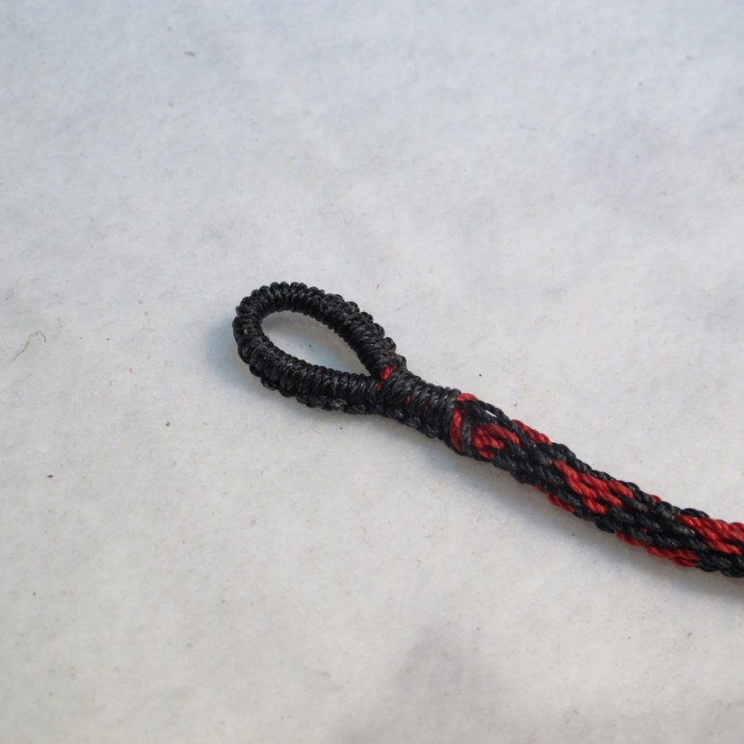 Finished Loop
2. Match up one end of each of the 6 strands. The 8 ft. strand will hang longer than the others.
3. Fold strands in half so that the ends of the shorter strands match up and the 8 ft. strand hangs longer on only one side.
4. Clipboard Method: Find the center fold point of the 6 strands, unfold the strands, and, without losing the center point, clip them onto the clip board with the 6 matching ends going up from the top of the clipboard & the 6 ends that include the longer end of the 8 ft. strand hanging below, onto the clip board. Then loosen the clip and move the strands down so that they are clipped at the spot 1 ½” above the center fold point. The longest strand should be on the furthest right side of the 6 strands, hanging longer than the other 5 strands.
5. Macrame Board Method: Find the center fold point of the 6 strands, unfold the strands, and, without losing the center point, squeeze them all together into a notch on the top of the macrame board with the 6 matching ends going up from the top of the board & the 6 ends that include the longer end of the 8 ft. strand hanging below, onto the board. Move the strands down so that they are inside the notch at the spot 1 ½” above the center fold point. The longest strand should be on the furthest right side of the 6 strands, hanging longer than the other 5 strands.

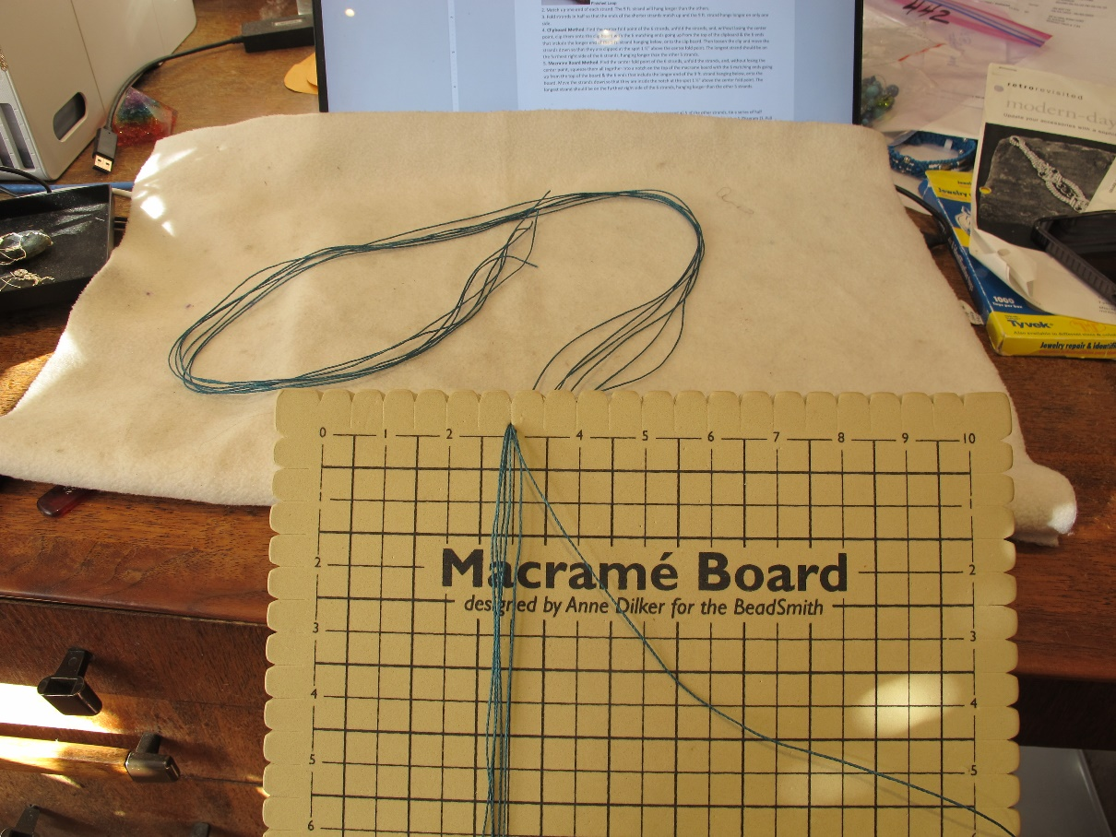
6. Using the longer strand as your working cord, and working around all 5 of the other strands, tie a series of half hitches. Alternate bringing the working cord over the other 5 (Diagram 1) and then under the other 5 (Diagram 2). Pull very tightly.
7. Continue tying alternating half hitches until you have a knotted section long enough, when folded in half, for your button to slip through (about 1 ½” to 2”, depending on size of button).

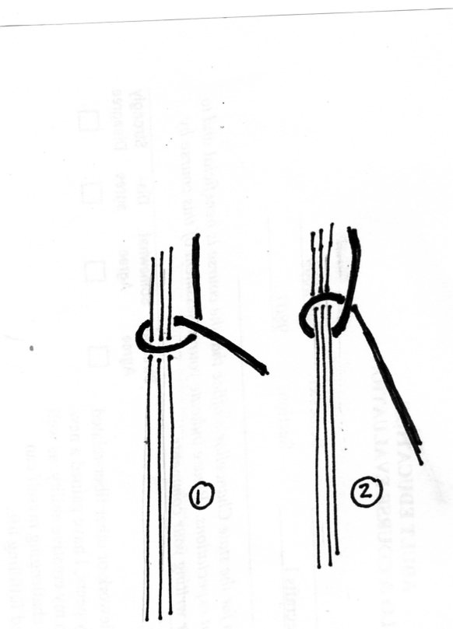 Alternating half hitches 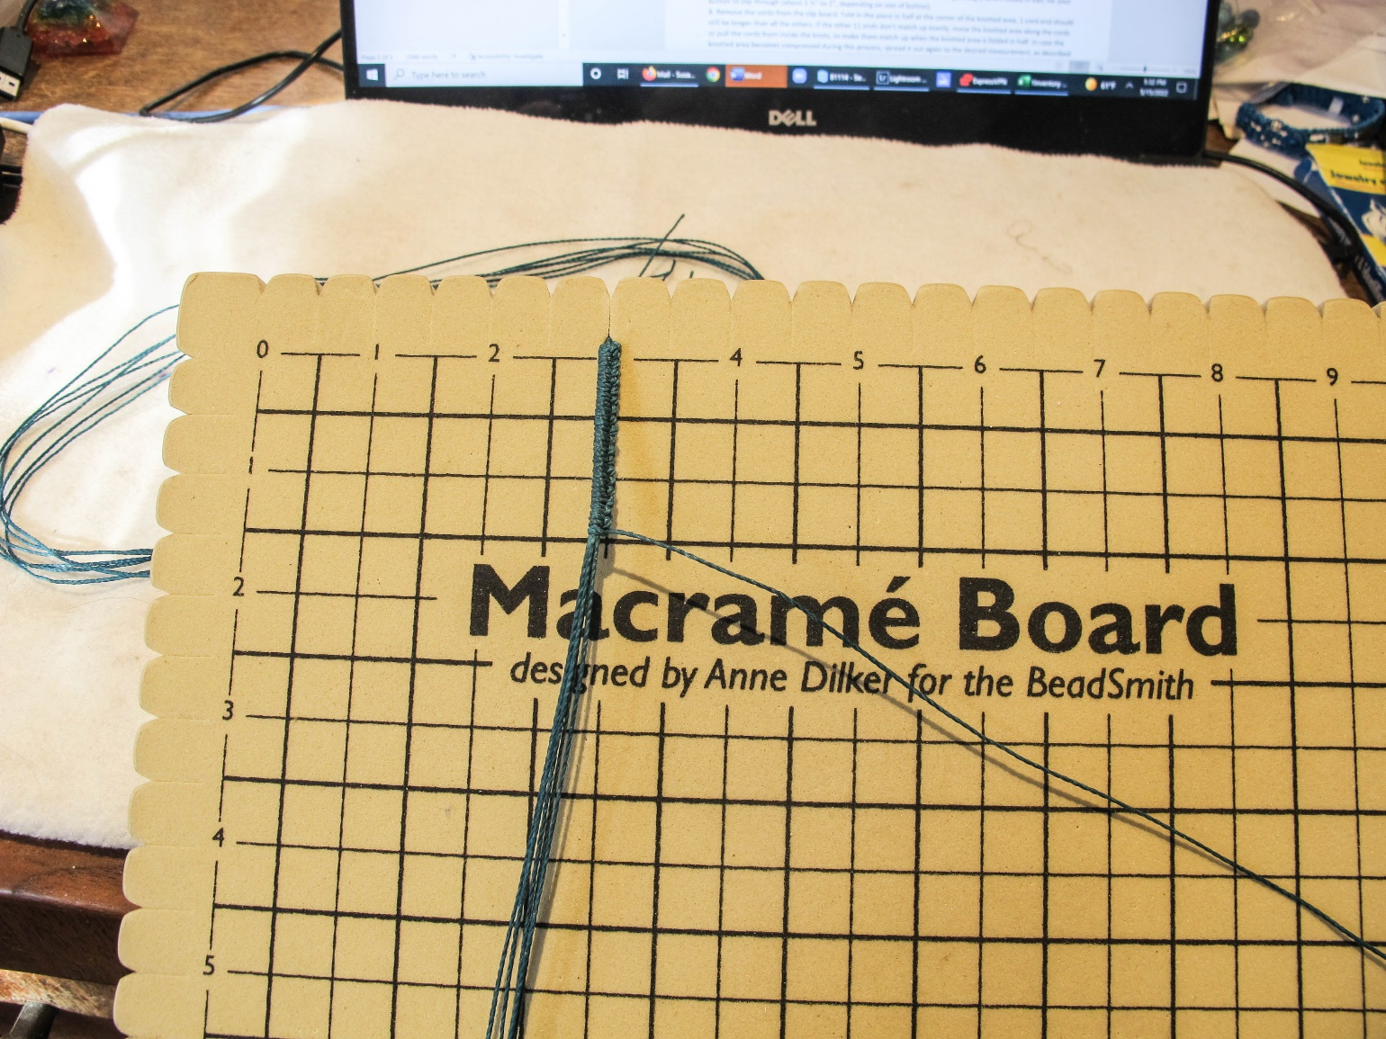

8. Remove the cords from the clip board. Fold the piece in half at the center of the knotted area. One cord end should still be longer than all the others. If the other 11 ends don’t match up evenly, move the knotted area along the cords or pull the cords from inside the knots, to make them match up when the knotted area is folded in half. In case the knotted area becomes compressed during this process, spread it out again to the desired measurement, as described in Step 7.
9. When 11 of the ends match up, and the knotted area is the right length to fit around the button, fold the knotted area in half again and match up the 2 end points of the knotted area. Hold these 2 end points together & clip the folded, knotted area onto the clipboard or pin it onto the macrame board with the longest of all 12 ends on the right-most side.
10. Tie another ½” (about 8 knots, depending on thickness of cord) of alternating half hitches, tightly, around all 11 of the other strands to hold them all tightly together. When competed, you should have a loop just the right size to fit around your button. The button should fit tightly but definitely be able to fit through the loop. You can adjust the loop size at this point by pulling the knots slightly up or down.
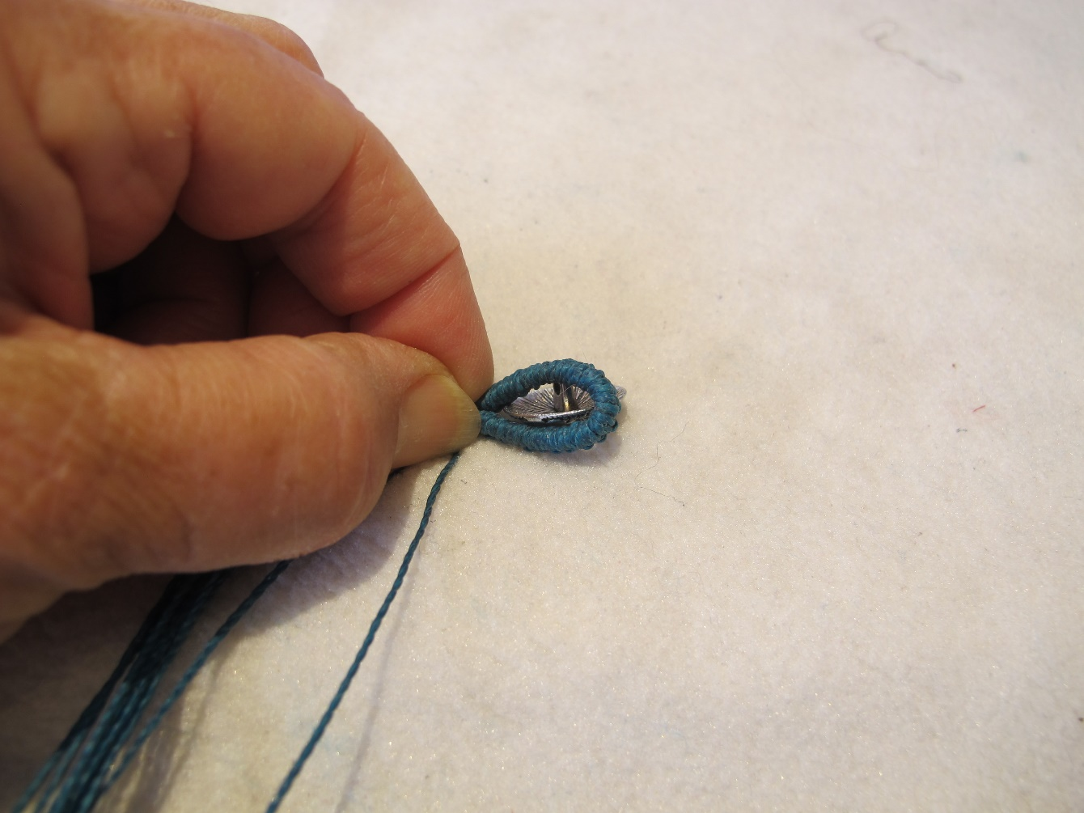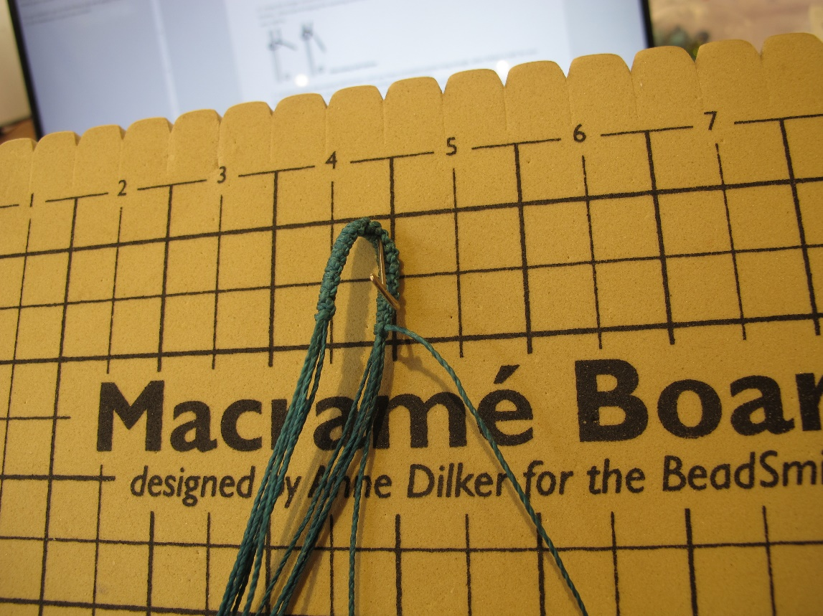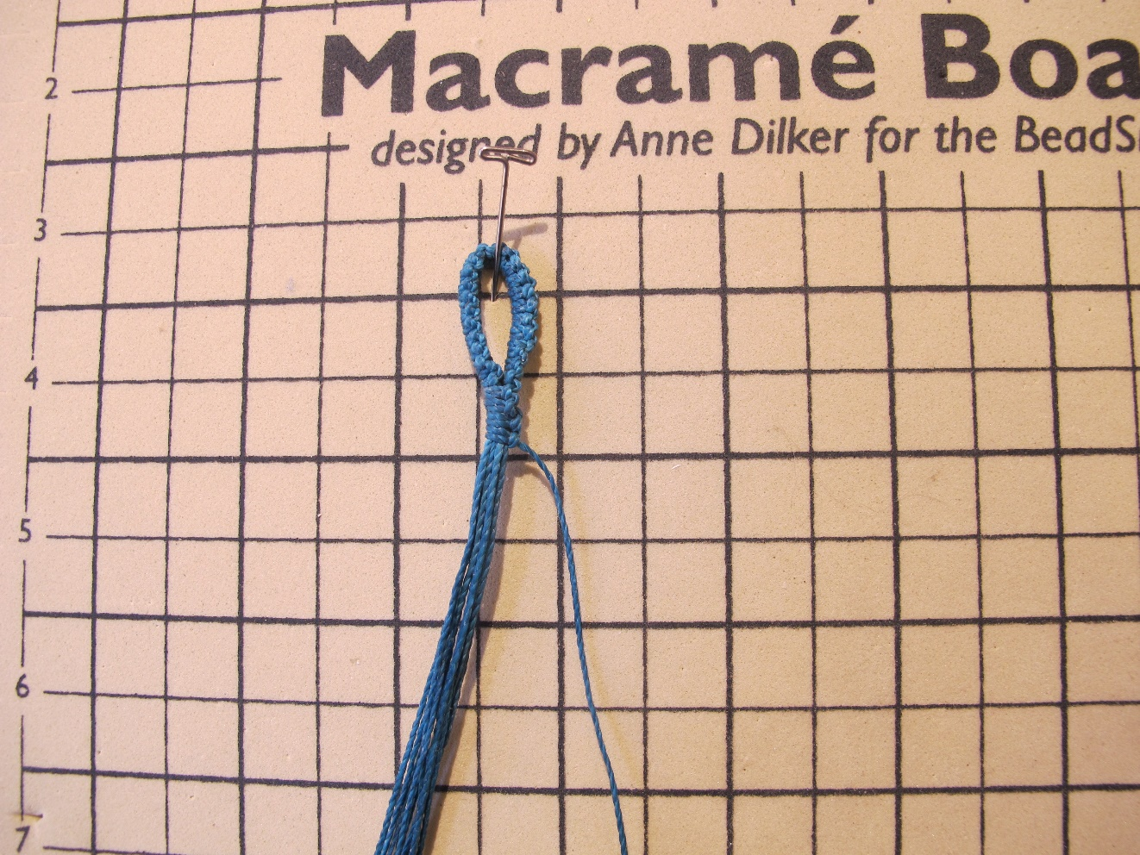

KNOTTING THE BODY OF THE BRACELET
1. You now have 12 strands of cord hanging from the loop. From now on, ignore the fact that one strand is longer than all the others. Using 2 strands on each side as your working cords, tie 4 square knots around the inner 8 strands.
(See Square Knot instructions at the end of this handout.)
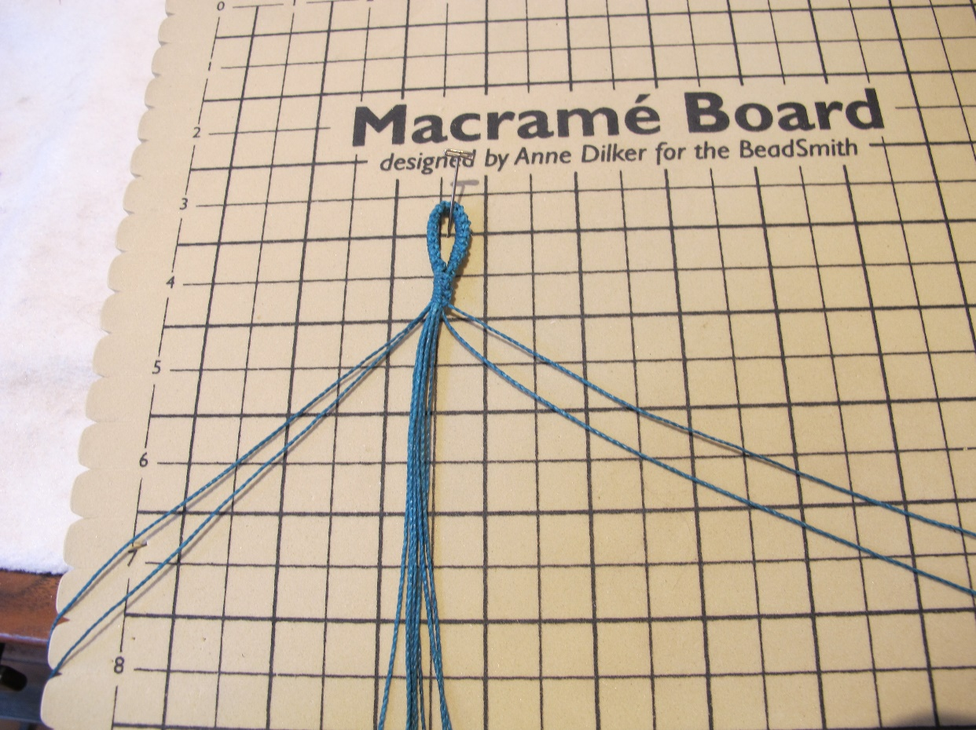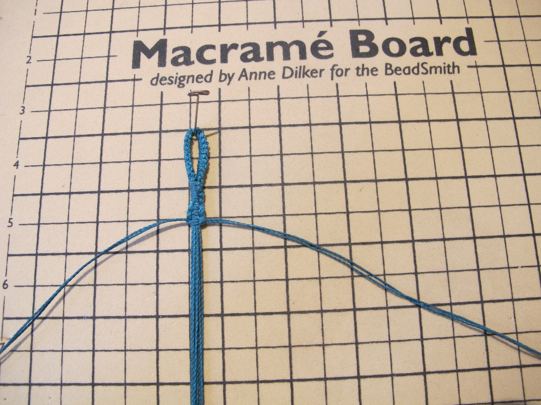

2. Separate the 12 strands into two sets of 6 strands each.
3. With each set, tie 2 square knots, using 2 strands on each side of each set as working cords to tie the square knots around the two inner cords.
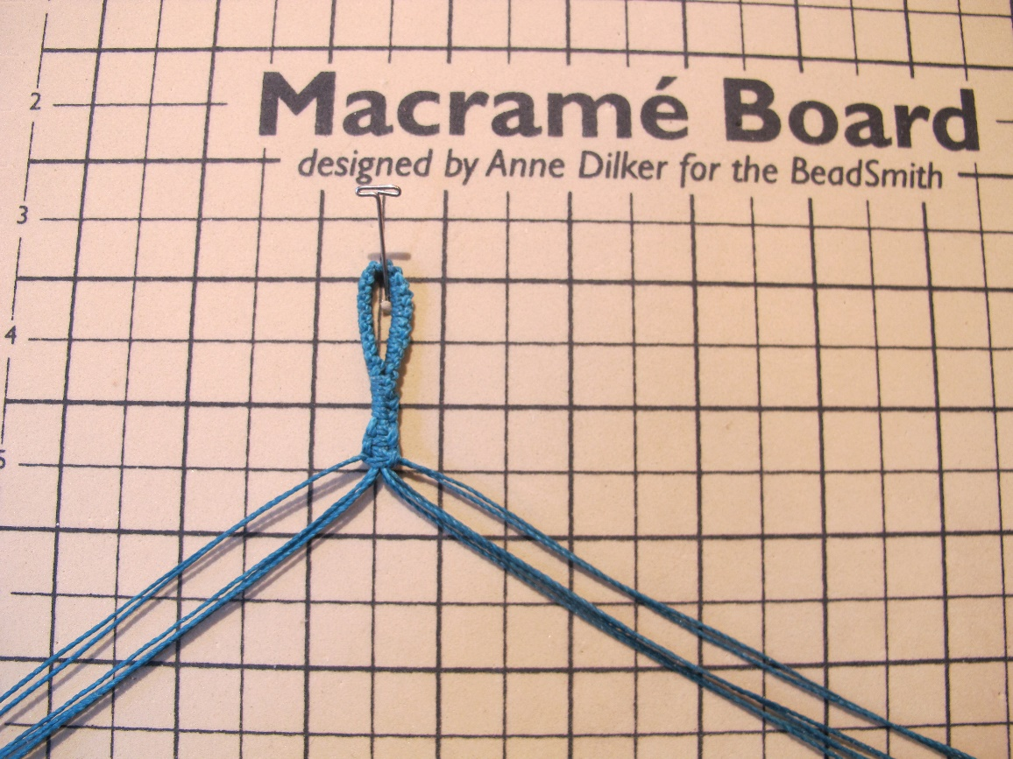 Step 2 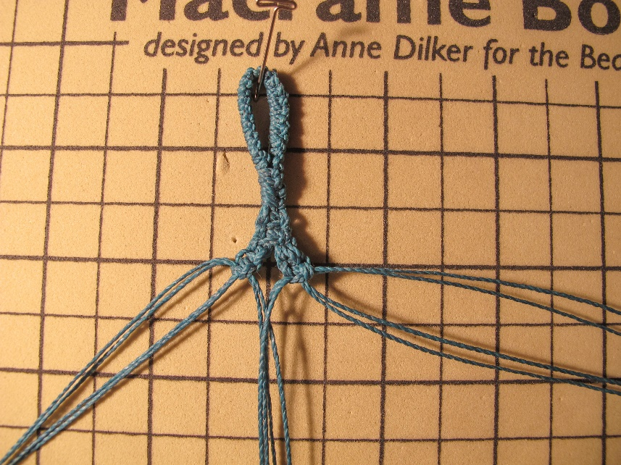 Step 3
4. Now separate the 12 strands into 3 sets of 4 cords each.
5. Tie 5 square knots with the center batch, this time tying one outer cord on each side around the two center cords.
6. Tie just one square knot on each of the two side sets, again tying one outer cord on each side around the two center cords.
7. Slide a bead onto the two center cords on each side.
8. Tie two more square knots on each side set, tying the knots around the beads.
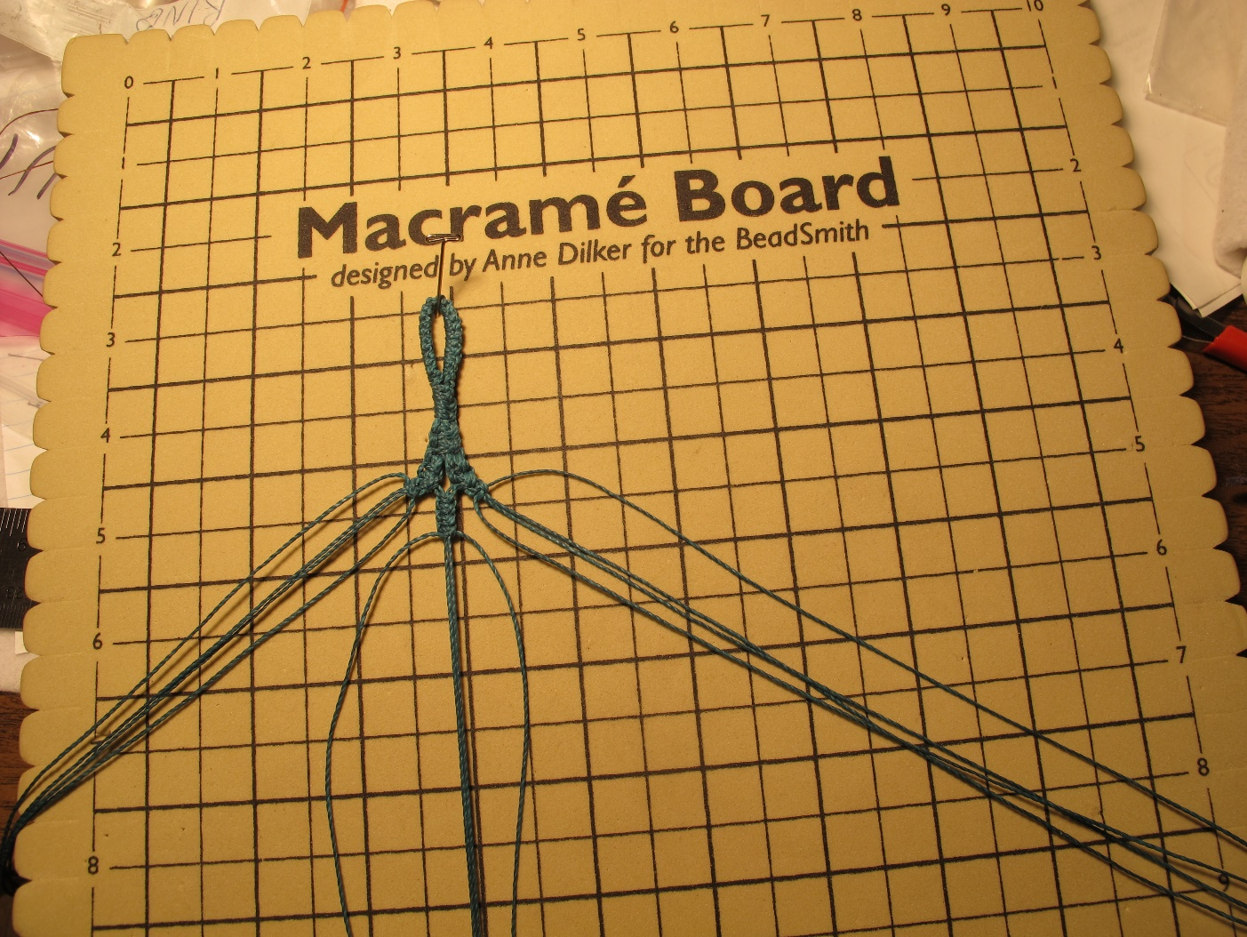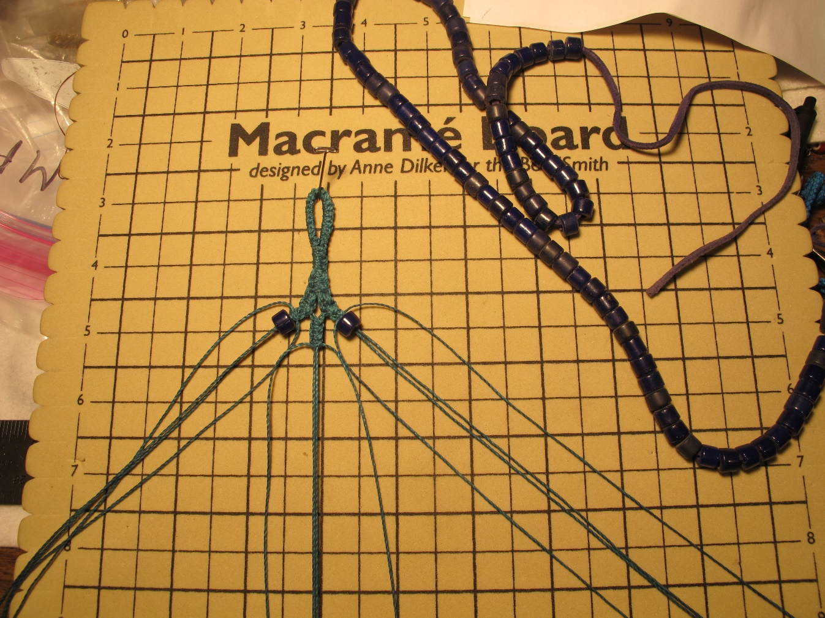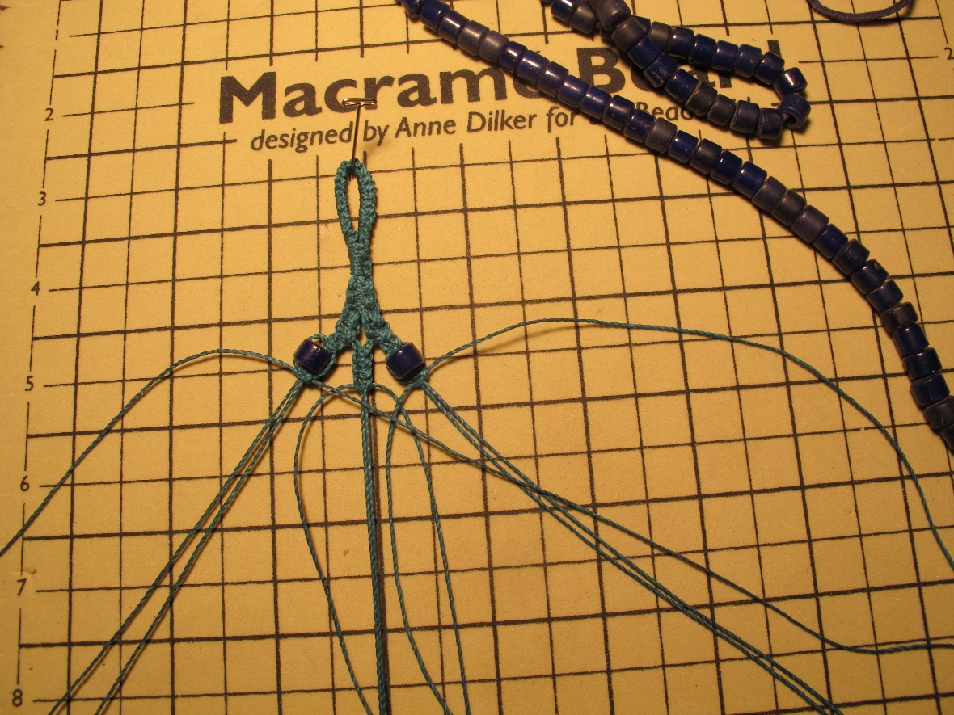
Steps 4 & 5 Steps 6 & 7 Step 8

9. Regroup the 12 strands into 2 sets of 6.
10. Beginning with the set on the right side, anchor the farthest-right (passive) strand with a pin (if using a macrame board, if not - just hold it).
11. Hold the passive strand diagonally across the remaining 5 strands. Tie one row of double half hitches, tying each strand from right to left twice around the passive cord.
12. Do the same thing in reverse on the left side.
13. Repeat Steps 11 & 12 to tie one more row of half hitches on each side, just below the first one.

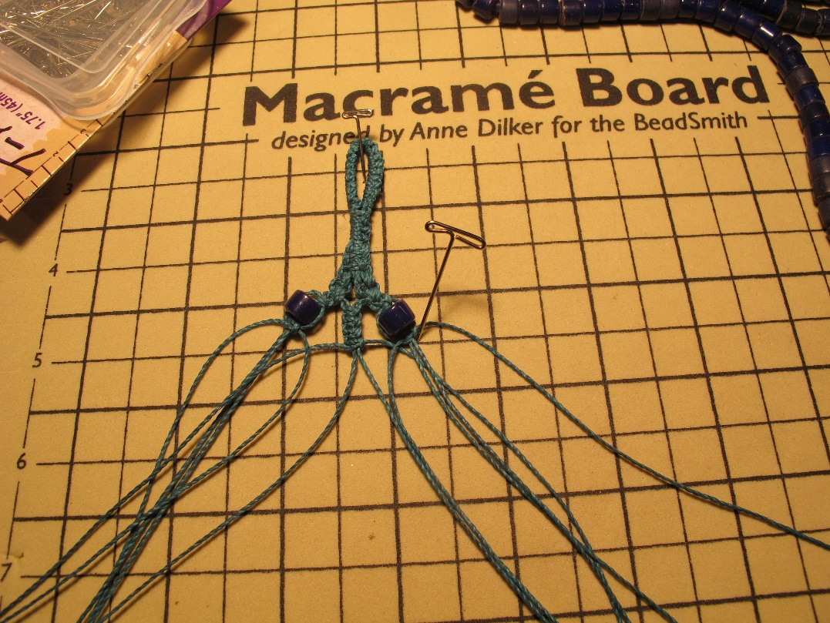 Step 10 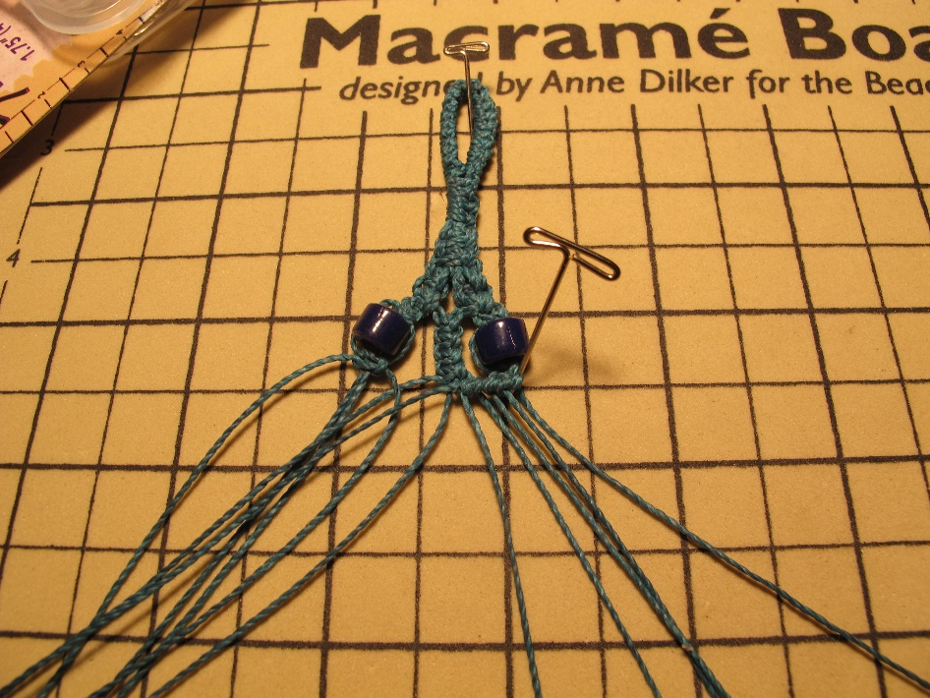 Step 11 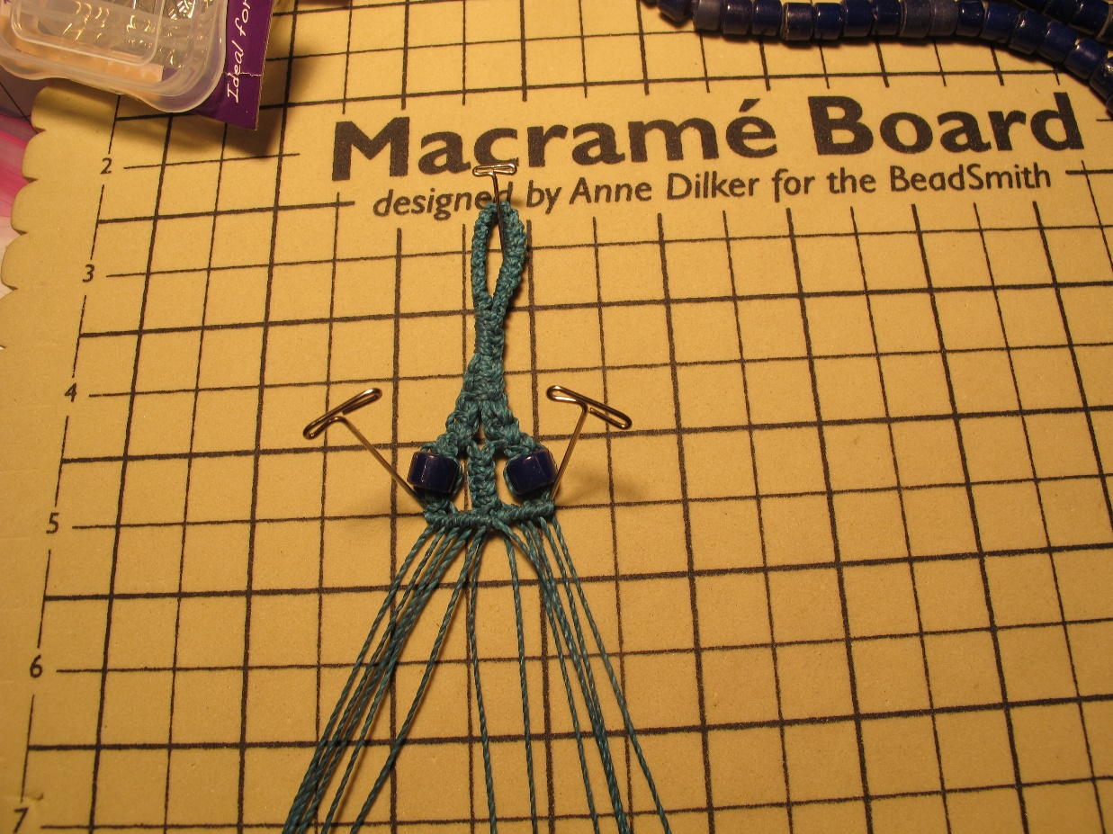 Step 12 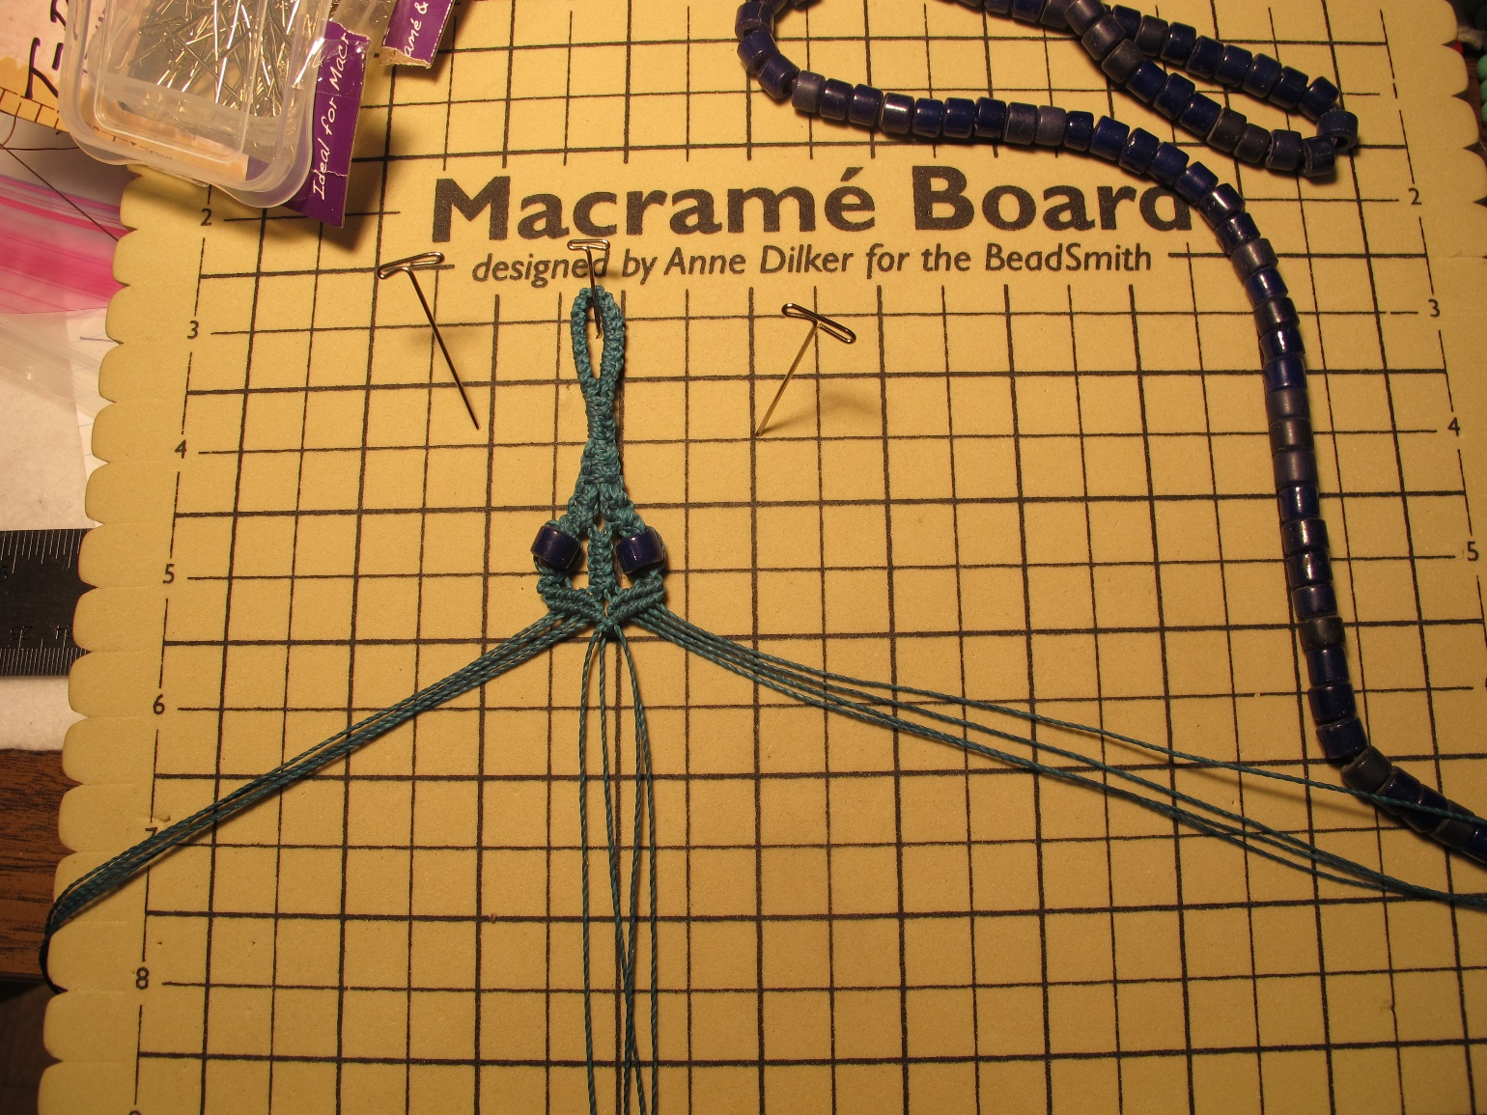 Step 13

14. Divide the strands into 3 sets of 4 strands each again.
15. With both side groups of 4, tie 12 square knots each.
16. With the center set of 4, tie 2 square knots, string a bead onto the 2 center cords and tie a square knot around it, tie one more square knot, string on another bead and tie 2 square knots around it.
17. Time to Evaluate:
a) The space between the 2 beads in Step 16 should be the center point of the bracelet. Measure from the end of the beginning loop you made to the center point. It should measure half of the length you want your finished bracelet to be. Example: If you want a 7” bracelet, the distance from the end of the loop to the center point should be 3 ½”. If it’s shorter than that, add another bead or a few more knots to make it the right length. The rest of the bracelet is going to be a mirror image of what you did before.
b) The two long rows of knots on the sides should be somewhat longer than the center area, so the side knots end up curving around the center area. If they are too short, add a few knots.
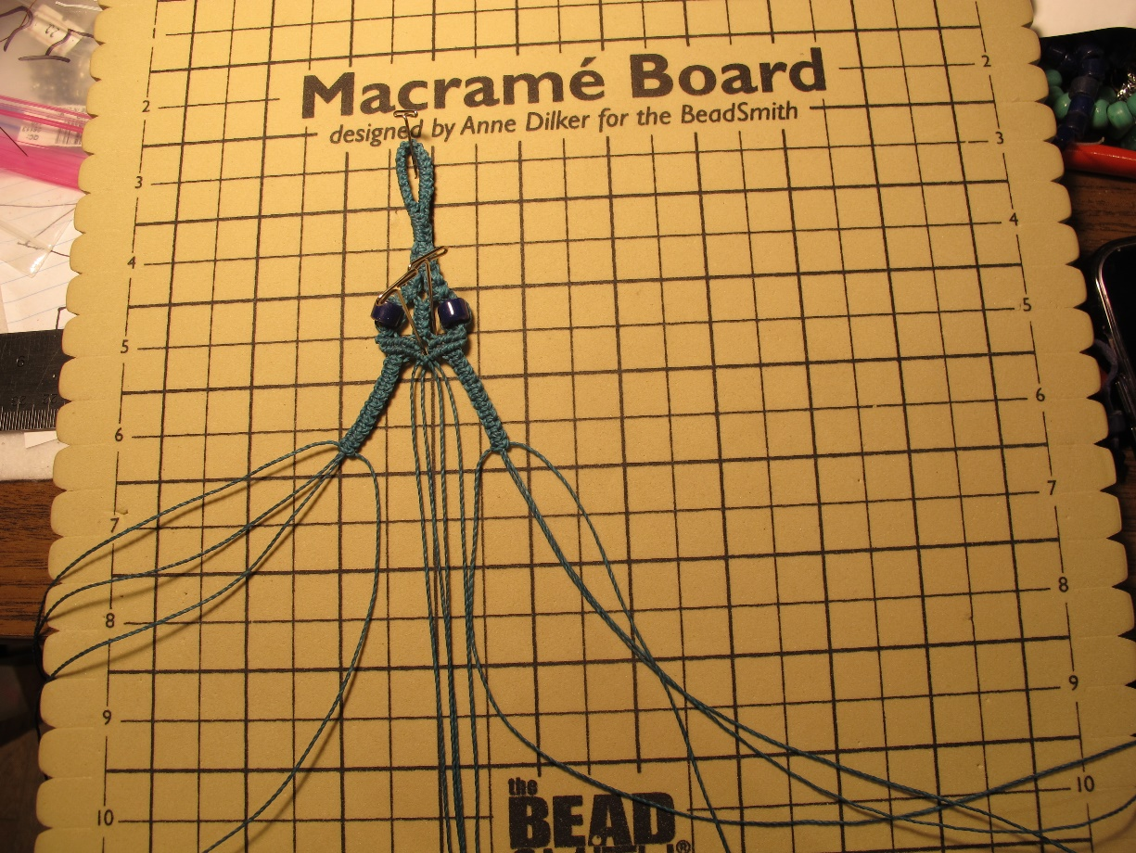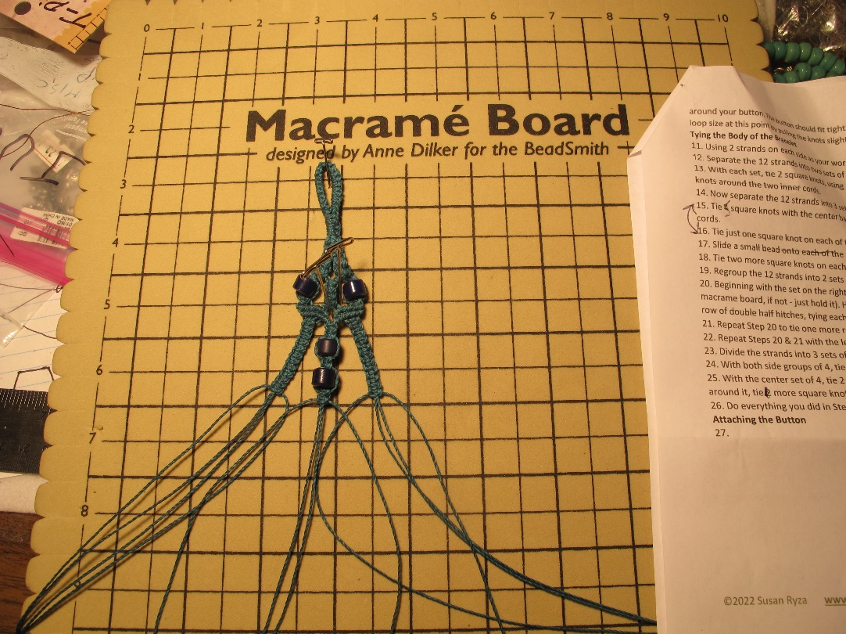
Step 15 Step 16

18. You will now do everything you did in Steps 1-16 in reverse, to create a symmetrical second half of the bracelet. Start by creating two rows of double half hitches, but this time working from the center out, rather than from the outside in as you did in Steps 10-13.
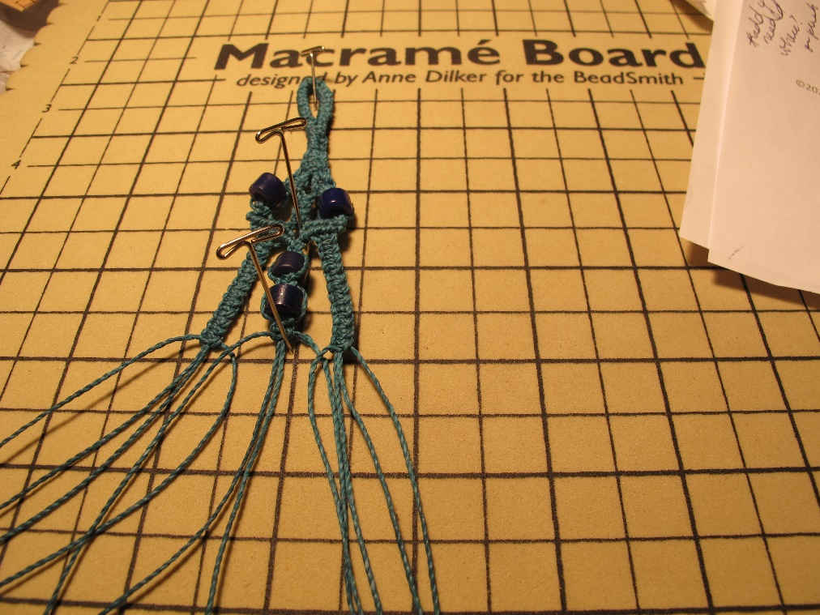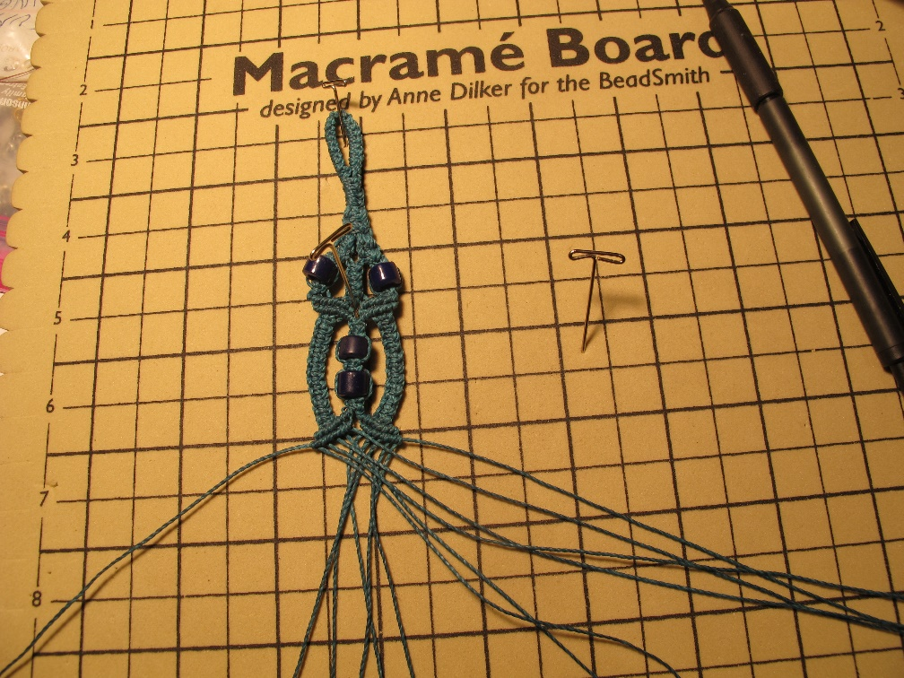
19. The next 3 photos show the remaining reversed steps.

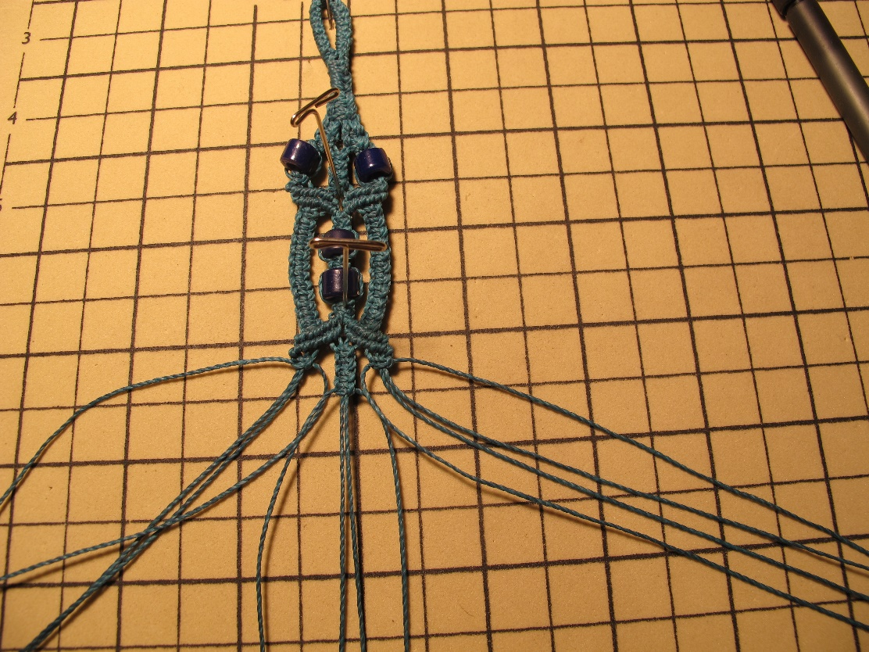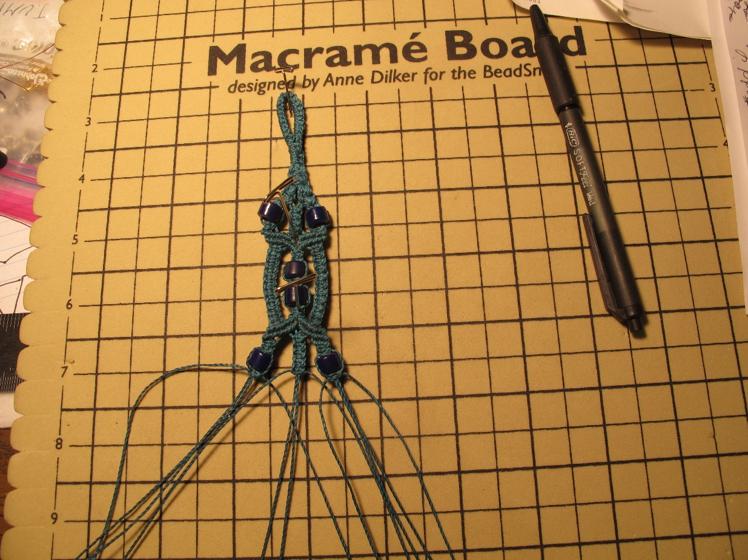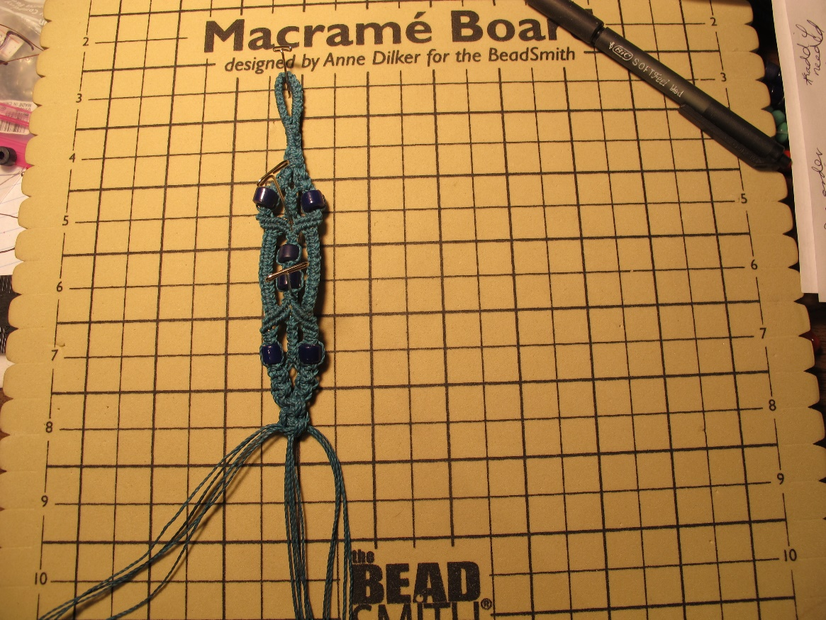

How to make a Macrame Square Knot
PART ONE:
Step 1. Bring the left side cord, across the center cord(s) & behind the right cord. This forms a half circle on the left side.
Step 2. Bring the right cord behind the center cord(s) & pull it up through the half circle on the left.
Step 3. Pull both side cords tight so the knot moves up the center cord(s) & lies flat. Make sure the center cords lie completely flat inside the knot.
PART TWO:
Step 4. Bring the right side cord across the center cord(s) & behind the left cord. This forms a half circle on the right side.
Step 5. Bring the left cord behind the center cord(s) & pull it up through the half circle on the right. Pull both cords again so the knot moves up & lies flat.
Step 6. The above steps complete one Square Knot.

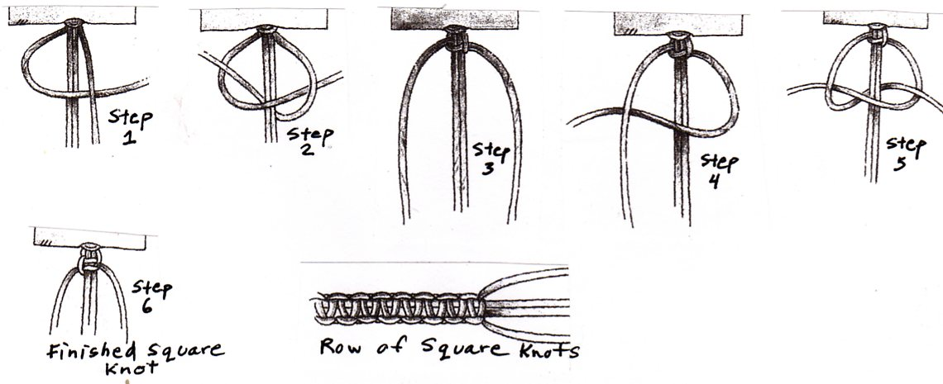

Attaching the Button
1. Slide the shank of the button onto as many of the center strands as possible and bring the button up as close as possible to the last square knot.
2. Tie 2 or 3 more square knots around the button.
3. Fold the knotted part over.
4. Smoothing all the strands into the center, choose the longest strand and pull it out to the right.
5. Using the long strand, tie about 10 alternating half hitches around all the rest of the strands. Pull the working cord very tight.
6. Tie the working cord and the cord next to it into a regular double knot. Pull it tight.
7. Trim off all the cords to about 1/8”.
8. Melt the ends with a lighter or glue them. NOTE: Melting only works with synthetic fiber.
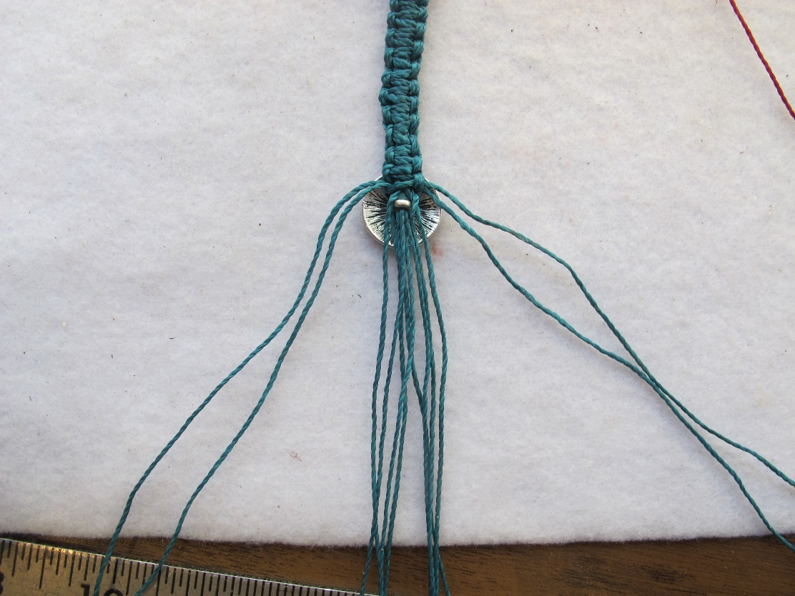 Step 1 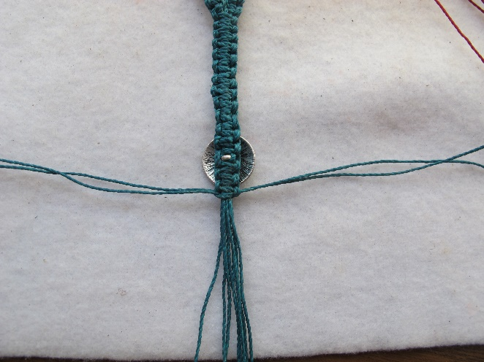 Step 2 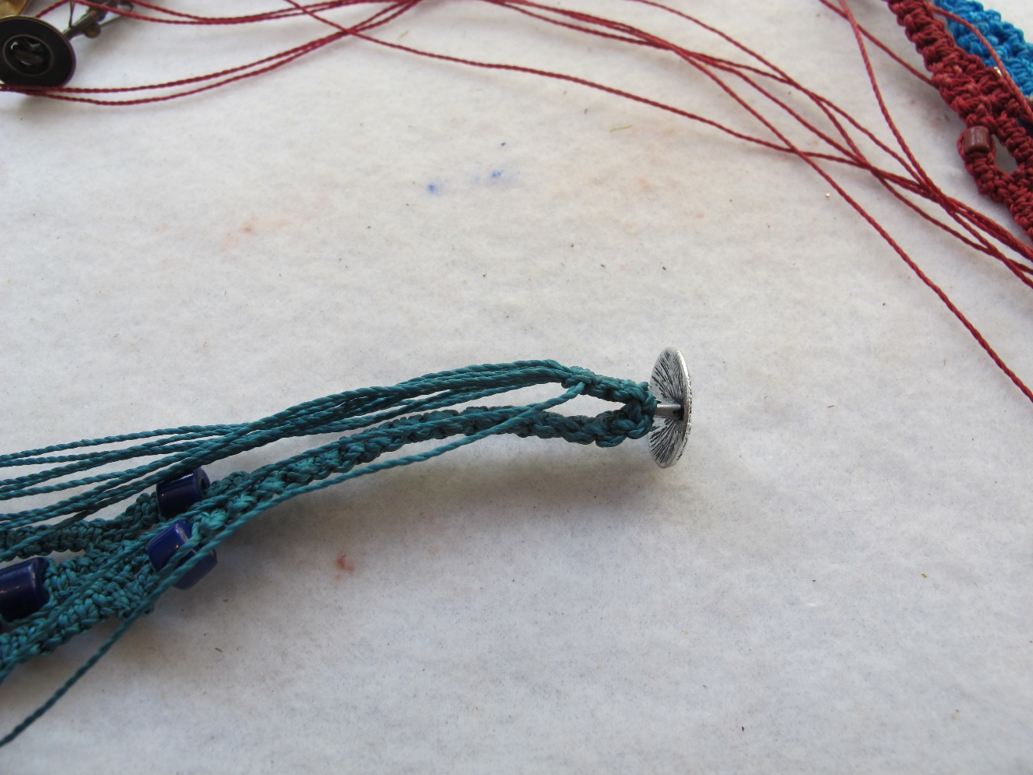 Step 3 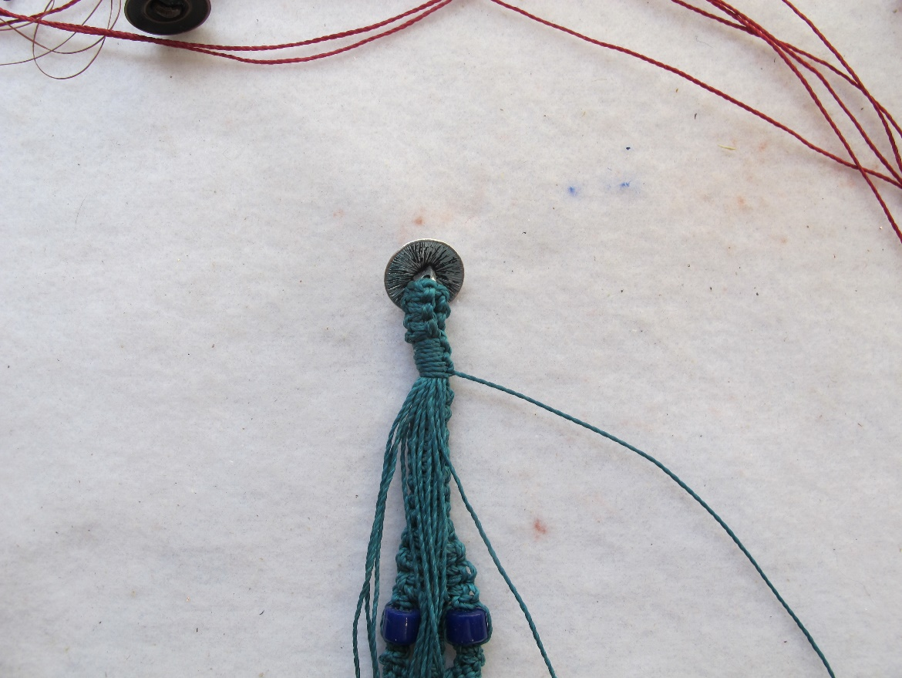 Steps 4 & 5 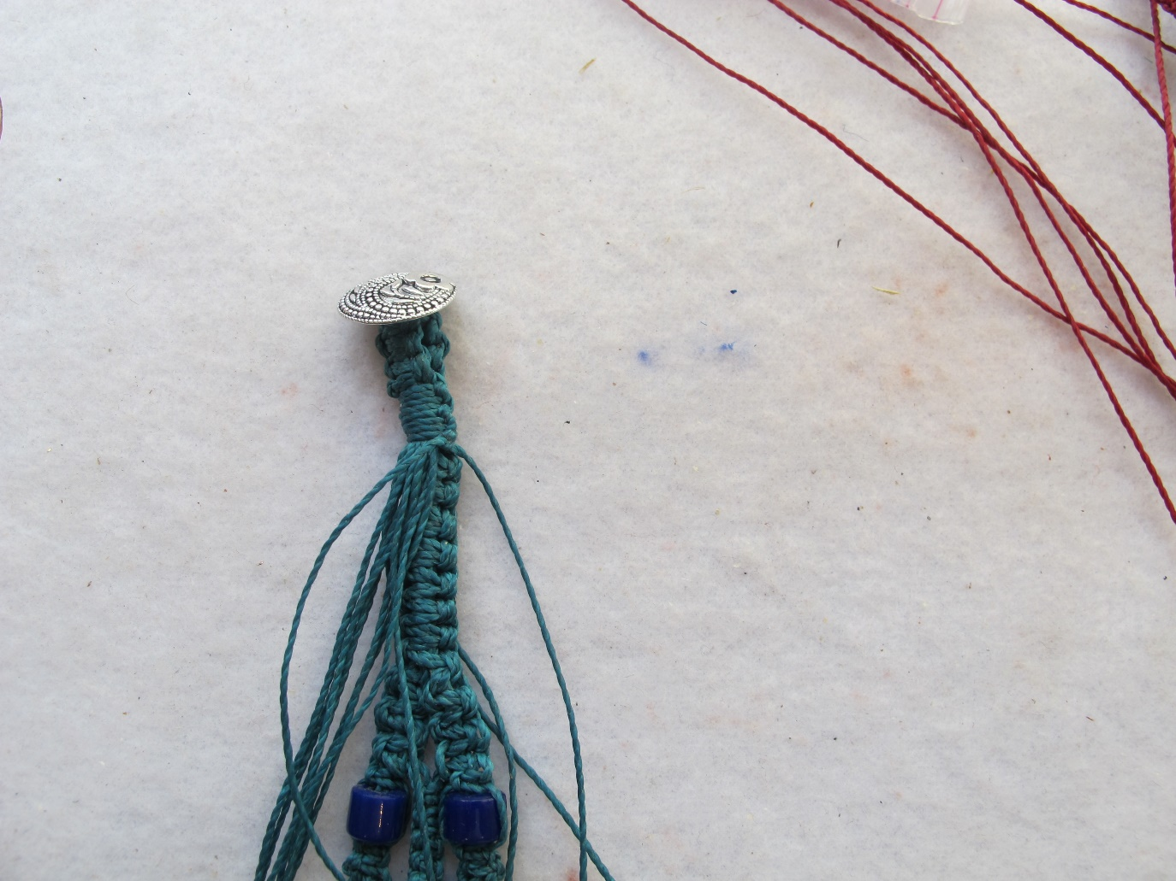 Step 6 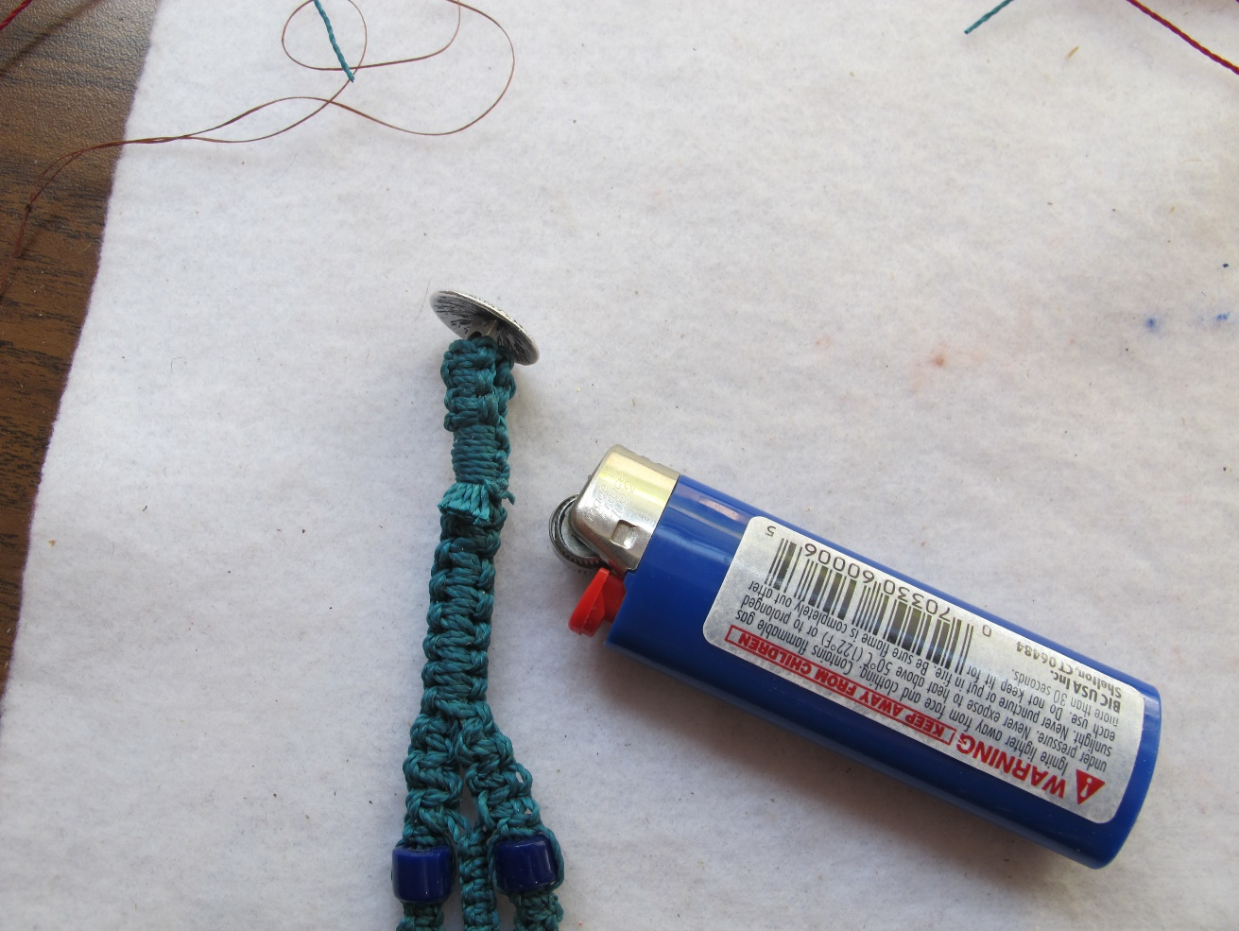 Step 7

©2022 Susan Ryza www.susanryza.com 5/30/22

