**Folded Paper Bracelet or Earrings**

(Miscellaneous Project #407)

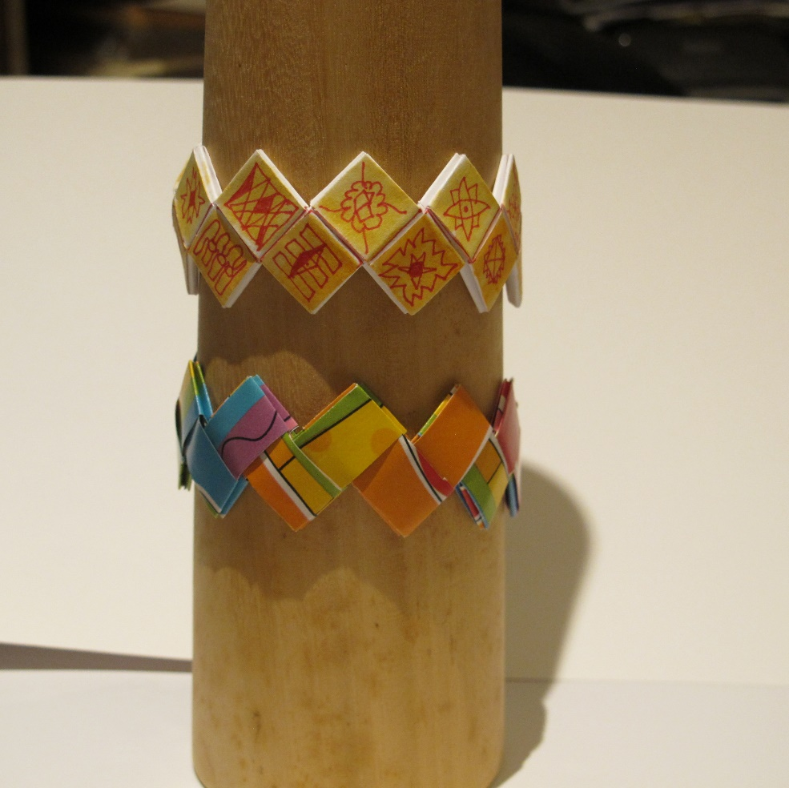 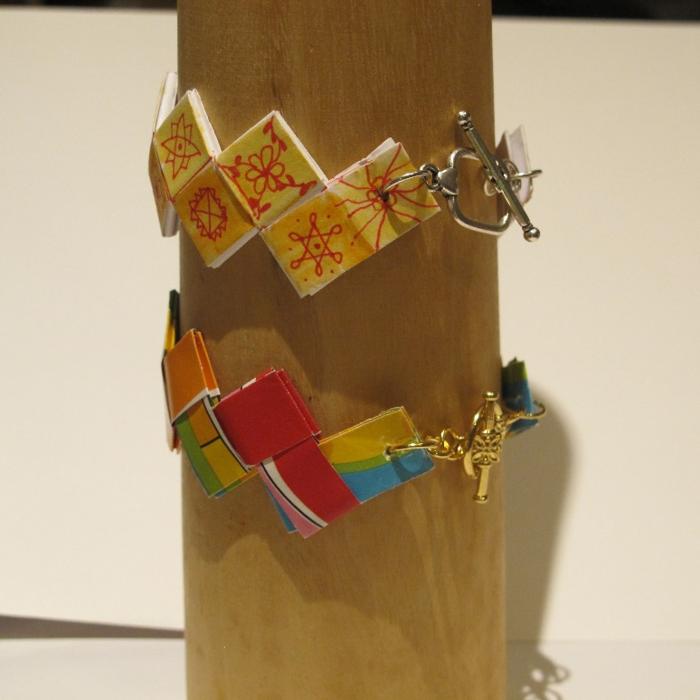

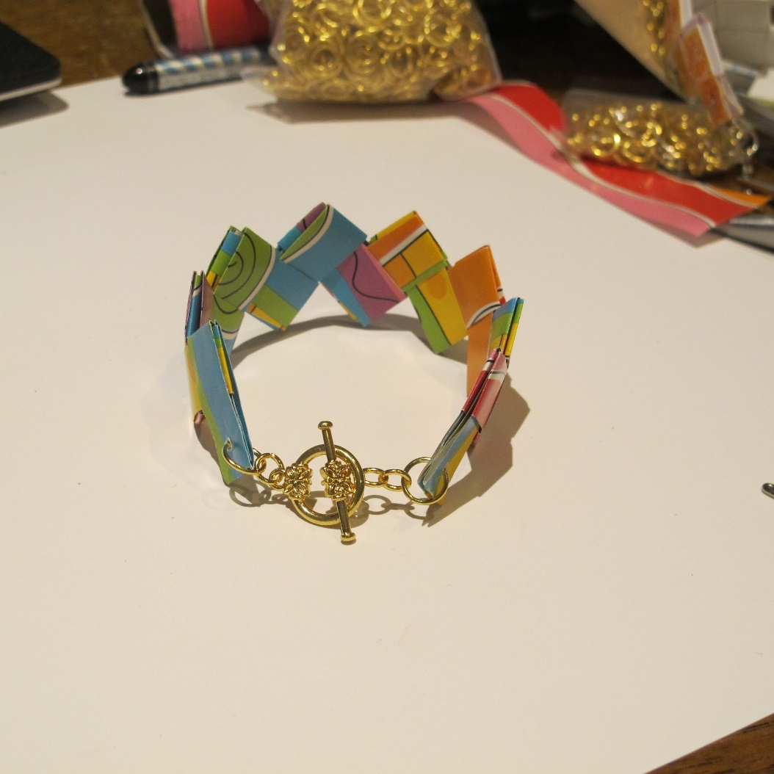 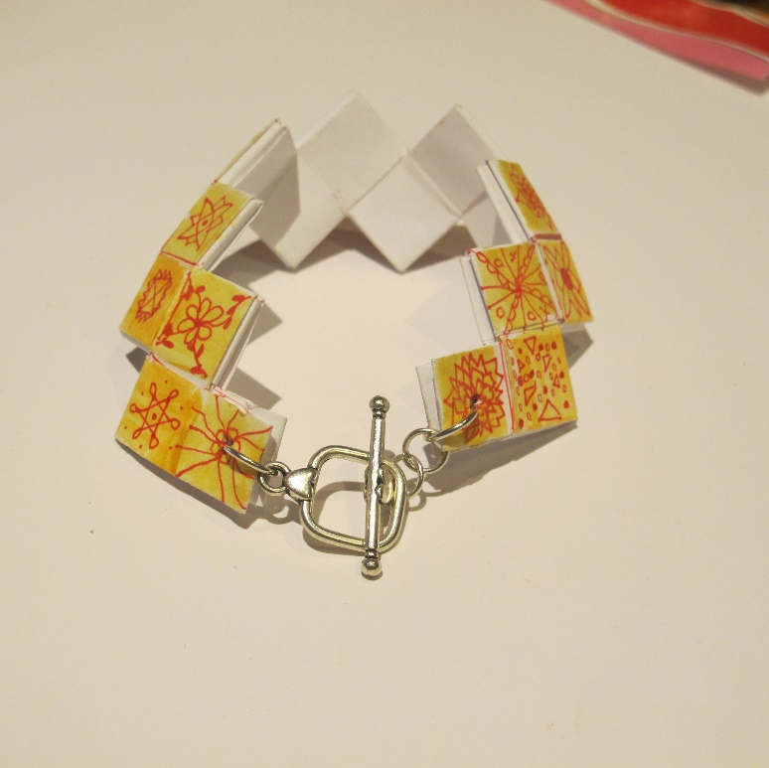

**Materials Needed**

8 ½” x 11” piece of plain paper or equivalent size of wrapping paper or origami paper

Markers, crayons, colored pencils or any kind of paint (optional)

(2) 18-gauge, 8mm. Outer diameter jump rings (Susan’s #2 rings)

(3-4) 18-gauge, 6 mm. jump rings (Susan’s #36)

1 toggle clasp set

2” of Scotch tape or packing tape or other strong (not Magic tape)

G-S Hypo Cement

1 pr. Of Earring wires

**Tools Needed**

Smooth, flat surface

Ruler

Sharp pencil

Sharp scissors or paper cutter

2 pairs of chain-nose pliers

Heavy pin or awl with a very sharp point

Markers, paints, colored pencils (optional)

**Instructions**

1. Choose your paper. It can be pre-decorated paper such as wrapping paper or origami paper or you can use plain, white paper and decorate it yourself.

2. If decorating your own paper, use markers, highlighters, crayons, colored pencils or any kind of paint. Cover one side of your plain paper with random, abstract markings or swaths of color.

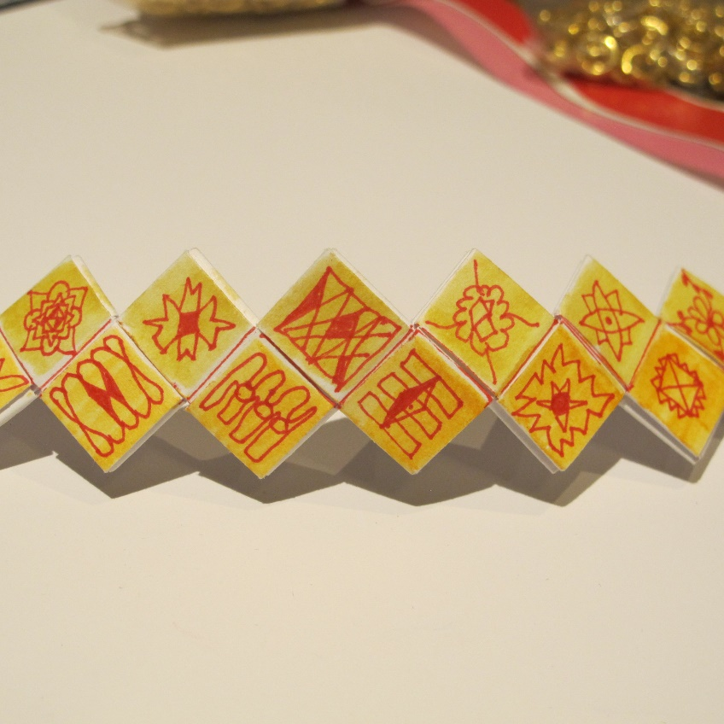

3. Use a ruler and sharp pencil to mark out strips. For the bolder size bracelet, you will need 14-16 strips cut to 4 ¼” x 15/16”. For the slightly more delicate bracelet, you will need about twenty 3 ¼” x ¾” strips. Use scissors or a paper cutter to cut them out.

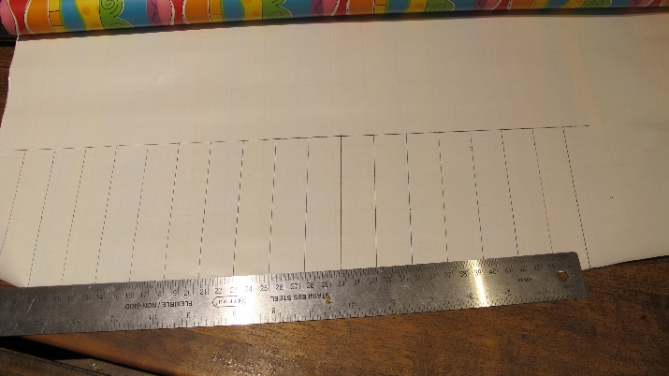 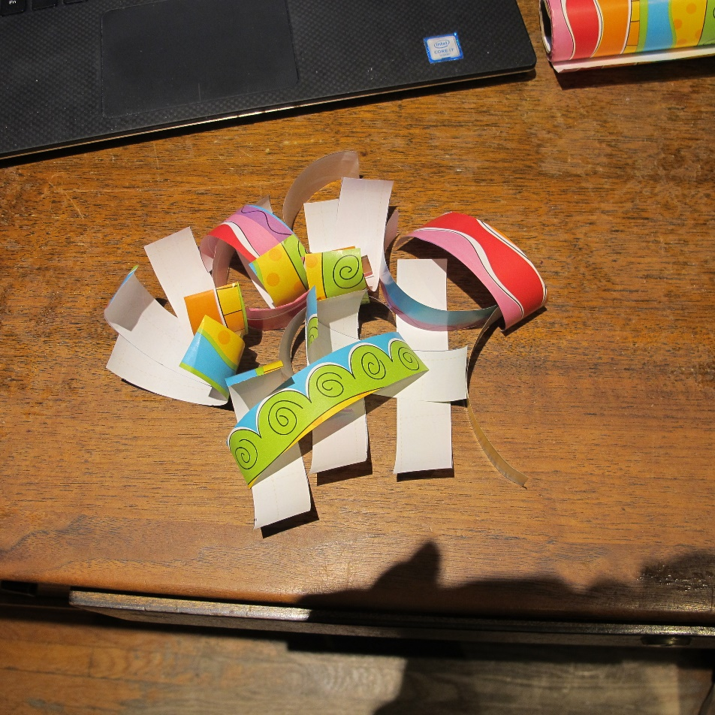

4. Make the components:

1. Fold one of the strips in half the long way with the decorative side of the paper facing out.
2. Keeping the paper folded from the last step, fold it in half the short way.
3. Unfold the last fold and mark the inside center line with a pencil or pen.
4. Fold each end in towards the center line to meet in the center, leaving a 1/8” space in the center between them.
5. Re-fold in half the short way as in Step B, so the two ends are folded inside towards the middle.

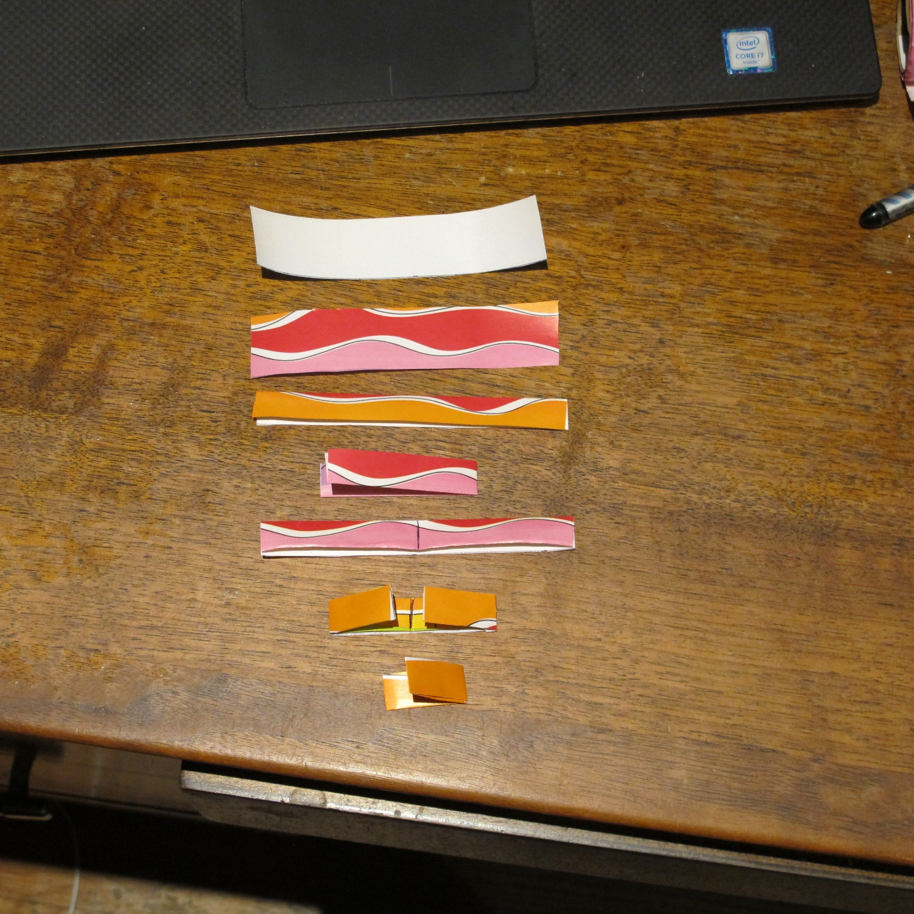

**Step 4a.**

**Step 4b.**

**Step 4c.**

**Step 4d.**

**Step 4e.**

5. Repeat the above process with all your strips

6. Put the components together:

1. Take the corners of the folded side of one of the components and slide them into the folded side of another component.
2. Push the two components together so they go in all the way to each of their center folds. Make sure the folded edges of the component you just pushed in are on the top, to make it easier to push the next component in.

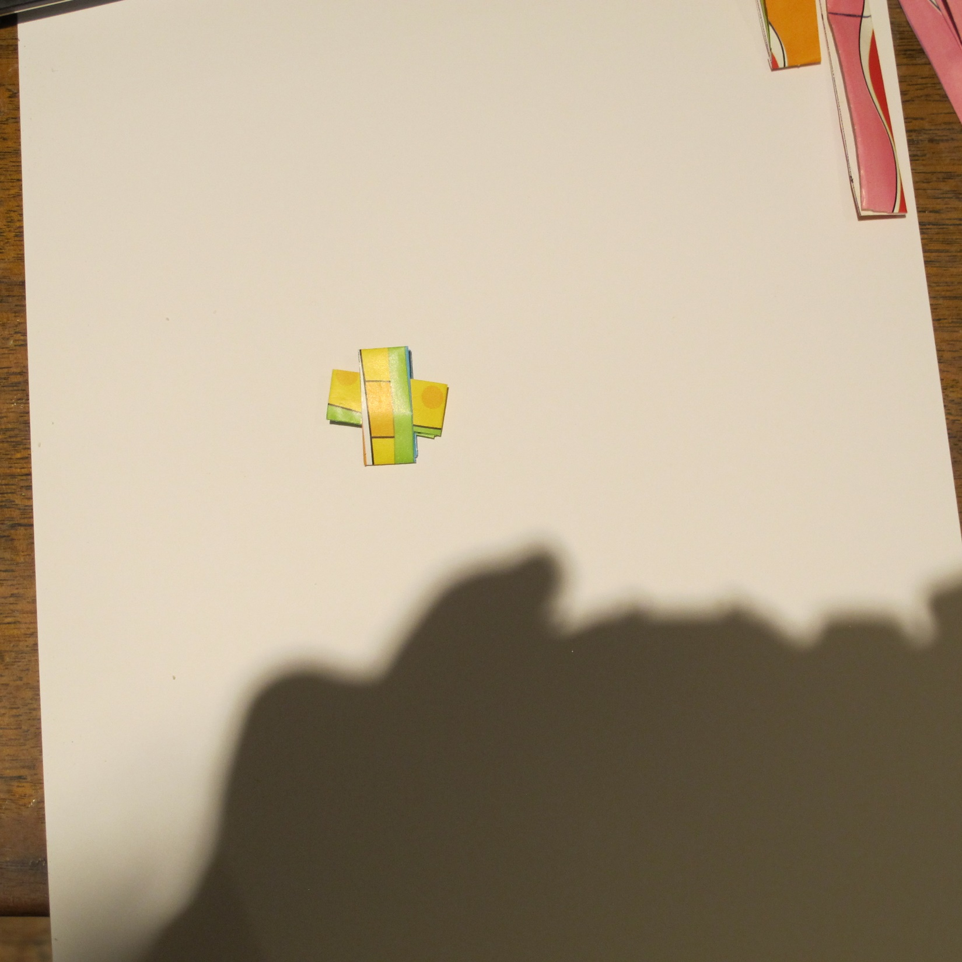 **Step 6a. 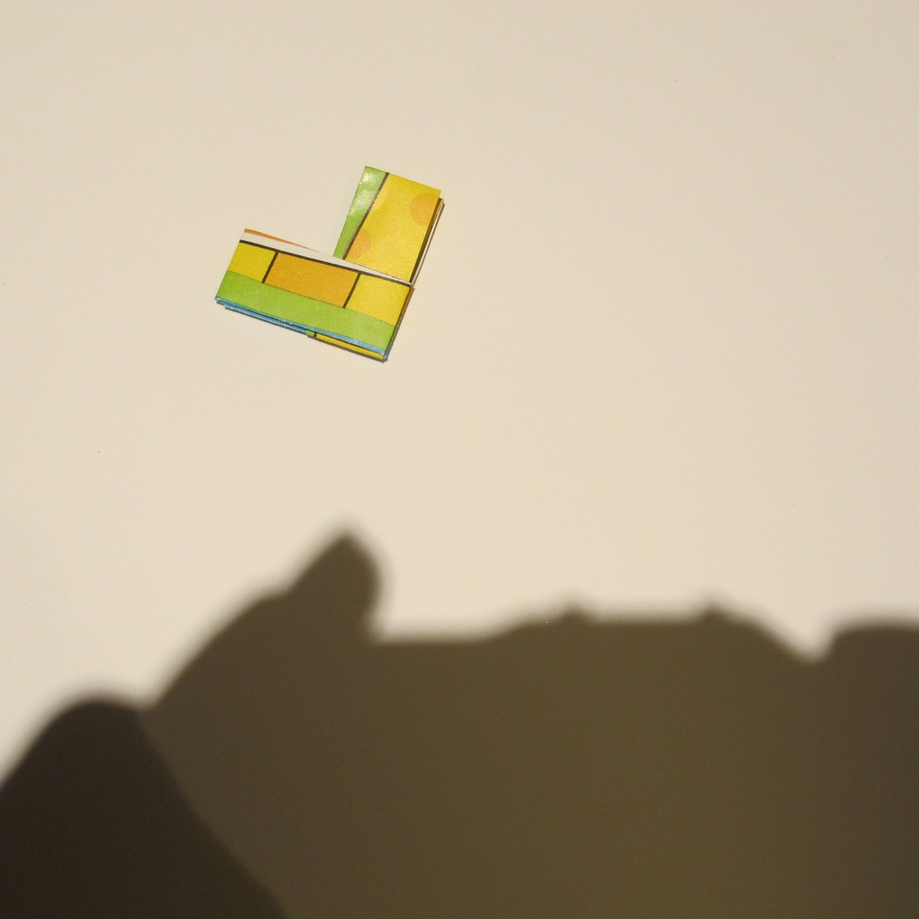 Step 6b.** 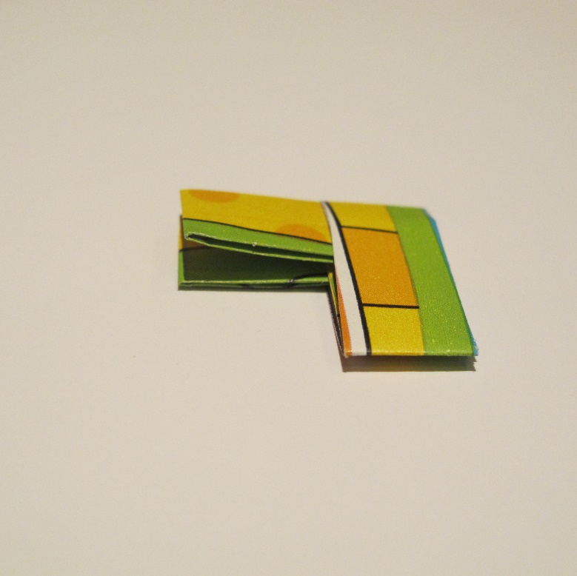

1. Slide in the next component, always sliding the folded edges into other folded edges.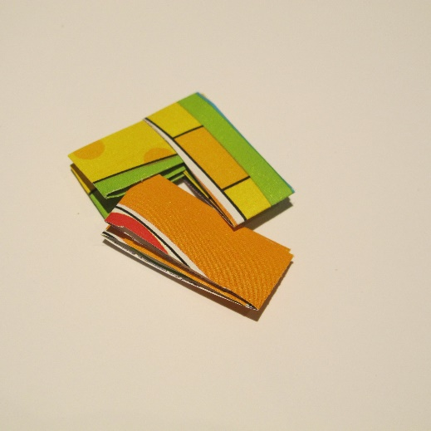 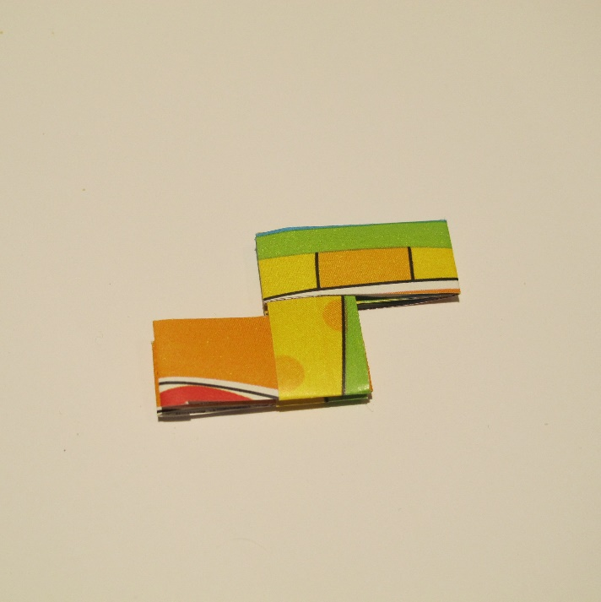 **Step 6c.**
2. Continue adding components to make a chain.

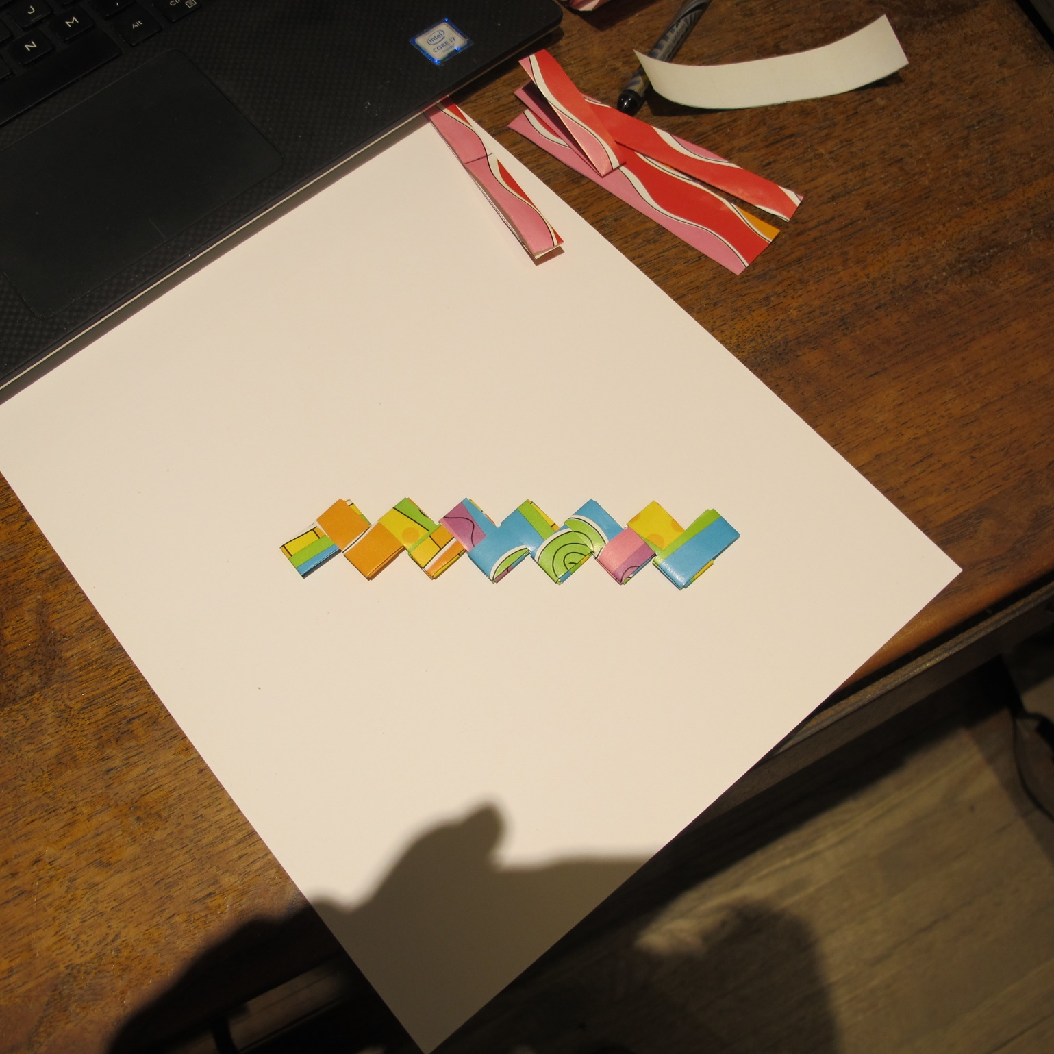 **Step 6d.**

7. Finishing the bracelet:

1. When the bracelet is about 1 ¼”-1 ½” shorter than the length you want it to be, the paper part of the bracelet is done. You can make it wrap around once, or multiple times.  **Multi-Wrap example**
2. Mark a dot in the exact center of each of the last squares on the ends of the bracelet.
3. Use your pin, awl or something with a very sharp point to puncture the spots where you made the marks. Make the holes from the outside of the bracelet towards the inside so that any rough edges will be on the inside. The holes need to be big enough to accommodate the 16-gauge jump rings, but no bigger.
4. Gently open the ends where the holes are and, on the inside of the folded paper where it won’t show, place a piece of tape over each of the holes to reinforce them.
5. Re-puncture the holes to go through the tape.
6. Put one of the large jump rings through each of the holes and close it. The rings should exit the bracelet at the very end of the last square, not at the side of the square.

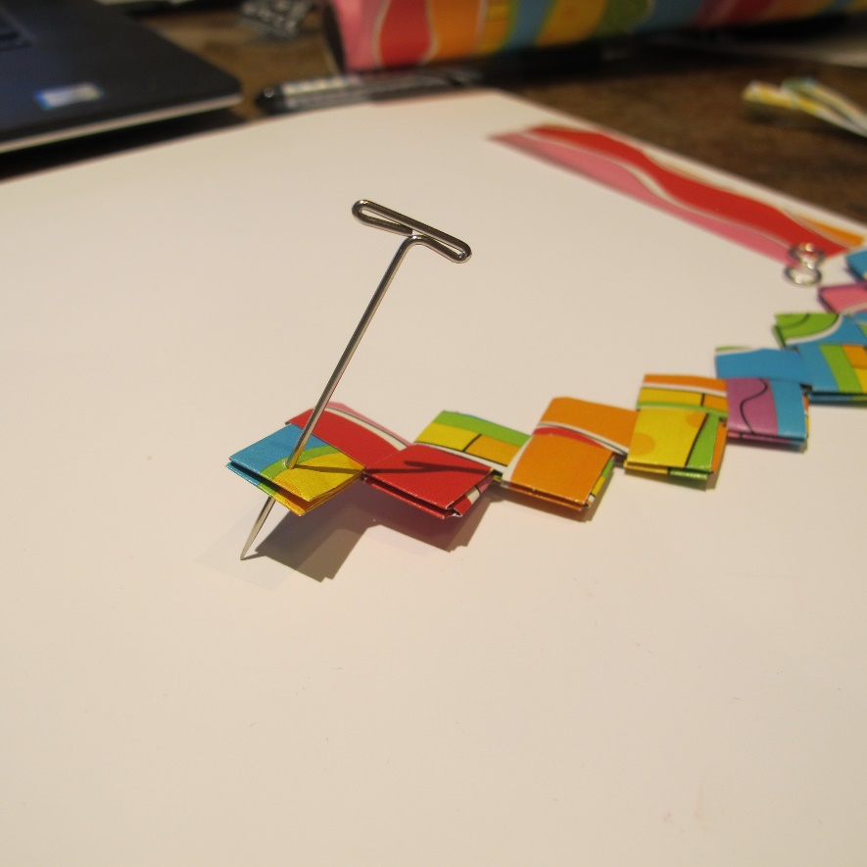**Step 7c. 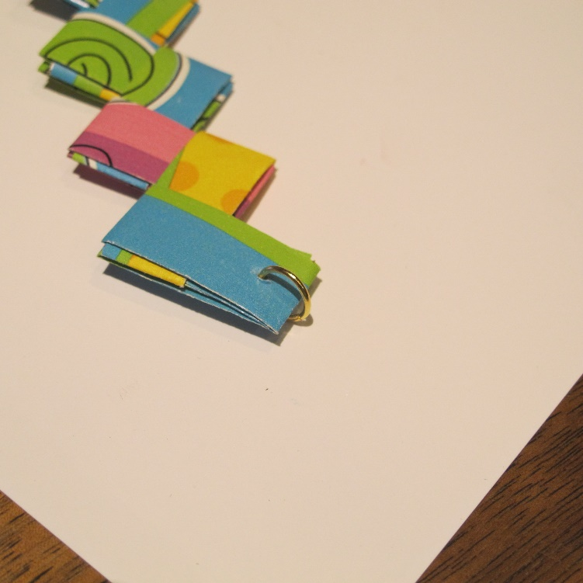 Step 7f.**

1. Squeeze a tiny bit of G-S Hypo Cement around the edge of each hole, to strengthen it. Don’t let the glue clog the opening of the hole.
2. Add one of the smaller jump rings to each of the larger rings. On one end, before you close the jump ring, slide the loop side of the toggle clasp into the ring.
3. On the other end of the bracelet, add 2 of the smaller jump rings to the larger jump ring. Before closing the last jump ring, slip in the bar side of the toggle clasp.

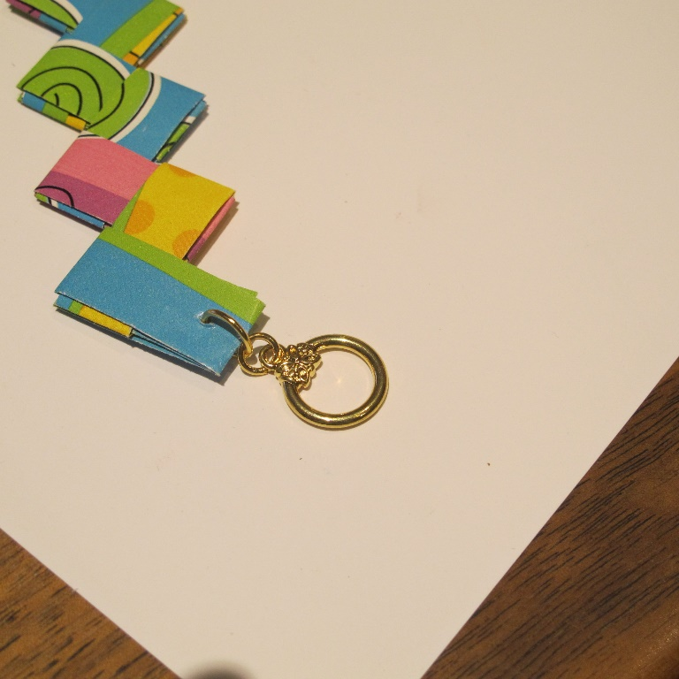 **Step 7h. 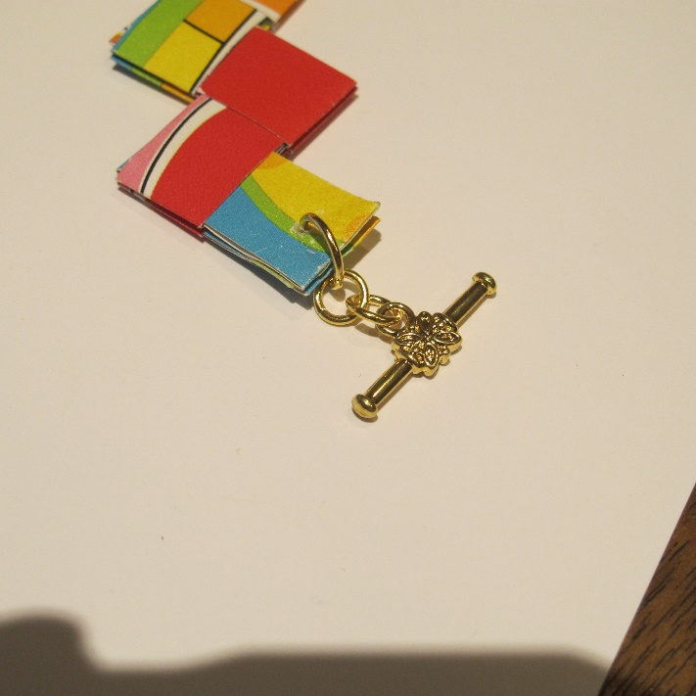 Step 7i.**

1. If the bracelet is too tight, add 2 more small jump rings to the bar side of the bracelet.

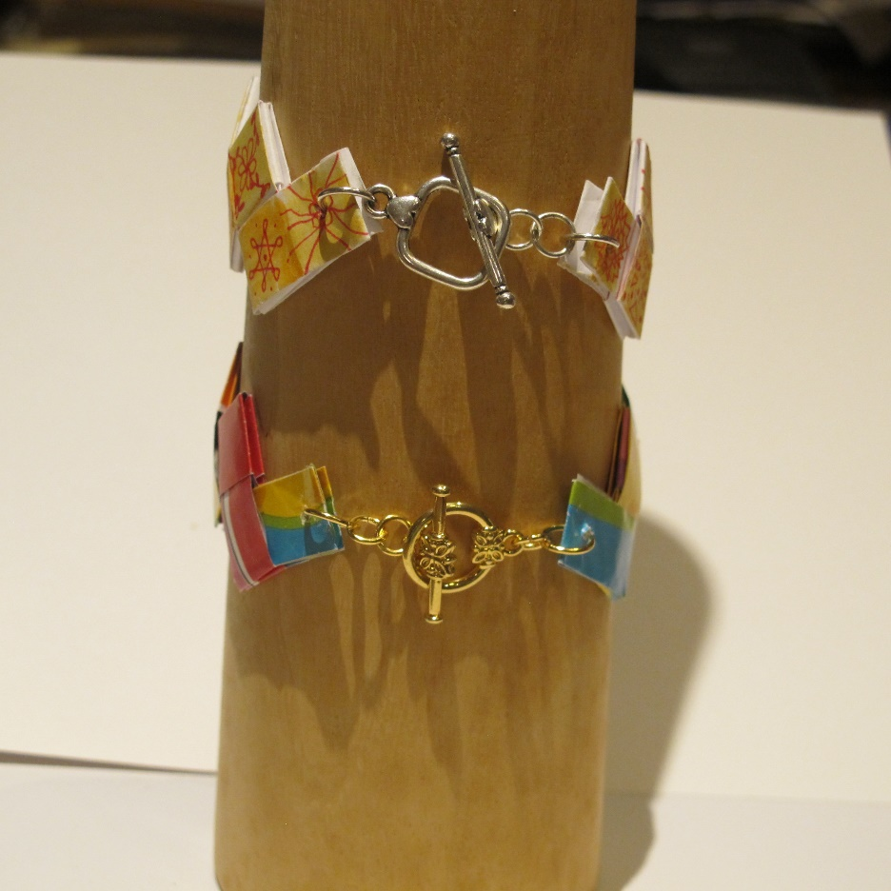

**EARRINGS (Make 2)**

Make a short chain of paper components and attach an earring wire the same way as you attached the clasp above.

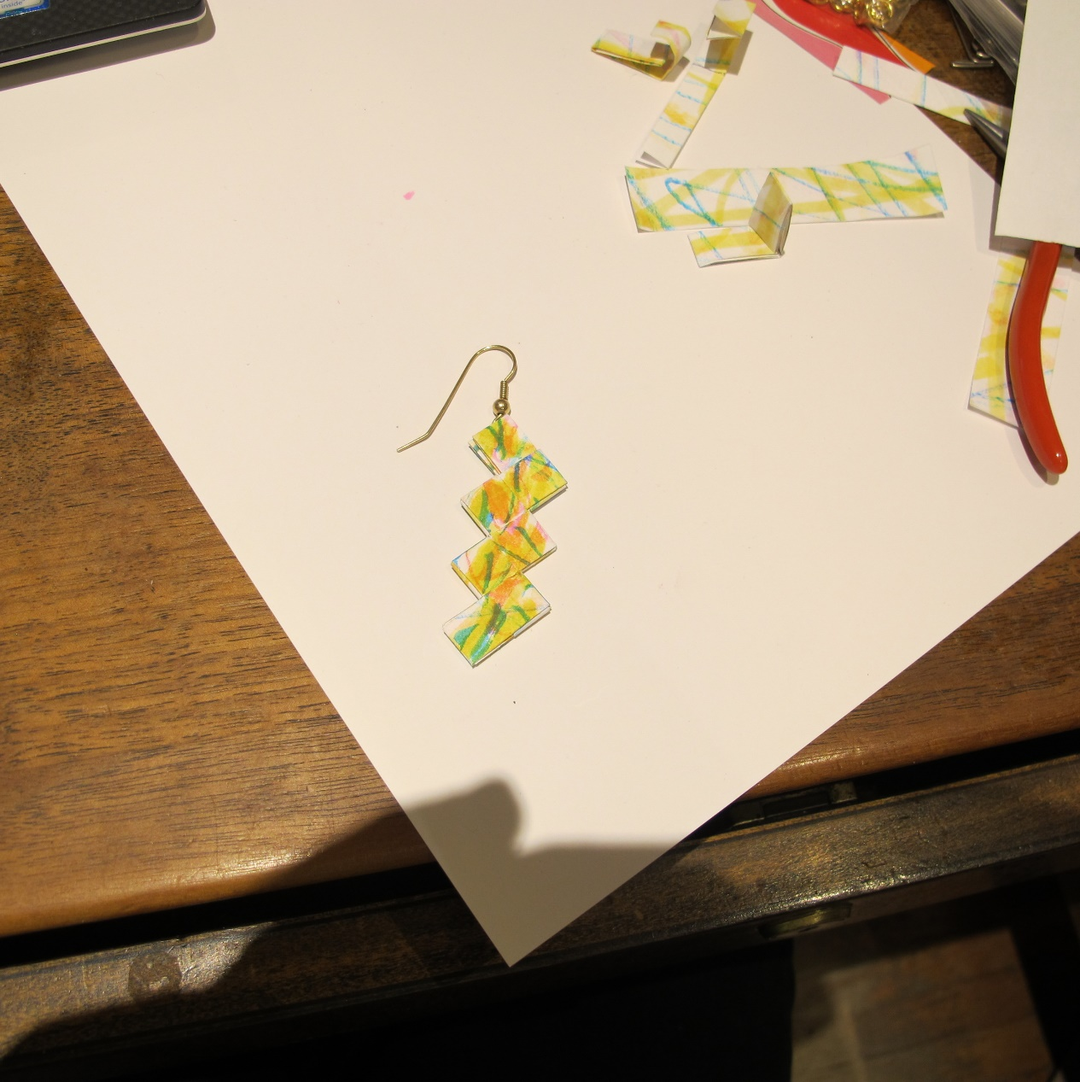

©2020 Susan Ryza [**www.susanryza.com**](http://www.susanryza.com) 12/2/20