**Hand-Made Cotter Pin Chain with Hand-Made Clasp**

(Craft Wire Project #403)

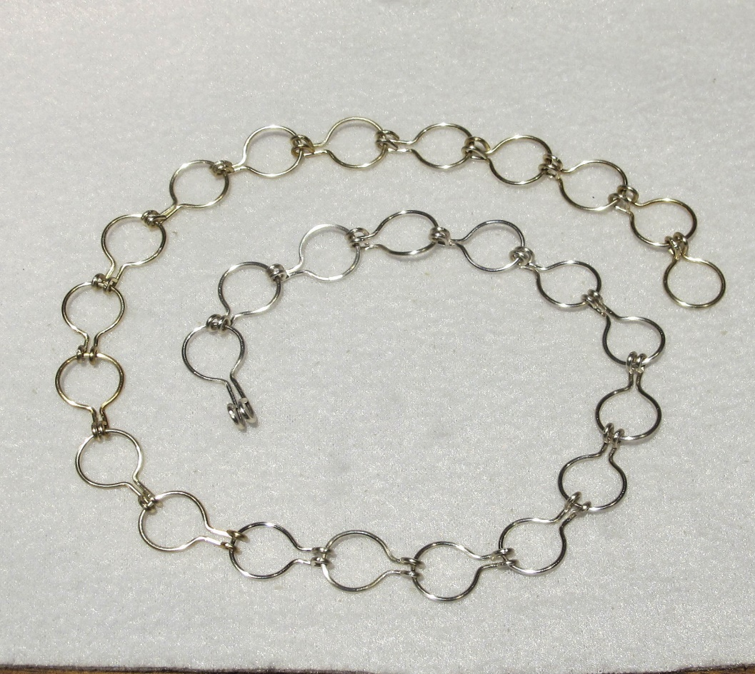

**Materials Needed for an 18” Necklace**

3 yards of 18-gauge wire

**Tools Needed**

9mm. bailing pliers or any 9mm mandrel

3mm. bailing pliers or any 3mm.mandrel

Round-nose pliers

Chain-Nose pliers

Wire flush cutters

Nylon-Jaw pliers

Ruler

**Instructions**

1. To make one chain component, cut a 3” segment of 18-gauge wire.

2. Hold your 9mm. mandrel at the center spot of the segment of wire.

3. Wrap both ends of wire around the mandrel to create a perfectly round loop in the center of the wire.

4. Find the spot where the two wire ends cross over each other & use chain nose pliers to bend each wire straight up, at a 90-degree angle from the circular loop. The two wire ends should be parallel to each other and should be side-by-side, touching each other.

5. Flush-cut the ends of the wire so they stick out exactly ½” from the edge of the circle.

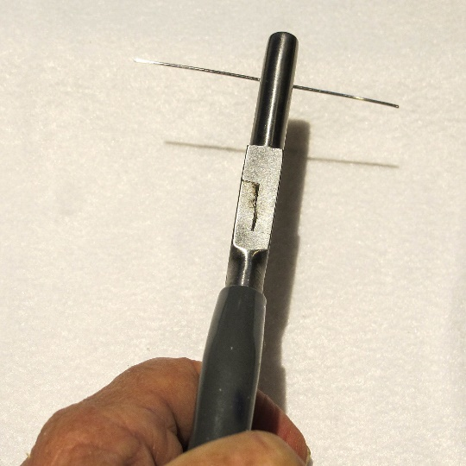**Step 2 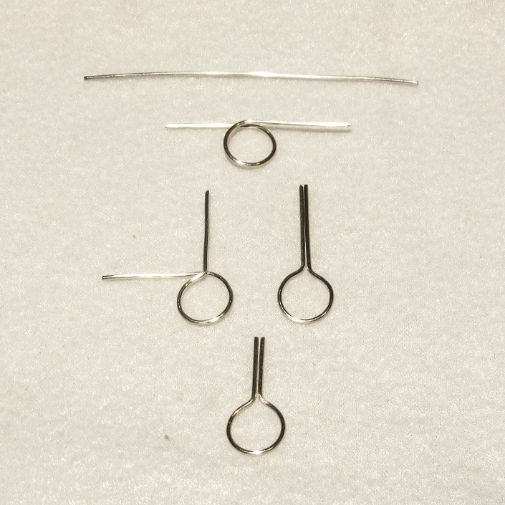Steps 1-5**

6. Use chain-nose pliers to make sure the piece is perfectly flat.

7. Repeat Steps 1-6 to make 30 chain components for an 18” necklace. Set aside 3” of wire to make one final component later on.

NOTE: Each finished chain component will measure about 2/3”, so you can make more or fewer depending on the finished length you want.

8. Pick up one finished component and rotate the ends of each wire down into a loop, one at a time. Make sure both loops are the same size and are tightly closed.

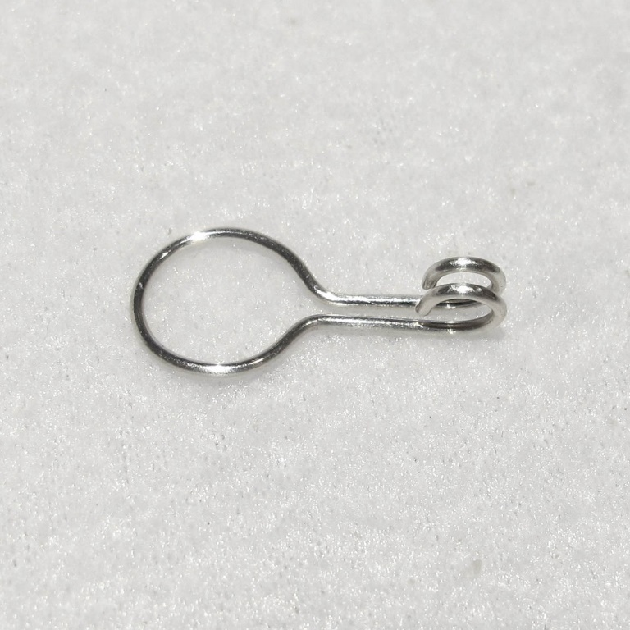**Step 8**

9. Now pick up another component & slide one of the straight ends into the loops from Step 8, as seen in the photo below on the left.

10. Continue pushing the new component into the Step 8 loops until the new component slides all the way in and it looks like the photo below on the right.

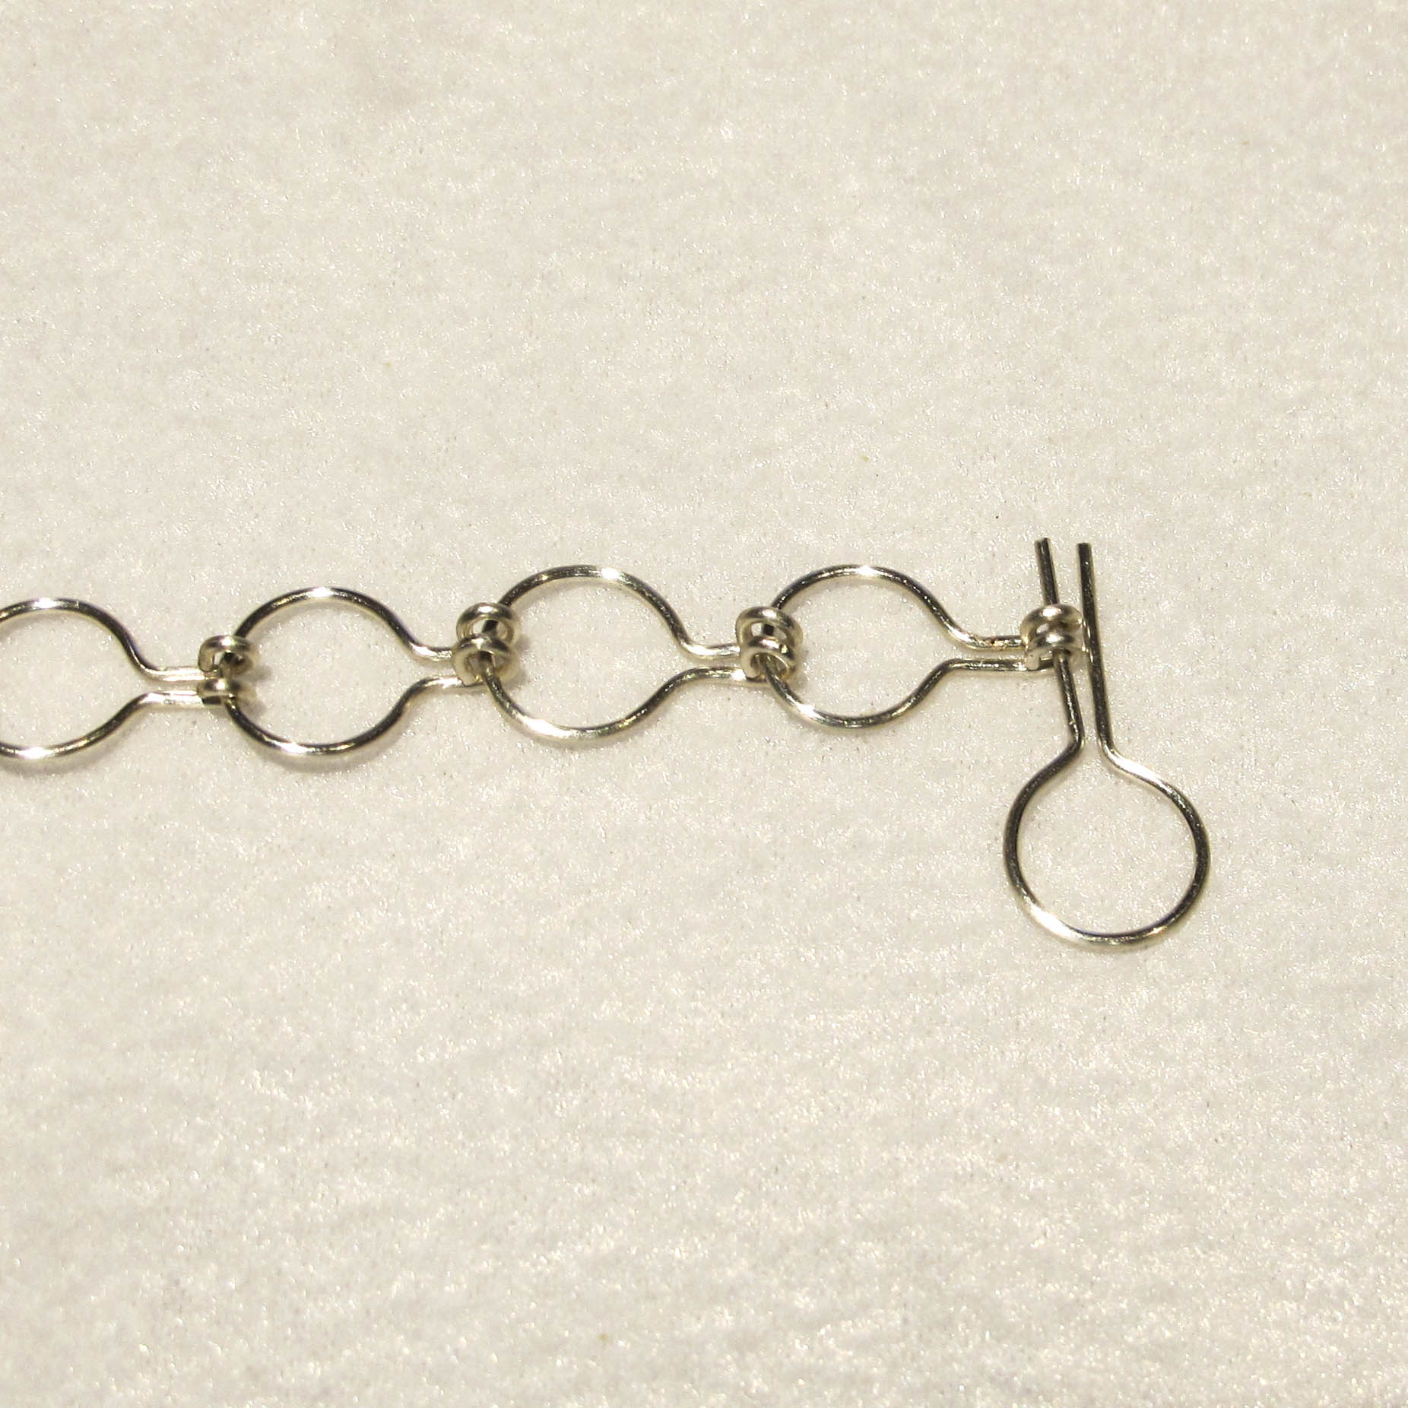**Step 9 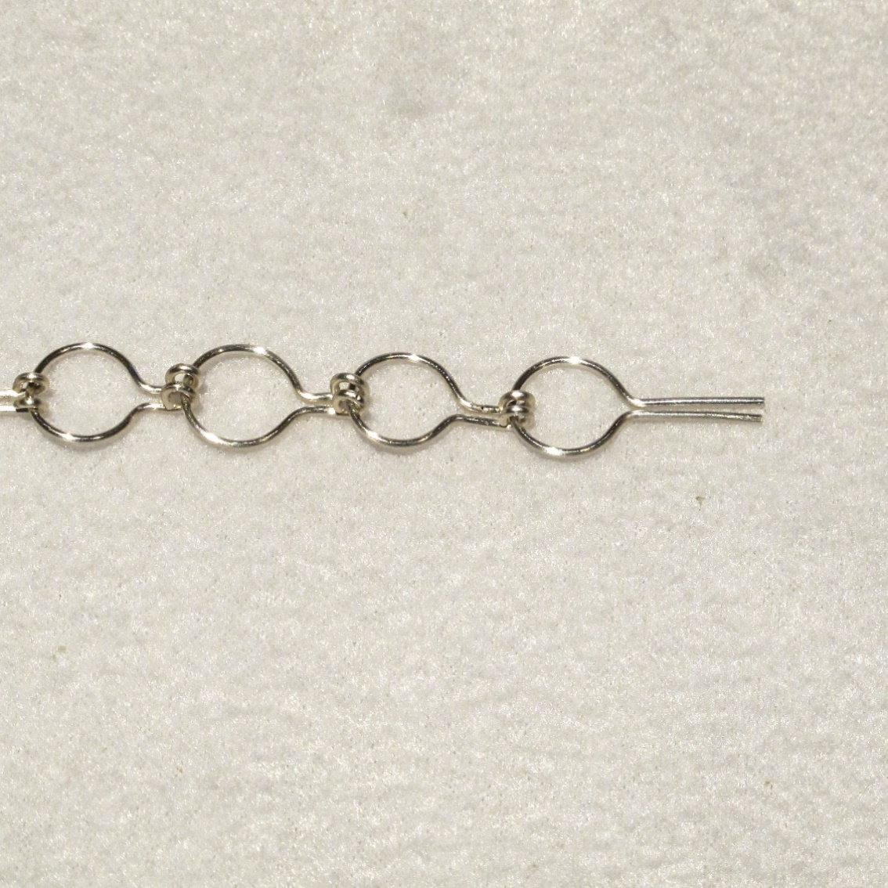Step 10**

11. Rotate first one and then the other straight end into loops.

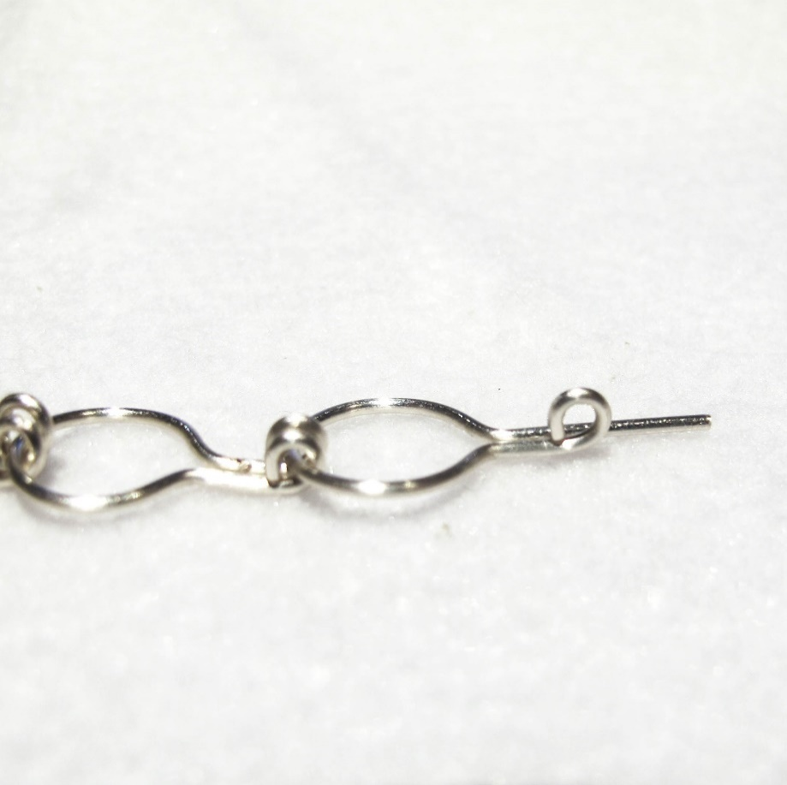 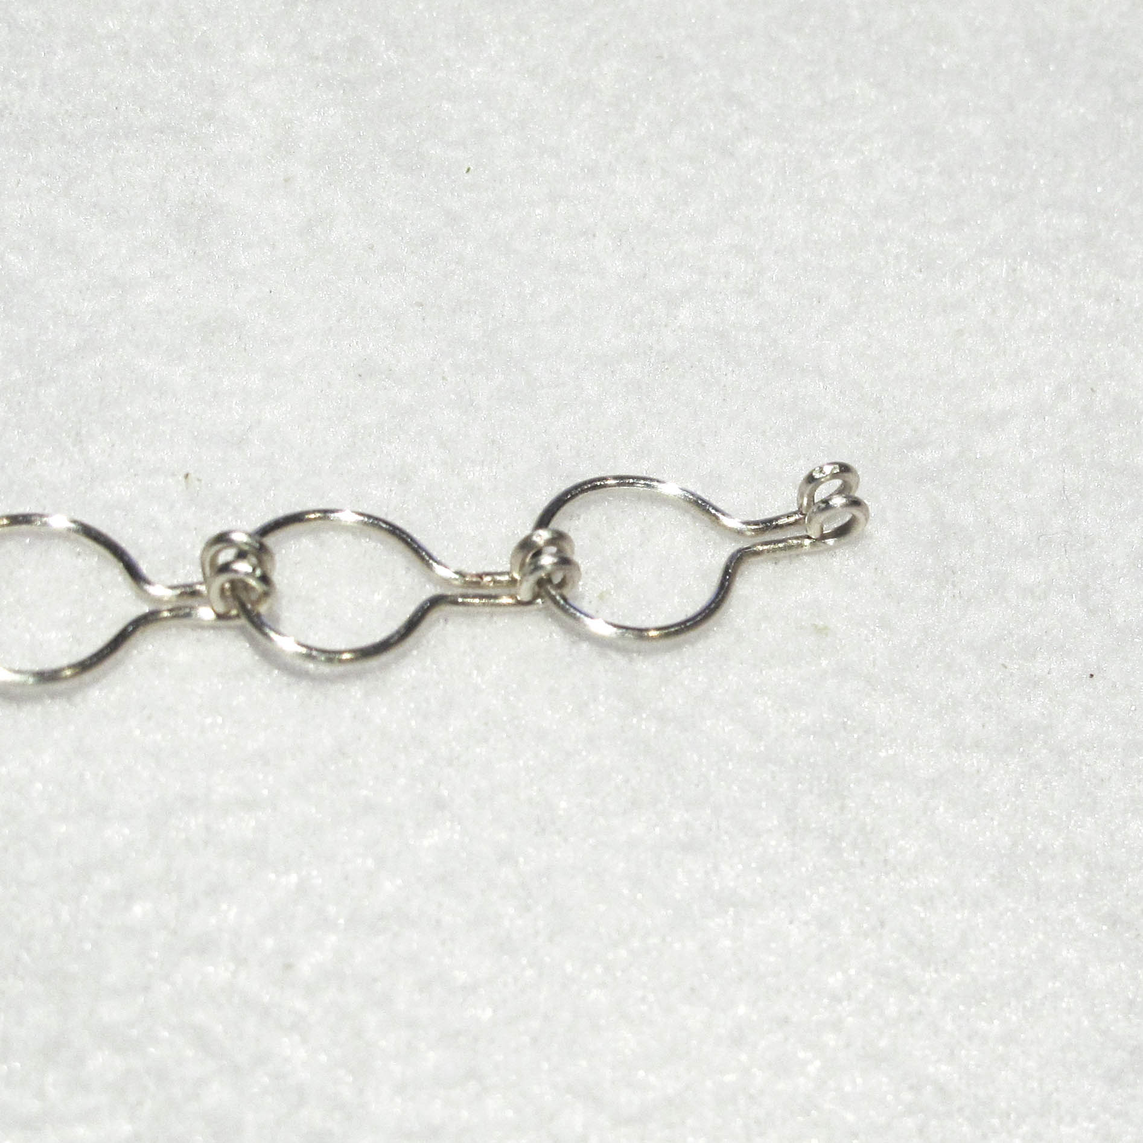

12. Repeat Steps 9-11 until you’ve used all your components.

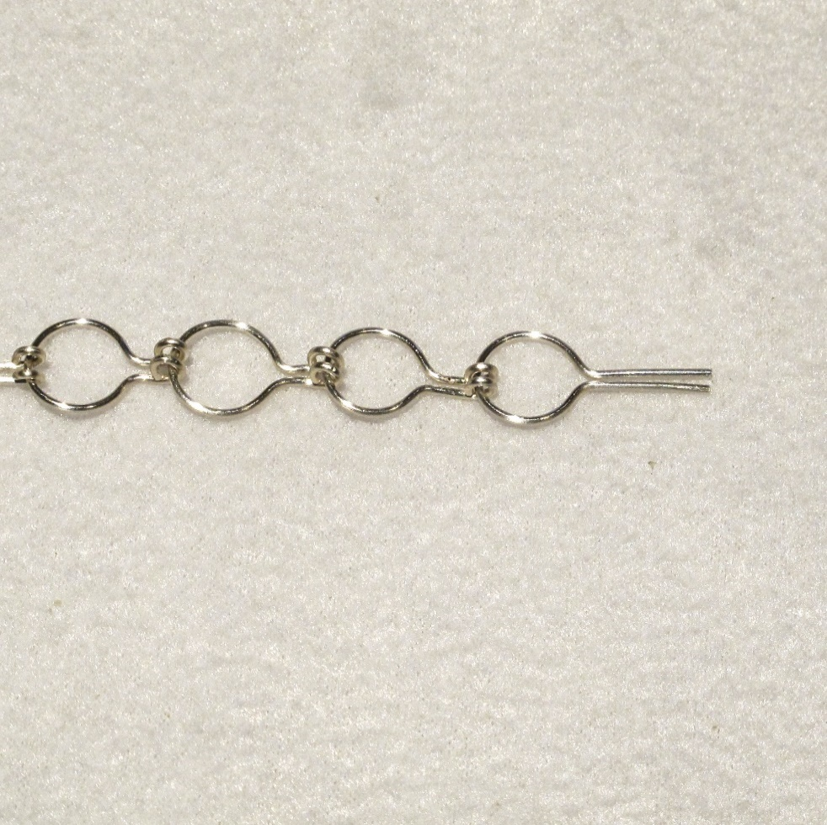 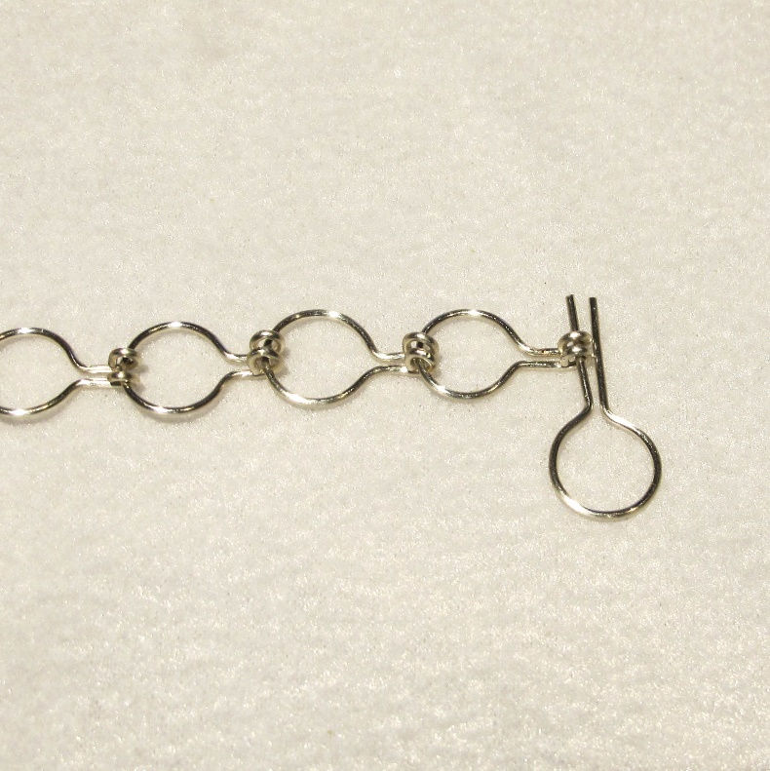

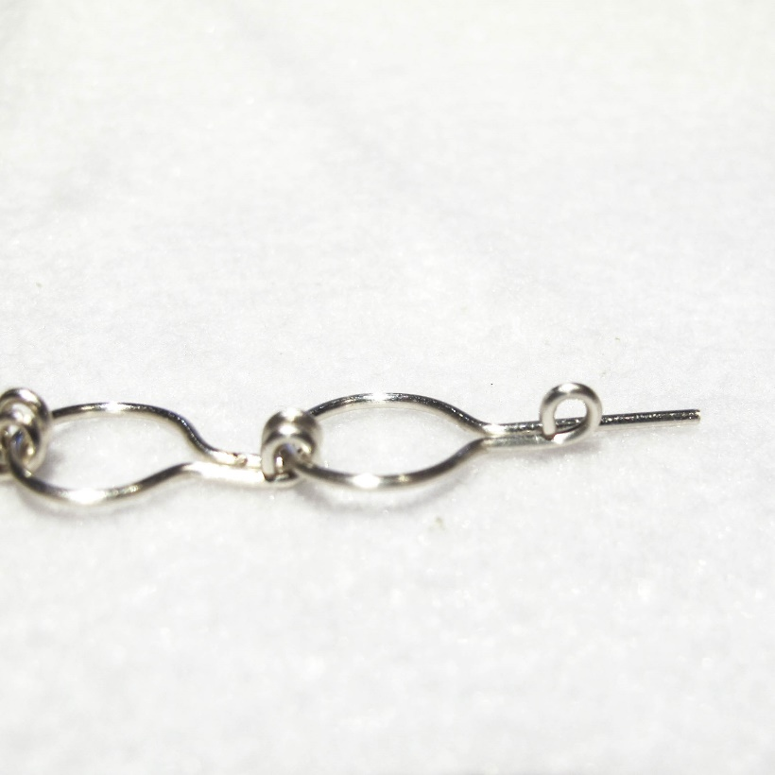 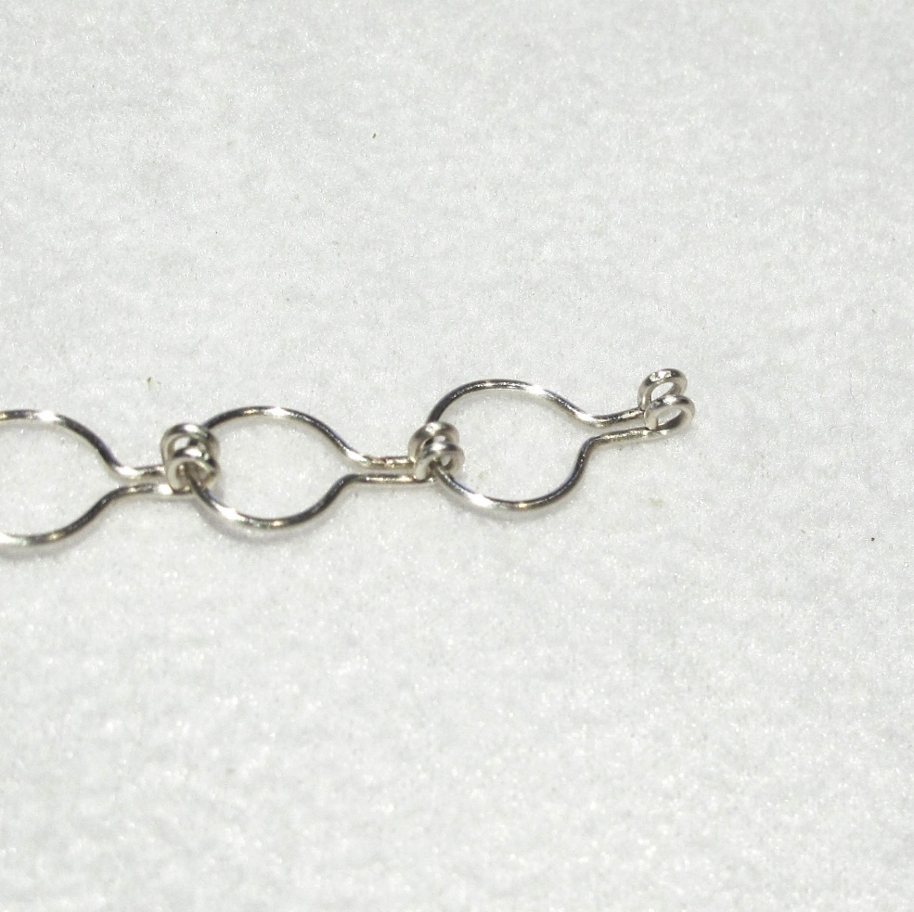

**MAKING THE CLASP**

13. When the necklace is the length you want it, take the last 3” piece of wire and repeat Steps 1-4.

14. Flush cut the straight ends just enough to make them even.

15. Repeat Steps 9 & 10 to connect this last component to the chain.

15. Use your 3mm. bailing pliers to make loops with both ends simultaneously. Don’t close these loops completely. Leave just enough of an opening to slide the 9mm. loop at the opposite end of the necklace into the loops to create a hook clasp.

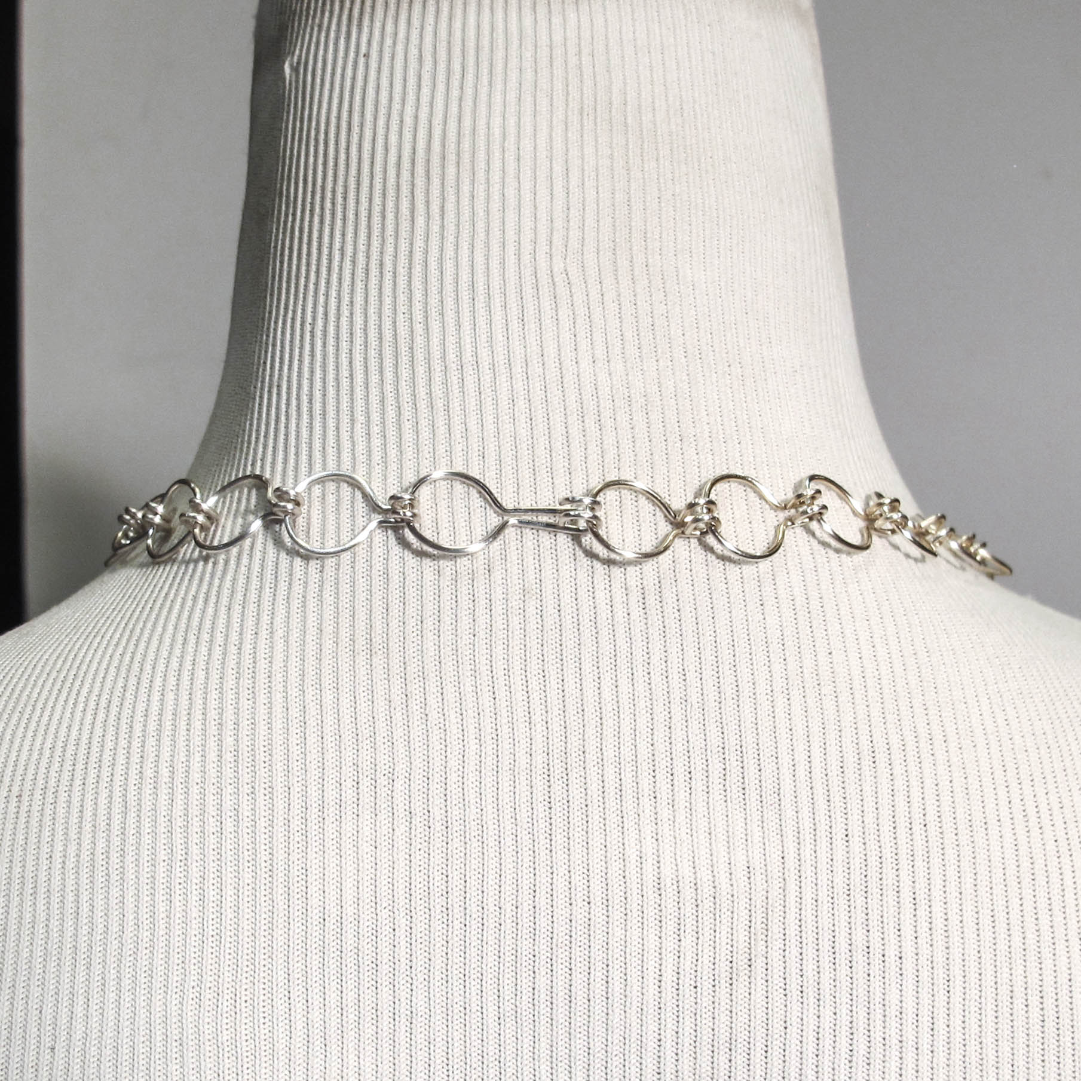 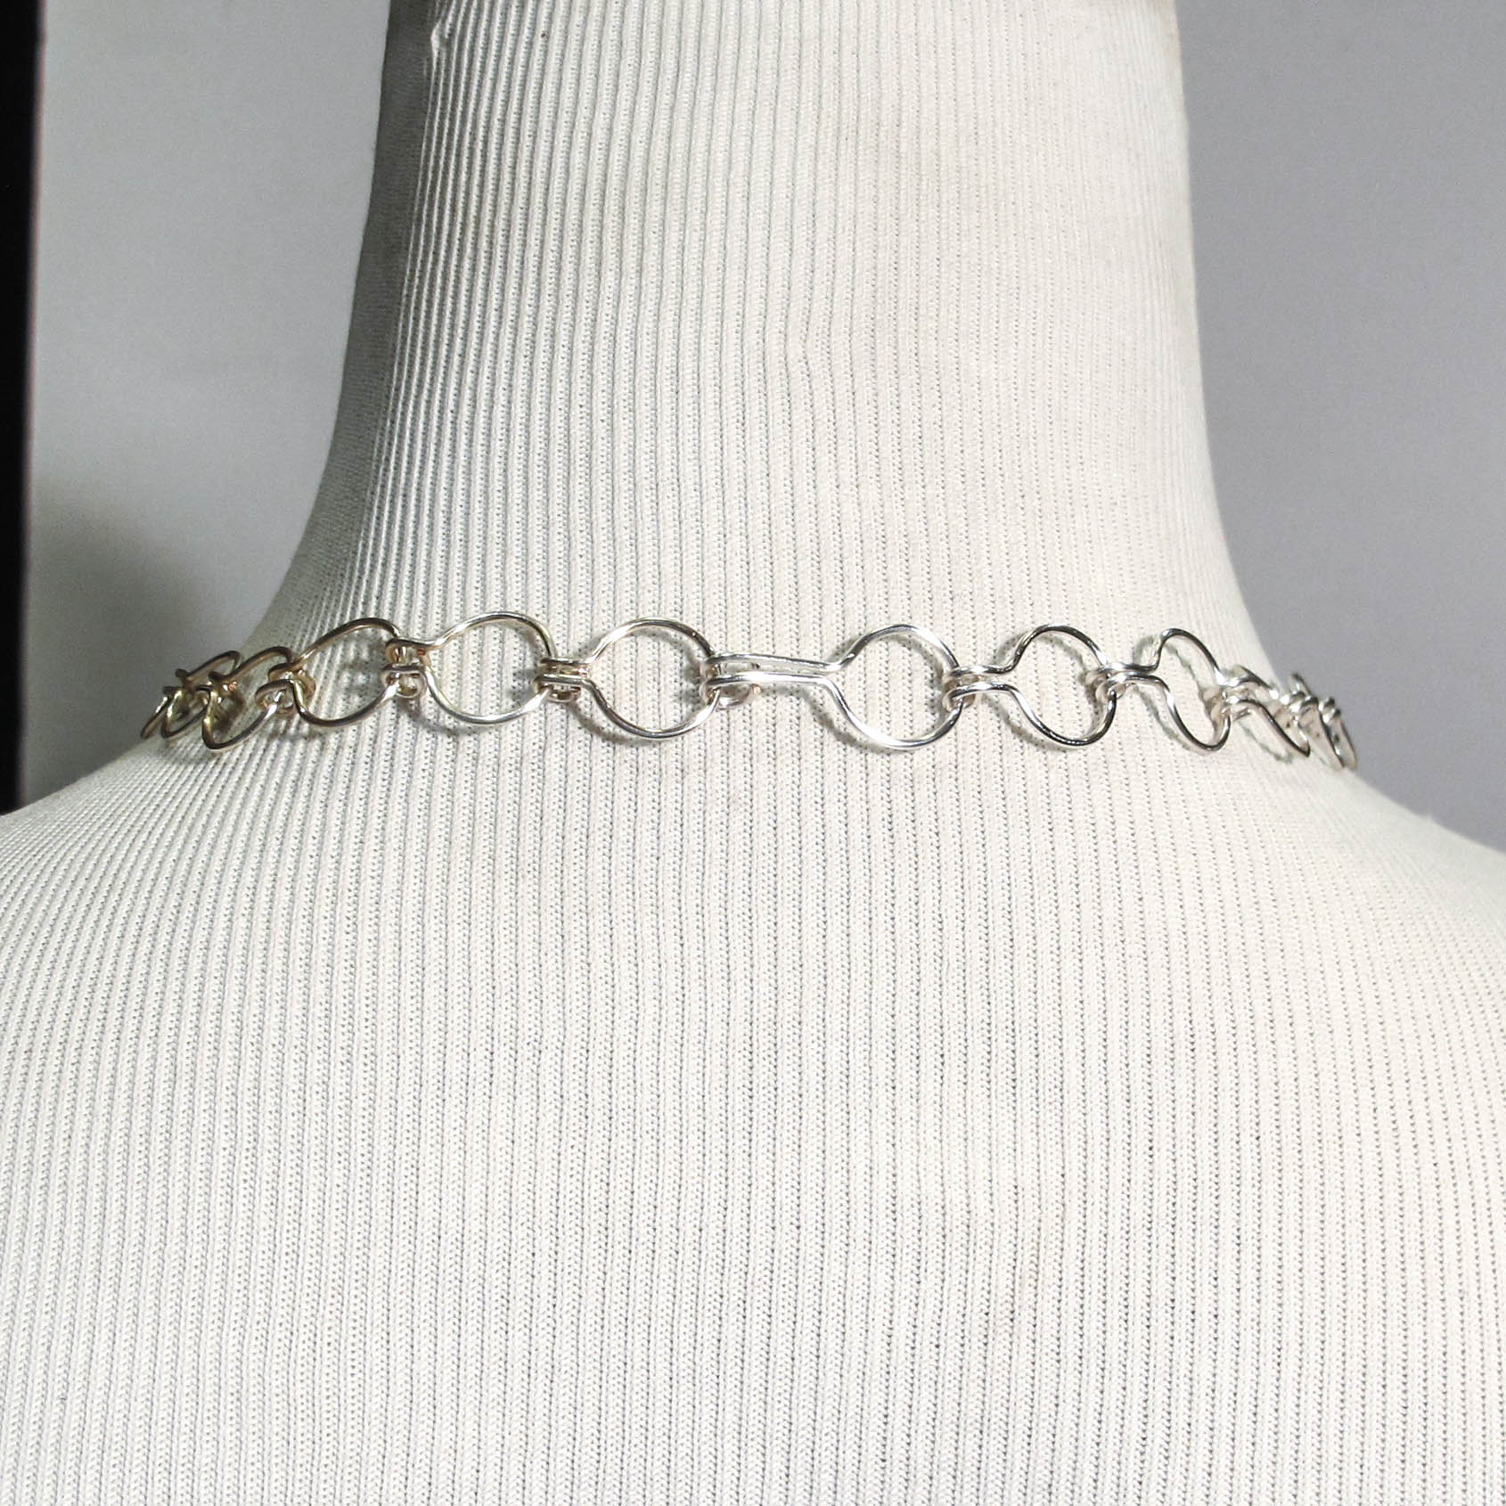

**Hook clasp facing out Hook clasp facing in**

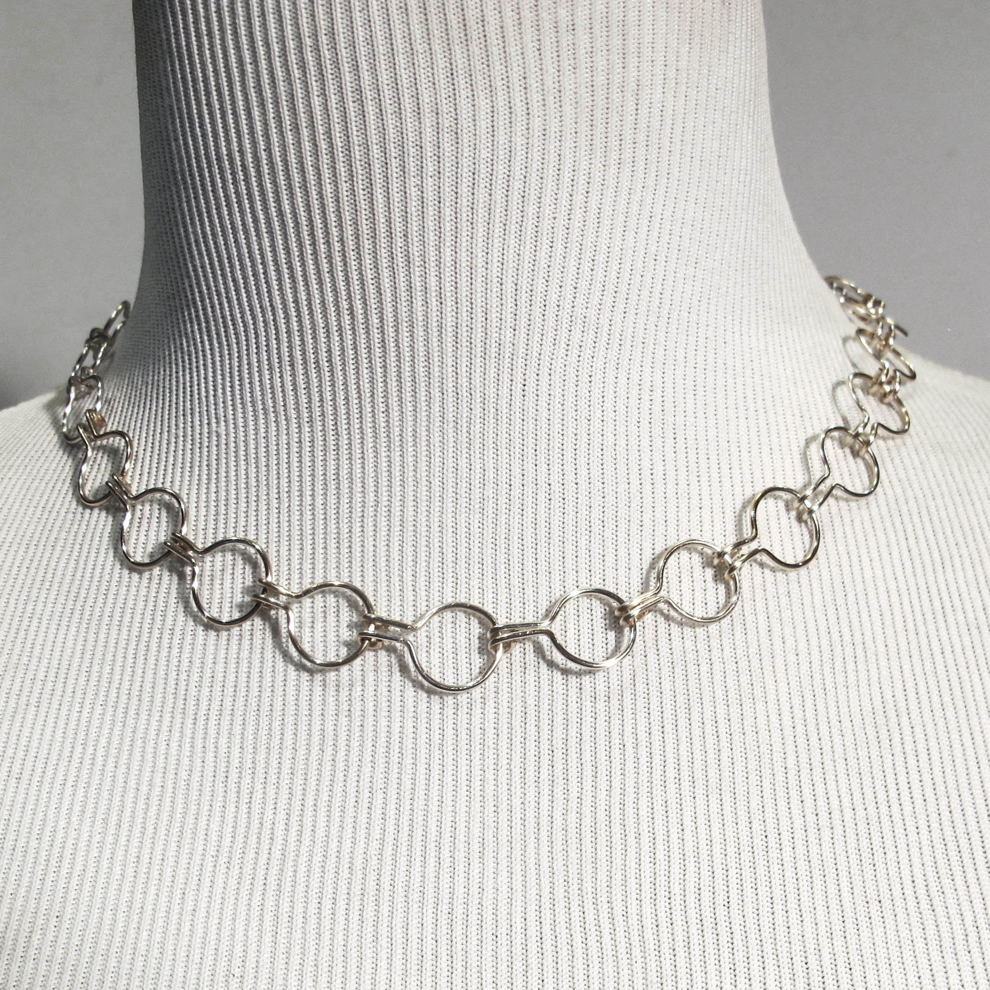

**©2020 Susan Ryza** [**www.susanryza.com**](http://www.susanryza.com) **10/11/20**