Endless Loom Stretchy Bracelet
(Bead Weaving Project #361)

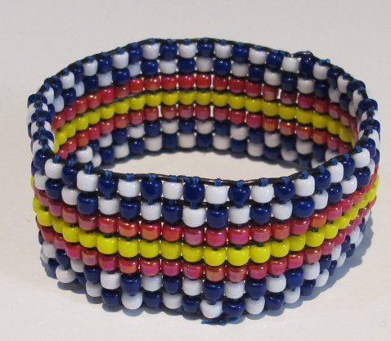

Materials Needed for 1” wide bracelet
Approx. 400 Size 6 seed beads, in as many colors as you choose
8 Beadsmith Endless Loom elastic bands
9 yards of Superlon thread, size D
G-S Hypo Cement
Graph paper
Colored markers or pencils

Tools Needed
Endless Loom & accessories
(2) #10 Beading needles
Chain-nose pliers
Wire flush cutters
Scissors
Project Mat

Instructions
1. Decide how big you want your bracelet to be. The stretchy bands are available in 7” or 8” sizes.
2. You’ll need one more stretchy band than the number of beads in the width of your bracelet. We will be making a bracelet that will be 7 beads across, so you’ll need 8 stretchy bands.
3. Plan your design on graph paper. The woven bracelet will use 7 rows per inch and will be 7 beads wide. If you plan to make a 7” bracelet, you will have about 49 rows of beading. An 8” bracelet will have about 56 row of beading. The number of rows is approximate because sometimes the bands will get a little stretched out and end up taking a few extra rows. For example, I used 7” bands but ended up with 54 rows, which is more like 7 ½”.
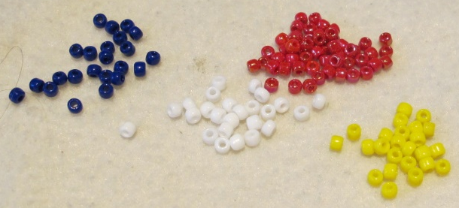 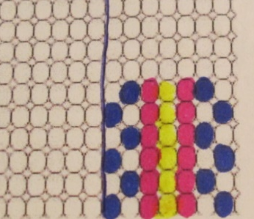 Step 3
4. Set up your loom: Choose the two Spacer Bars that match the size of your bands (ex: 7”). The sizes are marked on the spacer bars. Insert the bars into the holes on the insides of the loom bars to connect the loom. You can add rubber bands on the sides of the loom to keep it together if it feels loose (this may occur when the loom is older, but probably won’t be needed when the loom is new).
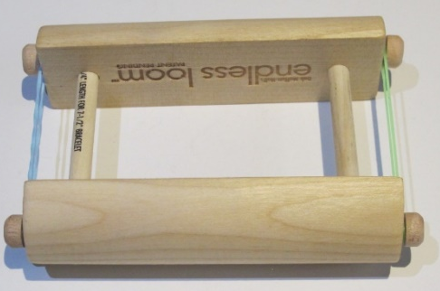 Step 4

5. Roll on your 8 stretchy bands. Space them apart approximately the width of a size 6 seed bead.
6. Slide a piece of folded paper into the space between the cords so the cords on the bottom don’t get visually in the way of seeing the top cords clearly.
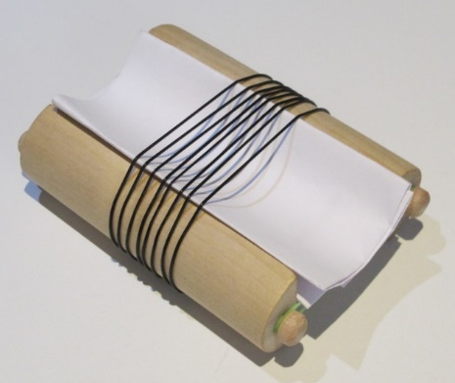 Steps 5 & 6
7. Cut 4 ½ yards of Superlon thread. NOTE: We don’t use Fireline with stretchy bands because they can cut into the rubber of the bands. Superlon is softer.
8. Flatten the end of the thread with chain-nose pliers and thread one of your needles.
9. Slide the needle to the very center of your thread and match the two ends up.
10. Leaving a 12” tail, tie the two thread ends, held together, to the stretchy cord on the furthest right side. (NOTE: If you’re left-handed, do everything on the opposite side.)
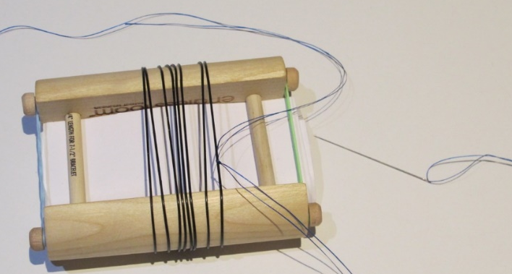 Steps 7-10
11. String on the 7 beads that make up the first row of your pattern. Slide the beads down to be next to the stretchy cords.
12. Bring the needle, thread and beads under the stretchy cords so that the 7 beads line up with the spaces between the cords.

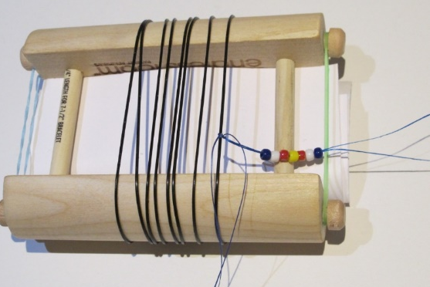 Step 11 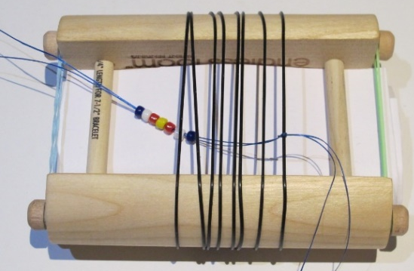 Step 12

13. Hold your finger under the beads and push them up into the spaces between the cords – each bead in its separate space.
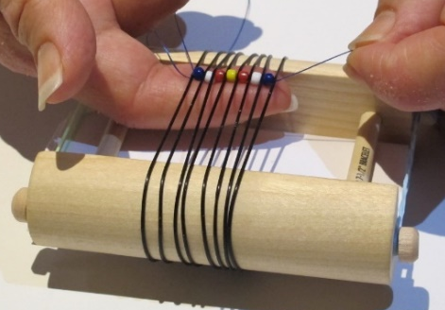 Step 13
14. Thread the needle back through the beads from left to right (opposite if you’re left-handed), making sure that the needle goes above the cords between the beads.
15. Pull everything tight and neat, without indenting the stretchy cords on the edges.
16. Repeat Steps 11-15 for each row of your pattern. Move the woven piece down to give yourself more weaving room when the loom space gets hard to manage. At some point, you’ll run out of thread. When you have about 12” of thread left, cut another 4 ½ yards of thread and repeat Steps 7-10 to start the new thread, right where the old thread left off. We will end off the tails later, so leave them hanging for now.
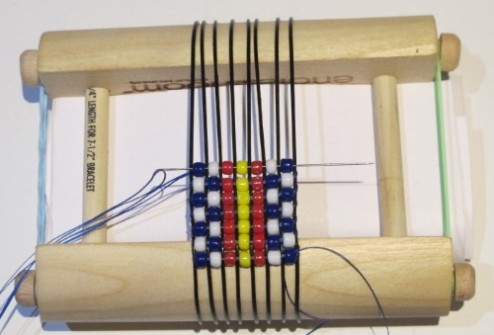 Steps 14-16
17. Stop weaving when there is enough space left for two more rows of beads. We will take the piece off the loom at this point because the stretchy cords will shrink a little bit when removed from the loom.
18. Let the piece sit for a few minutes for the cords to shrink. Then play with the woven rows to fill in any remaining spaces.
19. To end off the threads, tie two ends together that are near each other with double square knots, and then weave each thread tail back and forth through a few rows of beads. Put a dab of glue on each knot.
20. Trim off excess thread.

