European 4-in-1 Cuff Bracelet with Rubber O-Rings
(Chain Maille Project #344)
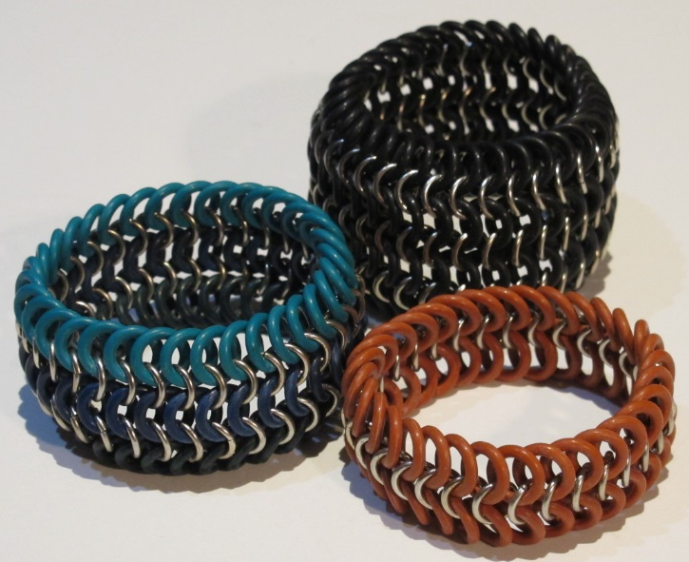
Materials Needed
For 7” bracelet: 34 metal rings and 68 rubber rings for base round.
34 metal & 34 rubber rings for each additional row.
Ring Sizes:
16-gauge jump rings, 7.5mm. outer diameter jump rings (Susan’s #33)
10mm Rubber O-Rings

Tools Needed
2 pairs of smooth-jawed pliers (chain-nose, flat nose or bent nose)

Instructions
1. Open all the metal jump rings so the right side of each ring is closer to your body than the left.
2. Slide four rubber rings onto one open metal ring (red in photo below). Close the metal ring. Arrange the jump rings as shown in the Step 2 illustration below.
3. Slide two rubber rings onto a new, open metal ring. Slide the still-open metal ring through the two top rubber rings of the 5-ring unit from the previous step. Close the metal ring. Be certain that the new metal ring is positioned in the same direction as the center metal ring of the adjacent unit.
4. Arrange the new rubber rings on either side into the same position as the previous rubber rings.
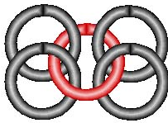Step 2 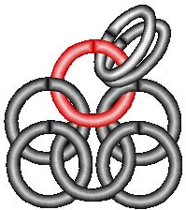Step 3 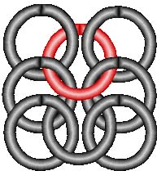Step 4

5. Slide two more rubber rings onto another open metal ring. Attach the metal ring through the top two rubber rings of the previous 5-ring unit. Close the metal ring.
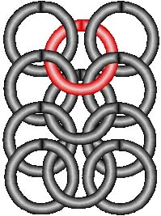Step 5
6. Repeat steps 3-5 until the bracelet is the desired length to go around your wrist. Test the piece for stretch to see how long it will actually be, before deciding when to stop. It will likely stretch a fair amount once it is on, so you’ll probably need to make it shorter than the actual length of your wrist.
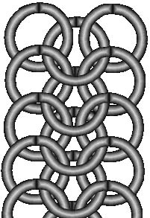Step 6
7. Once the piece is the right length, bring the ends together to connect them. Follow the pattern of the rings to finish off the final, connecting row so you have a continuous chain maille circle.
8. To add another row to widen the bracelet, begin by sliding two rubber rings onto one open, metal ring. Slide the metal ring through the first and second rubber rings anywhere along the right side of the base section of the bracelet.
9. Close the metal ring. Arrange the side rubber rings into the same position as the rings in the adjacent unit.
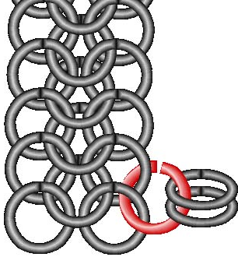Step 8 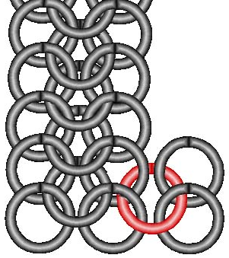Step 9
10. Slide another rubber ring onto a new, open metal ring. Slide the metal ring through the top right rubber ring of the previous unit and continue clockwise through the bottom left rubber ring of the next unit. Then go up through the top left rubber ring. The metal ring should be going through four rubber rings. Close the metal ring.
11. Repeat the previous steps until the new row goes all the way around the bracelet. Connect the two ends by adding the missing rings.

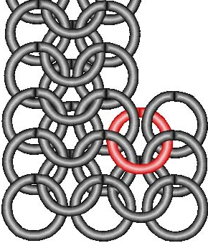Step 10 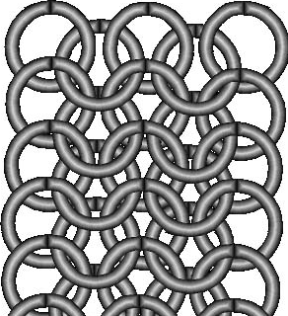Step 11
12. Add as many rows as you want the bracelet to be wide by following the same procedure.
13. Add additional rows of metal rings alone to both edges, if desired.

©2018 Susan Ryza www.susanryza.com 6/6/18 Updated 10/13/18

