Viking Knit Beaded Bangle Bracelet
(Craft Wire Project #219)

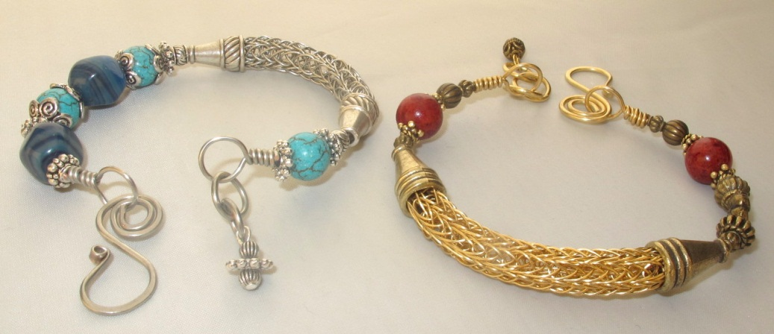

Materials Needed
4 yards of 24-gauge wire for Viking knit
20” of 18-gauge wire for bangle
12” of 16-gauge wire for clasp
12” of 20-gauge wire, any color
1 Head pin
1 Small bead for dangle
The following items with holes large enough to fit on 18-gauge wire:
-2 cones large enough to fit 5/16” ends of Viking Knit
-Bead caps
-Asst. Large & small beads: stone, metal, glass, etc.
-Decorative Metal spacers
Tools Needed
2 pairs of Chain-nose pliers
Round-nose pliers
Wire side cutter
½” Lazee Daizee Viking Knit tool
Viking Knit drawplate
7mm. & 9mm. mandrels or 7mm./9mm. bailing pliers
Steel bench block
Chasing hammer
Ruler

Instructions
MAKE THE VIKING KNIT PIECE:
1. Use 24-gauge wire to weave a 2” piece of Viking Knit or Double Knit on the ½” Laizee Dazee tool. Cut the first piece of wire 1 yard long and the next 2 pieces 1 ½ yards long each. If you’re doing double knit, weave the first 3 rows in single knit and then switch to double knit.
2. Pull the Viking Knit piece through the drawplate:
Cut the 20-gauge wire into two 6” lengths. Fold each 6” piece in half. Poke the first 6” piece through one end of the knit piece from the inside out, 2 rungs down from the end. Repeat this with the second 6” piece of 20-gauge wire.
Narrow the end of the knit piece by pushing it in with your fingers, and then grasp the ends of the 20-gauge wire to help pull the piece through the drawplate. Use chain-nose pliers to get a better grip on the 20-gauge wire, if necessary. Starting with the largest hole, pull the piece through each smaller hole successively, until it goes through the 5/16” hole. Pull it through each hole twice. By the time it goes through the 5/16” hole, the knit piece will be about 3 ½” long.
3. Remove the two folded pieces of 20-gauge wire and save for another Trim off any messed-up wire at the ends of the Viking knit pieces, as well as any loose pieces of wire.
4. When the ends are nice and neat, cut a piece of the Viking Knit that is about 2 ½” long. Do this by carefully cutting through one or 2 wires at a time, all around. Trim the cut end neatly again, and remove any loose pieces of wire.
5. Pinch in both ends of the Viking Knit piece with your fingers or with your chain-nose pliers.
6. Fit the ends securely into the 2 cones, one at each end of the knit piece. Set aside.
MAKE THE BEADED BANGLE:
7. Cut 20” of 18-gauge wire.
8. Place your chain-nose pliers 4” from one end of the wire and bend the wire to a 90-degree angle over the pliers.
9. Use a 7mm. mandrel or bailing pliers to create a round, wrapped loop from the bent section of the wire. Wrap the wire 3 times at the base of the loop. Make sure the wraps are tight and parallel and that the loop is centered over the wire. Use chain-nose pliers to squeeze the wraps together, if necessary.
10. Trim off excess wire & tuck in the end.
11. String on small & large metal & stone beads, bead caps, decorative wire spacers and the Viking Knit piece with cones – in any order you like, symmetrical or asymmetrical. The entire beaded area should measure about 5 ½”. Make sure the wire goes through the center of the Viking Knit Piece.
12. Push all the beads down against the wrapped loop you made at the beginning of the bracelet.
13. Bend the bracelet & the Viking Knit piece into a rounded, wrist-shape bracelet.
14. Use your chain nose pliers to measure the amount of space your 3 wraps used on the beginning end of the bracelet. Hold your chain-nose pliers next to the final bead strung to create the same amount of space, and bend the wire over the pliers to a 90-degree angle.
15. To complete the beaded section, make another 7mm. wrapped loop as you did in Step 9. Wrap 3 times into the space created by your chain-nose pliers in Step 14. Trim off excess wire & tuck in the end.
MAKE THE CLASP:
16. Cut a 3 ½” length of 16-gauge wire. Flush-cut the ends. Be sure to cut with the center of your cutting blade, not the tip.
17. Use your steel bench block and chasing hammer to flatten about ½” of one end of the wire.
18. Use the very tip of your round-nose pliers to curl the flat end into a small loop.
19. Place the 7mm. mandrel or bailing pliers behind the back of the small loop, about 1/8” away from the loop, and bend the wire backwards, away from the small loop, to create a large hook, as seen in the photo below. 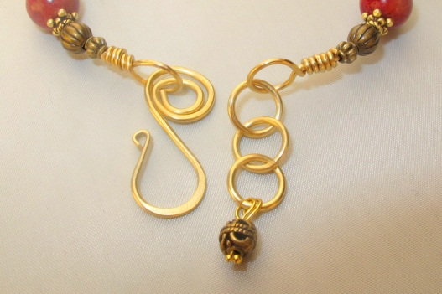
20. At the other end of the 16-gauge wire, make about a 4mm. loop by wrapping the wire around the fattest spot on your round-nose pliers. This loop should be going in the opposite direction from the hook, but on the same plane as the hook.
21. Use chain-nose pliers to wind the wire around the 4mm. loop to make a spiral that goes almost all the way up to the hook made in Step 19.
22. Hammer the top/side of the hook flat and hammer the spiral somewhat flat.
23. Use chain-nose pliers to pull open the inside of the spiral enough so that you can slip it onto the wrapped loop at one end of your beaded piece. The hook should end up facing towards the outside of the bracelet, as seen in the photo above. Close the spiral back up once the loop is in it.
MAKE JUMP RINGS:
24. Wrap the remaining 16-gauge wire around the 7mm. mandrel or bailing pliers to make a coil.
25. Spread the rings of the coil apart so you can fit your cutters between the rings.
26. Cut the rings into jump rings with flush-cut ends as follows: First cut one side flush and then turn the cutters around to flush-cut the other side. Make sure the cut ends of the rings will match up. After completing the first ring, flush-cut the newly-exposed end so you can begin the next jump ring. Be careful not to cut with the tips of the cutters because they may break. Spread the rings apart enough so you can cut with the center of the blade.
27. Attach 2 or 3 jump rings to the loop on the end of the bracelet that doesn’t have the hook, to make a small chain.
FINISH OFF:
28. Make a dangle out of the head pin and a small bead. Hang it from the last jump ring.
29. Open & close the bracelet by hooking the hook clasp into any one of the jump rings.

©2013 Susan Ryza www.susanryza.com

