Brick Stitch Comet Earrings
(Bead Weaving project #174)

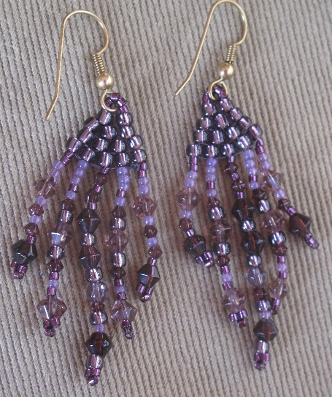

Materials Needed
80” size D beading thread, such as Fireline or Superlon
14 -#8 seed beads (plus more for dangles)
60 -#11 seed beads (plus more for dangles)
12” of asst. small beads, such as 4mm. bicones & 4mm. round,
& including extra #8 & #11 seed beads
1 pr. Earring wires

Tools Needed
Scissors
#10 beading needle

Instructions (Refer to drawings below.)
1. Cut 40” of beading thread & thread your needle.
2. Row 1 will be a base row of Ladder Stitch: String on two #8 seed beads.
3. Leaving an 8” tail, come around again & pass through the same beads again, going in the same direction.
4. Arrange the 2 beads to line up side-by-side, rather than hole to hole.
5. String on another #8 seed bead. Bring the thread back around through the previous bead.
6. Now bring the thread back through the last bead (the one you strung on in Step 5).
7. Repeat Steps 5 & 6 two more times, until you have a row of 5 beads, all side-by-side.
8. Sew back through each bead of row one again, to straighten and tighten all the beads.
9. Row 2: First Brick Stitch row. String on two #8 seed beads & pull them down to meet the previously completed row of beads. Pass the needle under the bit of thread showing between the second pair of beads of the previous row. Bring the thread back up through the last bead you just strung on.
10. String on another #8 seed bead and pass the thread under the thread between the next pair of beads & then back up through the bead you just strung on.
11. Repeat Step 10 one more time to complete Row 2.
12. Row 3: Going back in the opposite direction, follow Steps 9-10 to create a Brick Stitch row of 3 beads.
13. Row 4: Repeat Step 9 to create a Brick Stitch row of 2 beads. You now have a small pyramid of beads.
14. Making the earring wire loop: String on 5 #11 seed beads.
15. Pass the thread through the loop of an earring wire, pulling the tiny beads through the earring wire loop along with the thread. Go back down through the other #8 bead on the top row of the pyramid, pulling tight to create a loop of tiny seed beads that attaches the earring wire to the bead pyramid.
16. Go down through the next #8 seed bead & then up through other #8 seed beads so that you return to the base of the tiny seed bead loop again.
17. Pass back through all the tiny seed beads again, to strengthen the loop. Come around & do this a third time to make it really strong.
18. Now sew down through the #8 seed beads, using any path that ends up with the thread exiting down through the #8 bead at the opposite end of the Ladder Stitch base row from the tail.
19. You are now ready to make the 5 dangles that will hang down at the bottom of the earring, one from each #8 seed bead.
20. For the first dangle, add two or three #11 seed beads to the thread, then other assorted small beads, until you have 1” of beads hanging down. End with three #11 seed beads at the bottom, which will serve as an anchor to keep the rest of the dangle beads from falling off.
21. Bring the thread back up through all the beads of the dangle again, with the exception of the bottom 3 “anchor” beads. The anchor beads should form a triangle at the base of the dangle. Continue to bring the thread up through the #8 seed bead that’s just above it. Leave a little slack in the thread so the dangle won’t be too stiff.
22. Bring the thread over to the adjacent #8 seed bead & then down through that bead.
23. Repeat Steps 20-22 to make the next dangle, but make this one ¼” longer than the last one.
24. Repeat Step 23 to make the middle dangle.
25. Dangle #4 should be the same as dangle #2.
26. The last dangle should be the same as the first one.
27. To end off the thread, work the needle through the Brick Stitch triangle beads until the thread on the needle meets the 8” tail thread. Tie the two threads together with 2 square knots.
28. Weave in the remaining thread ends & clip off any excess thread.
29. Make another earring to complete the pair.
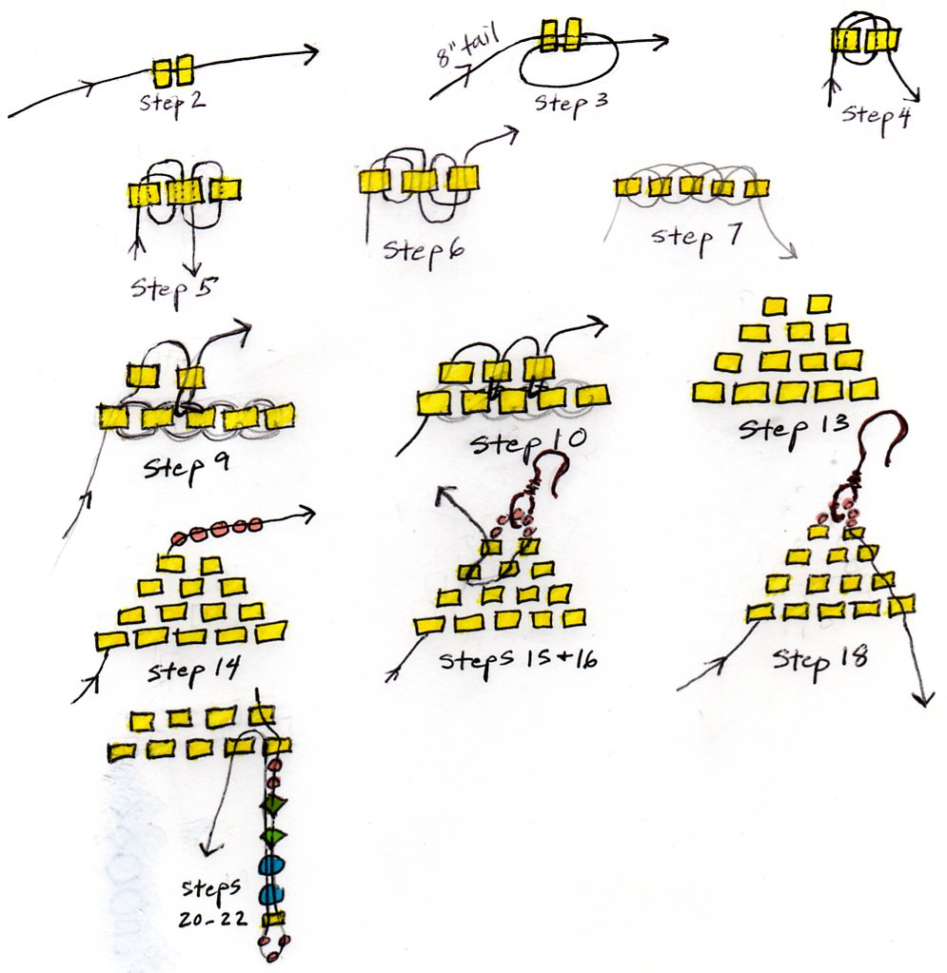

©2013 Susan Ryza www.susanryza.com

