10% CLP in Non Hazardous Base
Enchanted Forest
(4-tert-Butylcyclohexyl acetate)

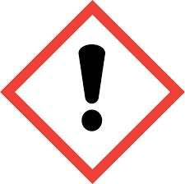
Warning: May cause an allergic skin reaction. Harmful to aquatic life with long lasting effects. IF ON SKIN: Wash with plenty of soap and water. If skin irritation or rash occurs: Get medical advice/attention. Dispose of contents/container to
approved disposal site, in accordance with local regulations.
Contains: (3,7-Dimethylocta-1,6-dien-3-ol; 3-Phenylprop-2-en-1-ol; 3,7-Dimethyloct-6-en-1-ol; 4-Allyl-2-methoxyphenol; 8-Methoxycedrane; 3-Phenylacrylaldehyde). May produce an allergic reaction.
Add - Your Trading Name, Address, Phone Number.

