**CERTIFICATE OF ANALYSIS**

|  |
| --- |
| **Product: Juniper Berry Essential Oil**  **Shelf Life: 2 years** |

|  |  |  |
| --- | --- | --- |
| **Test** | **Standards** | **Results** |
| **Biological name** | *Juniperi aetheroleum* | Complies |
| **Appearance** | Mobile, colorless to yellowish liquid | Complies |
| **Odour** | Characteristic fresh and slightly woody aroma. | Complies |
| **Refractive index at 25°C** | 1.451 to 1.483. | 1.4701 |
| **Specific gravity at 20°C** | 0.850 to 0.895 | 0.851 |
| **Optical rotation** | −15° to +20.5° | -2.587° |
| **Solubility** | Soluble in Ethanol | Complies |

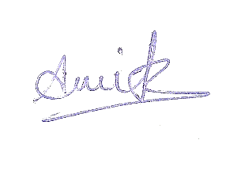 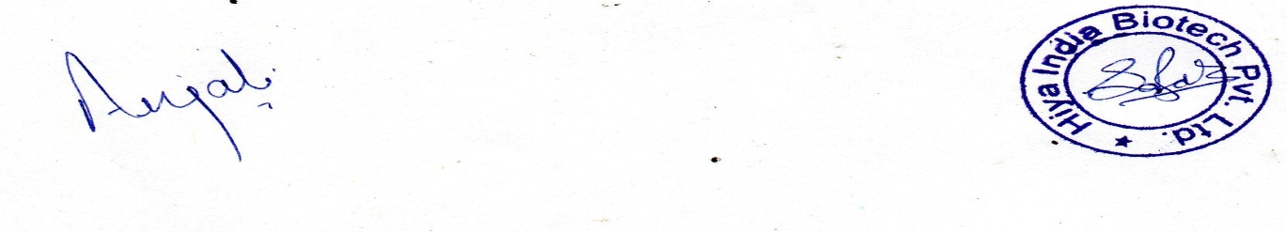

**Analysed By** **Approved By**

Note: Since it is an herbal product, there is likely to be minor colour variation from batch to batch because of the seasonal variations of the raw materials, Colour does not affect the quality and efficacy of the product.