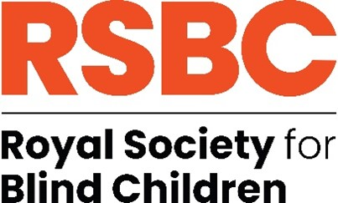

**Job Title: Mobility and Habilitation Officer**

**Reports to: Head of Pastoral and Therapies**

**Hours: 35 hours per week, Term Time + 3 weeks**

**Location: VI Centre of Excellence - Nescot College. Epsom, Surrey KT17 3DS**

**Salary: £35,000 - £40,000 FTE. Actual - £30,561 - £34,927 p.a.**

**Contract: Permanent**

## Are you interested in working for an organisation making a real difference to the lives of young blind and partially sighted people?

## Here at the Royal Society for Blind Children we believe that every blind young person should have the chance to live life without limits. Our values of Trust, Energy, Ambition, and Motivation underpin everything we do, and by giving young people the essential skills to take control of their life, they can unleash their true potential.

We are looking for a Mobility and Habilitation Officer to work with students/pupils with Vision Impairment (VI) at Dorton College/Surrey VI Centre of Excellence as part of the Therapies Team and wider college VI teams, as part of a holistic multi-disciplinary approach.

Working alongside and in liaison with the wider Dorton College/Surrey VI Centre of Excellence team, you will plan and deliver Mobility and Habilitation sessions for students at the college and targeted outreach sessions as required.

## Some main duties of this role include:

* Devise and carry out mobility and habilitation sessions as required
* Provide mobility and habilitation reports for annual reviews and other reviews in accordance with the college timescales
* Maintain up to date records of Mobility and Habilitation plans and progress trackers, to include EHCP target related and wider student progress.
* Carry out assessments for potential students and existing students as part of the ongoing assessment process.
* Plan and support/deliver sessions around independence and living skills as required.
* input into individual plans, student profiles, risk assessments, therapy programmes and specialist equipment lists when required.

The ideal candidate will have a Mobility and Habilitation qualification; excellent communication and interpersonal skills; the ability to work with a range of stakeholders; proven ability to write educational reports which are suitable for internal and external agencies; ability to work to deadline and complete actions in a timely manner.

In return we offer a competitive range of benefits including Employee Assistance Programme, Perkbox, flexible working opportunities, 3% contribution towards pension, access to 24/7 GP, mental health care and dental advice via apps if member of pension scheme, season ticket loan. We are a welcoming, diverse and inclusive workforce and are a Disability Confident Employer. We also hold the Investors in People Silver Award.

## For further details on the role, please refer to the Job Description and Person Specification. **https://www.rsbc.org.uk/pages/vacancies**

Please apply by emailing your CV and a supporting statement which details how you meet the requirements of the role and person spec to[**recruitment@rsbc.org.uk**](mailto:recruitment@rsbc.org.uk)

**Closing date: 09 July 2025**

**Interview: July**

**To apply you must have the right to work in the UK. We do not provide any sponsorship.**

The Society is committed to safeguarding and promoting the welfare of children, young people and adults and expects all staff and volunteers to share this commitment. Therefore, all posts are subject to an Enhanced Disclosure check from the Disclosure and Barring Service and 2 satisfactory professional references. Registered Charity No.307892