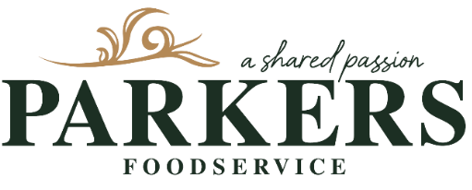

Delivery Driver / Warehouse Operative

We’re looking for a reliable and hardworking individual to join our team as a Delivery Driver/Warehouse Operative.
About the role:
You’ll be responsible for delivering goods to our local customers, as well as supporting warehouse operations when not on delivery.
Main duties include:
- Driving a 3.5 tonne van to deliver orders to local customers
- Assisting with unloading lorries and putting stock away
- General warehouse duties and maintaining a tidy workspace
- Packing and preparing customers orders
- Working as part of a small, friendly team
Requirements:
- A full, clean UK driving licence held for at least 3 years
- Previous experience driving a 3.5 tonne van preferred
- Strong customer service skills with the ability to represent the company professionally when interacting with customers
- Good timekeeping, attention to detail and a positive attitude
- Forklift experience is an advantage (training can be provided)
- Good knowledge of local and regional roadways and routes
- You will need your own transport to travel to and our depot due to the rural location of the business and be physically fit to cope with the demands of this position in a very busy environment

If you’re motivated, reliable, and enjoy a mix of driving and hands-on warehouse work, we’d love to hear from you.

