Refrigerated Counter-Top Prep

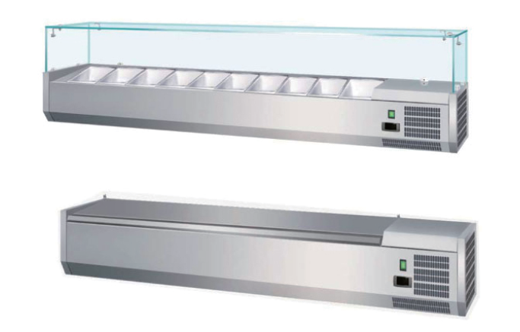

Installation,Operation & Maintenance Manual

(HC Gas R600a used)

Table of Contents

Safety Tips………………………………………………………………………..1
Introduction………………………………………………………………………1
Installation…………………………………………………………………………1
Fit Glass Panels…………………………………………………………….1
Operation………………………………..…………………………………………2
Storing Food………………………………..…………………………………….2
Turn On………………………………………………………………………………2
Cleaning, Care & Maintenance……………………………………………2
Cleaning the Condenser………………………………………………………2
Troubleshooting………………………………………………………………….2
Technical Specifications……………………………………………………….3
Electrical Wiring…………………………………………………………………..3
Disposal……………………………………………………………………………….3
Compliance………………………………………………………………………….3

Safety Tips
- Position on a flat, stable surface.
- A service agent/qualified technician should carry out
installation and any repairs if required. Do not remove
any components or service panels on this product.
- Consult Local and National Standards to comply with
The following:
·Health and Safety at Work Legislation
·BS EN Codes of Practice
·Fire Precautions
·IEE Wiring Regulations
·Building Regulations
- DO NOT use jet/pressure washers to clean the appliance.
- DO NOT use the appliance outside.
- DO NOT use this appliance to store medical supplies.
- DO NOT use electrical appliances inside the appliance.
(e.g. heaters, ice-cream makers etc.)
- Always carry, store and handle the appliance in a
vertical position and move by holding the base of the
appliance.
- Always switch off and disconnect the power supply to
the unit before cleaning.
- Keep all packing away from children. Dispose of the
packaging in accordance with the regulations of local
authorities.
- If the power cord is damaged, it must be replaced by
an agent or a recommended qualified technician in
order to avoid a hazard.
Introduction
Please take a few moments to carefully read through this
manual. Correct maintenance and operation of this
machine will provide the best possible performance from
your product.

We pride ourselves on quality and service, ensuring that at
the time of packing the contents are supplied fully functional
and free of damage.
Should you find any damage as a result of transit, please contact
your dealer immediately.
Installation
Note: If the unit has not been stored or moved in an upright position, let it stand upright for approximately 12 hours before operation. If in doubt allow the appliance to stand.

1. Remove the appliance from the packaging. Make
sure that all protective plastic film and coatings
are thoroughly removed from all surfaces.
2. Maintain a distance of 20cm (7 inches) between
the unit and walls or other objects for ventilation.
Increase this distance if the obstacle is a heat source.

Note: Before using the appliance for the first time,
clean the shelves and interior with soapy water.

3. Level the appliance by adjusting the screw feet.

Fit Glass Panels(optional)
1. Screw the collars to the rim of the appliance.

Note: Ensure the hole in the collar for the grub screw face
Inwards.

2. Slot the two side panels into the collars, with the holes in
The glass at the top.

Note: Ensure the screw hole furthest from the edge of the panel
goes to the back of the appliance.

3. Screw a grub screw into each collar to secure the panels.

Note: Ensure the soft end of the grub screw is the end making
contact with the glass.

4. Slot the rear panel into the collars, with the holes in the glass
at the top.
5. Screw a grub screw into each collar to secure the panel.
6. Slot the plastic plugs into each of the holes.
7. Screw the brackets to the inside of each pane using the bolt
assemblies.

Note: Ensure the short end of the bolt assembly is on the outside
of the panels.

8. Place the top panel onto the brackets, ensuring all holes line up.
9. Insert the plugs and attach the top panel to brackets with the bolt
assemblies.

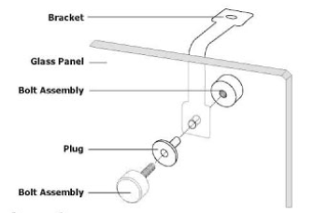

Operation
Storing Food
To get the best result from your appliance, follow these instructions:
1. Only store foodstuffs in the appliance when it has reached the correct operating temperature.
2. Do not place uncovered hot food or liquid inside the appliance.
3. Do not obstruct the fans inside the appliance.
Turn on
1. Close the door(s) of the appliance.
2. Ensure the power switch is set to [O] and turn on at the socket.
3. Switch on the power [l]. The current temperature within the appliance is displayed.
Cleaning, Care & Maintenance
·Switch off and disconnect from the power supply before cleaning.
·Clean the interior of the appliance as often as possible.
·Do not use abrasive cleaning agents. These can leave harmful residues.
·Clean the door seal with water only.
·Always wipe dry after cleaning.
·Take care when cleaning the rear of the appliance. Sharp edges can cut.
An agent or qualified technician must carry out repairs if required.
Cleaning the Condenser
Periodically cleaning the condenser is mandatory and failure to do so will void the warranty.
We recommend that our agent or qualified technician clean the condenser.
Troubleshooting
If your appliance develops a fault, please check the following table before making a call to your dealer.
Fault | Probable Cause | Action
The appliance is not working | The unit is not switch on | Check the unit is plugged in correctly and switched on
The appliance is not working | Plug and lead are damaged | Call your agent or qualified technician
The appliance is not working | Fuse in the plug has blown | Replace the fuse
The appliance is not working | Power supply | Check power supply
The appliance is not working | Internal wiring fault | Call your agent or qualified technician
The appliance turns on, but the temperature is too high/low | Too much ice on the evaporator | Defrost the appliance
The appliance turns on, but the temperature is too high/low | Condenser blocked with dust | Call your agent or qualified technician
The appliance turns on, but the temperature is too high/low | Doors are not shut properly | Check doors are shut and seals are not damaged
The appliance turns on, but the temperature is too high/low | Appliance is located near a heat source or air flow to the condenser is being interrupted | Move the refrigerator to a more suitable location
The appliance turns on, but the temperature is too high/low | Ambient temperature is too high | Increase ventilation or move appliance to a cooler position
The appliance turns on, but the temperature is too high/low | Unsuitable foodstuffs are being stored in the appliance | Remove any excessive hot foodstuffs or blockages to the fan
The appliance turns on, but the temperature is too high/low | Appliance is overloaded | Reduce the amount of food stored in the appliance
The appliance turns on, but the temperature is too high/low | The discharge outside is blocked | Clear the discharge outlet
The appliance turns on, but the temperature is too high/low | Movement of water to the drain is obstructed | Clear the floor of the appliance (if applicable)
The appliance turns on, but the temperature is too high/low | The water container is damaged | Call your agent or qualified technician
The appliance turns on, but the temperature is too high/low | The drip tray is over flowing | Empty the drip tray(if applicable)
The appliance is unusually loud | Loose nut/screw | Check and tighten all nuts and screws
The appliance is unusually loud | The appliance has not been installed in a level or stable position | Check installation position and change if necessary

Technical Specifications (R600a)
Model | Voltage | Power  (W) | Current  (A) | Temperature  Range | Capacity | Dimensions  HxWxD(mm) | Weight  (kg)
GX-VRX1200/330-H6C | 220～240V/50Hz | 110 | 0.8 | 2～10℃ | 5xGN1/4 Container | 430x1200x335 | 25
GX-VRX1400/330-H6C | 220～240V/50Hz | 110 | 0.8 | 2～10℃ | 6xGN1/4 Container | 430x1400x335 | 27
GX-VRX1500/330-H6C | 220～240V/50Hz | 110 | 0.8 | 2～10℃ | 7xGN1/4 Container | 430x1500x335 | 29
GX-VRX1600/330-H6C | 220～240V/50Hz | 110 | 0.8 | 2～10℃ | 7xGN1/4 Container | 430x1600x335 | 30
GX-VRX1800/330-H6C | 220～240V/50Hz | 110 | 0.8 | 2～10℃ | 8xGN1/4 Container | 430x1800x335 | 32
GX-VRX2000/330-H6C | 220～240V/50Hz | 110 | 0.8 | 2～10℃ | 10xGN1/4 Container | 430x2000x335 | 34
GX-VRX1200/380-H6C | 220～240V/50Hz | 110 | 0.8 | 2～10℃ | 4xGN1/3 Container | 430x1200x395 | 28
GX-VRX1400/380-H6C | 220～240V/50Hz | 110 | 0.8 | 2～10℃ | 6xGN1/3 Container | 430x1400x395 | 30
GX-VRX1500/380-H6C | 220～240V/50Hz | 110 | 0.8 | 2～10℃ | 6xGN1/3 Container | 430x1500x395 | 31
GX-VRX1600/380-H6C | 220～240V/50Hz | 110 | 0.8 | 2～10℃ | 7xGN1/3 Container | 430x1600x395 | 32
GX-VRX1800/380-H6C | 220～240V/50Hz | 110 | 0.8 | 2～10℃ | 8xGN1/3 Container | 430x1800x395 | 34
GX-VRX2000/380-H6C | 220～240V/50Hz | 110 | 0.8 | 2～10℃ | 9xGN1/3 Container | 430x2000x395 | 36

Electrical Wiring
Appliances are supplied with a 3 pin, moulded, BS1363 plug and lead, with a 13 amp fuse as standard. The plug is to be
connected to a suitable mains socket. Appliances are wired as follows:
•Live wire (coloured brown) to terminal marked L
•Neutral wire (coloured blue) to terminal marked N
•Earth wire (coloured green) to terminal marked E
All appliances must be earthed, using a dedicated earthing circuit.
If in doubt consult a qualified electrician.
Electrical isolation points must be kept clear of any obstructions. In the event of any emergency disconnection being
required they must be readily accessible.

R600a refrigerant is used for this equipment.
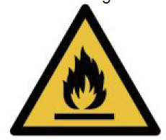
Caution!
Consult reprair manual/ower’s guide before attempting to install or service this product. All safety precautions must be followed. Dispose of properly in accordance with federal or local regulations. Risk of fire or explosion due to puncture of refrigerant tubing. Follow handling instructions carefully.
Danger!
Risk of fire or explosion. Flammable refrigerant used. To be repaired only by trained service personnel. Do not use mechanical devices to defrost refrigerator. Do not puncture refrigerant tubing.


Disposal
EU regulations require refrigeration product to be disposed of by specialist companies who remove or recycle all glasses,
metal and plastic components.
Consult your local waste collection authority regarding disposal of your appliance. Local authorities are not obliged to
dispose of commercial refrigeration equipment but may be able to offer advice on how to dispose of the equipment locally.
All packaging materials should be disposed of in an environmentally friendly way.
The cardboard may be used as scrap paper. The protective foil and the foam cushions are CFD-free.
Do not allow children to play with the packaging and destroy plastic gags safely.


Environmental protection
Discarded electric appliances are recyclable and should not be discarded in the domestic waste! Please actively support us in conserving resources and protecting the environment by returning this appliance to the collections centers (if available).

Compliance
Parts have undergone strict product testing in order to comply with regulatory standards and specification set by
international, independent, and federal authorities.
Products have been approved to carry the following symbol:

