Assembly Instructions
2 in 1 Fire Bowl
Please check the carton and packing materials before disposing to make sure that you have all the parts for this product
Part List
Part List | Description | Qty. | Drawings
A | Fire Bowl | 1 | 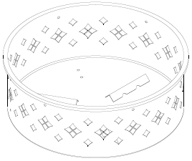
B | Leg | 3 | 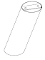
C | Ring Parts | 6 | 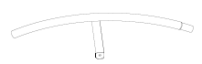
D | Holder | 1 | 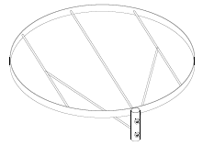
E | Support Pole | 4 | 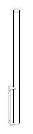
F | Bolt（M6×8MM） | 14 | 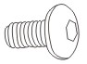
G | Screw Ring | 2 | 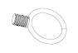
H | Poker | 1 | 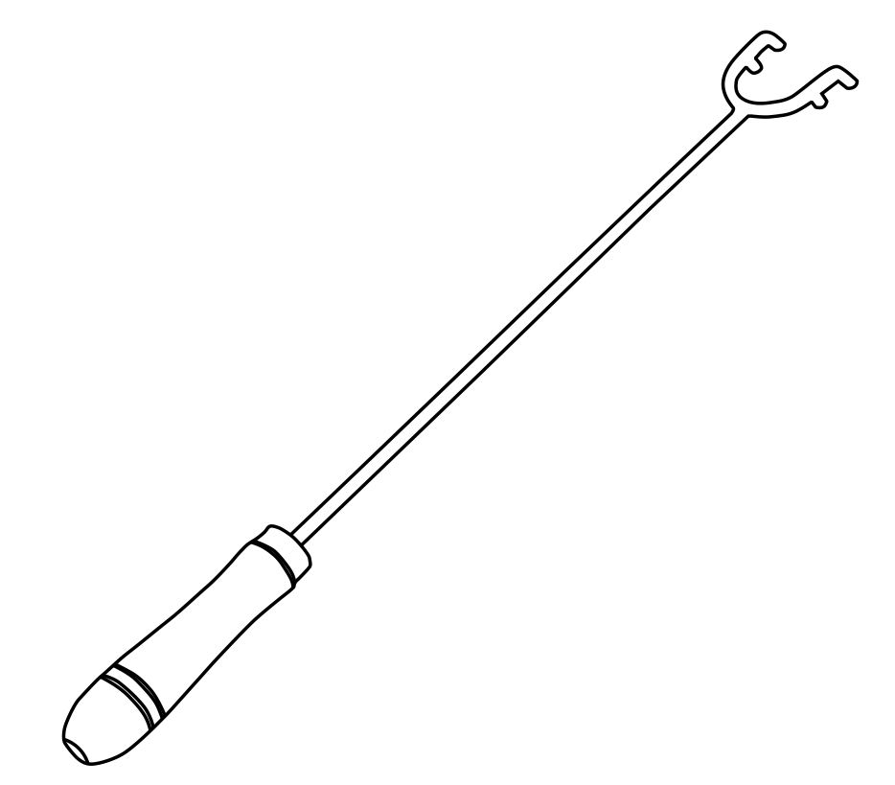
I | Allen Wrench | 1 | 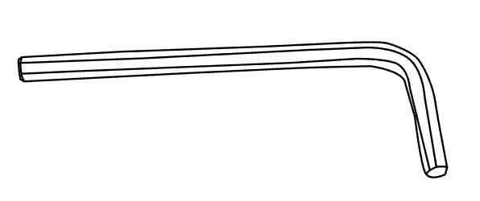
J | BBQ Grill | 1 | 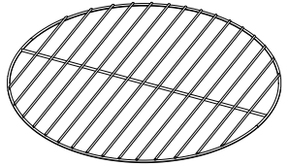
Tool required: Allen Wrench (provided)

Special Warnings
- Check local bylaws before using the fire pit.
- This fire pit is intended for Outdoor Use Only! DO NOT use on wooden decks.
- This fire pit is intended to Burn Wood Logs Only! DO NOT burn coal, leaves or other combustible materials in the fire pit.
- NOT for use by children. Keep children and pets away from the fire pit.
- Fire pit is hot, use with caution. NEVER touch hot fire pit with bare hands.
- NEVER leave burning fire pit unattended and always extinguish fire completely before leaving the fire pit.
- Maintain a minimum of 5 FT from any structure!
- DO NOT use near flammable or combustible objects or materials.
- Only CHROMED PLATED COOKING GRID (Pre-installed) Operation Instructions
- Place logs on grate and light with match. DO NOT overload logs.
- Please use Poker (provided) when handling.
- We do not recommend pouring water over the fire unless necessary. The fire should be allowed to expire on its own.

Care and Maintenance

This fire pit is a quality-built product and is made to last for many years.
The frame structure of this unit is made of powder-coated steel extrusion and should resist rusting under normal use. Should rusting occur, we suggest using a steel brush on the affected area followed by a spray coating of high temperature anti-rust paint.
For additional rust proofing of the bowl, grate and mesh lid we recommend that a coat of high temperature primer (such as rustoleum or similar brand) is applied before use.

Assembly Instructions
Estimated Assembly Time: 20 Minutes

DO NOT over tighten hardware!

Step 1: Connect Legs (B) to Fire Bowl (A) by using Bolts (F), Tighten Bolts accordingly with an Allen Wrench (I). （View Fig.1）
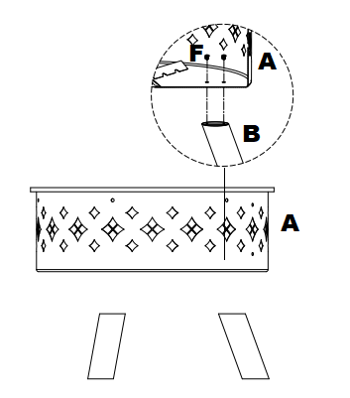

Fig.1

Step 2: Attach Support Pole (E) to Fire Bowl (A) by using Bolts (F) Full Tighten! （View Fig.2）

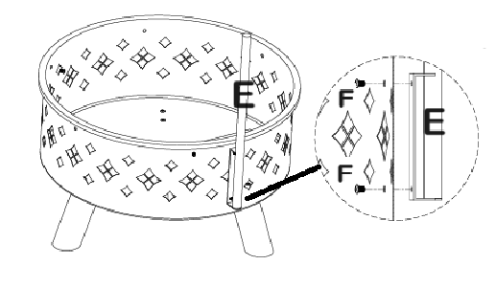

Fig.2

Step 3: Fix Ring Parts (C) to Fire Bowl (A) by using Bolt (F). Hand tighten! （View Fig.）
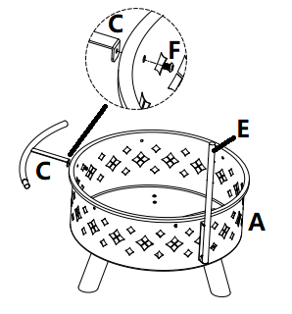

Fig.3

Step 4: Repeat Step 3 to make the Ring a circle. Put BBQ Holder (G) onto Support Pole (E) b using Screw Rings (G). But BBQ Grill (J) onto Holder (D),
Tighten Bolts accordingly with an Allen Wrench (I). （View Fig.4）

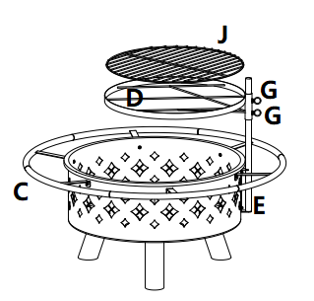

Fig.4

Your FIRE Bowl and BBQ are ready for use!

