SECTION 1: Identification of the substance/mixture and of the company/undertaking

1.1. Product identifier
Product form | : | Mixture
Product name | : | Sugar Cookie Crunch
Product code | : | FR:SugCkCr

1.2. Relevant identified uses of the substance or mixture and uses advised against
Recommended use | : | Perfumes, Fragrances

1.3. Details of the supplier of the safety data sheet
Canwax Inc., 114 Lindgren Rd. W., Unit 1B Huntsville, ON P1H 1Y2 705-789-1002

1.4. Emergency telephone number
1-844-POISON-X or 1844-764-7669 | :

SECTION 2: Hazards identification

2.1. Classification of the substance or mixture

GHS-US classification
Skin Sens. 1 | H317
Full text of H statements : see section 16

2.2. Label elements

GHS-US labeling
Hazard pictograms (GHS-US) | : | 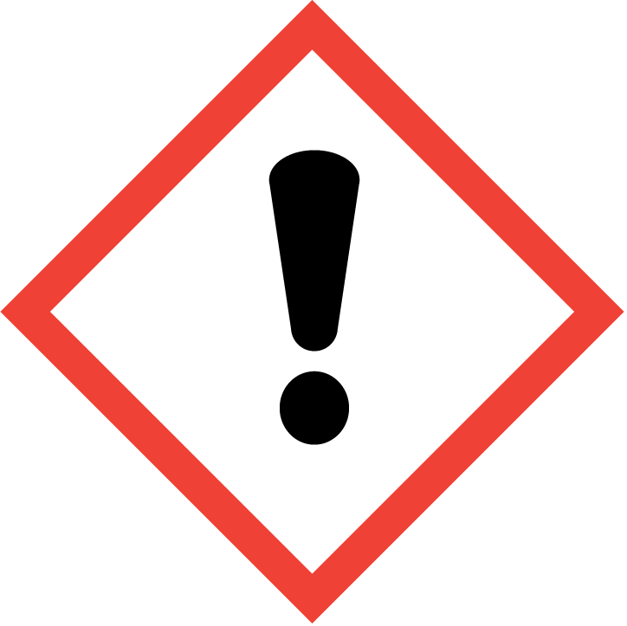  GHS07
Signal word (GHS-US) | : | Warning
Hazard statements (GHS-US) | : | H317 - May cause an allergic skin reaction
Precautionary statements (GHS-US) | : | P272 - Contaminated work clothing must not be allowed out of the workplace  P280 - Wear eye protection, face protection, protective clothing, protective gloves  P302+P352 - If on skin: Wash with plenty of water  P333+P313 - If skin irritation or rash occurs: Get medical advice/attention  P363 - Wash contaminated clothing before reuse  P501 - Dispose of contents/container in accordance with local/national laws and regulations

2.3. Other hazards
No additional information available

2.4. Unknown acute toxicity (GHS US)
Not applicable
SECTION 3: Composition/Information on ingredients

3.1. Substances
Not applicable

3.2. Mixtures

Name | Product identifier | % | GHS-US classification
Benzyl benzoate | (CAS No) 120-51-4 | 20 - 40 | Acute Tox. 4 (Oral), H302
Coumarin crystals | (CAS No) 91-64-5 | 0.62 - 2.62 | Acute Tox. 4 (Oral), H302  Skin Sens. 1B, H317  Aquatic Acute 2, H401  Aquatic Chronic 2, H411

Allergen report available upon request.
Full text of H-phrases: see section 16

SECTION 4: First aid measures

4.1. Description of first aid measures
First-aid measures general | : | Never give anything by mouth to an unconscious person. If you feel unwell, seek medical advice (show the label where possible).
First-aid measures after inhalation | : | Allow victim to breathe fresh air. Allow the victim to rest.
First-aid measures after skin contact | : | Wash with plenty of soap and water. If skin irritation or rash occurs: Get immediate medical advice/attention. Get medical advice/attention. Specific treatment (see Wash skin with plenty of water, Call a physician immediately on this label). Wash contaminated clothing before reuse. Remove affected clothing and wash all exposed skin area with mild soap and water, followed by warm water rinse.
First-aid measures after eye contact | : | Rinse immediately with plenty of water. Obtain medical attention if pain, blinking or redness persists.
First-aid measures after ingestion | : | Rinse mouth. Do NOT induce vomiting. Obtain emergency medical attention.

4.2. Most important symptoms and effects, both acute and delayed
Symptoms/effects | : | Not expected to present a significant hazard under anticipated conditions of normal use.
Symptoms/effects after inhalation | : | May cause an allergic skin reaction.

4.3. Indication of any immediate medical attention and special treatment needed
No additional information available

SECTION 5: Firefighting measures

5.1. Extinguishing media
Suitable extinguishing media | : | Foam. Dry powder. Carbon dioxide. Water spray. Sand.
Unsuitable extinguishing media | : | Do not use a heavy water stream.

5.2. Special hazards arising from the substance or mixture
No additional information available

5.3. Advice for firefighters
Firefighting instructions | : | Use water spray or fog for cooling exposed containers. Exercise caution when fighting any chemical fire. Prevent fire-fighting water from entering environment.
Protection during firefighting | : | Do not enter fire area without proper protective equipment, including respiratory protection.

SECTION 6: Accidental release measures

6.1. Personal precautions, protective equipment and emergency procedures

6.1.1. For non-emergency personnel
Emergency procedures | : | Evacuate unnecessary personnel.
6.1.2. For emergency responders
Protective equipment | : | Equip cleanup crew with proper protection.
Emergency procedures | : | Ventilate area.

6.2. Environmental precautions
Prevent entry to sewers and public waters. Notify authorities if liquid enters sewers or public waters.

6.3. Methods and material for containment and cleaning up
Methods for cleaning up | : | Soak up spills with inert solids, such as clay or diatomaceous earth as soon as possible. Collect spillage. Store away from other materials.

6.4. Reference to other sections
See Heading 8. Exposure controls and personal protection.

SECTION 7: Handling and storage

7.1. Precautions for safe handling
Precautions for safe handling | : | Wash hands and other exposed areas with mild soap and water before eating, drinking or smoking and when leaving work. Provide good ventilation in process area to prevent formation of vapor.
Hygiene measures | : | Contaminated work clothing should not be allowed out of the workplace. Wash contaminated clothing before reuse.

7.2. Conditions for safe storage, including any incompatibilities
Storage conditions | : | Keep only in the original container in a cool, well ventilated place away from : Keep away from heat, hot surfaces, sparks, open flames and other ignition sources. No smoking. Keep container closed when not in use.
Incompatible products | : | Strong bases. Strong acids.
Incompatible materials | : | Sources of ignition. Direct sunlight.
Storage temperature | : | 25 °C
Storage area | : | Store in a well-ventilated place. Store away from heat.
Special rules on packaging | : | Store in a closed container.
Packaging materials | : | Do not store in corrodable metal.

7.3. Specific end use(s)
No additional information available

SECTION 8: Exposure controls/personal protection

8.1. Control parameters
No additional information available

8.2. Exposure controls
Personal protective equipment | : | Avoid all unnecessary exposure.
Hand protection | : | Wear protective gloves.
Eye protection | : | Chemical goggles or safety glasses.
Respiratory protection | : | Wear appropriate mask.
Other information | : | Do not eat, drink or smoke during use.

SECTION 9: Physical and chemical properties

9.1. Information on basic physical and chemical properties
Physical state | : | Liquid
Color | : | light yellow amber
Odor | : | Sweet
Odor threshold | : | No data available
pH | : | No data available
Relative evaporation rate (butyl acetate=1) | : | No data available
Melting point | : | No data available
Freezing point | : | No data available
Boiling point | : | No data available
Flash point | : | > 93.33 °C (closed cup) ASTM D7094
Auto-ignition temperature | : | No data available
Decomposition temperature | : | No data available
Flammability (solid, gas) | : | No data available
Vapor pressure | : | No data available
Relative vapor density at 20 °C | : | No data available
Relative density | : | ≈ 1.16
Solubility | :
Log Pow | : | No data available
Log Kow | : | No data available
Viscosity, kinematic | : | No data available
Viscosity, dynamic | : | No data available
Explosive properties | : | No data available
Oxidizing properties | : | No data available
Explosion limits | : | No data available

9.2. Other information
No additional information available

SECTION 10: Stability and reactivity

10.1. Reactivity
No additional information available

10.2. Chemical stability
Not established.

10.3. Possibility of hazardous reactions
Not established.

10.4. Conditions to avoid
Direct sunlight. Extremely high or low temperatures.

10.5. Incompatible materials
Strong acids. Strong bases.

10.6. Hazardous decomposition products
fume. Carbon monoxide. Carbon dioxide.

SECTION 11: Toxicological information

11.1. Information on toxicological effects

Acute toxicity | : | Not classified

 | Sugar Cookie Crunch
Skin corrosion/irritation |  | : | Not classified
Serious eye damage/irritation |  | : | Not classified
Respiratory or skin sensitization |  | : | May cause an allergic skin reaction.
Germ cell mutagenicity |  | : | Not classified
Carcinogenicity |  | : | Not classified

 | Sugar Cookie Crunch
Reproductive toxicity |  | : | Not classified
Specific target organ toxicity – single exposure |  | : | Not classified

 | Sugar Cookie Crunch
Specific target organ toxicity – repeated exposure |  | : | Not classified

Aspiration hazard | : | Not classified
Potential Adverse human health effects and symptoms | : | Based on available data, the classification criteria are not met.
Symptoms/effects after inhalation | : | May cause an allergic skin reaction.

SECTION 12: Ecological information

12.1. Toxicity
No additional information available

12.2. Persistence and degradability
Sugar Cookie Crunch
Persistence and degradability | Not established.

12.3. Bioaccumulative potential
Sugar Cookie Crunch
Bioaccumulative potential | Not established.

12.4. Mobility in soil
No additional information available

12.5. Other adverse effects
Effect on ozone layer | : | No additional information available

Effect on the global warming | : | No known effects from this product.

Other information | : | Avoid release to the environment.

SECTION 13: Disposal considerations

13.1. Waste treatment methods
Product/Packaging disposal recommendations | : | Dispose of contents/container in accordance with local/national laws and regulations. Dispose in a safe manner in accordance with local/national regulations.
Ecology - waste materials | : | Avoid release to the environment.

SECTION 14: Transport information

In accordance with DOT
Not regulated for transport

Additional information
Other information | : | No supplementary information available.

ADR
No additional information available
Transport by sea
No additional information available
Air transport
No additional information available

SECTION 15: Regulatory information

15.1. US Federal regulations
All components of this product are listed, or excluded from listing, on the United States Environmental Protection Agency Toxic Substances Control Act (TSCA) inventory.

15.2. International regulations

CANADA

Benzyl benzoate (120-51-4)
Listed on the Canadian DSL (Domestic Substances List)

Coumarin crystals (91-64-5)
Listed on the Canadian DSL (Domestic Substances List)

EU-Regulations

Benzyl benzoate (120-51-4)
Listed on the EEC inventory EINECS (European Inventory of Existing Commercial Chemical Substances)

Coumarin crystals (91-64-5)
Listed on the EEC inventory EINECS (European Inventory of Existing Commercial Chemical Substances)

Classification according to Regulation (EC) No. 1272/2008 [CLP]
Not determined

Classification according to Directive 67/548/EEC [DSD] or 1999/45/EC [DPD]
15.2.2. National regulations

Benzyl benzoate (120-51-4)
Listed on the AICS (Australian Inventory of Chemical Substances)
Listed on IECSC (Inventory of Existing Chemical Substances Produced or Imported in China)
Listed on the Japanese ENCS (Existing & New Chemical Substances) inventory
Listed on the Japanese ISHL (Industrial Safety and Health Law)
Listed on the Korean ECL (Existing Chemicals List)
Listed on NZIoC (New Zealand Inventory of Chemicals)
Listed on PICCS (Philippines Inventory of Chemicals and Chemical Substances)
Listed on INSQ (Mexican National Inventory of Chemical Substances)
Listed on CICR (Turkish Inventory and Control of Chemicals)
Listed on the TCSI (Taiwan Chemical Substance Inventory)
\
Coumarin crystals (91-64-5)
Listed on the AICS (Australian Inventory of Chemical Substances)
Listed on IECSC (Inventory of Existing Chemical Substances Produced or Imported in China)
Listed on the Japanese ENCS (Existing & New Chemical Substances) inventory
Listed on the Japanese ISHL (Industrial Safety and Health Law)
Listed on the Korean ECL (Existing Chemicals List)
Listed on NZIoC (New Zealand Inventory of Chemicals)
Listed on PICCS (Philippines Inventory of Chemicals and Chemical Substances)
Listed on INSQ (Mexican National Inventory of Chemical Substances)
Listed on CICR (Turkish Inventory and Control of Chemicals)
Listed on the TCSI (Taiwan Chemical Substance Inventory)
\

15.3. US State regulations

California Proposition 65 - This product does not contain any substances known to the state of California to cause cancer, developmental and/or reproductive harm

SECTION 16: Other information

Other information | : | None.

Full text of H-phrases:
------ | H302 | Harmful if swallowed
------ | H317 | May cause an allergic skin reaction
------ | H401 | Toxic to aquatic life
------ | H411 | Toxic to aquatic life with long lasting effects

NFPA health hazard | : | 1 - Materials that, under emergency conditions, can cause significant irritation. | 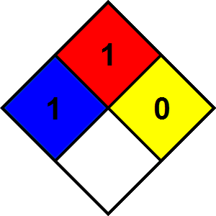
NFPA fire hazard | : | 1 - Materials that must be preheated before ignition can occur.
NFPA reactivity | : | 0 - Material that in themselves are normally stable, even under fire conditions.

