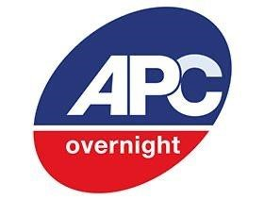

**APC RESTRICTED POSTCODES FOR FISH DELIVERIES:**

For the safety and welfare of our Koi, some postcodes are restricted for delivery. Our courier cannot guarantee the delivery of the fish before a certain time thus, it is in the best interest of the fish to not send them to those locations. We apologise for the inconvenience.

|  |  |  |  |
| --- | --- | --- | --- |
| AB10 - AB16  AB21 - AB25  AB30 - AB39  AB41 - AB45  AB51 - AB56  BT1 - BT99  CA7 - CA9  CA17 - CA21  DD5 - DD11  DG1 - DG14  DG16  EH43 - EH45  FK8  FK17 - FK21  GY9 - GY10,  HS1 - HS9  IM1 - IM9  IM86 - IM87  IM99  IV2  IV4 - IV32  IV36  IV40 - IV49  IV51 - IV56  IV63 |  |  | KA26 - KA28  KW1 - KW17  KY9 - KY10  KY16  LA10  LA17 - LA21  ML12  NE47  PA20 - PA49  PA60 - PA78  PA80  PH1  PH3 - PH26  PH30 - PH44  PH49 - PH50  PO30 - PO41  RD1- RD2  TD1 - TD15  TR21 - TR25  ZE1 - ZE3 |