**MOZA MTLP Take-off Landing Panel User Manual**

**Product Features**

* Multi-Function Brake Lever
* Realistic Switch Caps
* Programmable Panel Lights
* 25 Switch Signals
* High-Precision Hall Sensor
* High-Strength Structure

**Specifications**

Supported Platform: PC

Housing Material: Composite material

Grip Material: Aluminum Alloy

Rated Voltage: 5V

Rated Current: 0.3A

Connection Ports: USB Type-B, RJ11

Mounting Method: Mounts on a desktop with desk clamp or directly onto flight simulator cockpits.

Desktop Clamp: Optional

**Connection Ports**

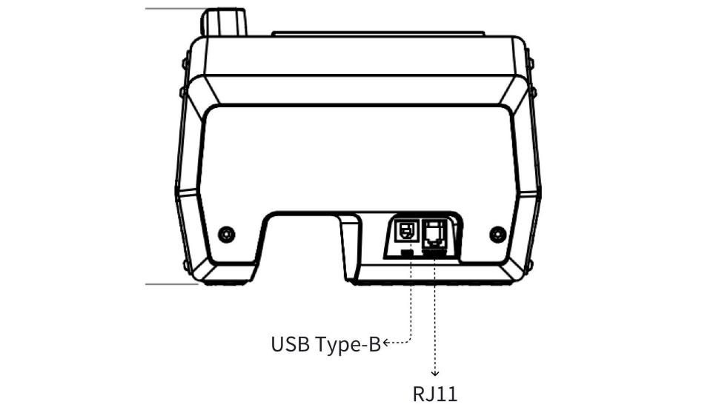

**Parameters**

Net Weight: KG

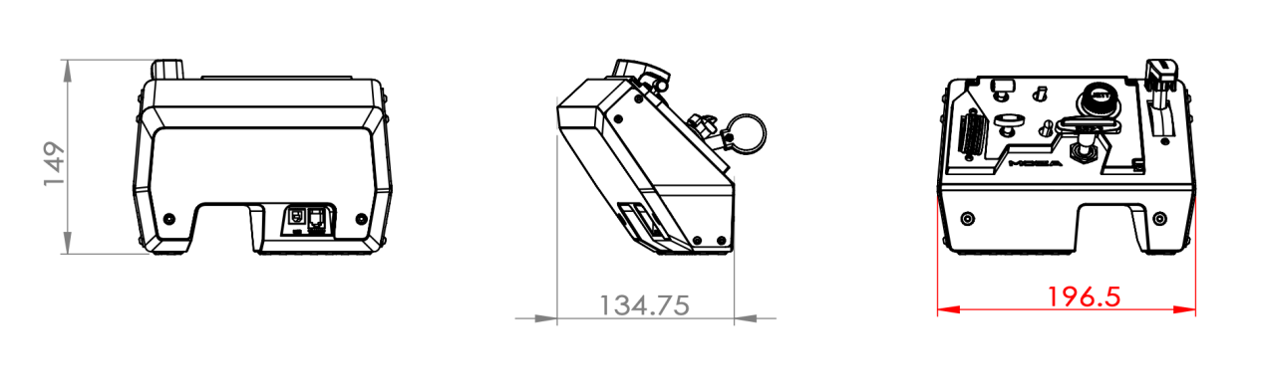

Hole Patterns:

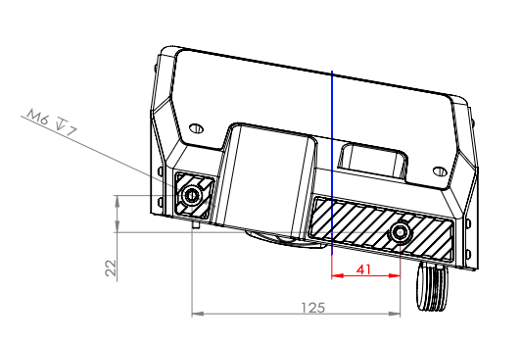

**User Guide**

**Securing the Panel**

* Secure the MOZA MTLP Panel to the desk clamp using the 2 screw holes on the bottom.
* Place the desk clamp on the tabletop and tighten the star-shaped handle until the clamp is securely fastened to the desk.

*The MOZA desktop clamp must be purchased separately.

**Connecting to PC**

1. **Direct Connection to PC**

* Use the included USB cable to connect the Type-B end to the corresponding port on the back of the MOZA MTLP panel, and the Type-A end to your PC. If connected successfully, the device's light will gradually illuminate, and the MOZA Cockpit will indicate that the device is connected and functioning correctly.

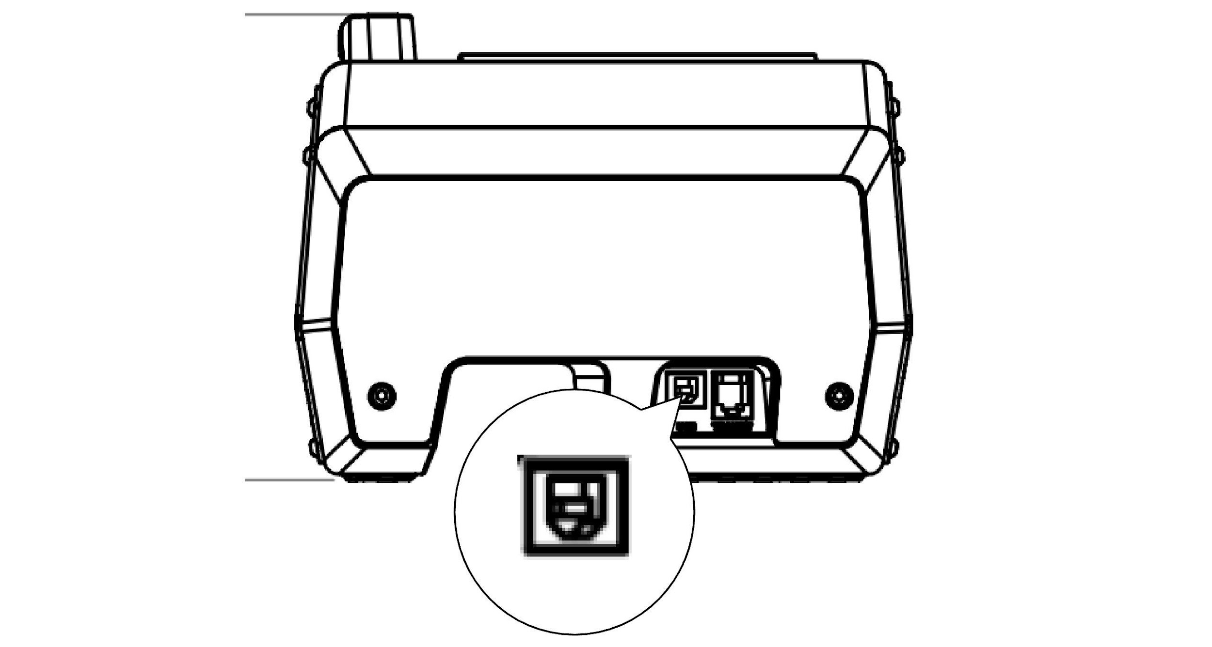

* If the device fails to light up, check the light brightness settings in the MOZA Cockpit.

* If the device light flashes, it indicates BOOT mode. Please exit BOOT mode from the host computer.

**2. Connecting to PC through MOZA Flight Base**

* Connect one end of the included RJ11 cable to the corresponding port on the MOZA MTLP panel and the other end to the MOZA Flight Base. Power on the base; if connected successfully, the device light will illuminate, and the MOZA Cockpit will indicate that the device is connected and functioning correctly.

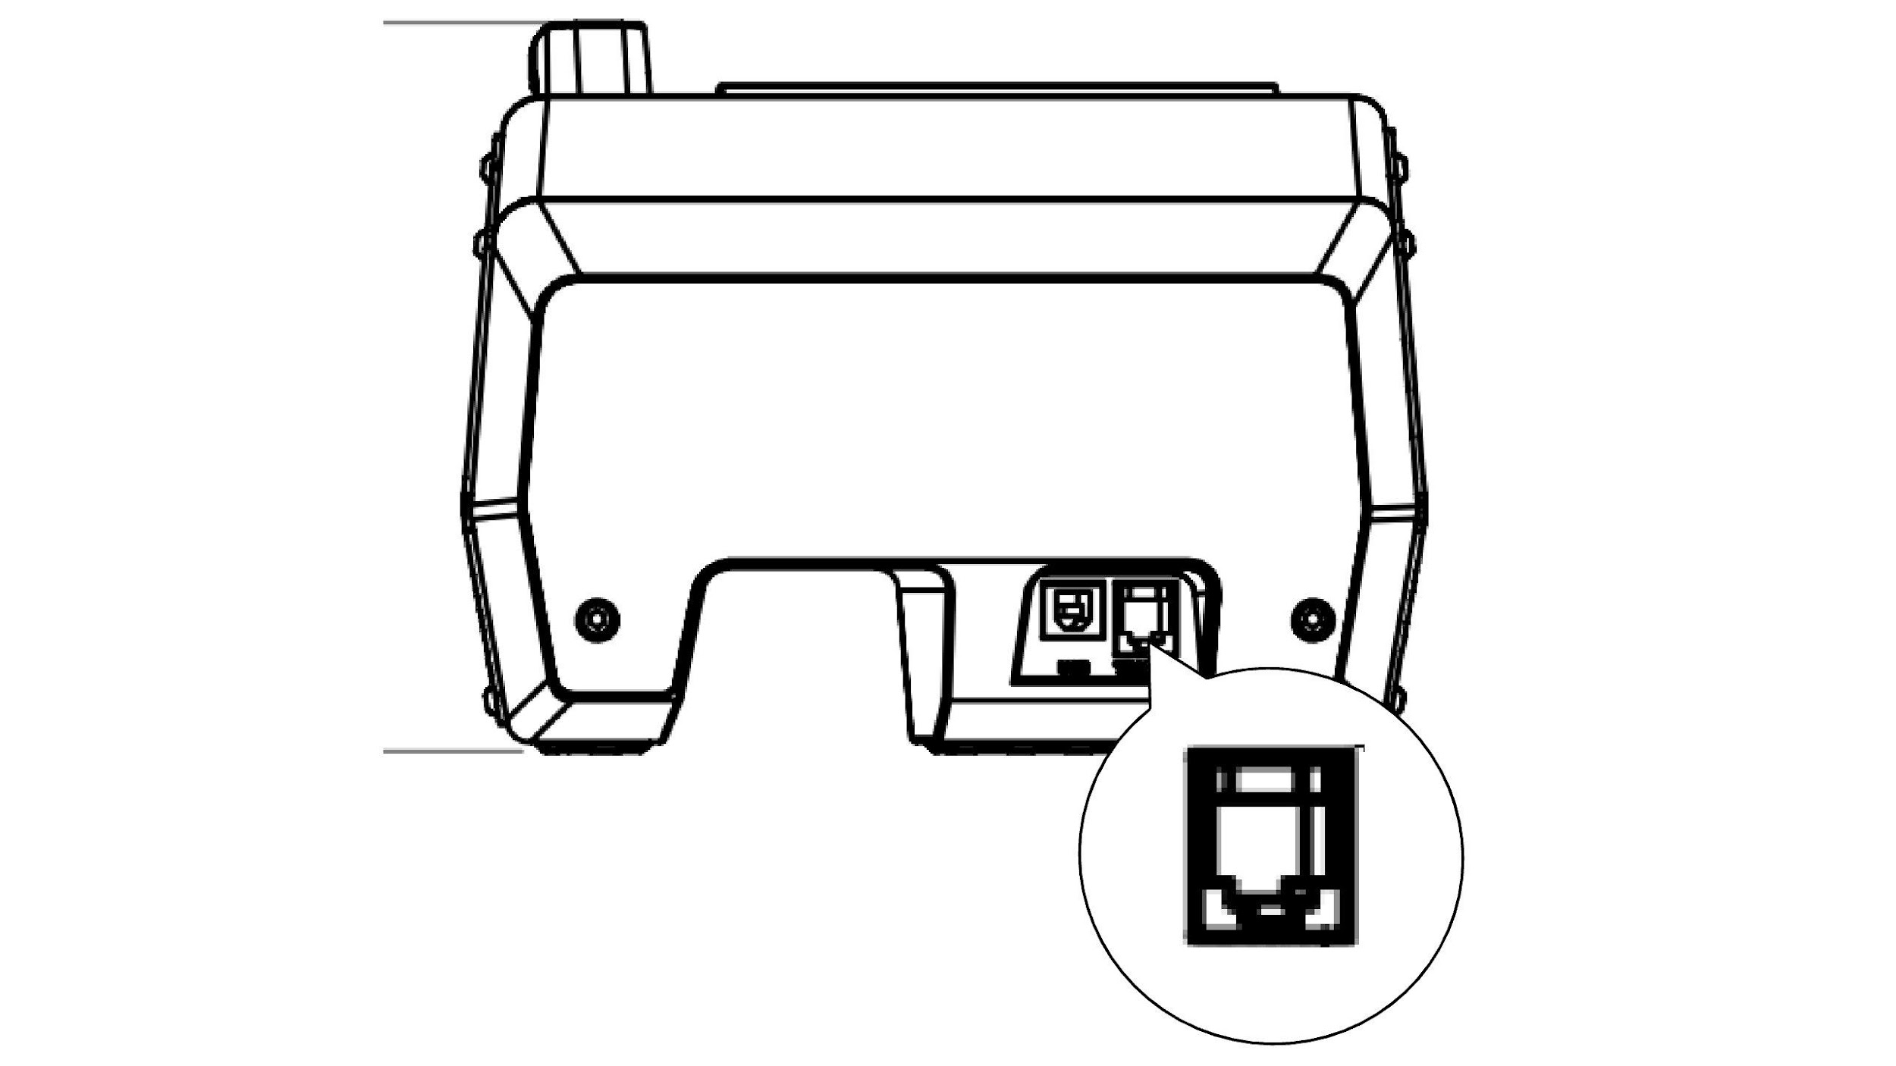

* If the device fails to light up, check the light brightness settings in the MOZA Cockpit.

* If the device light flashes, it indicates BOOT mode. Please exit BOOT mode from the host computer.

**Software introduction**

The main home page allows users to not only view the operational status of connected devices, including the base, flightstick, throttle, rudder, etc, but also provides quick access to start your favorite games/simulators directly from the MOZA Cockpit Software.

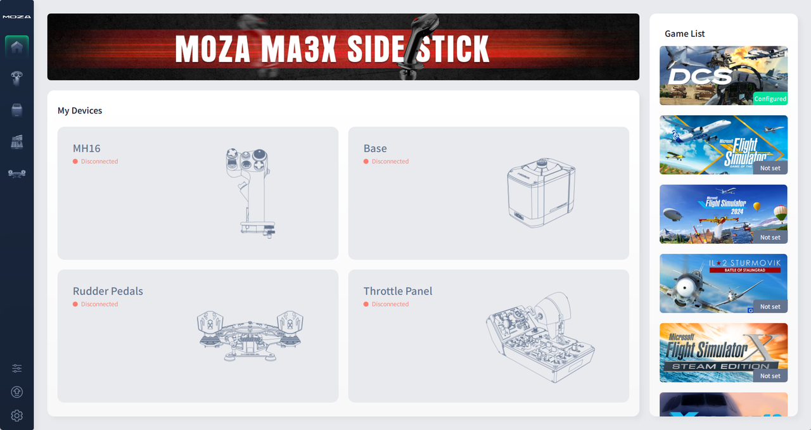

**Panel Configuration Interface**

The MTLP Panel and MTP Throttle Panel share a unified configuration interface. The interface adapts based on the connection scenario:

1. **Both MTLP and MTP Connected:** The interface displays the control panel along with **the instrument panel diagram**, providing a comprehensive view of both devices. *(Refer to the image below)*

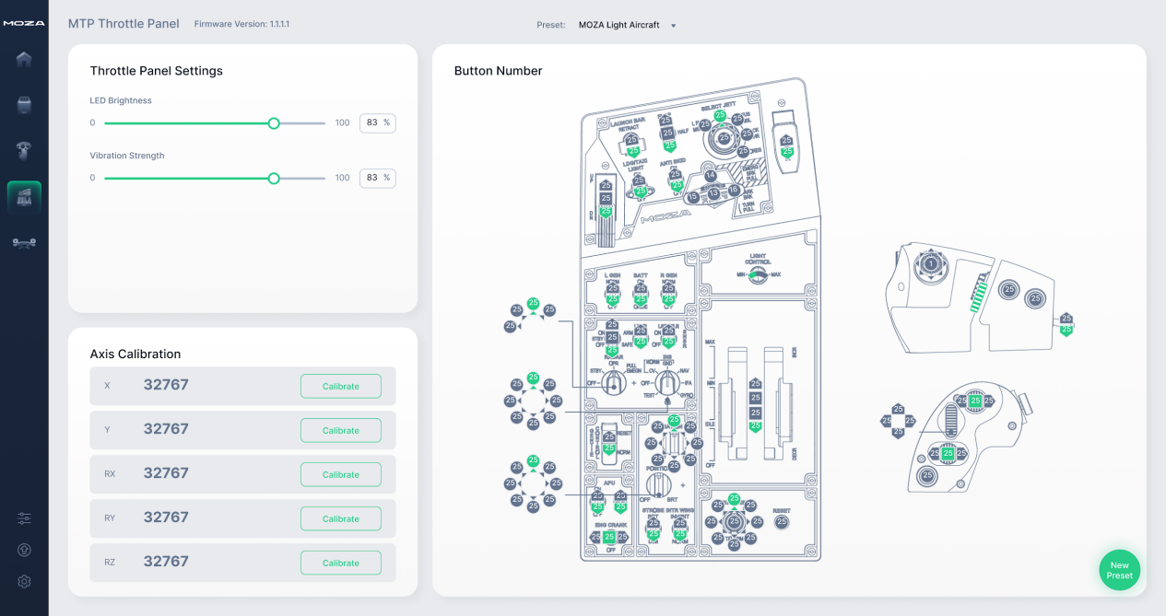

1. **Only MTLP Connected:** The interface displays the **MTLP panel diagram** tailored to the connected device. *(Refer to the image below)*

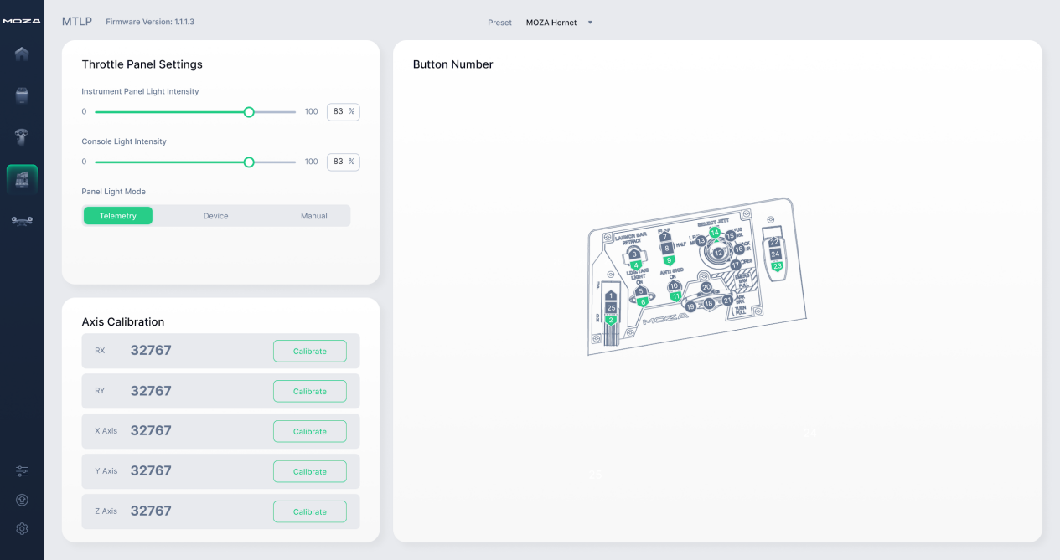

**Panel Backlight Adjustment**

The MTLP Panel provides three modes for adjusting backlight brightness:

* **Manual Mode:**
  + Adjust the backlight brightness using the *Instrument Panel Light Intensity* slider in the MOZA Cockpit software.
  + Set the slider to **0%** to completely turn off the backlight.
* **Telemetry Mode:**
  + Synchronizes the panel backlight brightness with in-game cockpit lighting using telemetry data.
* **Device Mode (Requires USB connection):** 
  + *Connect both the MTLP and MTP panels to your PC via USB.*
  + *Use the dimmer knob on the front of the MTP panel to adjust brightness.*
  + ***Note:*** *In this mode, the brightness levels of both panels are synchronized.*

**Precautions**

* Do not expose the device to liquids or humidity as it may cause fire or electric shock.
* Avoid using the device in direct sunlight.
* Do not use MOZA flight sim gear with the MOZA racing gear.
* Recommended indoor temperature: 5°C ~ 30°C.
* For your safety and well-being, please monitor your gaming time and take breaks as needed.
* The device is not suitable for children under the age of 6, small accessories may pose a choking hazard!
* Children under 13 should have adult supervision.
* It is strictly forbidden to disassemble the equipment by yourself, failure to adhere to this will result in loss of warranty.
* The equipment must be connected with the factory-supplied power supply to ensure the electrical safety and the protection of user rights and interests.
* In order to ensure user safety, parts repair or replacement can only be carried out by officially authorized repair centers.
* Non-standard power supplies are strictly prohibited even if data such as related voltages match.
* Use only AC power provided by a standard wall outlet to avoid damage to the product.
* Do not expose the device to heat sources.
* Unplug the power cord of the device if it will not be used for a long time.
* If you find any abnormality, please stop using it immediately and seek help from MOZA representatives or authorized repair centers.
* Stay tuned to our official website and social media platforms for the latest product updates.