Type of house | Order in the  clip | Street, estate or flat | Have a garden? | Have a space to park a car? | Close, fairly close or far from the town centre
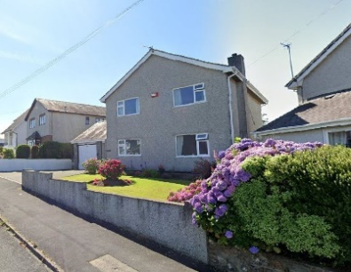
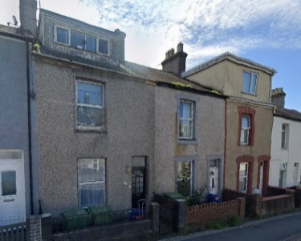
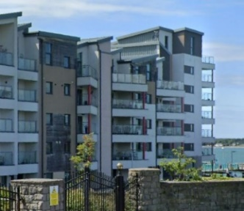
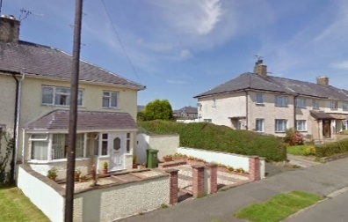
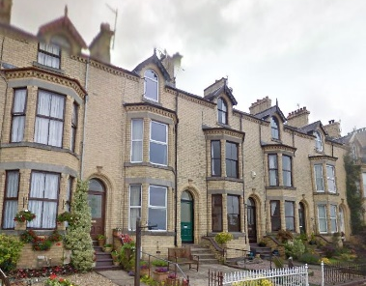
Complete the sentences by deleting the incorrect words in bold print.
The oldest/newest houses are located near the centre of town. Estates of houses can be found in the centre/at the edge of the town where there’s enough space for each house to have a garden and perhaps a space to park a car at least one car. New luxury flats are often built on land that was once used for industry or transport. These sites are often close to/far from the centre of town.
Mixed Sheet 4

