**Create a Vlog**

What is needed to create a successful vlog? Watch the video and draw up your own success criteria.

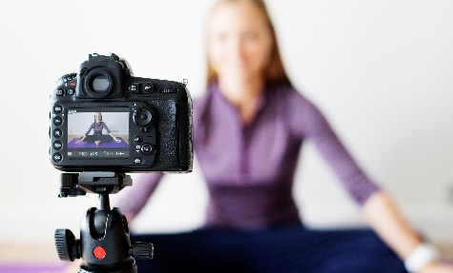

**Your vlog’s layout:**

Set out roughly what you want to include in the different parts of your vlog – you can create a script if you feel the need. You will plan one part and then film straight away before going on to the next part.

**Part 1**: Your response to the two big questions. Explain what the questions were and look back at the post-it.

**Part 2:** Your reaction (on video!) to the film. What makes 'react-to' videos fun and funny?

**Part 3:** Go back to the two big questions and answer them again. Have your views changed? How? And why?

Don't forget to edit the vlog to make it exciting and to encourage people to continue watching!

What apps can you use to edit? Ask the rest of the class if you're not sure!

_________________________________________________________________

**Peer Assessment:**

Watch another vlog and give a mark out of 5 to the following:

|  |  |
| --- | --- |
| **Success Criteria:** | **Mark out of 5** |
| An entertaining and exciting presentation? |  |
| Time. Is the vlog long enough or too long? |  |
| Is the editing effective? |  |
| Are the two big questions being discussed? |  |

How could your partner improve their vlog next time?

__________________________________________________________________________________________________________________________________

How can you improve your vlog next time?

____________________________________________________________________________________________________________________________________________________________________________________________________________________________________________________________________

**Additional Task:**  Film yourself displaying some special skill (similar to the movie 'Siot!') and add it to your vlog.

Plan your filming here: