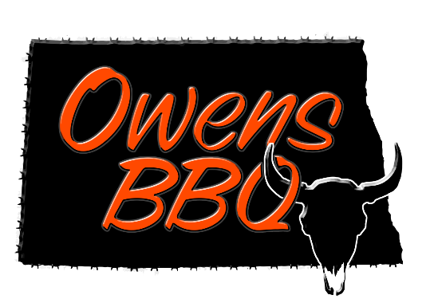

www.OwensBBQ.com
Owens BBQ
7660 30th Ave NW
Glenburn, ND 58740
OwensBBQ@srt.com
(701) 362-7386

Hot Honey Stick Seasoning – 25 lb. batch
** These are only our recommendations for % of pork/venison, times, temps, and plate size for grinding **
20 lbs. venison or beef and 5 lbs. pork
1 package of Hot Honey Stick Seasoning
1 package of the Speed Cure
2-3 cup cold water

8 TBSP seasoning AND 1/8 tsp Speed Cure per lb. of meat for smaller batches

Process:
- Grind pork and venison or beef through a 3/8” (10mm) plate.
- Place meat in meat mixer or tote. Mix seasoning, speed cure, and water together then mix that into the ground meat for 5 minutes or until well mixed.
- Once you have all the seasonings mixed in do a second grind of the meat. Grind through a 3/16” (4.5mm) plate. If you want to add cheese or fruit, now is the time.
- Stuff into casing. Suggested size 19mm or 22mm mahogany collagen casings or 20/22mm natural sheep casings. Rest meat overnight before smoking for the cure to work and to develop the flavors more.

Smoking:
- Set Smokehouse temp at around 130° with the damper open and add meat sticks with no smoke for 1-2 hours for the sticks to dry. Do not have any pieces touching if possible.
- Turn the Smokehouse temp up to 150°- 160° with the damper open and smoke for 2-3 hours. This is all a personal preference.
- Once you are done smoking you need to finish cooking and get the sticks up to the proper internal temperature. Turn the Smokehouse up to 170° - 190° and cook until internal temp is 155°. Remove from smoker and allow to cool. We like refrigerate overnight before packaging.

Recommendations – To add in extra flavor add 2-4 lbs. of High Temp Pepper-Jack Cheese or another flavor. Or add 1-2 lbs. of dehydrated pineapple (diced).

NOTE: do not mix cheese or fruit in and then through the grinder again, you want to mix in the cheese as the final step before stuffing, packaging, or making into patties.

