Air Compression Therapy Device

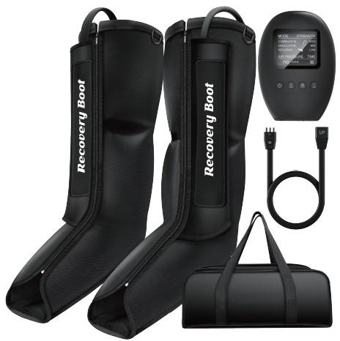

User Manual

Please read the manual carefully before use and keep it well for further reference.

Contents
Safety Precautions 01-02
FAQs 02-03
Specifications 03-03
Troubleshooting 04-04
Names of Components 05-05
Operating Instructions 06-07
Notes after Use 08-08
Cleaning 08-08
Storage& Maintenance 09-09
Disposal 09-09
Package Includes 10-10
Contact Us 10-10

Safety Precautions

Please read the following safety precautions carefully to ensure safe and correct use.
Warnings
1.If you experience severe pain, any unusual symptoms, or want to remove the sleeves in an emergency during use;
·Press the power button to stop the device or disconnect the hoses;
·Remove the sleeves and consult your doctor.
2. Consult your doctor before using this device if you have any of the following conditions:
· Experiencing inflammation, an infection, pain of unknown origin, at or near the site of application; · Have bone fractures or dislocations at or near the site of application;
· Receiving medical treatment, or have a contraindication requiring the use of any medical control unit; · Using pacemaker or other medical devices which are susceptible to electrical interference;
· Suffering from malignant tumors;
· Suffering from cardiac diseases;
· Having serious peripheral neuropathy dysfunction or sensory disturbance caused by diabetes; ·Being unsuitable to do the massage because of traumas on the body;
3.Keep it out of the reach of infants, children and people without the ablity to use it independently.
4. Don't use another power adapter but the original one.
5. Don't scratch, damage, process, excessively bend, pull or twist the power cord of the adapter. Otherwise, it may cause fire or electric shock.
6. It is not allowed to use when the power adapter has dysfunctions or the plug is loose.
7. Don't plug or unplug the power adapter with wet hands.
8. Don't put the control unit in the quilt or use the machine in high temperature condition.
9. It is forbidden to remodel, disassemble or repair the machine without permission. 10.No modification of this equipment is allowed.

Cautions
1.Only use the power supply provided with the system. Using a different power supply may cause the system to operate incorrectly.
2. Don't use it in the bathroom or other humid places.
3. Keep it out of the reach of children.
4. Unplug the power adapter when you are not using it.
5. Don't walk around when you are using this device or wearing the sleeves.
6.Do not leave the system, power supply, or any accessories that could be damaged by children, pets, pests, or liquids.
7. The attachments are designed to be used by only one person at a time.

FAQs
Q1: How does this product work?
A1:This is an air compression leg massager, 3 air chambers (foot, lower calf and upper calf) inflated and deflated with a sophisticated sequence to stimulate hand kneading and stroking, maximizes blood flow throughout the body to help with reduced muscle soreness and/or pains to the treated areas, and enhanced circulation.
Q2: How many massage modes, and what's the difference?
A2: There are 3 massage modes, please check the difference as below:
Mode1: Sequence Mode
Foot chamber compress and then release → lower calf chamber compress and then release → upper calf chamber compress and then release.
* There will be a brief rest period and then the cycle will begin again.
** This will repeat until the session time runs out.
Mode 2: Circulation Mode
Foot chamber compress and hold pressure → lower calf chamber compress and hold pressure → upper calf chamber compress and hold pressure → all 3 chambers release at the same time.
** There will be a brief rest period and then the cycle will begin again.
** This will repeat until the session time runs out.
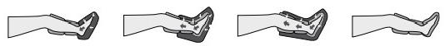

Mode 3: Combination Mode
Mode 1 and mode 2 runs alternately in this mode until the session time runs out.

—2—

Q3: what should l do if feel the massage strength is t00 weak 0r t00 strong？
A3: There are 9 levels of massage intensity selectable via the control unit, please selectthe intensity
which is fitfr yu . lf yu still feel it s too strong atthe lowest set ing , please stop using the device , we
suggest consulting yur doctor befre yur next use .
Q4: How long should l use it？
A4: It is recommended to use it once or twice a day, no more than 30 minutes at a time . Butyu can
use it longer ifyu feel too tired and want it massage longer to work on the soreness .
Q5: can l only apply on one leg？
A5: Both sleeves need to be connected to make it work, yu can wear one ofthe sleeve on the desired
eg and let another sleeve lay aside , but we suggest to use both atthe same time to get a better relief.
Q6: why does the control unit make a sound？
A6: The sound comes from the working air pump in the control unit, providing air continuousyto the
airbags in the sleeves , it s a low sound and that sa normal phenomenon .
Q7: I have bigger legs , can l use this product？
A7: Fit king compression boots with a standard size which can fit diferent legs because ofthe built- in
pressure sensor technology. The sensor system will detecte the pressure and automatically stop
infating until it reaches a specific pressure value . You can use this product as long as the circumference
Of yur calf does not exceed 22" .
Q8: when should l use this product？
A8: This product pushes the blood to fW, efectively remove musce soreness and fatigue , yu can
use it anytime yu want . You can use it befre the work out to warm up yur muscles , use it after
exercise fr bet er and faster recovery, or use it when yu back home after a long day work .

ModeI | S9031
Name | Air compression Therapy Device
charging voltage | AC Input: 100~240 volts , AC 50/60HZ , DC Output: 12V 1A
Rated power | 12W
compression Mode | 3 Modes: sequence Mode , circulation Mode , combination Mode .
Intensity Levels /  pressure Range | 9 Levels: Low-60/70/80mmHg，MID-90/100/110mm Hg  HIGH - 120/130/140mmHg
Timer | 3 choices: 20 / 25 / 30 Minutes
SIeeve Type | 3-chambers sleeve - Foot/ Lower calf/ upper calf
operating  conditions | Temperature: +5 ct0 40 C (41 ° F to 104 ° F) ；  Humidity: 1% to 90% non - condensing；  Atmospheric pressure : 70 kpa to 106 kpa .
storage conditions | Temperature: -20 c t0 55 ℃ ; Humidity: 5% to 90% non - condensing；  Atmospheric pressure: 50 kpa to 106 kpa;  keep Dry and Avoid Direct sunlight Exposure .

- 3 -

Troubleshooting

Problems | Possible Causes | Solutions
1.Doesn't work and screen  is off | 1. Power is not turned on.  2. Adapter is not securely connected.  3. Faulty wall outlet. | 1. Press the power button to turn the control  unit on.  2.Make sure the power adapter is connected  well to the control unit and the wall outlet.  3. Check if the wall outlet works.
2. The screen  is on but  the sleeves  doesn't work | 1. Only connect one of the  sleeves with the air hose.  2. Air hoses are not securely connected.  3. The sleeves have been damaged. | 1. It works only when 2 sleeves are connected to the air hose.  2. Please check if the air hoses are inserted correctly and completely to the control unit and the junction box (pay attention to the 'UP' mark)  3. Check if the sleeves have an air leak, if there is, please contact our customer  service
3.Break off  during  operation or  stop pumping | 1.Air hoses are not securely  connected.  2. The power adapter falls off.  3. The treatment session time is up. | 1. Please check if the air hoses are inserted correctly and completely to the control unit and the junction box( pay attention to the  'UP' mark)  2. Make sure the power adapter is connected well to the control unit and the wall outlet;  3. The device will shut off automatically when the pre-set timing is up, press the power  button to start a new session if needed.

—4—

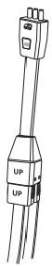
Names of Components

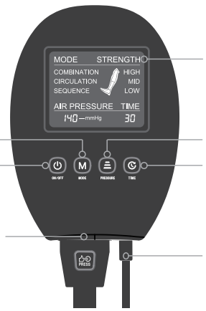  Mode Button  _  3 Modes  Power Button-  ON/OFF |  | Display Screen  Intensity Button  Low/Mid/High  Time Button  20/25 /30 Minutes
Air Hose  Connect Port | Power Port
Control Unit

Display current setting and
working status (remaining
time and pressure range)
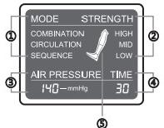
① Current Mode
② Current Intensity
③ Current Pressure
④ Remaining Time
⑤ Compressing Chamber
Display Screen

Air Hose

Connector to
the Control Unit

Junction Box
for Sleeves' Hoses

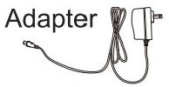

Massage Sleeves
① Massage Sleeve Connector
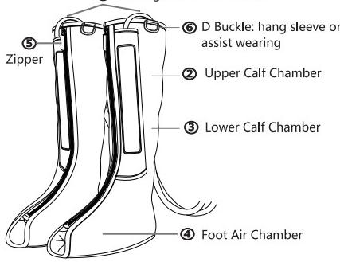

—5—

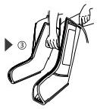
Operating Instructions
Please read safety precautions carefully before using the product. In order to get better massage, please use it according to the instruction.

1. Inserting the sleeve hose connectors firmly into the hose.
** Two sleeves need to be connected to
make it work.

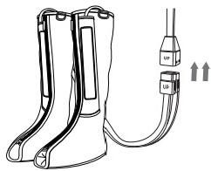

2. Connect the hose to the control unit, you will hear an audible 'click'.

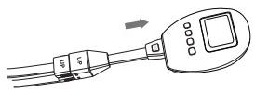

3. Connect the adapter well with the outlet and the control unit, there will be a 'Di'
sound and the screen will flash display for 1 second.
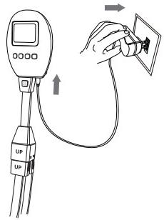

4.Put the sleeves on your leg properly,
pay attention to the Left/ Right Leg tag.
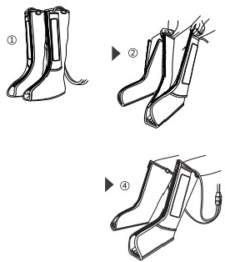

** Please make sure the zipper is zip up completely before wearing, never try to use the system with the zipper partially or totally unzipped;
"You can use the D Buckle on top of the sleeve to assist with putting it on quickly.

—6—

5. Find a comfortable position sitting, reclined, or lying down. Press the power button to start.
1). There is a 'Di' sound, the screen will be light up and display current setting;
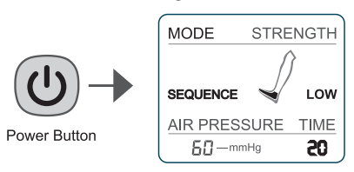
2). It will begin with the default setting of: Mode 1(Sequence Mode), Low intensity (the lowest), 20 minutes timing.

6.Press the mode button to change the massage mode, 3 modes are optional,
see the difference in FAQS A2 session.
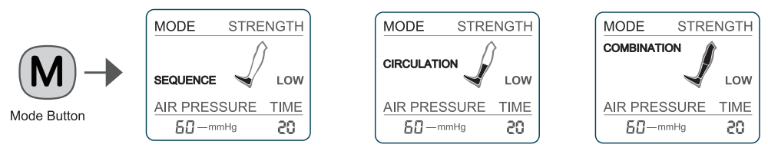

7. Press the intensity button to change the massage strength, 9 levels are optional.
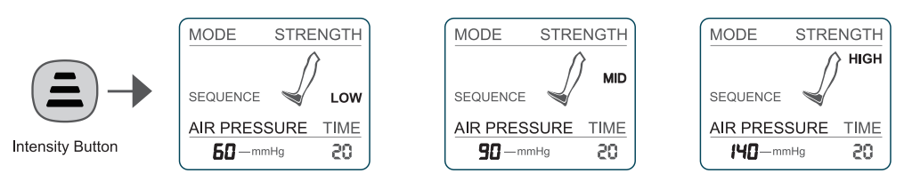

8.Press the time button to change between 3 treatment session times, 20 mins, 25 mins or 30 mins. The time can be adjusted anytime while the session is running.
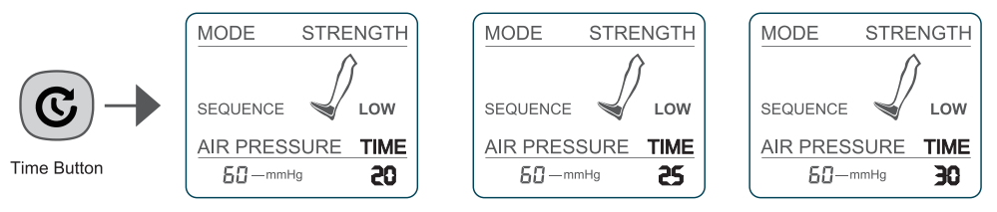

9. The device will automatically shut off after the treatment time is up, you can press the button if you wanna enjoy more or end the massage earlier at any time.

—7—

Notes After Use
1. If you are done using the device, turn off the control unit by pressing the power button, and disconnect the adapter from the control unit and the outlet.
2. Disconnect the hose from the control unit by pressing the button on the top of it and pulling away.
3. Disconnect the sleeves from the hose, remove the them from your legs (Optional).
4. Pack all the accessories into the original package or into the storage bag.
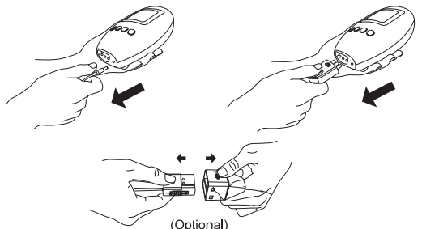

Cleaning

Make sure to cut off the power before you clean the device.
1. If dirty, please wipe the control unit, sleeves and hoses with a damp, clean cloth.
2. Dry thoroughly with a clean cloth.
3. Don't use gasoline, alcohol, diluent and other irritating liquid to wipe the machine in case it causes malfunction or the components are damaged or discolored.
4. Don't allow foreign matters to enter the hoses.
5. Don't dry clean.

—8—

Storage & Maintenance
1. Don't disassemble the device by yourself. It has no user-serviceable parts. When service or repairs are required, please contact customer service at service@ifitking.com.
2. Keep it out of the reach of infants, children and people without the ability to use it independently.
3. Don't place it in high temperature and humidity conditions.
4. Avoid direct sunlight.
5. Avoid needles puncture the sleeves and hoses.
6. Don't place heavy stuff on it.
7. Keep the open ports of the control unit, hose interconnect, and power inlet free of debris.
8. Do not allow lint or dust to accumulate on the control unit or the hose interconnects. If lint or dust accumulates, wipe down the system with a dry cloth before use.

Disposal

Please adhere to the local regulations when you dispose of the waste.

—9—

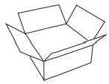
Package Includes

· 2 x Massage Sleeves
·1 x Control Unit
· 1 x Air Hose
·1 x Power Adapter/ AC100~240 V,50/60Hz; DC12V1A
· 1 x User Manual
·1 x Portable Storage Bag

Contact Us
If you have any problem during use, please feel free to contact our customer service team at any time.

Note: Please tell us your order number along with the problems you meet in the email. Pictures or videos are welcomed for faster and better service.

—10—

