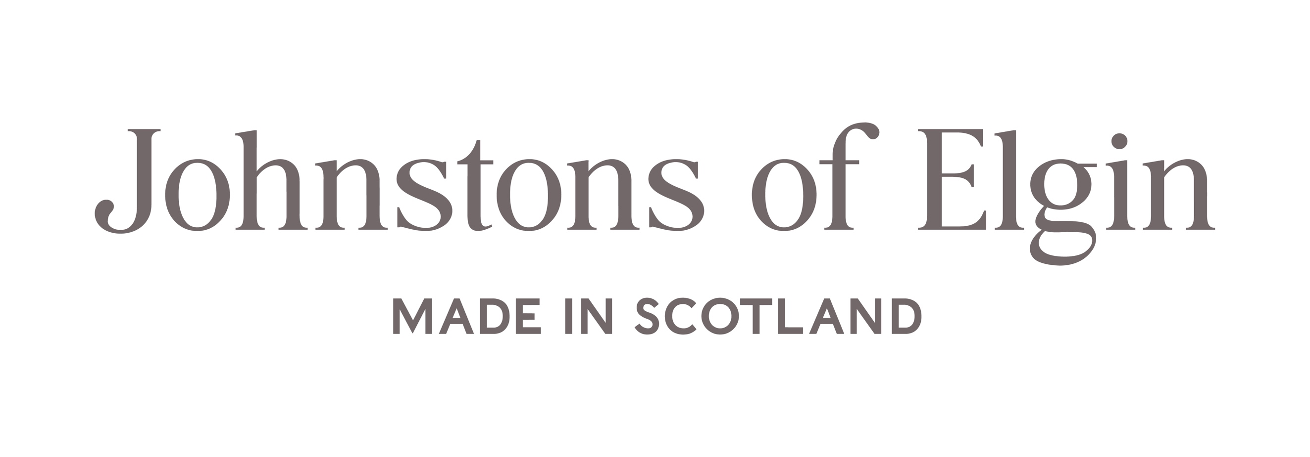

Gender Pay Gap Report for Year Ending 5th April 2024

1 Foreword
At Johnstons of Elgin (“Johnstons”), we believe diversity and inclusion are essential to our continued long-term success. We are firmly committed to fostering a culture shaped by our values, where everyone feels they can bring their whole authentic selves to work and is supported to develop and grow their skills.
Since 2017, the UK Government has required public and private sector employers with 250 or more employees to publish key data on the gender pay gap in UK businesses. This report provides a snapshot of our UK gender pay gap data, comparing trends with previous years. It also recognises our actions to improve diversity and inclusion and further narrow our gender pay gap.
Although it is a legal requirement to publish our gender pay gap data annually, producing a gender pay gap report allows us to be open and honest about any disparities in our business. It also demonstrates a genuine concern for pay equality and our commitment to facing the problem head-on. We believe transparency drives accountability and allows us to better determine where to improve.
We confirm the information in this report is accurate and published in accordance with the UK gender pay gap reporting guidelines and regulations.

2 Gender Diversity at Johnstons
Changes in the Board have resulted in the percentage of female Board members increasing from 38% to 43% and the percentage of female members in the Executive Team has increased from 33% to 45%. This increase is due to the appointment of a female Operations Director to lead our Elgin Mill operations. The split between male and female managers remains at the same level as in 2023.
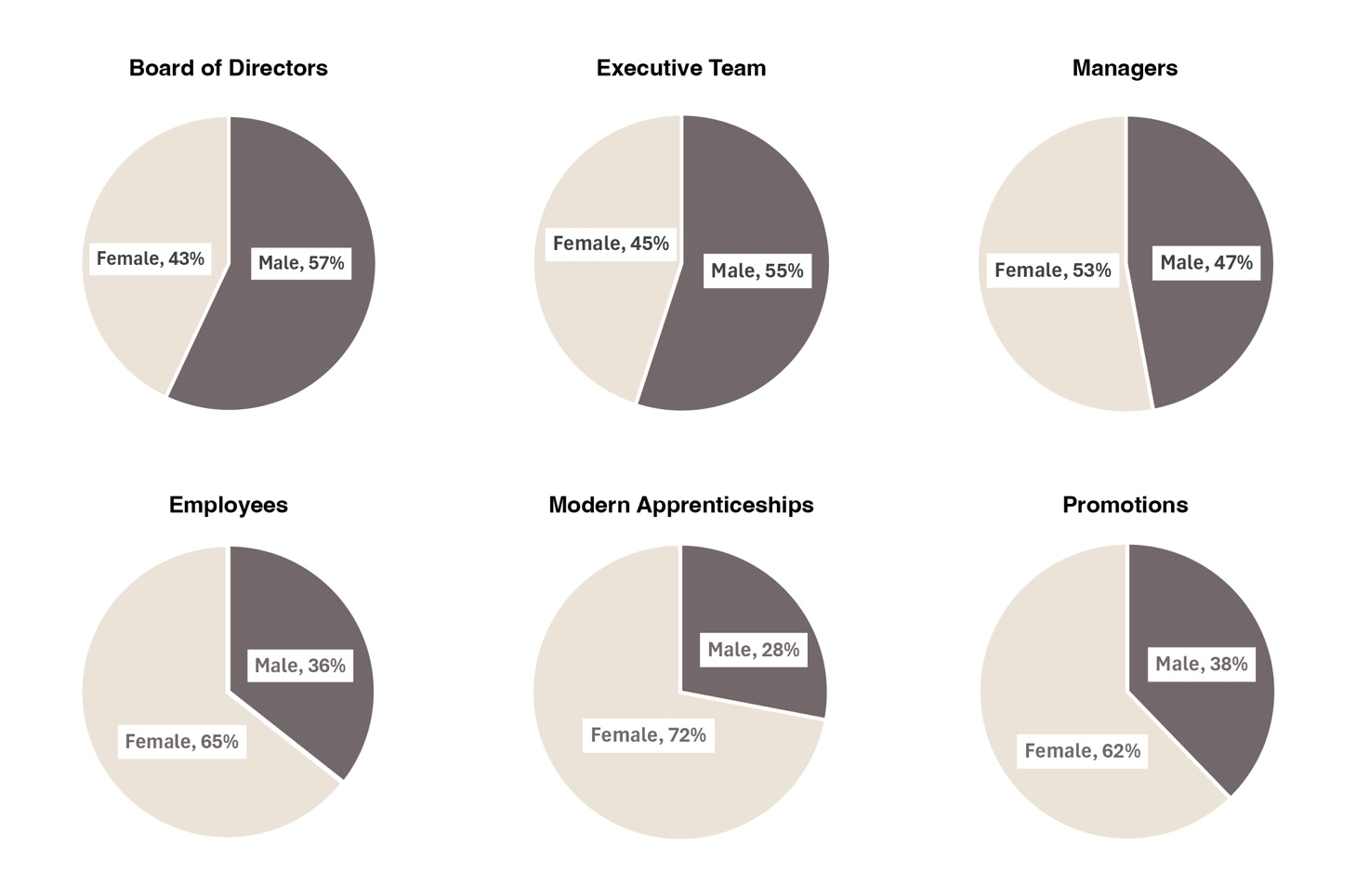

3 Understanding our Gender Pay Gap (GPG)
Whilst we promote equal access to opportunities for all at Johnstons, our gender pay gap continues to be driven by the composition of our workforce. Approximately two-thirds of our overall workforce are female but there has been a tendency in the textiles industry for some jobs to attract female candidates, whilst others attract mostly male candidates. The issue being that the roles which mostly attract male candidates tend to sit in the upper quartiles, and those that attract women sit in the lower quartiles.

We operate a three-shift rotation in our more technical departments, which can create challenges for our female employees, who may traditionally have more childcare and caregiving responsibilities. This is evident in our workforce demographics, where 52% of our female employees work part-time hours, and only 33% of our shift workers are female. We provide a shift allowance for employees who work rotational shifts and as male employees predominantly occupy these positions, this disparity contributes to our gender pay gap. Among employees who receive shift pay, only 33% are female.

 | 2024 |  | 2023
UK Pay Quartile | Men | Women | Men | Women
Upper Quartile | 53.4% | 46.6% | 61.4% | 38.6%
Upper Middle Quartile | 49.0% | 51.0% | 48.9% | 51.1%
Lower Middle Quartile | 23.1% | 76.9% | 23.9% | 76.1%
Lower Quartile | 21.0% | 79.0% | 19.0% | 81.0%

MEAN PAY GAP
14.4%
2023: 16.2%
MEDIAN PAY GAP
12.6%
2023: 12.9%

Nevertheless, we are pleased to see continued improvements in the majority of the key GPG measures, particularly in the year end 5 April 2024 where the mean hourly pay gap reduced by 1.8% compared to 2023 figures. This reflects that we have seen an increase in appointment and promotion of women into supervisory and management positions, with the percentage of women in the upper quartile increasing by 8%.

4 Understanding our Gender Bonus Gap
Our gender bonus gap data captures bonus pay as defined in the reporting requirements over a 12-month period up until 5 April 2024.
MEN RECEIVING A BONUS
2.1%

2023: 86.7%
WOMEN RECEIVING A BONUS
1.1%

2023: 85.9%
MEDIAN BONUS GAP
16.7%

2023: 5.3%
MEAN BONUS GAP

22.1%

2023: 34.8%

In 2023, we paid two extraordinary bonuses to our employees: one to celebrate the company’s 225th anniversary and the second a cost-of-living bonus, which is why there is such a large difference in bonus comparisons from 2023 to 2024.

5 Closing the Gap
We have continued with initiatives to narrow our GPG further, which include:
- Publish the minimum salary on all job advertisements and refrain from asking candidates for their salary history during recruitment. In doing so, we can remunerate all employees fairly, regardless of any gender bias, and ensure past pay discrimination does not follow women through their careers.
- Our management team is encouraged to consider whether a role can be worked flexibly or is eligible for job sharing. Where available, this will be outlined on job advertisements, as requiring all employees to work full-time specified hours each week can contribute to an internal gender pay gap where this method of working is not suitable for a particular gender, such as women.

In 2025, we are implementing a new HR system that will allow us to improve our recruitment process and further reduce bias. The system will allow us to anonymise application elements that identify gender, such as name, email address, etc. This will ensure that the criteria for selecting interview candidates are objective and solely based on skills, experience, and qualifications that match the vacancy.

Chris Gaffney
Chief Executive

