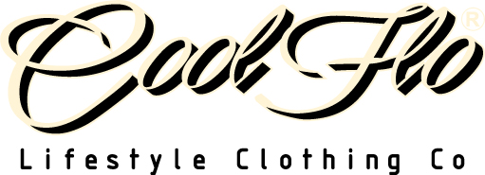
DELIVERY NOTE / RETURNS FORM
Thank you for purchasing from www.coolflo.co.uk. We hope that you enjoy our product/s and come back to visit us again soon.
We hope that you are entirely satisfied with your purchase; however, should you wish to return an item we will be happy to exchange or refund it within 30 days of receipt. Please use this form and follow the steps below. The item must be returned to us in its original condition with all of the packaging, labels and tags intact.
Please follow these steps to return/exchange your order within 30 days of receipt:
- Please return the item in its original condition and in secure packaging along with this completed form detailing the reason for return. *(Please note that we are only able to carry out an exchange on an item for the same item in a different size/colour.)
- The goods must be returned at your cost. We will not refund postage costs unless the item is faulty or we have sent the wrong item. We recommend that you use recorded delivery to return any item/s to us. Always get a Proof of Posting Certificate from the Post Office – we cannot be held responsible for goods lost in transit.
- Please allow up to 21 days for postal returns to be processed.

This returns policy does not affect your statutory rights.

Your Name | Your Cool Flo Order Number
 | #

Qty | Product Description | Colour | Size | Price | Reason for return  (please circle)
 |  |  |  |  | A UNWANTED GIFT
 |  |  |  |  | B DOES NOT FIT
 |  |  |  |  | C FAULTY
 |  |  |  |  | D WRONG ITEM RECEIVED
 |  |  |  |  | E OTHER

*If you would like to exchange the garment for a different size, please state the size here ______________________.
If you would like a refund, please tick here. □

Our Address: Cool Flo Clothing Co. Ltd, Unit 10, Highway Farm, Horsley Road, Downside, Cobham, Surrey,
KT11 3JZ
Our Email: orders@coolflo.co.uk

