Installation Instructions

Part number: 3BR

Description: 3 position battery mount / basket riser

Parts list:

Battery mount / basket riser frame (1)

“T” brackets (2)

“L” brackets (2)

Clamps (2)

¼”-20 lock nut (8)

¼”-20 carriage bolt (2)

5/16-18 x 1” carriage bolt (4)

5/16 flat washer (4)

5/16 lock washer (4)

5/16-18 nut (4)

Process steps:

1. Install the 2 end support “T” brackets, clamps and ¼-20 lock nuts to the rear axle cage next to the fender mounting plates. Do not tighten until the final step.

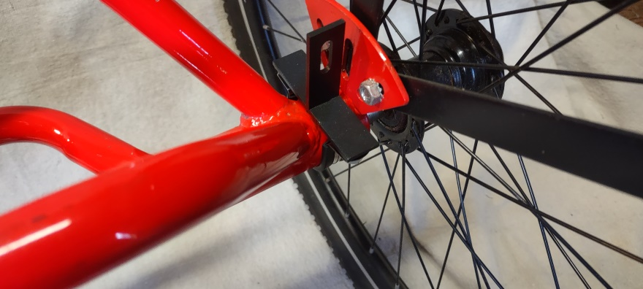 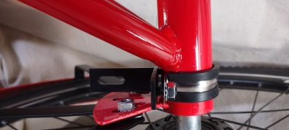

1. Assemble “L” brackets to the battery mount / basket riser frame on the threaded studs using ¼-20 lock nuts. Finger tighten only at this point to allow adjustment to mate with the “T” brackets.

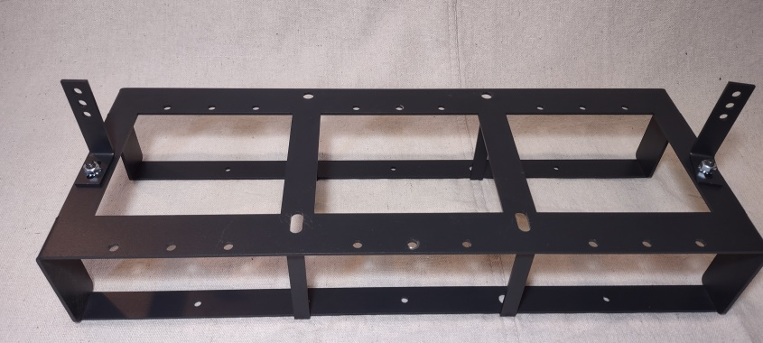

1. Place battery mount / basket riser frame with “L” brackets attached onto the trike axle cage to align with the basket holes. The round holes are closest to the front of the trike. Use the basket bolt, nuts and washers provided with your trike to loosely attach the assembly.

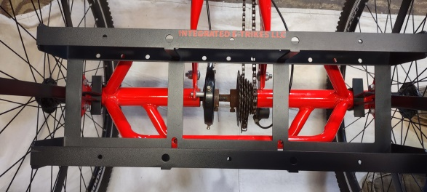

1. Adjust “L” bracket to mate with the “T” bracket. The “L” bracket can contact either the front or the back of the “T” bracket. Use the carriage bolts through the slot on the “T” bracket. The square portion of the carriage bolt engages with the slot on the “T” bracket. Finger tighten together using lock nuts.

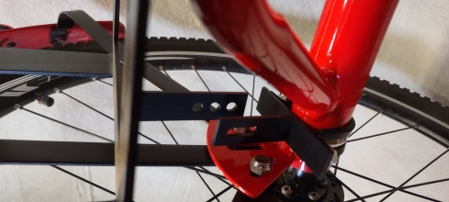 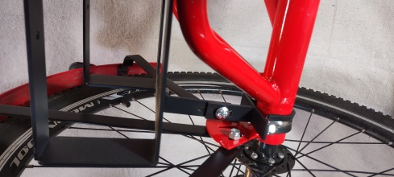 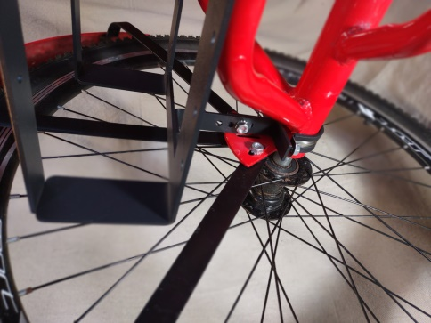

1. Make any positioning adjustments to all components and tighten all fasteners.

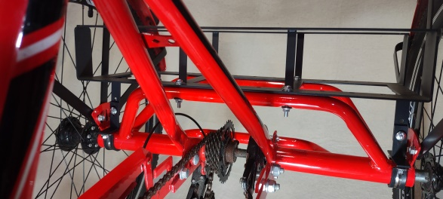

1. Place basket onto the top of the battery mount / basket riser frame and determine the desired location.
2. 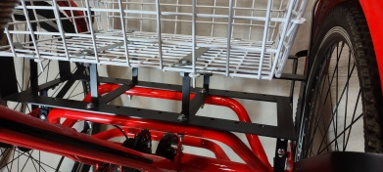
3. Position the flat basket mounting plates provided with your trike to align with the basket mounting holes on the battery mount / basket riser frame

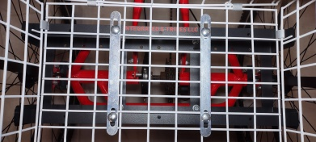

1. Insert 5/16” X1” carriage bolts through the top and fasten with the flat washers, lock washers and nuts.