PN: RCFAGKMIMO1

Payton Pawluski

**Installation/Setup Instructions for Key Module**

**Basic Remote Function**

1. Arming the remote TX/RX system

O

* 1. Rotate the TX E-stop (A) clockwise on the Remote and R Box E-stop. Turn Battery Disconnect key to ON

1. RcFarmArm System On/ Tractor Key to on Position
   1. Press the On Start button (G)
2. Start Tractor Engine
   1. Press and Hold “Unlock” (I) AND press and Hold “On” (G) to crank the engine over, once engine is started release both buttons (G + I)
3. Press the TX E-stop (A) to turn off Tractor Engine and RcFarmArm System

**Figure 1**

**Turn “O”Green Key to ON for Operation**

**Key module Installation/Setup**

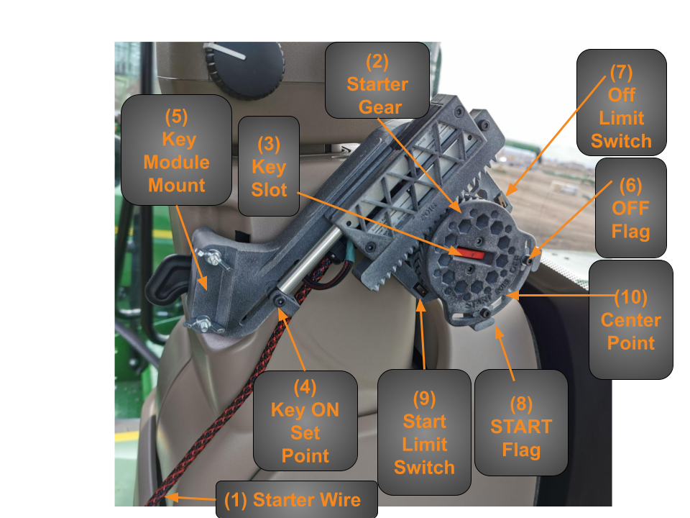

**Figure 2**

*IMPORTANT: Steps 1 through 6 are done when the Key Module is NOT mounted*

Use Figure 1 and Figure 2 as reference for these Installation/Setup Instructions.

**Turn “O”Green Key to ON for Operation**

1. Connect “(1) Key Module Wire” 6 pin Deutsch Connector to the side of the R Box Module

a. Note: If you have the option to control a Rodono Xtend, your serial number will end with a “R”. Then the 4-pin connection is used to connect the Key Module to the R Box and the 6-pin connector used is for the auxiliary connection.

1. Putting RcFarmArm Module into operational ready state (Armed)

a. Turn the R Box battery disconnect key to the “On” position

b. Turn the R Box RX E-stop clockwise.

***Now the RcFarmArm Module is armed and ready for use.***

1. Turn the TX E-stop (A) on the remote clockwise

*Remote transmitter (TX) is now armed and ready for use.*

1. Press the “ON/Start” (G) button, the RcFarmArm system is now ON.

a. The “(2) Starter gear” will turn, the “(3) Key Slot” is now in “Key ON Position”

1. Loosen ”(4) Key ON Set Point”

a. Allowing for the adjustment of the Key ON actuator for Step 6.

1. Put the key of your tractor into the ignition and turn your tractor key to the ON position

*Do not start the engine of your tractor.*

1. Slide the Starter module, aligning “(3) Key slot” over your tractors key.

a. If the “(5) Key Module mount” does not algin correctly, you will need to adjust “(2) Starter gear”.

b. Move “(4) Key On Set Point”, with key sitting in “(3) Key Slot Starter” to adjust.

c. Secure “(5) Key Module Mount” and “(4) Key ON Set Point”

*NOTE: The Key Module is mounted at this point NOT set*

1. Loosen “(6) OFF Flag” and “(7) START Flag” move them to farthest point apart from each other.
2. Depress the TX E-stop “(A), figure 2”

a. “(2) Starter Gear” will rotate the tractors key to its OFF position.

*Note: tractor keyed power should be OFF, if not procced to 9.b.*

1. Adjust the OFF position by moving “(6) OFF Flag” slowly in small steps to the center of “(2) Starter Gear” until the tractor ignition is OFF. Secure “(6) OFF Flag”.

*Note: OFF position is now set*

*Make sure that your TRACTOR is in Neutral and the Park Brake ON.*

10.Turn the TX E-stop (A) on the remote clockwise, press the “(G) ON Start” button

a. “(2) Starter Gear” will rotate turning the tractor key to ON. Cycle the Key Module between the key ON (pressing “ON/START (G)” and OFF (depressing TX E-Stop) position to make sure that the “(6) OFF Flag” and “(4) Key ON” position is correct.

11. Arm the TX E-stop, press “(G) ON Start” to turn RcFarmArm system ON, then press “(G) On/Start” + “(I) Unlock” together and hold them down to set starter (see figure 2) *If engine starts release both (G) and (I)*

a. “(2) Starter Gear” will rotate to the “(9) Start Limit Switch”, Tractor starter should be engaged.

*Note: the tractor starter should engage, if not procced to 11. b.*

b. Adjust the Start position of “(2) Starter Gear” by moving “(8) START Flag” with little steps towards the center of the starter gear until the tractor starter engages.

*If engine starts release both (G) and (I)*

*Note: if you cannot cycle your tractor key from on to start twice, Depress E-stop and repeat step 11. Example Puma, Claas, Fendt*

Please contact us if you have any questions regarding the installation, setup and operation of you RcFarmArm, please have your serial number handy.



# 724071 Range Road 52

**County of Grande Prairie No. 1 Alberta, Canada T8X 4M8**

[**rcfarmarm@gmail.com**](mailto:rcfarmarm@gmail.com)

1-833-327-6276