**Induction heater**

**SP85320**

*Instructions for use and maintenance*

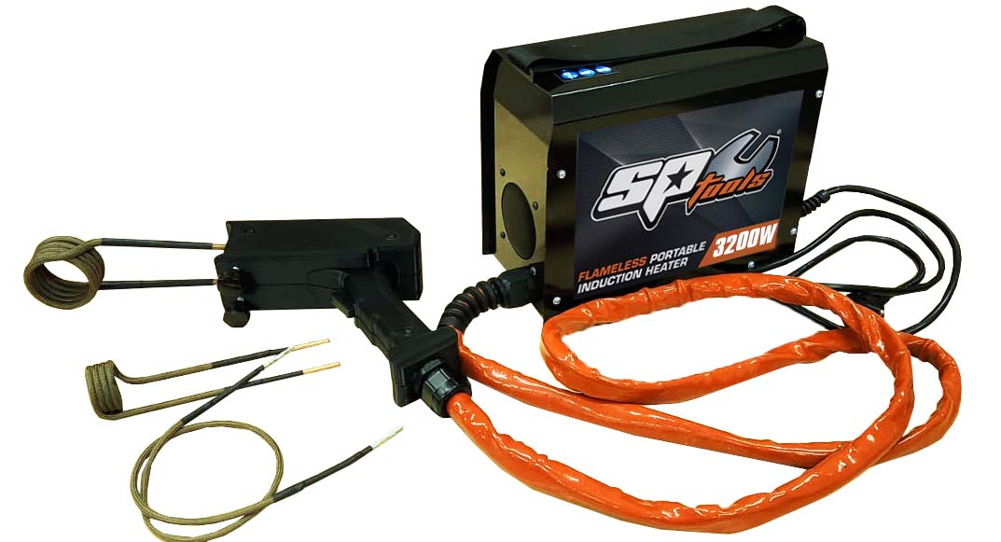



# TABLE OF CONTENTS

1 Table of contents 2

2 Introduction 3

2.1 Induction heating principal 3

3 Safety instructions 3

3.1 General safety rules 3

3.2 Electrical safety rules 4

3.3 Fire safety rules 5

3.4 Safety rules for personal protection……………………………………………………………………………………6

3.5 Safety rules for using the device 7

4 Technical data 9

5 Use 9

5.1 Detachable coils 10

5.2 Flat coil 10

5.3 Customized fixed coils 11

5.4 Flexible coil 11

6 Device indicators 13

7 Possible problems and troubleshooting 13

8 Storage and maintenance 14

8.1 Cooling, dismantling and storage 14

8.2 Proper cleaning and maintenance 14

9 Warranty conditions 15

9.1 Conditions of non-acceptance of the guarantee 15

10 Warranty service 15

11 Disposal of used equipment 16

12 Type of coils 16

13 Consumable spare parts 18

14 Meaning of used symbols 19

15 Possible problems and troubleshooting 20

16 Warranty 21

17 Certificates of Quality 21

18 Declaration of Conformity 22

**INDUCTION HEATER – SP85320**

# INTRODUCTION

This device generates alternating current of high frequency. The current passing through a SP Tools induction Heater heat-ing coil creates an alternating magnetic field which by using the principle of electromagnetic induction vibrates electrons inside the heated material. The energy of moving electrons is dissipated as heat, which heats the metal in the work field of the instrument. The more easily magnetizable material, the more heat it generates. The device heats easily ferrous metals and their alloys, but has no effect on glass, plastics, wood, textiles and other non-conductive materials.

## Induction heating principal

Induction heating is the process of heating an electrically conducting object (usually a metal) by electromagnetic induction, through heat generated in the object by eddy currents. An induction heater consists of an electromagnet, and an electronic oscillator that passes a high-frequency alternating current (AC) through the electromagnet. The rapidly alternating magnetic field penetrates the object, generating electric currents inside the conductor called eddy currents. The eddy currents flowing through the resistance of the material heat it by Joule heating. In ferromagnetic (and ferrimagnetic) materials like iron, heat may also be generated by magnetic hysteresis losses. The frequency of current used depends on the object size, material type, coupling (between the work coil and the object to be heated) and the penetration depth.

An important feature of the induction heating process is that the heat is generated inside the object itself, instead of by an external heat source via heat conduction. These objects can be heated very rapidly. In addition there need not be any external contact, which can be important where contamination is an issue. Induction heating is used in many industrial processes, such as heat treatment in metallurgy, Czochralski crystal growth and zone refining used in the semiconductor industry, and to melt refractory metals which require very high temperatures. It is also used in induction cooktops for heating containers of food; this is called induction cooking.

# Safety instructions

## General safety rules

**Read carefully all instructions in the manual. Failure to follow these instructions may result in electric shock or burns, fire and / or serious personal injury!**

Users are responsible for installing and using the system in accordance with the instructions provided in this manual. The contractor shall not be liable for damages resulting from improper use and handling.

The device may be operated only by persons properly trained and appropriately qualified. Do not operate SP Tools induction Heater under the influence of drugs, alcohol or medications.

Bystanders should be kept safely away when operating with the device, even when cooling the heated material.

Avoid working in the rain, water and moist environments. Keep work area well ventilated and dry, clean and well lit.

This device cannot be used by children, people of any physical or mental disabilities, non trained persons and people of little or no knowledge of the usage of the device. The induction heater SP Tools induction Heater must be used only for the purposes of the induction heating. The device SP Tools induction Heater cannot be used for the welding or charging purposes.

## Electrical safety rules

**This is a safety class I device, which may be supplied with power only from the power outlet with a protective conductor,** which must be connected to the device as first and in any case must not be interrupted /e.g. by an extension cord/. Any interruption of the protective earth conductor, or its disconnection will cause a potential electric shock hazard that can cause injury. Make sure that the device /device chassis/ is properly grounded.

Do not twist or sharply bend the power cord, as it may damage the internal wiring. Never use SP Tools induction Heater if the power cord shows any signs of damage. Keep the power cord away from heat, oil, sharp edges or moving parts. Never repair the power cord if damaged, the power cord must be replaced. Damaged cords create a risk of electric shock.

It is necessary to tight the screws for coil /9/ properly after every changing. Free screws can harm damages on the machine and sparking which causes the overheating of the contacts – the working current is 300A!!! The material of the heating coil is being expanded and contracted while working.

Therefore it is necessary to check all the time the tightened of the screws on the handle.

I tis forbidden to use the device if the cover, handle, coil or cable is damaged or not in a 100% fit – there is a danger of injury or death by the electrical current or a fire. Keep the cables, working coils and the device itself off the another heat devices, acetone, colours, dope, hydroxides, the other chemicals, sharp edges or moving parts. The red isolation to the handle /4/ and the isolation of the coils /10/ is resistant for the oils, acids only for a little. If the cord, isolation or the isolation of the working coil is damaged, must be replaced only by the manufacturer or responsible person trained by the manufacturer to prevent any injury or harm.

The manufacturer and the seller are not responsible for the consequences of an inappropriate usage of the device written in this manual.

Do not touch the working coil while in process of heating. Do not switch on the machine without the working coil. There are high current peaks while the machine is ON without the working coil and therefore the device can be damaged by that because of the damaging the overvoltage protection.

Do not use the working coils with damaged isolation or no isolation.

Before replacing the applicator /coil/, disconnect SP Tools induction Heater from the power source /wall outlet.

If you are not using SP Tools induction Heater unplug the power cord from the outlet.

**CAUTION  
This product is for class A industrial use. It may cause radio interference in residential, commercial and light industrial environments. This product is not intended for installation in residential environment, business environment and light industry with connection to the public supply network; user may be required to take adequate measures to reduce the interference.**

**Caution! High voltage danger 1600V on the primary side of the transducer.**

**Caution! High current 300A on the secondary side of the transducer and on the output of the device.**

**Do not open the cover of the SP Tools induction Heater while working process.**

## Fire safety rules

Do not use the device if suspecting the gas leaking or flammable or blowing up materials.



Do not heat aerosol or other cans, metal containers, and any pressure vessel used for the storage of fuel, compressed gases and liquids. The heat generated by SP Tools induction Heater may cause them to explode and their con-tents may ignite.

Do not use the heating spiral /coil/, if the isolation is damaged. A defect in the isolation may cause sparks in contact with metal objects or between the turns of the coil. In particular, when working on / or near gas pipes and / or gas tanks it may pose a danger of explosion or fire. Using coils with damaged isolation will void the warranty.

Always have the fire extinguisher near to the device while working which is able to extinguish the electrical devices under the voltage – CO2 or dust extinguishers.

The water or foam extinguishers are absolutely inappropriate.

The fire under the voltage always extinguish from the distance at least 2m.

If possible switch off the power.

## Safety rules for personal protection

Persons with pacemakers or other metal or electronic surgical implants must not operate with the device SP Tools induction Heater and must keep a safe distance of at least 1m from the device.

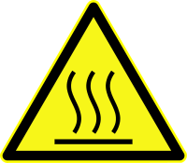When working with SP Tools induction Heater do not wear any metal objects such as jewellery, rings, watches, necklaces, identification tags, belt buckles, piercing and even clothing with metal parts such as metal rivets, buttons and zippers, etc. SP Tools induction Heater can heat up these metal objects quickly and cause serious burns or clothing ignition.

**ATTENTION: Coil applicator and heated object can reach high temperatures and cause burns or cause a fire.**

 When using the device SP Tools induction Heater always wear safety goggles or face shield.

When using the device SP Tools induction Heater hazardous fumes may be produced by burning old paint, lubricants, sealants, adhesives, etc.

These exhalations can be toxic. Always wear appropriate protective masks or respirators.

 When working with the device SP Tools induction Heater always wear protective gloves with corresponding thermal resistance. High temperatures generated by the use of SP Tools induction Heater may cause serious burns in the case of touching the heated part. Always keep proper footing and balance for safe control of the device even in un-expected situations. The isolation of the working coils consists of glass fibres so while manipulating always use the protective gloves. The cable from the device to the handle van be overheated for some reason so always use the non flammable protective gloves. Do not touch the components of the device by the non protected skin. Do not wear the clothes from oils, grease or petrol. There is a risk of fire or burning.  
The working space always kept in a fresh air condition.

While working with the SP Tools induction Heater do not wear on you and do not get close with the red cable /4/ or the working coil /10/ to the electronical devices like cell phones, USB media etc.... There is a real risk of damaging such a devices.

While working close to the sensitive electronical devices always unplug them from the source of power or from batteries. Always stay on a flat, dry and non electrical ground.

Do not use SP Tools induction Heater near the device with pyrotechnics /e.g. airbag/. The resulting heat can cause their unexpected explosion. Keep a minimum distance of 10-20 cm from these devices.

## Safety rules for using the device

**Do not leave SP Tools induction Heater unattended when switched on. Make sure that the power supply unit and the handle has an adequate supply of air for cooling.**

After finishing the work with the SP Tools induction Heater do not switch it off immediately but keep it on 6,5minutes to cool down properly. After that you can switch off the device from the source of power. The working coils always let cool down on the non flammable surface before putting them to the case.

Make sure the vents are clean and free of dust and dirt not to impede the flow of cooling air.

Do not attempt to repair SP Tools induction Heater. The device does not contain any user-serviceable components, except for replaceable heating coils.

Before connecting SP Tools induction Heater to the wall outlet make sure the outlet voltage corresponds to the voltage on the rating plate. If the wall outlet voltage does not match the voltage indicated on the rating plate, it may result in a serious risk of damage to SP Tools induction Heater.

Do not exceed the operating cycle SP Tools induction Heater which has no time limitation but the thermal fuse which switches OFF the unit if overheated and switches ON when cooled down. The main equipment is protected against device overheating, but heating coils are not, which may cause their damage.

**EXTENSION CORDS:**

Extension cords – if necessary, you may use only the following extension cords:

• up to 5m with 2.5 mm2 diameter

• up to 15m with 4 mm2 diameter

Use only one extension cord – do not connect two or more extension cords. Do not use any other extension cords than those mentioned above. Unpack the extension cords - tightly packed extension cords may overheat and cause fire.

**GENERATORS:**

When using the device with an alternate source of power – e.g. with mobile electric generator, it is necessary to use a quality alternate source of sufficient power and AVR quality control. Use a generator with a power output of at least 7 kW, or DC / AC inverter with a power output of 7 kW and only with a sine wave – do not use the inverter with a square or quasi-sine wave. Failure to comply with the above requirements may result in damage to the device and void the warranty.

The device must be protected from rain and moisture, mechanical damage and possible ventilation of neighbouring machines, excessive overloading and rough handling.

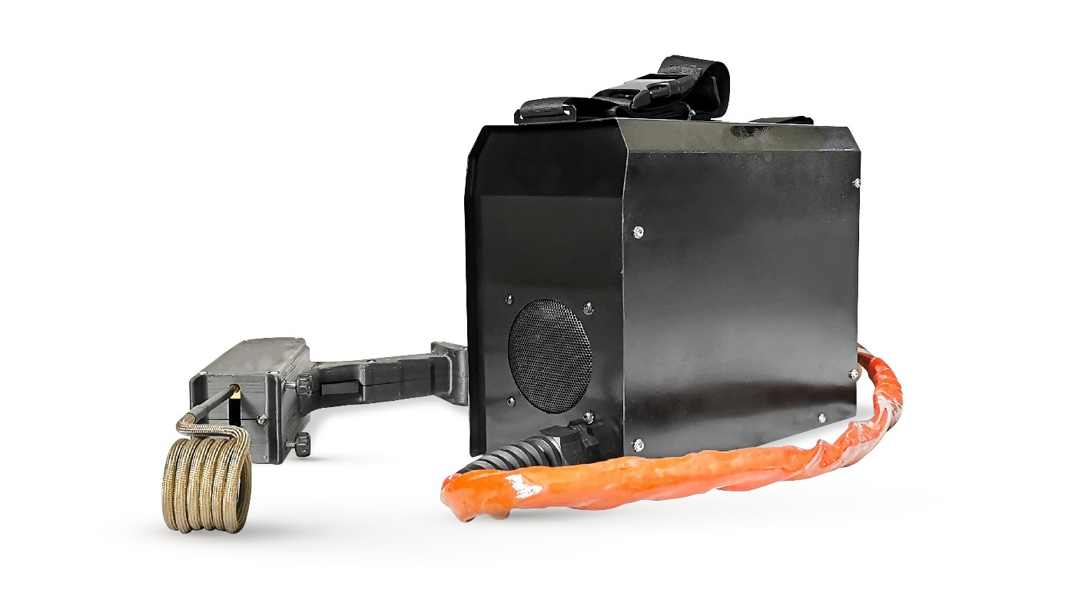

11

1

3

2

10

6

9

5

4

8

7

1. Handle
2. Info LED light
3. Trigger button
4. Working LED light
5. Tightening screws
6. The hole for the heating coil
7. Heating coil
8. Fan
9. Connection cable
10. Cover
11. Carrying belt

# Technical data SP Tools induction Heater SP85320

|  |  |
| --- | --- |
| **TECHNICAL DATA** | |
| **Input voltage** | 230V +10% -15% 50/60 Hz |
| **Input current** | max. 14A |
| **Input** | max. 3,9 kW |
| **Power** | max. 3,2 kW |
| **PF (power factor)** | 0,99PFC |
| **Load factor** | 100 % |
| **Cover** | IP 20 |
| **Dimensions cm** | 23,5x18x9,6 |
| **Total length cm** | 320 |
| **Weight kg** | 8 |

# Use

Before usage of the device, check the incoming cable, handle and the handle cable to assure that they are not damaged.

1. Disconnect the device from the electric network and loosen the screws on the handle.
2. Insert the working coil into the holes in the clamping holder of the coils and tighten the locking screws on the sides.
3. Connect the supply cable of the device into a properly grounded standard socket ~230V, 50/60Hz and turn on the device using the main switch. Before turning on, make sure that the handle is laid in a safe place and that the heating button is not pressed down.
4. Attach or put the working coil on the material you want to warm up and press the button on the handle. Heating remains activated during the pressing of the .

After finishing the cycle, release the button on the handle and remove the heating coil from the heated material.

While working with the SP Tools induction Heater slowly move with the working coil to prevent the sticking to the heated material. You can hear a little buzz during the operation or small vibrations which is absolutely normal features of the induction procedure.

Always check the tightened of the working coils.

NOTE: During heating there should be a gap of around 3-5mm between the coil and the heated material to avoid excessive wear of the heating coil. A gap larger than 3-5mm decreases heating efficiency and extends the heating time

After finishing heating, place the handle with the heating coil in a safe, inflammable place until the heating coil is completely cooled. Then turn off the device using the main switch and disconnect it from the electric network.

**ATTENTION: The coil and the heated object can reach a high temperature and/or cause burns or result in fire.**

## Heating coils

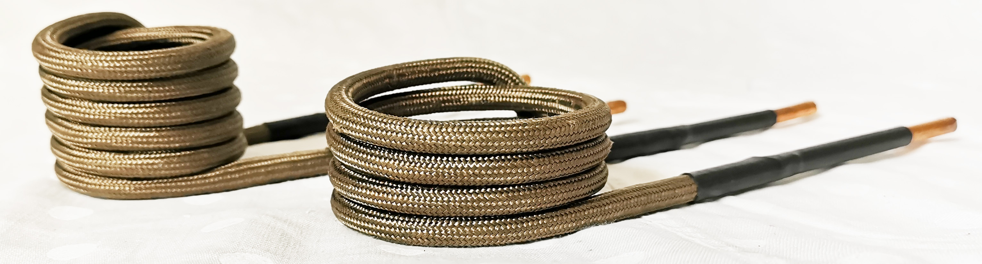



NOTE: The service life of the coils can be increased by cleaning rust, paint, oil etc. from the heated material. During heating, there should be a gap around 3-5mm between the coil and the heated material to avoid excessive wear of the heating coil.

Holding of the coil directly on the hot material can cause the burning of the coil insulation, thereby shortening the service life of the coils. We recommend limiting direct contact of the coil with the hot material to the minimum.

**TIP!** For loosening nuts, screws etc., it is not necessary to heat the material until it is red hot. Heat the nut for 15-30 seconds and try to loosen it using a wrench. If it is not possible, heat again for 15-30 seconds and then try loosening using the wrench again.

## Flat coil



The flat coil shaped coil is intended for the heating of flat sheet metals and for the straightening of small dents in car bodies by heating. The flat coil is also in-tended for easy peeling off of stickers, sealants, putties etc by heating of the base material – steel sheet metal.

1. Connect the coil to the coil handle
2. Place the coil with its area over the material
3. Press the button and guide the coil above the material in a gyratory movement
4. After heating of the material, allow the coil to cool off for at least 2 minutes.

NOTE: It is possible to use the coil to remove various adhesive stickers, seal-ants and gaskets which are stuck to sheet metal or metal – for example in automotive, services etc.

The coil is used heating of the base material and thus softening, or alternatively, hardening of the glue, putty, etc. We recommend holding the coil around 5-15mm far from the heated material – it is possible to regulate the required temperature and heating time by changing the distance.

## Customized fixed coil

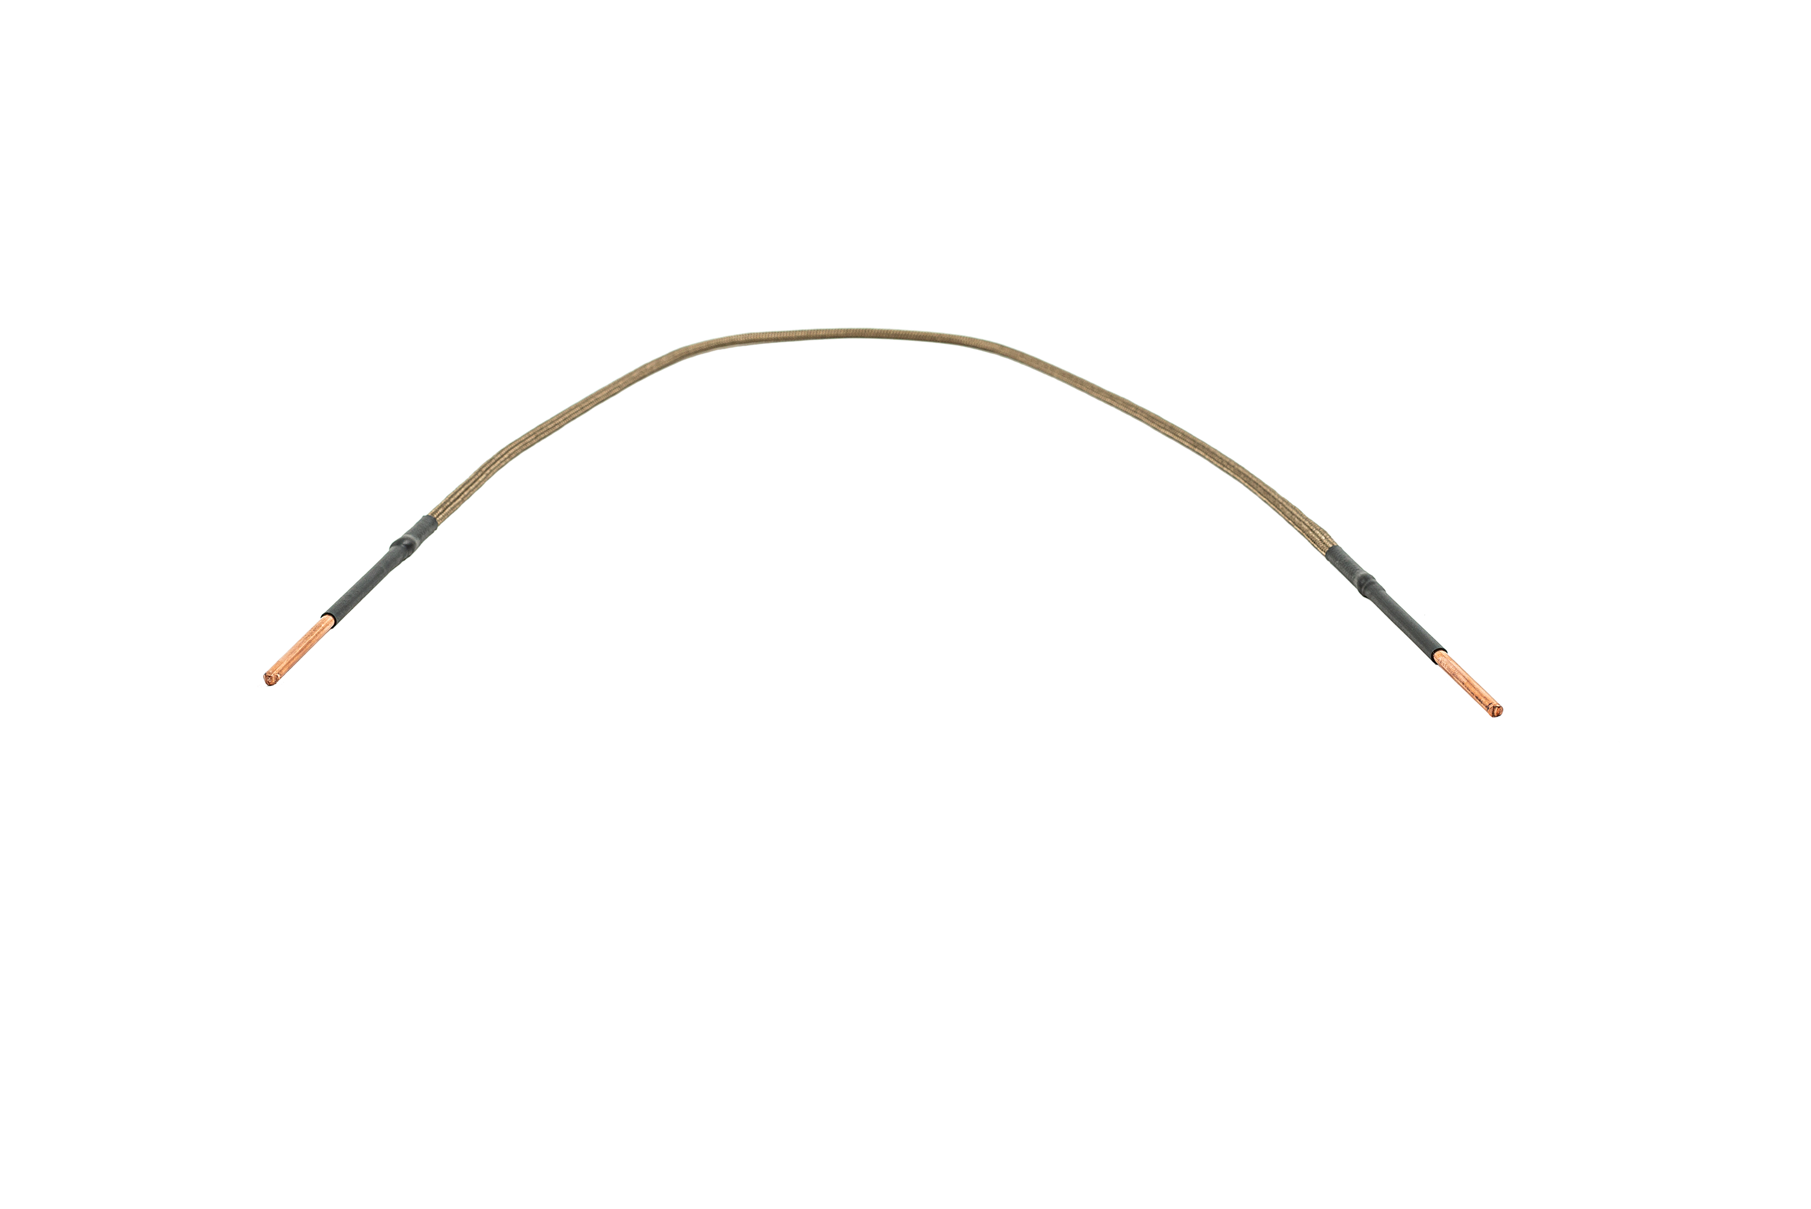

User shaped solid coils can be shaped and adapted directly by the user according to requirements of the individual application. They can be used for the same purposes as attachable coils.

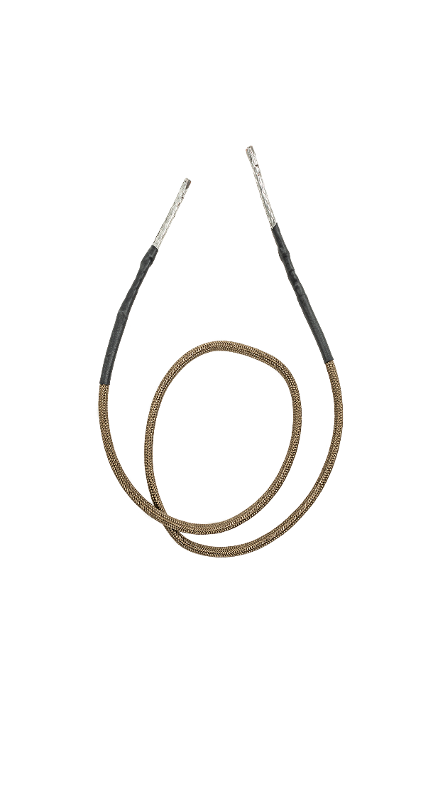

## Flexible coil

The flexible coil is used for the loosening of axle fitments, stiffened sensors, ball joints etc and in applications where is not possible to use attachable coils.

Applications:

1. Connect one end of the coil to the coil holder and secure it by the locking screw

Wrap the free end of the conductor over the part which needs to be heated. Make around 1-3 turns.

1. Connect the second – free end of the coil into the coil holder and secure it by the locking screw
2. Pressing of the key activates the heating.
3. After finishing heating, one end of the coil will be release and the coil will be unwound from the heated material



If the overload of the device occurs /the LED warning light on the handle is flashing red/, unwind one loop and repeat the procedure until the heating is carried out without overload and turning off.

If the heating has a low intensity, on the contrary, try adding one loop.

They allow a higher intensity heating on a small area and are especially used for attaching to the heated material.

1. Connect the coil into the coil holder
2. Attach the coil on the material with the circular area of the coil
3. Press the button for pprox.. of 10-15 seconds.
4. After heating the material, let the coil cool off for at least 50 seconds.

# Device indicators

|  |  |  |
| --- | --- | --- |
| **Colour** | **Meaning of colour** | **Troubleshooting** |
| green | stand by/ready  If the Green light is on while working and the machine is not heating the thermal fuse deactivated the current circle to protect the machine. | OK  Wait for 1,5minute to cool down the thermal fuse under the 70C and the current circle will be activated again.  If the induction heater is not working after that, please call the service. |
| Orange | heating in progress / device is working | OK |
| red flashing | device is overloaded by the outgoing power | Use another working coil or keep the distance between the coil and material around 3mm. |
| red light on | the temperature of the device is overloaded | Keep the device ON to cool down by its own ventilators pprox.. 1,5min. |
| Red and white light is flashing | Missing coil /  Damaged coil | Check if the coil is in the handle or if it is properly tightened or if the working coil is not damaged of the isolation. |
| White light is on | Working light | Working light for better visibility of the working material and space. |

# POSSIBLE PROBLEMS AND TROUBLESHOOTING

SP Tools induction Heater is designed and constructed so that when an overload occurs, there is a temporary turning off, which is indicated by the flashing of the LED on the handle.

The induction coils do not have any thermal protection and thus they are not protected against overload. The operating cycle of the induction coils is set for 3-5 minutes of activity – heating and 2-3 minutes of cooling.

If the device stops working, check that it is properly connected with the electric network and also check the plug connector and socket, the fuses or breaker. Check the value of the supplied network current. Also make sure that the incoming and connection cable (if you use it) is not damaged. Let the device cool off for at least 10 minutes and then reconnect it. If the problem persists, contact your supplier.

Usage of an inappropriate extension cable (too long, small diameter of wires) can cause insufficient power of the device – see the safety regulations.

In case of other problems contact your supplier.

# Storage and maintenance

## COOLING, DISMANTLING AND STORAGE

After completion of heating, make sure that the coil holder and coils used are placed in a safe place. Handling the device or its parts before letting it cool down can result in injury, damage to the equipment or fire.

After completion of heating, leave the device turned on for 10 more minutes – the device will be cooled down by fans until cooled off completely and then will turn off the fans. Then shut it down by the main power switch and disconnect it from the power supply.

If you unplug the unit immediately, let all working coils cool down for at least 15 minutes.

After cooling, place the device and its accessories in the case. Place the cords so as to avoid their sharp bending or twisting – it could cause their damage.

Always use the air pressure device to blow up all the dust and small parts of the metal to prevent any damage of the induction heater. Do not open the cover of the device! Only person after the training.

## Proper cleaning and maintenance

Make sure the device is turned off, unplugged and cooled. Use a dry, clean cloth or paper towel to remove grease, oil and other impurities from the machine. Use freely available non-volatile cleaning agents for grease, oil and dirt that is difficult to remove. Before the first reuse of SP Tools induction Heater allow all components to air dry.

Do not immerse any part of the device in water or other liquids. Do not clean the components with volatile organic compounds such as gasoline, benzene, kerosene, methyl ethyl ketone (MEK), fuel oil, brake parts cleaners, paint and thinner remover, varnish removers, self-adhesive solvents, etc. These substances cause fire and cause hardening or dissolving of polymeric materials used in the device.

Do not use heat sources, heaters, burners, microwave ovens or gas furnaces, etc. for drying the device and its parts after cleaning.

# Warranty

Machine warranty period is determined by the manufacturer for 12 months from the sale of machinery buyer.

Warranty period begins on the date of de-livery of the machine to the purchaser, or the possible delivery date.

The warranty period does not cover expendable parts – coils. Warranty period does not include the period from the application of a legitimate complaint until the machine is repaired.

Content of the guarantee is responsible for the delivery of machines at the time of delivery, and the warranty period will have the characteristics laid down by mandatory specifications and standards.

Responsibility for defects that occur after the machine sold under warranty, consists in the obligation of free defect removal machine supplier, or service organization authorized by the machine.

Condition of warranty is that the machine is used in a manner and for the purposes for which it is intended. Such defects are not recognized extraordinary wear and damage due to insufficient care or neglect seemingly insignificant defects.   
For example, the defect cannot recognize:

Equipment damage due to inadequate maintenance,

Mechanical damage due to rough handling, etc.

The warranty does not cover damage due to failure to meet the obligations of the owner, his inexperience, of impairments, failure to comply with the provisions referred to in the instructions for use and maintenance, the use of machines for the purposes for which it is not intended, overloading the ma-chine, even if temporary. Maintenance and repairs must be exclusively used by original equipment manufacturer.

During the warranty period are not allowed any modifications or changes to the machine, which can affect the function of each part of the machine. Otherwise the warranty will not be recognized.

Warranty claims must be applied immediately upon detection of manufacturing defects or material defects, and that at the retailer.

If a warranty repair will replace the defective part, transferred ownership of the defective part to the manufacturer.

## Non warranty conditions

The usage of the SP Tools induction Heater in other way that is allowed by the

manufacturer.

* + - 1. The usage of inappropriate working coils which are not being supplied by the

manufacturer.

* + - 1. The usage of another isolation than is recommended by the manufacturer.
      2. The damage due to the overloading the device.
      3. Manual damage of the device and its components by the user.
      4. The other non specified manual or technical damages made by the user.
      5. Damaging of the overvoltage protection components.

# Warranty service

Warranty service can be performed only by a trained service technician authorised by SP Tools Europe BV.

Before performing warranty repairs it is necessary to check the data of the machine – the date of purchase, serial number, machine type. If the data are not consistent with the conditions for the recognition of warranty repairs, for example, expiry of the warranty period, improper use of the product contrary to the instructions for use, etc., it is not a warranty repair. In this case, all costs associated with the repair shall be borne by the customer.

# Disposal of used equipment

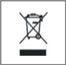These machines are built with materials that do not contain substances that are toxic or poisonous to the user. For the disposal of waste equipment use the collection points for the abstraction of used EEE. Do not dispose of the used equipment in common waste.

# Type of coils

*Please see* [*www.sptoolseurope.com*](http://www.sptoolseurope.com)

# THE MEANING OF USED SYMBOLS

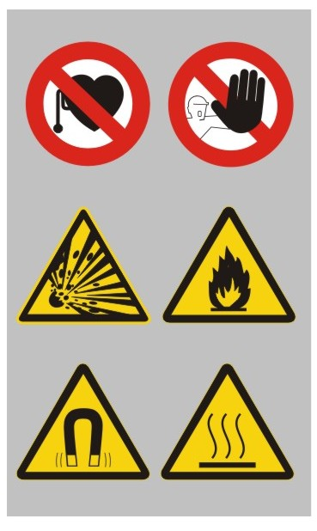

* Usage restriction of the persons with the cardiac stimulator or any other metal or electrical implant!
* Usage only by the trained persons!
* Danger of explosion!
* Danger of fire!
* Caution very strong intensity of magnetic field!
* Caution strong heat device!

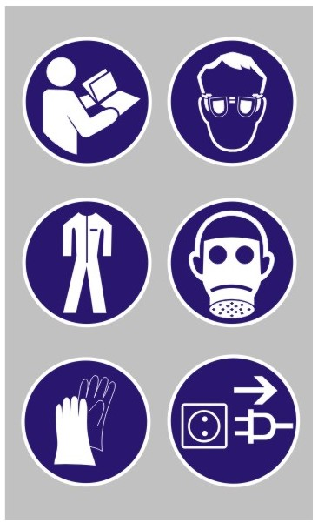

* Before usage read the manual carefully.
* Use the protective equipment – gloves, glasses.
* Always use the protective clothes.
* Use the protective respirators.

* Use the protective working gloves.
* Switch OFF the device while not in use and unplug from the power of supply.

# POSSIBLE DEFECTS AND THE SOLUTIONS

|  |  |  |
| --- | --- | --- |
| *Defect* | *Feature of the defect* | *Solution* |
| The heated material is not being heated. | LED light on the handle is flashing on RED.  **When pushing the trigger on the handle with the coil without any load. Wrong coil or damaged coil, coil without the exact number of rounds or bad connection of the coil.** | Use the standard coil supplied by the manufacturer and check the correct connection. |
|  | LED light on the handle is flashing on RED.  When the device is being heating with the working coil the material, the protection of the overloading is being activated. | **Increase the distance between the material and the working coil by using the bigger coil or getting the coil slowly away from the material. When using the flexi coil take of one round.** |
|  |
| Heated material is being heated slowly. | The temperature of the heated material is increasing slowly or not at all. | Use another working coil bigger than the heated material. Check if the heated material is ferromagnetic. |
|  |  | Check the connector where is the device plugged in if there is enough power of 230V. Check if the power is not from another power source such as generator or DC/AC power device where is not the sinus current but only quasi-sinus current or the power supply device is not powerful enough!  **Plug the device into another power of supply.**  Check the prolonger cable for the interference.  **If sorted out this issue the LED light on the handle must be switched ON orange.** |
| The orange cable from the device to the handle is overheated. | The temperature of the cable is higher than normal. | Check the induction heater SP Tools induction Heater if it is not being overloaded for a very long period of time. |
| The heated material is not being heated. | LED light is flashing on RED. The device is overheated. | Let the device SP Tools induction Heater to be cooled down and control it all the time. |
|  | The LED light is switched on RED even after the time 3 min of cooling down. LED light is not being ON at all. The ventilators of the device are being stopped. The SP Tools induction Heater has no reaction on the trigger. There is some defect on the device. | Send the induction heater SP Tools induction Heater to the service centre or directly to the manufacturer. Do not use the device! |

# Warranty certificate

|  |  |
| --- | --- |
| Date of sale |  |
| Dealer signature and stamp |  |

|  |  |  |  |
| --- | --- | --- | --- |
| **Record of the service operation** | | | |
| Date of takeover by service | Date of repair | Number of claim protocol | Signature |
|  |  |  |  |
|  |  |  |  |
|  |  |  |  |

# Certificates of quality

Producer: **SP Tools Europe BV**

Product type: **SP Tools Induction Heater SP85320**

Serial number: …………………………………………………………………………….

Date of output control: ………………………………………………………………………….

Controlled: …………………………………………………………………………….

# Declaration of conformity

Producer:

**SP Tools Europe BV**

Declare that the product:

**SP Tools Induction Heater SP85320**

This conformity certificate confirms the conformity of the product with essential safety requirements of the

following EC/EU New Approach Directives as amended:

2014/35/EU LVD Directive 2014/35/EÚ Low voltage

2014/30/EU EMC Directive 2014/30/EÚ EMC

Harmonized standards used for the conformity assessment:

EN 60335-1:2012/AC:2014/A11:2014/A13:2017/A1:2019/A14:2019/A2:2019/A15:2021

EN 60335-2-45:2002/A1:2008/A2:2012

EN 61326-1:2013

EN 55011:2016/A1:2017/A11:2020/A2:2021

EN 61000-3-3:2013

Other standards and specifications used for conformity assessment:

EN IEC 61000-3-2:2019/A1:2021

EN 61000-3-3:2013/A1:2019/A2:2021/AC:2022-01

The certificate has been issued on the basis of the tests of the product type sample.

The results are recorded in the Conformity assessment report No. 230500016 dated 01.03.2023.

**m**ark can be used only in the case of conformity assessment according to all relevant EC/EU Directives

Date of issue: 1.3.2023

**All rights reserved 2023**