SHELTER
ASSEMBLY MANUAL
Model # 304015R
(W30H15R SERIES)
Size: W9.15mxL12mxH4.5m

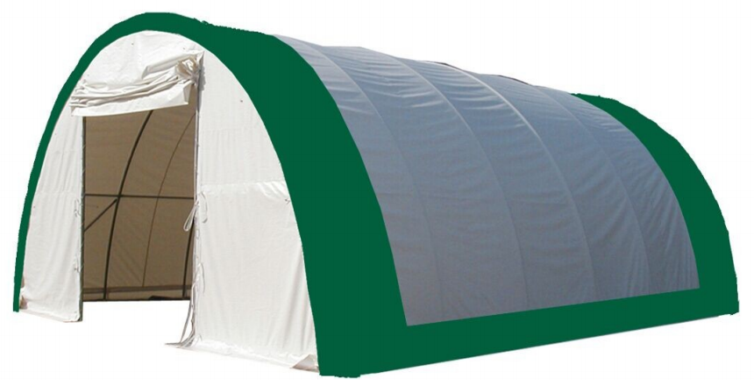

Part List
Parts Code | Description | Qty
1 | Roof Bent Tube | 7
2 | Middle Bent Tube | 10
2A | Middle Bent Tube for front and back door | 4
3 | Lower Bent Tube | 10
3A | Lower Bent Tube for front and back door | 2
3B | Lower Bent Tube for Assembly Winch | 2
4 | Purlin | 30
4A | Strengthening Support Tube(5group) | 10
4B | Upper vertical supporting tube | 5
5L | Side Base Plate for Connors (at left) | 2
5R | Side Base Plate for Connors (at right) | 2
6 | Base Plate for front and back door | 4
7 | Base Plate for inner sidewall | 10
8L | Lower Door track at left | 2
8R | Lower Door Track at right | 2
9L | Upper Door Track at left | 2
9R | Upper Door Track at right | 2
10 | Side Horizontal Connection Tube for door | 4
10A | Bottom Horizontal Tube for assembly winch | 2
10B | Winch | 2
10C | Steel Wire for Winch | 2
11 | Door Beam | 2
11A | Suspender Tube | 2
11B | Angle Iron Plate | 2
12 | Lower Tensioning Tube for front and back door | 4
13 | Diagonal Bracing Tube | 8
13A | Clip for Diagonal Bracing Tube | 16
13B | Splint for Door Track | 8
14 | Lower Tensioning Tube for roof cover (2 sets) | 2 Group
15 | Door Dropping Tube | 14
16 | Stake Peg | 50
17 | Bolt M10x90mm | 35
18 | Bolt M8x50mm | 84
19 | Bolt M10x30mm | 35
19A | Bolt M10x90 mm | 52
19B | Bolt M10x60 mm | 8
21 | Rachet Tie Down | 14
22 | Roof Cover | 1
23 | Front and Back Door Cover | 2
24 | Knitting Rope for No.22,23 | 1 bundle
25 | Nylon Band for Winch | 14
26 | Round Plastic Plug | 4
26A | 30*50mm Square Plastic Cap | 8

SPECIFICATION
W30' x L40'xH15'
Width: 9.15m Length: 12m Height: 4.5m
Door dimension: W3.5mxH3.5m (W11'6'' x H11'6'')

IMPORTANT-----READ MANUAL FIRST

Improper site preparation, Assembly and Maintenance may invalidate warranty and cause unnecessary and costly mistake. If you have any questions contact your local dealer.

For User Friendly assembly we have identified each individual component with the part code as indicated in the parts list. Please refer to the part code numbers and drawing to ensure problem free assembly.

It’s necessary to tighten the roof fabric enough to avoid “hammocks” on the roof and also re-tighten once or twice again after a few months of use. This is important when assembly in cold weather (autumn and winter) because the fabric is stiff then and when we got the sun and warm weather afterwards it will make the fabric “slack” again and need to be re-tighten before next winter.

It’s the owners responsibility to take of snow immediately if not slide off by itself.

READ ALL INSTRUCTIONS BEFORE ASSEMBLY

- Keep work area clean. Cluttered areas invite injuries. Do not set up near snow drifts, in slippery places, in high winds, or wet location.
- Keep children away. All children should be kept away from the work area.
- Don’t over reach. Keep proper footing and balance at all times.
- Do not assemble in under the influence of alcohol or drugs. Read warning labels on prescriptions to determine if your judgment or reflexes are impaired while taking drugs. If there is any doubt, do not assemble.
- Be aware of possible windy conditions; fasten the bases in concrete if these conditions are likely to occur. Remove the cover during hurricane.
- Be careful with power and heat sources. Do not keep heat sources near the tarpaulin. Do not expose to open flame.
- Be aware of personal safety during assembly and use. Be careful not to pinch fingers with clips and tubes when assembling: when using makes sure there is adequate ventilation for exhaust and other dangerous fumes.

EQUIPEMNT AND TOOLS FOR INSTALIATION
- Measuring tape
- String for alignment
- Step ladder
- Welder
- Sledge hammer
- Wrench
- Scissors
INSTALLATION PROCESS
A—BASE INSTALLATION
Please refer to the diagram (Figure 1) to place the base plates.
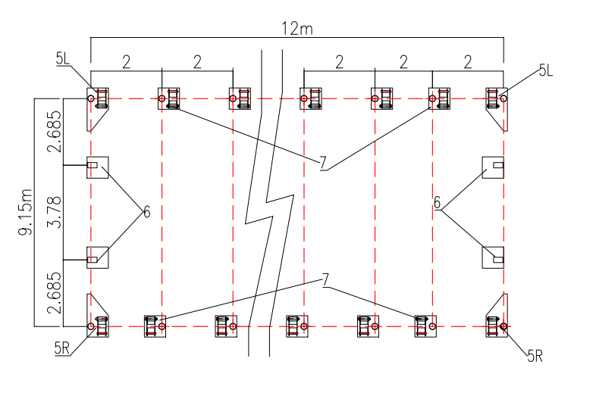 Figure 1
1. The measure if from center to center of the tubes. Referring to the above diagram and confirm the place of the base plates. ENSURE THAT THE FOUNDATIONS IS SQUARE.
2. There are three holes on the Base Plates (No.5, 7) and two holes on the Base Plate (No.6), for Stake Peg (No.16). THUS ALL BASE PLATES ARE SECURED.
Foundation Placement
As Figure 2 shows each Base Plate is equipped with three pieces of Stake Peg (No.16).
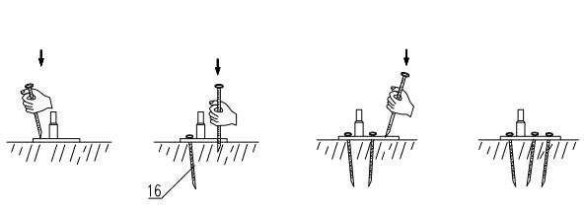 Figure 2
Note: The Stake Pegs apply for normal conditions, not suitable to the rock ground, frozen soil and concrete ground.

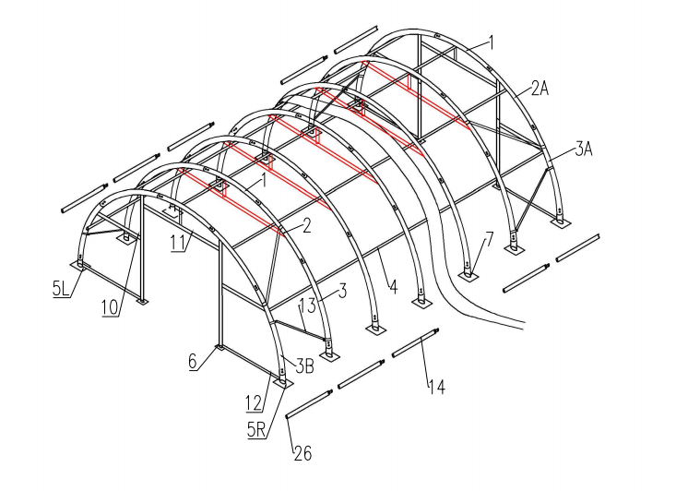
(W30'x L40' x H15') FRAME SKETCH Figure 3
B—FRAME INSTALLATION
- As Figure 4 shown to find one Roof Bent Tube (No.1), two pieces of Middle Bent Tubes for doors (No. 2), Lower Bent Tube (No. 3) and assemble every group arch with Screw . DO NOT install the screw on the top of the truss where the fabric will rest.
Note: Middle Bent Tube and Lower Bent Tube for two end tubes (No.2A&3A) which are welded with steel plates for Door are different.
- Lift an assembled arch onto one base plate and force the other end of the arch onto the opposite base plate.
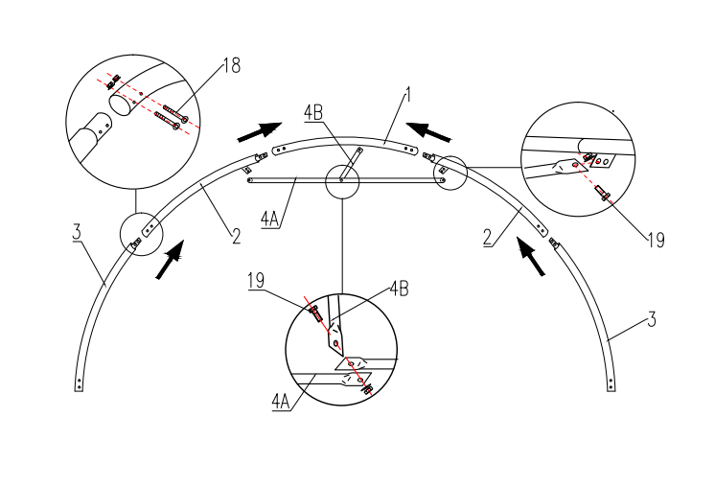

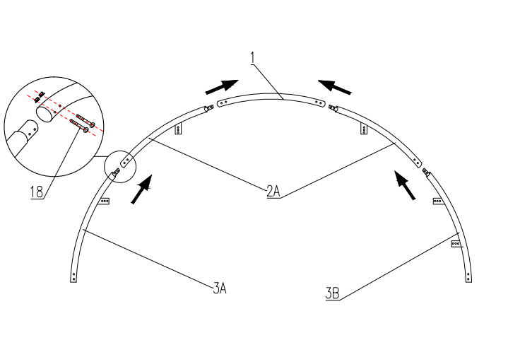

Figure 4

IMPORTANT: THE ARCHED WILL BE WIDER THAN THE BASE PLATES
- When finish installing the first two arches into the base plates, use purlins (No.4) to connect them by Screw M10x80 (No.17). Then install the third arch into the third arch into the plate and connect the Purlins. In this turn, fix all other arches and other purlins. Then come to install the front panel and back panel. Find the relative components and assemble them. The horizontal Strengthening Support Tube (No.4) under the roof bent tube is used for making the frame be much stronger(4A).
- Connect the Diagonal Bracing Tube (No.13) with clip (No.13A) between the Lower Bent Tubes as figure

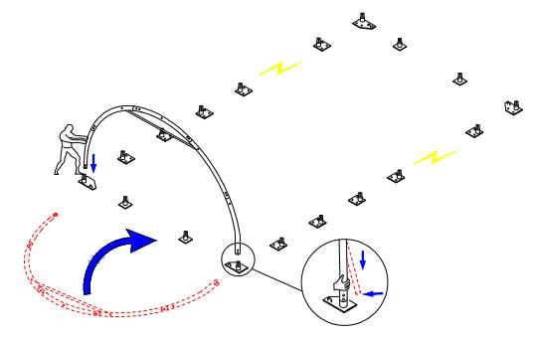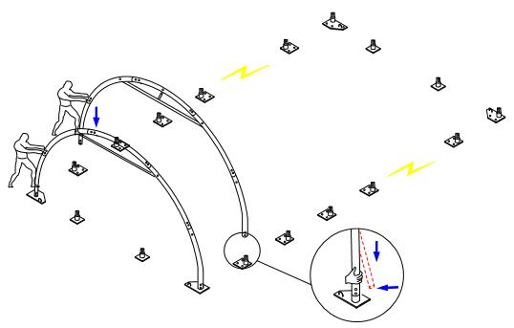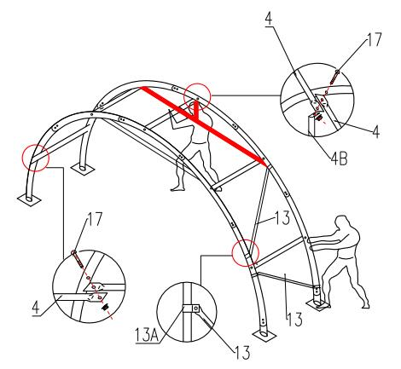

Figure 5

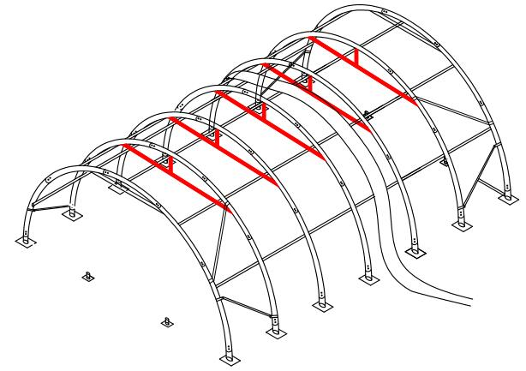

Figure 6
C—INSTRUCTION THE FRONT AND BACK COVER

Fit the tension tube (No.12) and them insert into the base plates as shown, install the Connection tubes for door (No.10).
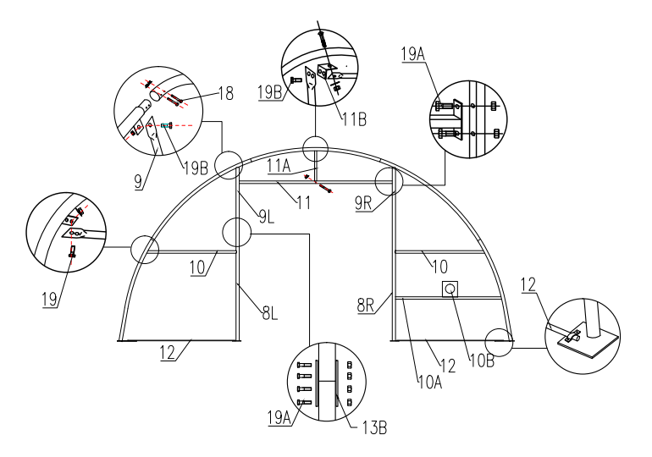 Figure 7

Method of Fastening Front and Back Cover .
Use Knitting Rope (No.24) on Front and Back cover (No.23) to lace the grommets in the end to the tension tubes evenly.
The end covers are tied to the frame (Roof, Middle &Lower Bent Tube) by Knitting Rope. They are also been secured to the end frame (door tube and side rail) by Knitting Rope.
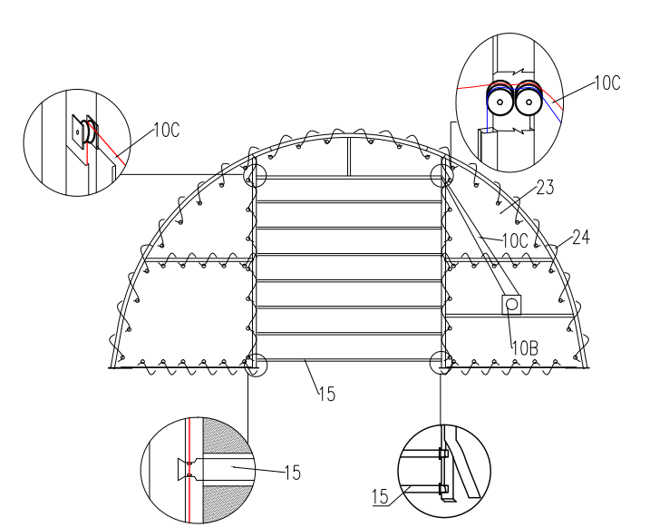 Figure 8

D—INSTRUCTION THE ROOF COVER
NOTE: DO NOT install the cover onto the frame of your building in high wind conditions. A slight breeze is the most advantageous for cover installation. To take advantage of the breeze, pull the cover up over the arches with breeze blowing in the cover like a sail filled with air.

- Assemble Tension Tube for Roof Cover (No.14) before installing the cover.
- Roll out the roof cover on a ground sheet. Align the cover evenly to each end of the frame.
Note: Be sure doing not pullover the end of the roof cover.
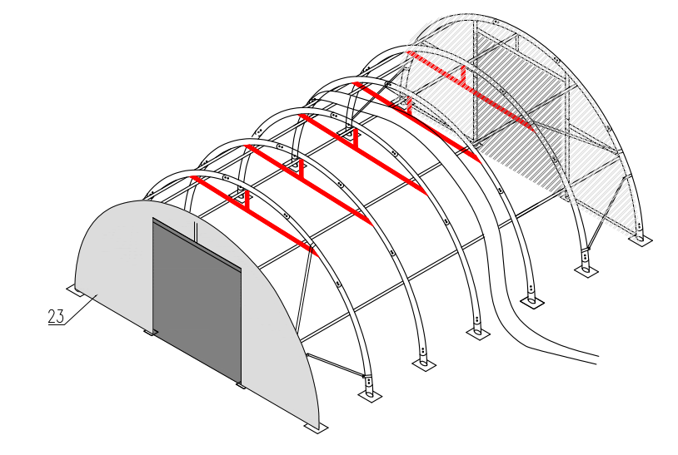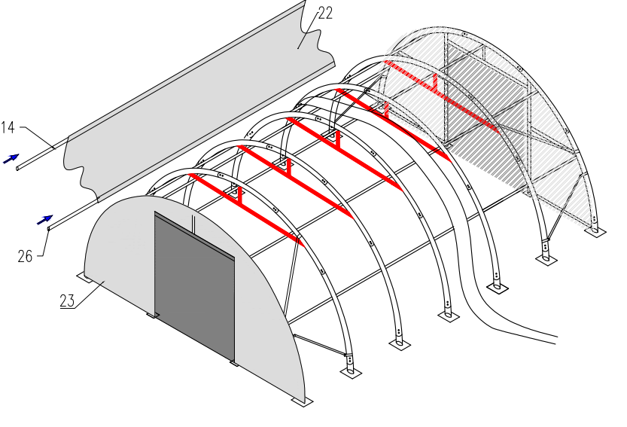

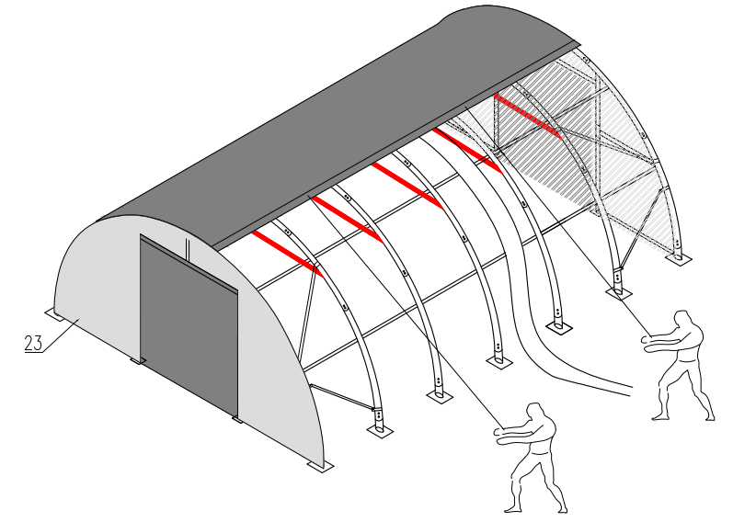

- Pull the cover over the frame EVENLY, CAREFULLY AND SLOWLY. Insert the tension tubes (No.14) into the cover pipe pockets and loosely secure the Nylon Band (No.25) for Winch in the Winch (No.21). DO NOT TIGHTEN. Adjust the cover so that it is square and evenly centered on the frame. Put the lower tension tube inside.

Note: The end flaps must overhang evenly at both ends.

- With the end flaps flipped back and out of the way, use the supplied Knitting Rope (Part No. 24) to tighten the roof cover to the end arches. The rope should be cut as your requirements when using. The recommended procedure is to use separate pieces of rope and start by first lacing the cover from the bottom edges up to the top center. Secure the ropes at the top center and then apply tension as you lace down both sides. Fasten the rope at the bottom edge. Put the Plastic Plug (No.26) for part No. 13& 14 onto the end of tubes. Drive the Ratchet Tie Down forth and back and then roof cover is tightened.

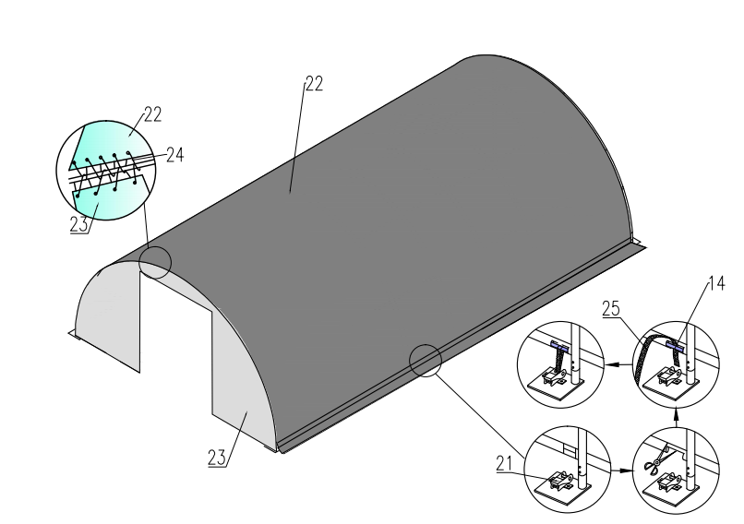

Figure 11

Tidy the cover, Roof Cover, Back Cover and Front Cover. Fasten the band inside the end of the roof cover, make the cover well fold to the frame and tie the end of the band to the Clips on Base Plates at four corners.
NOW THE INSTALLATION IS FINISHED.

NOTE: DO NOT LEAVE THE ROOF COVER UNATTACHED UNDER ANY CIRCUMSTANCES until the final assembly and tightening has been completed. The process is quite easy. But some tightening adjustments will be necessary to produce a flat, tension ed roof cover. Please adjust the roof cover every month.

