Rotary Tiller Instruction Manual旋耕机说明书

- This is a skid steer loader and rotary tiller这是一款滑移装载机旋耕机。
- 2050mm wide x 713mm high x676mm long, weighing 230kg; 2050mm宽 x 713mm高 x676mm长，重230kg
- Hydraulic motor drive, chain two-stage transmission液压马达驱动，链条二级传动。
- G1/2 quick connectorG1/2快速接头
- The blade is made of 65Mn刀片采用65Mn制成
- It can be used for loosening the soil in gardens可用于园林土壤翻松。
- The working depth can reach 160mm作业深度可以达到160mm，
- Black powder coating黑色粉末涂层。

规格specification | 单位  unit | 72″
width宽度 | mm | 2050
length长度 | mm | 835
height高度 | mm | 590
Work pressure工作压力 | MPa | 16
Work flow工作流量 | L/min | 50
motor speed  马达转速 | r/min | 180
rated power  额定功率 | KW | 8
Chain Size  链条规格 | 美标 | 16A
traveling speed行走速度 | m/min | 10
weight重量 | KG | 230
Working width工作宽度 | mm | 1830
Packing weight包装重量 | KG | 272
Packing width包装宽度 | mm | 2180
Packing length包装长度 | mm | 722
Packing height包装高度 | mm | 680
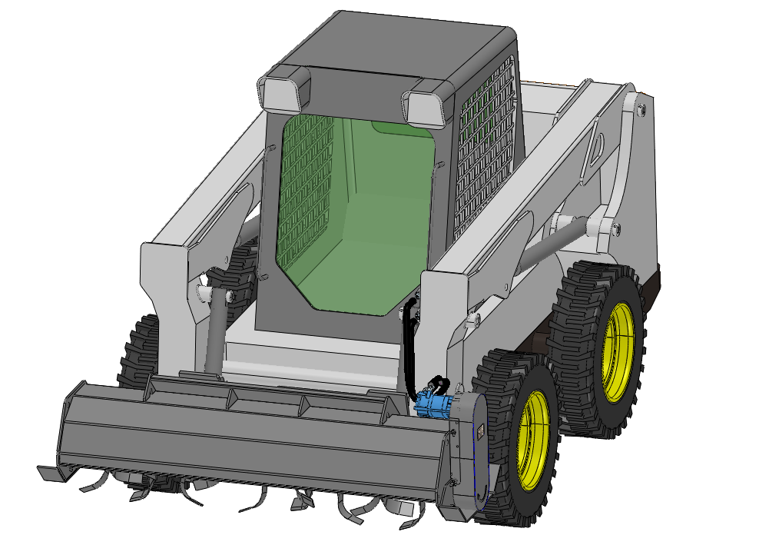

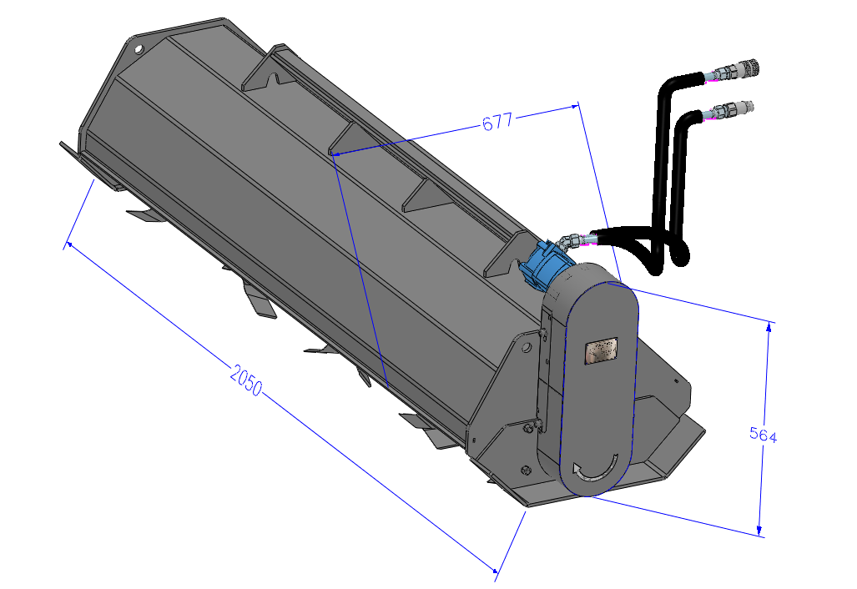

Assembly disassembly drawing of 72-inch rotary tiller72英寸旋耕机总装分解图
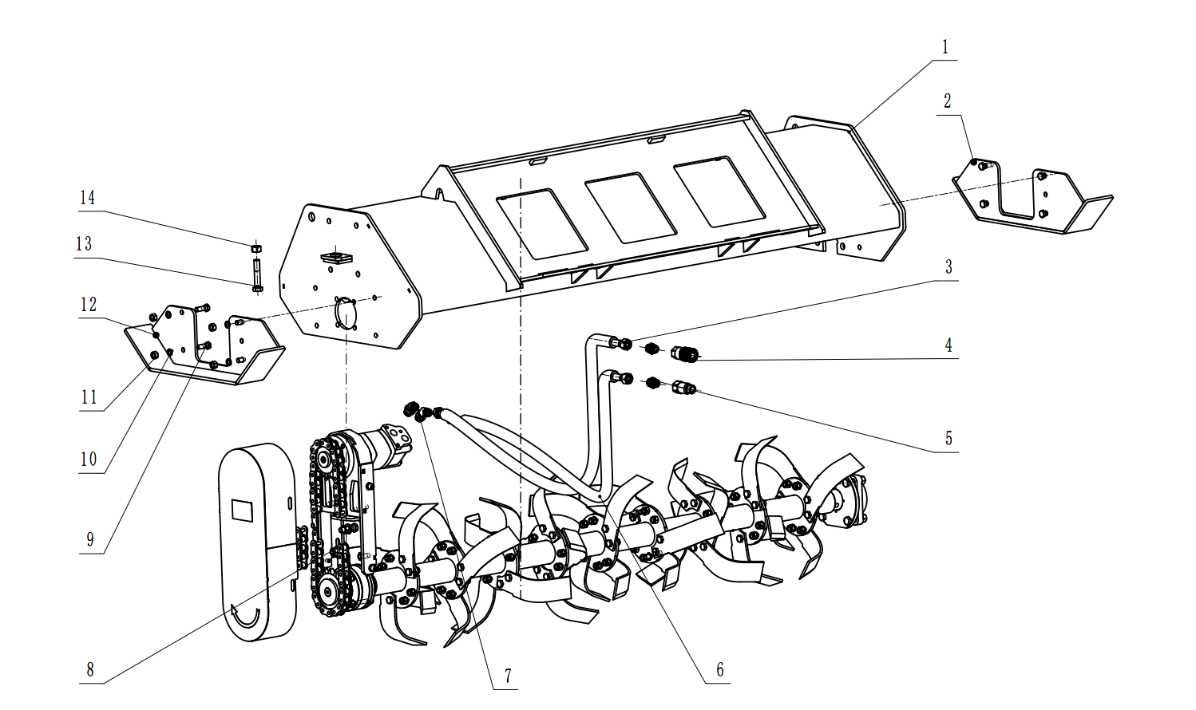

Installation method of 72-inch rotary tiller72英寸旋耕机安装方法
1.When using this product, place it on a flat ground immediately to prevent it from toppling over and injuring people
使用本产品时现将本产品放置平坦地面，防止倾倒伤人。
2Install the product on the skid steer loader将产品安装在滑移装载机上。
3As shown in the figure, loosen the 8 bolts at the left and right brackets respectively and reinstall the brackets如图所示，分别松开左右支架处8个螺栓，重新安装支架。
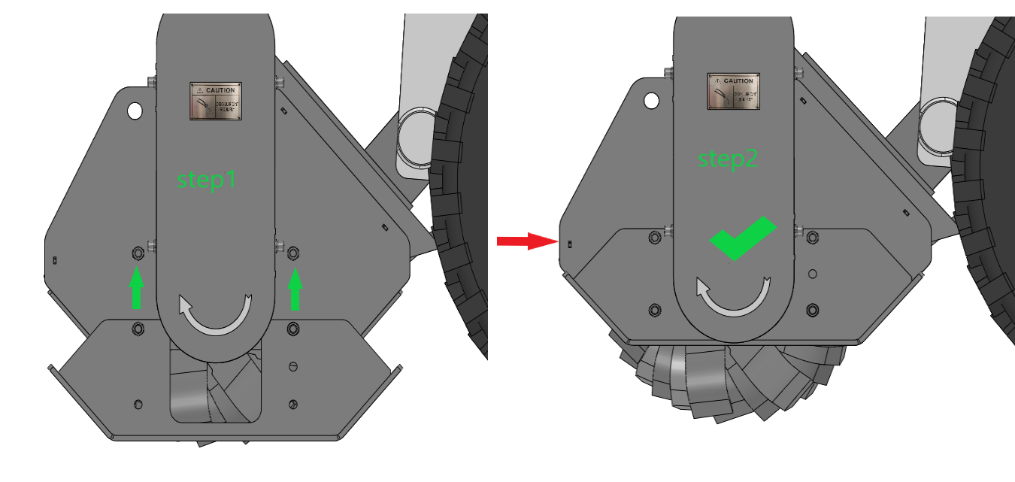

Usage method and precautions of 72-inch rotary tiller
72英寸旋耕机使用方法以及注意事项

1 When you use this product for the first time, you must open the chain guard, apply lubricating oil to the chain, and add lubricating oil again after continuous operation for more than 240 hours. This product when idle for a long time in the chain sprocket, please apply appropriate rust-proof oil or lubricating oil to prevent rust, and regularly check.

当你第一次使用时本产品时必须打开链条防护罩，向链条处涂抹润滑油，连续工作超过240小时再次添加润滑油。
本产品长期闲置时请在链条链轮涂抹适当防锈油或润滑油防止生锈，并且定期检查。

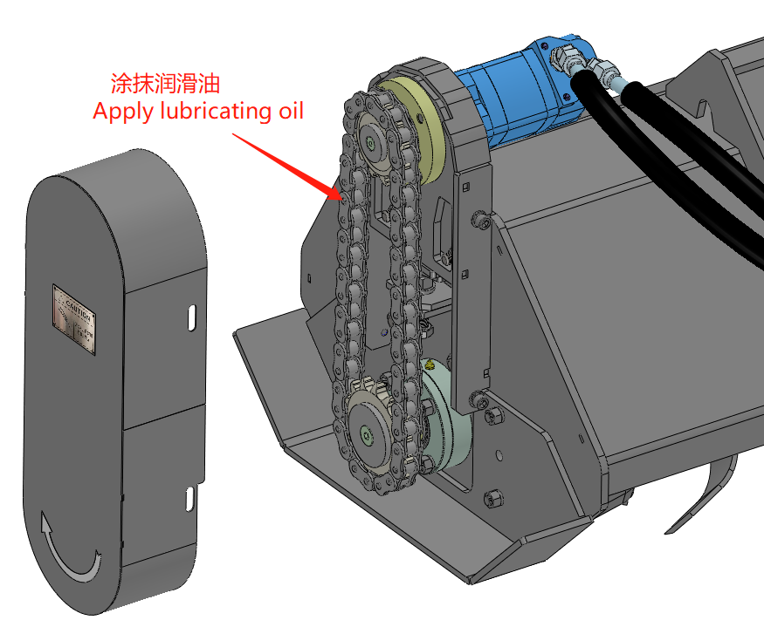

2 The chain of this product is of American standard 16A-44 sections. After using it for a period of time, you will find that the chain has grown. Don't worry, this is a normal phenomenon. This product can adjust the center distance of the sprocket according to usage, to adjust the tightness of the chain. When the adjusting bolt reaches the maximum limit, it indicates that the service life of the chain has reached its limit. Please contact us to replace the chain in time.本产品链条为美标16A-44节，当你使用过一段时间后，会发现链条增长现象，不必担心这属于正常现象。
本产品可以根据使用情况调节链轮的中心距，来调节链条的松紧程度。当调节螺栓达到最大极限，说明链条寿命已达极限。请联系我们及时更换链条。
Users are prohibited from adding or removing chains at will***用户禁止随意增减链条***

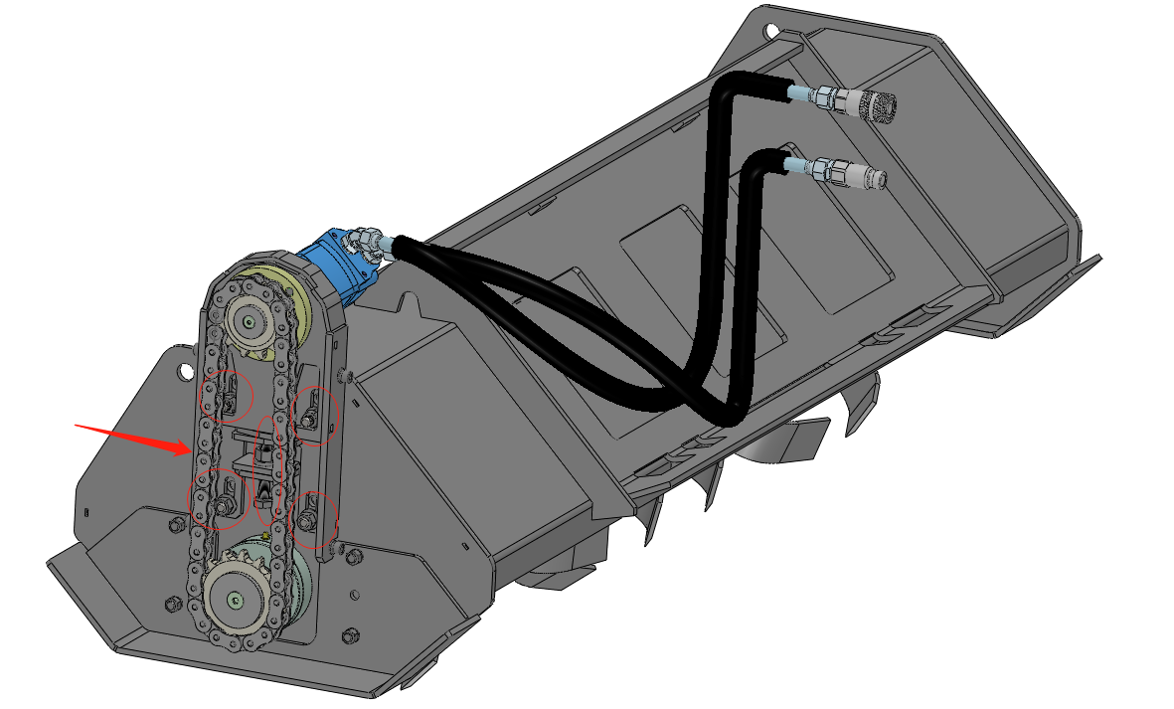
3. There should be at least a 12mm distance between the chain and the sprocket of the rotary tiller. This product is prohibited to take off the chain chain cover use, when you find loose cover is loose, motor bracket or sound in the use process, please close parking loader checks, and timely reinforcement bolt.旋耕机链条与链轮之间至少保持12mm的距离。
本产品禁止脱去链条链条防护罩使用，当您发现防护罩螺栓松动、马达支架松动或使用过程中有异响，请关闭装载机停车检查，并及时加固螺栓。

4.For the first time using this product, open the chain guard and add grease to the bearing housing. Inject lubricating oil into the oil nozzle regularly in the future.
首次使用本产品打开链条防护罩向轴承座处添加黄油。以后定期向油嘴处注入润滑油。

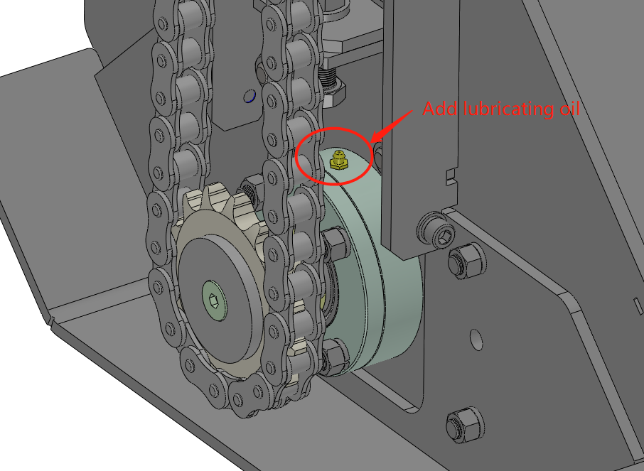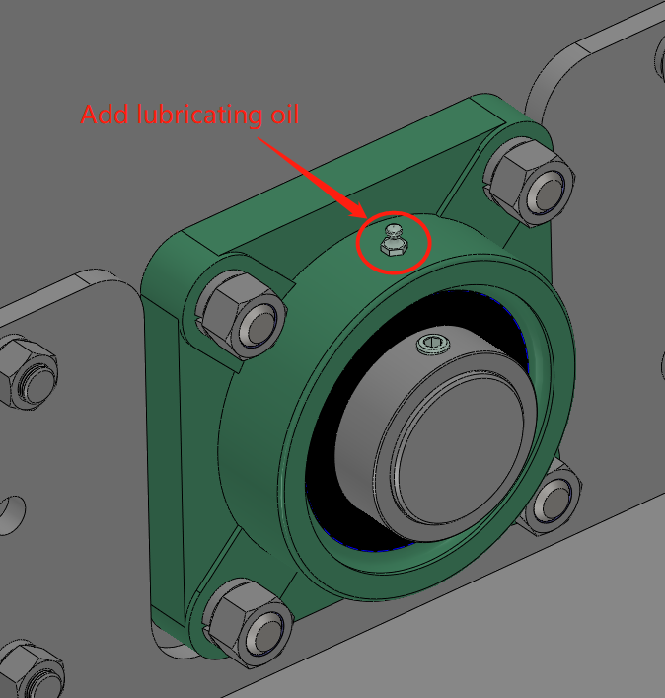

5. When using this rotary tiller, the skid steer loader is moving backward. Please pay attention to judging the possible obstacles such as personnel, livestock, gullies and hills in the driving direction. Rotary cultivator, slip reproduced machine front within 5 can't have people, animals, vehicles and other perishable goods, watch the splash damage使用本旋耕机时，滑移装载机倒退行驶，请注意判断行驶方向可能出现的人员，牲口，沟壑丘陵等障碍。
旋耕机工作时，滑移转载机前方5之内不能有人员、牲口、车辆等易损物品，谨防飞溅物造成损伤。
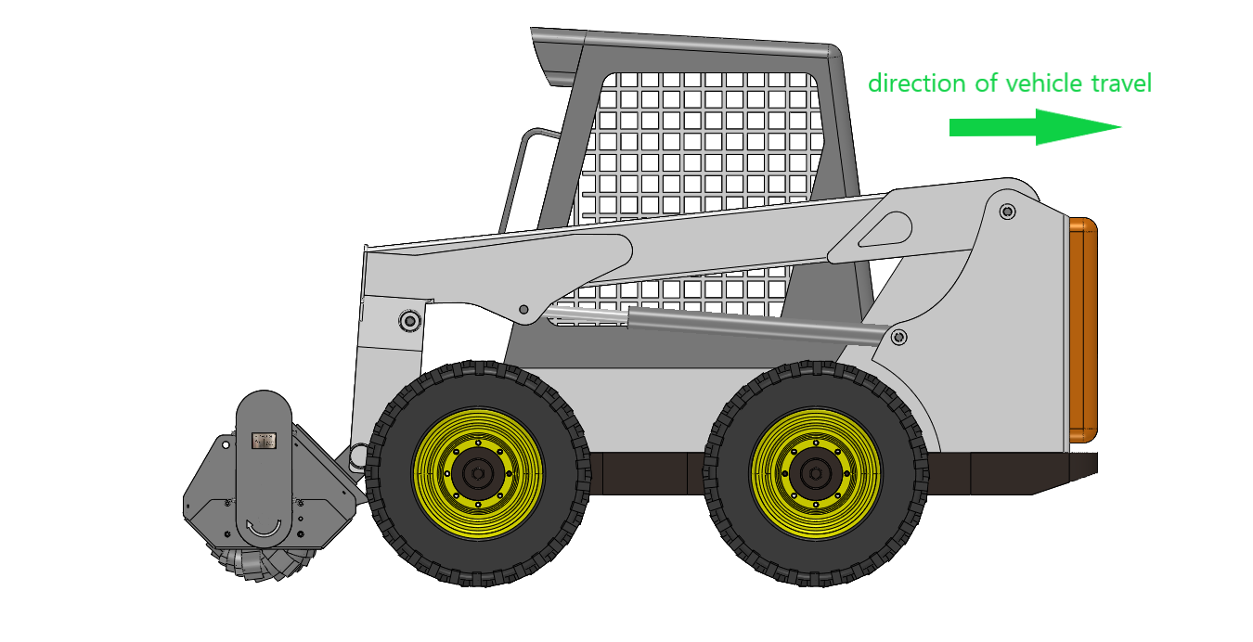

6 When the rotary tiller is idle, please reinstall the left and right brackets back to their original positions with bolts. Store on a flat surface. Do not step on it at will to avoid overturning and causing accidental injury
旋耕机闲置放置时请用螺栓将左右支架重新安装回原来位置。存放于平坦场地。不得随意踩踏，以免造倾翻成意外伤害。
7 When maintaining and repairing the rotary tiller, please turn off the skid steer loader
旋耕机维护检修时请将滑移装载机熄火。

