READ THROUGH THE INSTRUCTIONS FIRST BEFORE DOING ANYTHING. My personal email is mike.s.meeks@gmail.com should you have any further questions. Don’t worry because I do not mind. Rather you ask than screw something up and be mad at me. Just kidding, shoot me an email if you need to and remember that these instructions make sense to me because I designed it so I may be confusing or out of logical order simply because of that.

- Using the picture below, cut out the flaps

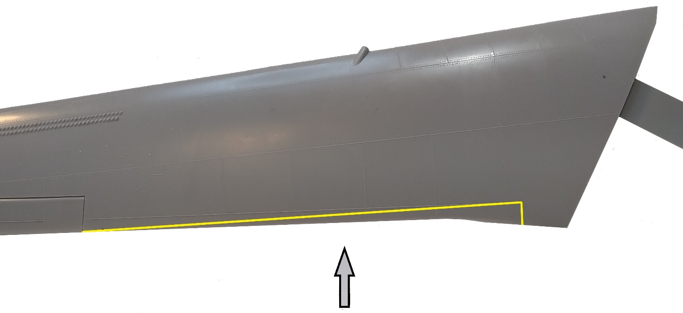
- Cut along the yellow line for the upper wing half using the above picture as a guide.
- The look you are trying to achieve is shown below. Pay particular attention to the arrows as a reference.
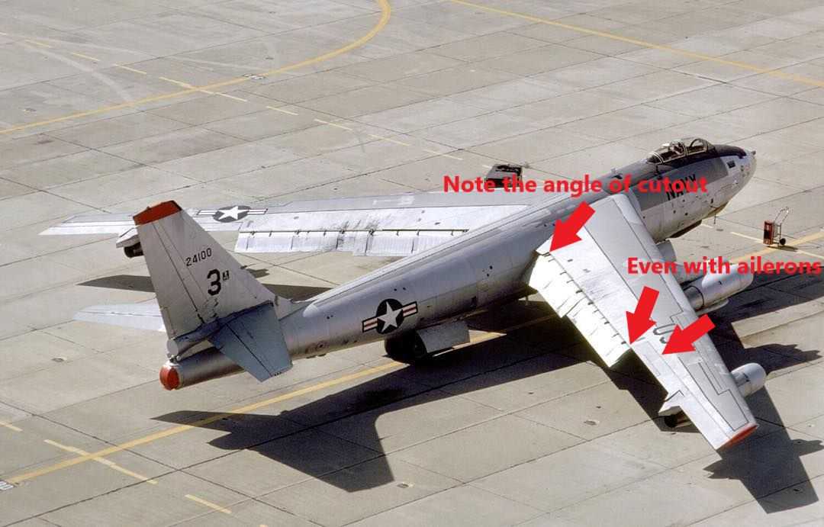

4.
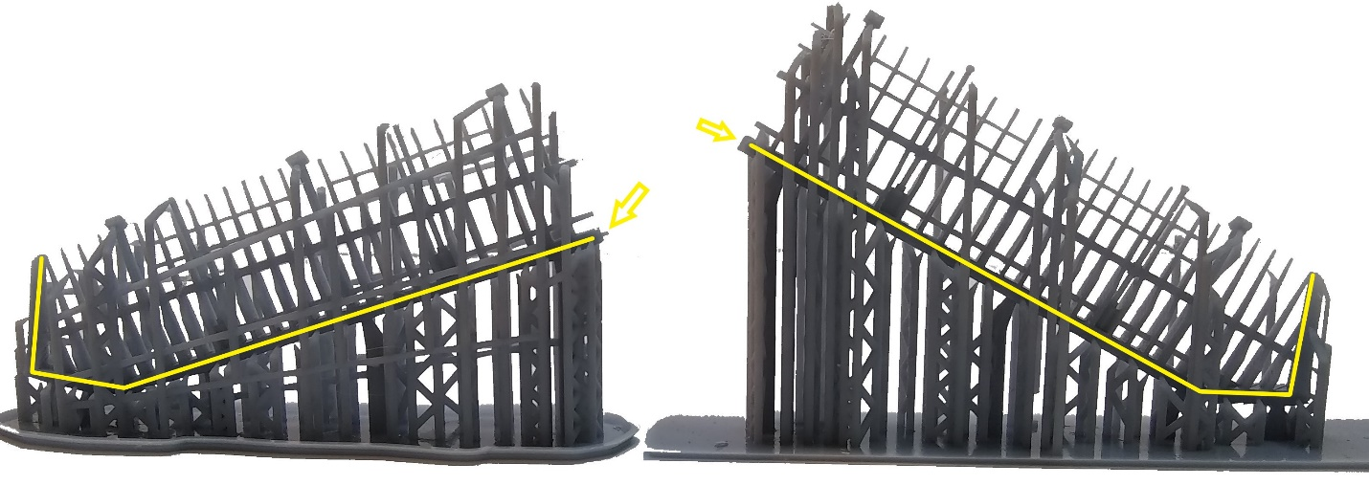

Above, I have highlighted the leading edge of the spar housing for reference. Start cutting out the spars from the printer supports. Start with the trailing edge (i.e. the top) and clip the support as close to the spar as you can. ALL the delicate parts of the spar must be cut from the supports BEFORE you proceed to cutting off the supports along the yellow line. Note the yellow arrows. These are alignment pins and on the opposite side is the holes to align to. Some of the holes, due to the print process, may be too small. In those cases, either cut off the pin or expand the hole.
THESE PARTS ARE EXTREMELY DELICATE SO TAKE YOUR TIME. The picture below shows the areas in red of which you are cleaning up. Remove everything in the spaces with red. The yellow shows the curvature of the spars for orientation. The next picture down is the look you are trying to achieve. Note how the spaces in which the red arrows point out are cleaned up. The yellow arrows are flap attachment points which we will get to later.
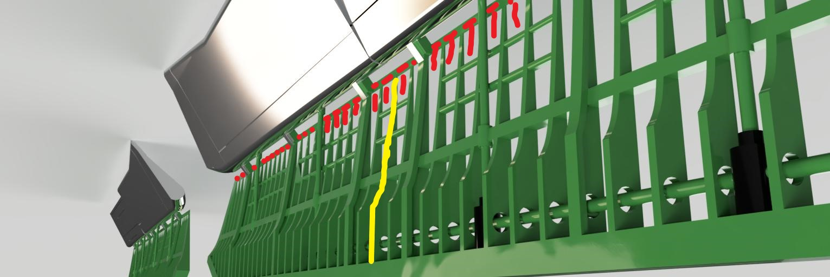
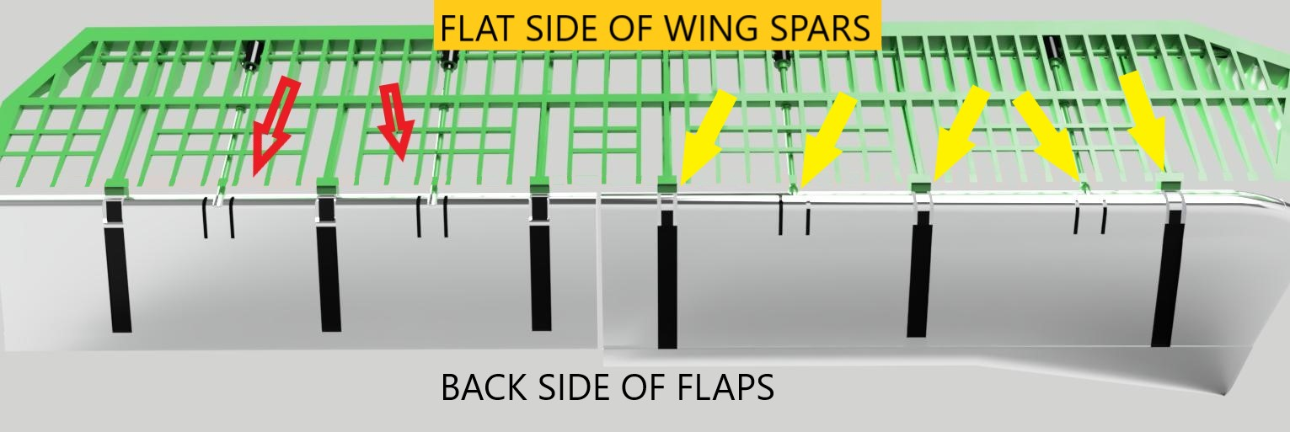
Afterwards, start cutting the faps from the printer supports. The flaps are sturdier but I would still cut from the top down.
6.
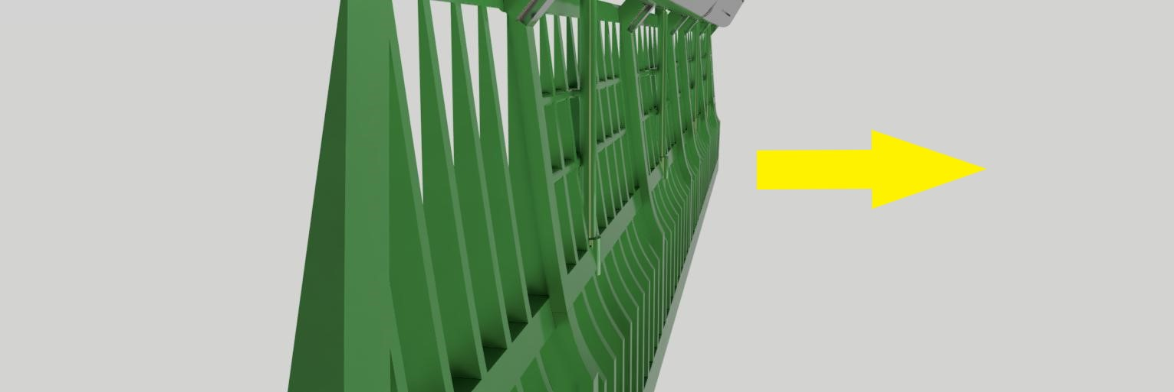

Notice the curvature of the wing spars. The arrow points towards the ground as if they are already installed on the model. The side away from the arrow is the flat side. Place the flat side down on a flat surface to align and glue the spar halves together.

7.
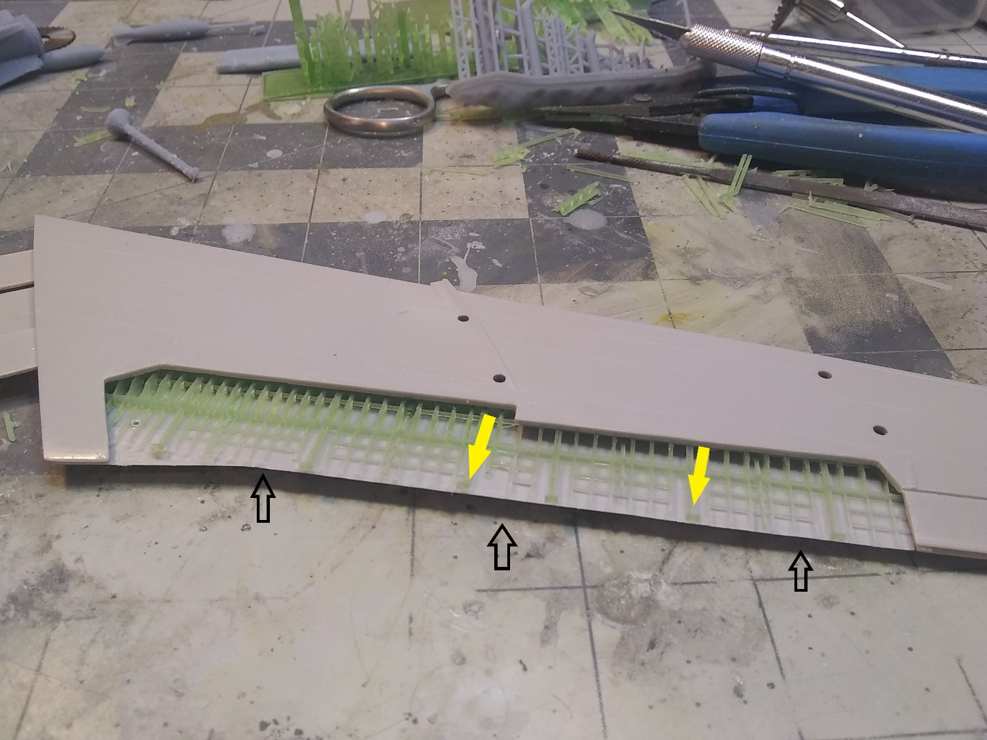

Using the picture above, align (don’t glue yet) the joined spar halves in the wings as shown. The black arrows are pointing to a flange on the inside of the upper wing half along the trailing edge. File that flange down using the spar halves as a reference for how far they should be sanded. The yellow arrows point to the a few of the connection points for the flaps. Remember, the spars go FLAT SIDE towards the upper wing half. Once you get the desired fit, i.e. looking like the picture above with both wing halves coming together without force, glue the spars to the upper half of the wing. Once glue has set, glue the wing halves together. The picture below should be used for orientation reference with special not of the black arrows. This is the same orientation as the spars in the picture above.
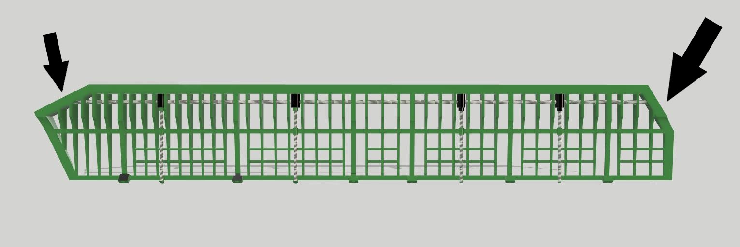

8. 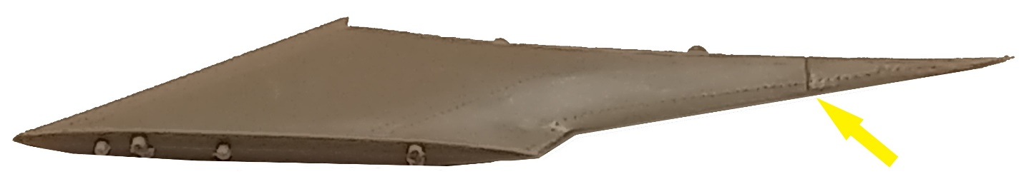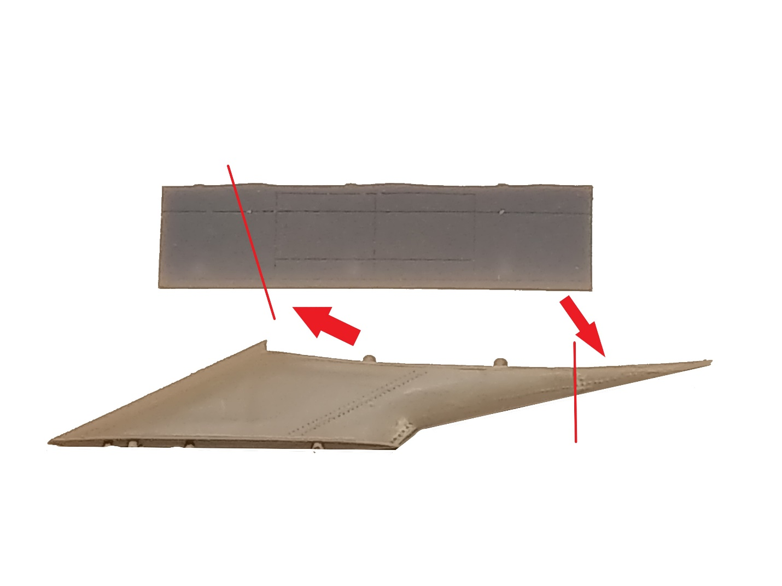

Next glue the inboard wing mounts together as shown above. Dry fit the engine mount to the wing so you can better understand this next step take mental notes of the position of the trailing edge of the engine mount and its location on the outer flap. Afterwards, cut off the trailing edge tip of the mount as depicted by the red line and yellow arrow. You are going to use this piece to glue to the outer flap along the red line of the flap as shown above. Use the wing halves as a guide for the mount and flap to place the trailing edge mount piece. Below is another reference, the picture is not my own and I do not know who the photographer was to give credit.
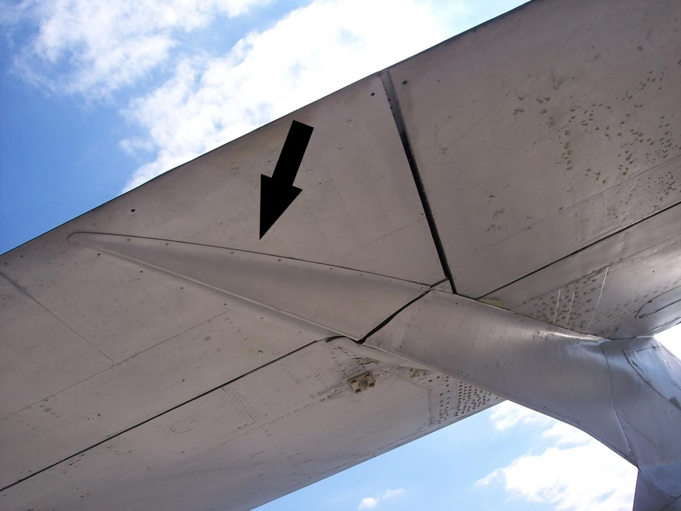

9. Once step 8 is complete, glue to the flaps to the wing spars as depicted below.
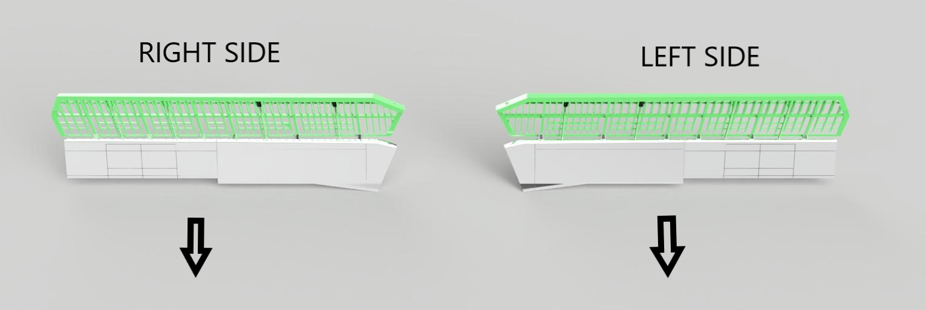
Below are the points of reference for the flap orientation. Note the flap slots (grooves). These should face skyward once connected to the model.
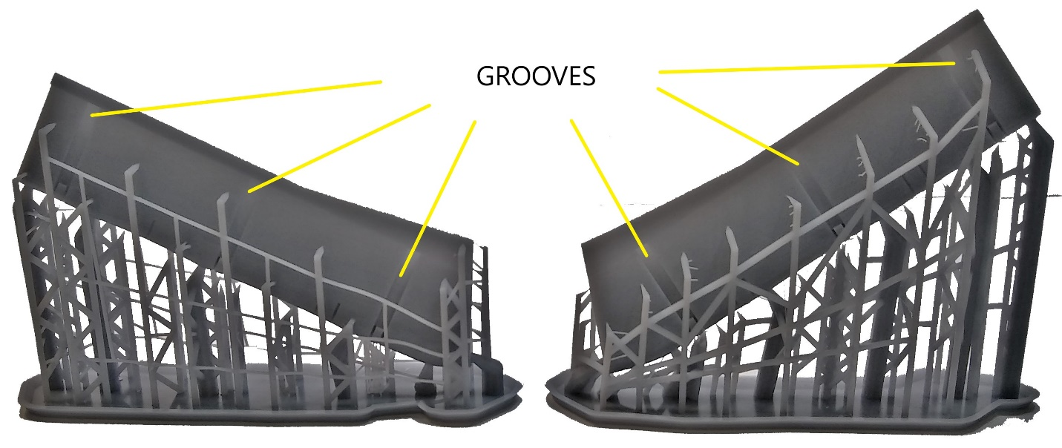
The flap connect points are shown in yellow below.

Below is the flap angle. The flat sides of the connection points should guide the flap angle.
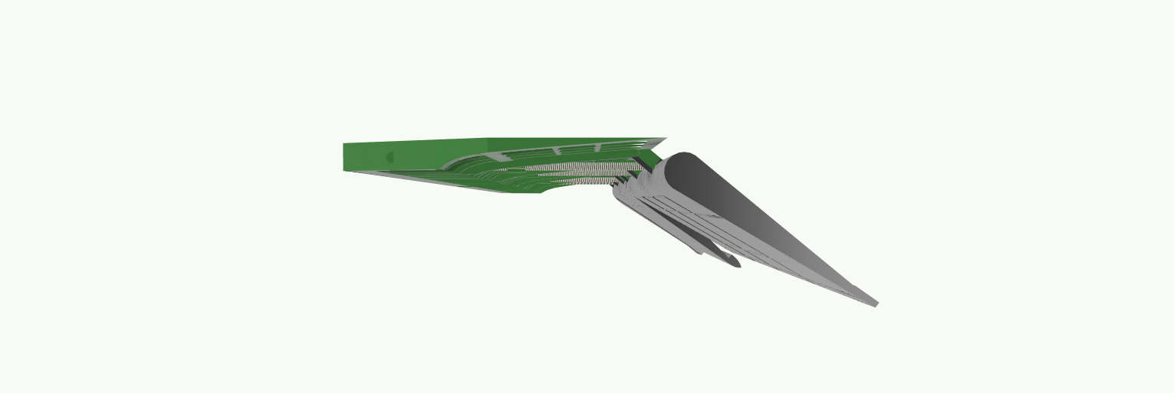

10. Once both sides look like the picture below, then you’re done.
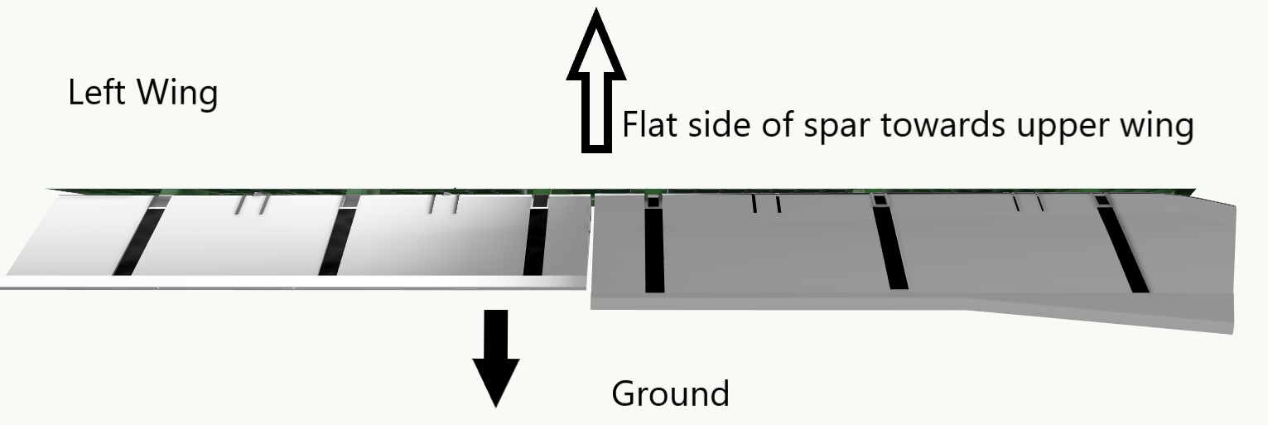

Remember, contact me for questions or just a critique of these instruction if you determined they are useless. I can’t make them better without input so fire away. Again, thanks for your purchase and good luck. r/Mike

